NOT Inspections Module 3 Printout

1.3 Learning Goals
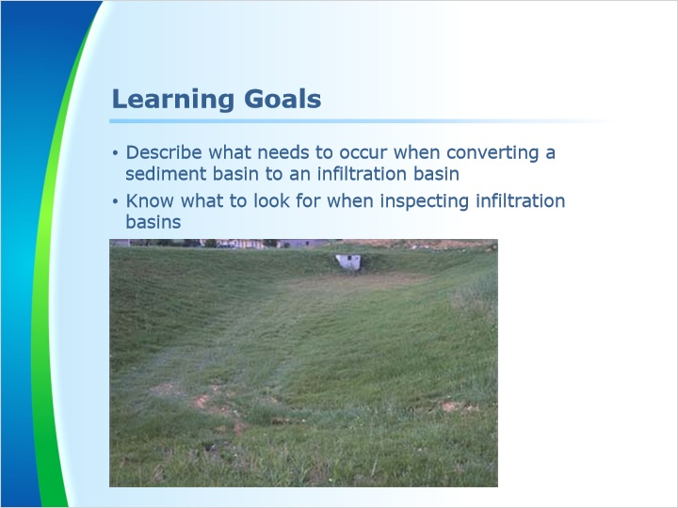
Notes:
Welcome to Module 3. In this module, we will look at some examples of infiltration basins. Specifically, we will discuss what needs to occur when converting a sediment basin to an infiltration basin and what to look for when inspecting infiltration basins.

1.4 Converting Basins to PCSM
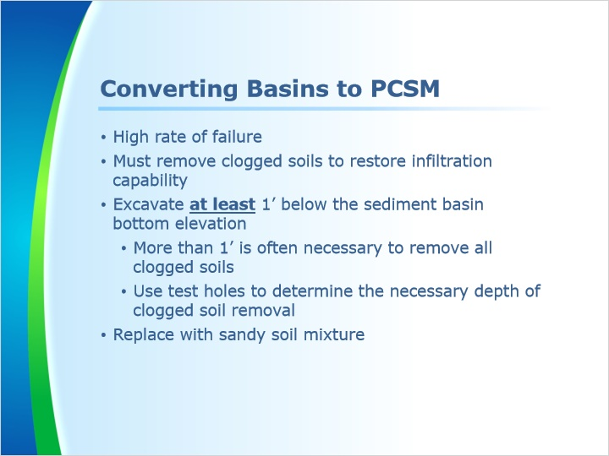
Notes:
When sediment basins are used during construction and converted to an infiltration basin after construction has finished there is a much increased percentage of failure of the infiltration basin. When used as a sediment basin during construction the underlying compacted and clogged soils must be removed to restore infiltration capability. The NPDES permit requires that additional soil testing be performed if areas planned for infiltration are compromised through compaction or other means. In this case, compaction of the soils is likely as well as clogging of the basin bottom soils due to its use as a sediment basin during construction.

The 2006 Stormwater BMP Manual states that over-excavation of at least one foot of soil below the sediment basin bottom should be conducted when a sediment basin is converted to an infiltration basin. Appendix C of the 2006 version of the BMP Manual contains this information as well as several other important things to consider when conducting soils tests and utilizing infiltration BMPs to manage post-construction stormwater runoff. Experience has proven that excavation of one foot of soils from the bottom of a sediment basin during conversion to an infiltration basin is often not enough to remove all the clogged soils.

It is suggested that retesting infiltration rates be done prior to removing the prescribed one foot of basin bottom soils. Test holes could be excavated at one foot, two feet and three feet below the sediment basin bottom to conduct soil investigation and determine what depth of clogged soils will need to be excavated for adequate infiltration rates to found.

Excavations deeper than the prescribed one foot should be replaced with a sandy soil mixture to bring the basin bottom back up to the proposed infiltration basin bottom. The Stormwater BMP Manual suggests that a 6 inch layer of sand or gravel be placed on infiltration basin bottoms where soils are found to have poor infiltration rates. Experience has found this to be very effective since sand and gravel is not broken down to smaller soil particles by the impacts of falling rain drops where it can clog underlying soils and cause infiltration failures.

1.5 Example 1: Gully on a Riprap Apron
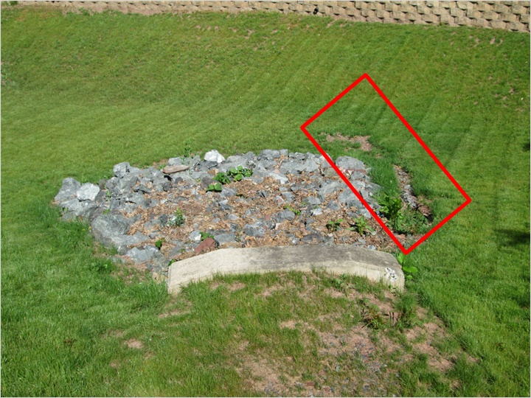
Notes:
This riprap scour protection apron at the end of the incoming storm sewer pipe coming into a basin is not constructed properly. The apron was not adequately channelized to keep flows in the center of the apron. Runoff is exiting the apron on the right side of the photo where an erosion gully is beginning to form. Despite the plan detail for the apron showing it to be channelized, contractors often fail to raise the sides of the aprons to keep flows within the protected area where energy of the concentrated runoff flows can be properly dissipated by the rock. An easy fix to this problem is to filling the erosion areas with topsoil and use large rock to build up the sides of the apron to keep runoff flows in the center of the apron as intended.

1.6 Example 2: Rock Forebay Berm
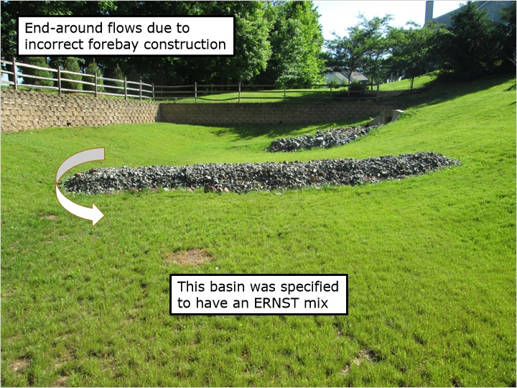
Notes:
This photo shows a rock forebay berm in the same stormwater basin shown in the previous slide. In this case the rock is not level, allowing end-around flows at the low spot, as shown by the arrow. Additional rock should’ve been placed up the slope on the left side of the rock berm as was done on the right side.

This basin was specified to have an ERNST seed mix as the permanent vegetation on the basin floor. The developer indicated that it was the responsibility of the homeowner to maintain the basin and that they continually mow it and keep it in a grassed condition. Since it was not installed as per the project specifications, the permit was not terminated. A revised plan was submitted to add several water tolerant trees to the basin bottom in lieu of the ERNST seed mix. After the trees were added, the riprap forebay berm and apron fixed, the NPDES permit was terminated accordingly.

1.7 Example 3: Outlet Riser
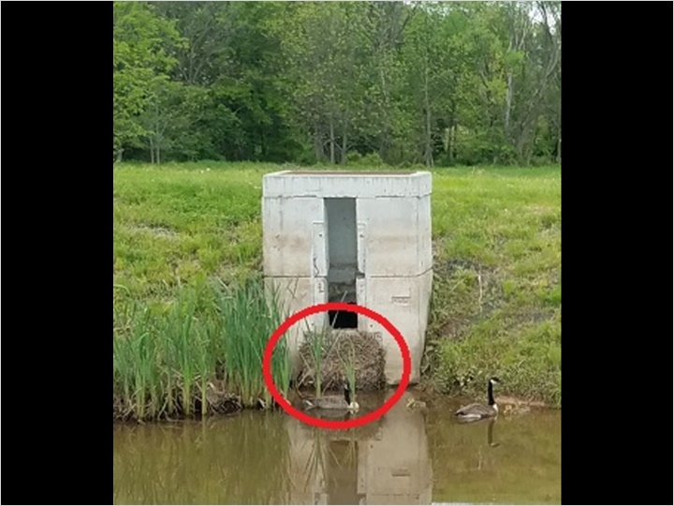
Notes:
This outlet riser in a constructed wetlands basin has a large vertical outlet weir and a smaller circular orifice, which cannot be seen, provided at the water surface elevation. Inspectors should measure the outlet orifices and weirs to ensure that they are the same size and elevation shown in the plan details. Look for trash racks covering the orifices, weirs and the top of the outlet structure where overflows are designed to enter before discharging over the emergency spillway. In this case, the trash rack is provided only on the lowest orifice and is covered with vegetative debris. It is not being maintained as required to remove debris from the trash rack. No trash rack was placed on the vertical outlet weir as was required by the plan detail. There is a grate on the top of the structure instead of the trash rack shown in the plan detail. Grates on top of outlet structures can become quickly clogged during large runoff events, often leading to unintended discharges over the emergency spillway instead of through the outlet piping as designed. It can also be seen that the top of this riser is actually higher in elevation than the berm behind it. Risers should generally not be higher than the berm since overflows should be directed through the outlet piping before discharging over the emergency spillway. Outlet risers should have all joints and pipe penetrations sealed so that the only discharge is through the orifices and weirs as calculated. As noted in the rain garden overflow section, the use of butyl mastic is highly preferred to seal riser joints as it will provide a reliable long-term seal.

1.8 Example 4: Mastic Seal
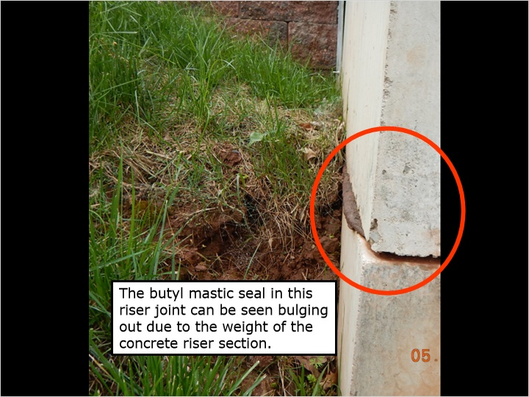
Notes:
The butyl mastic seal in this riser joint can be easily seen bulging out of the joint within the red circle. You can also see that the use of mastic creates a small, approximately ½ inch gap between the riser sections, a potential indicator that a sealing product was used between the riser joints. When mastic is not used, the two concrete sections are often very tight together but not sealed as required. As noted previously, an inspector can attempt to look through the riser joint for signs of light coming through. That would be an indication that the joint has not been sealed.

1.9 Example 5: Concrete Cradle
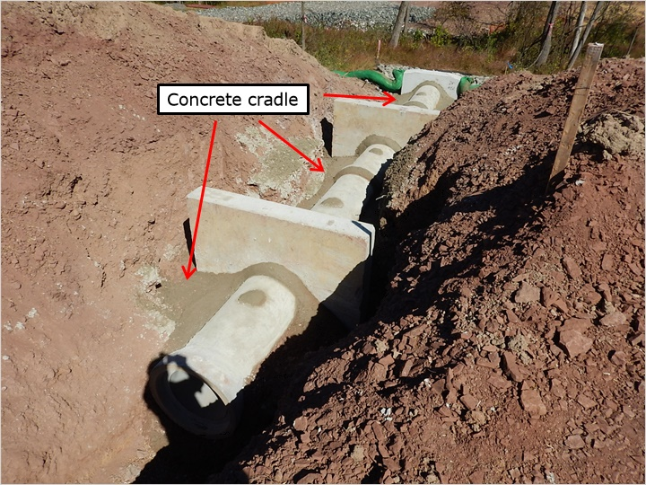
Notes:
Concrete cradles along basin outlet piping are required by the Pennsylvania Erosion and Sediment Pollution control Manual for all permanent basins and temporary sediment basins with drainage areas of 10 acres or more. The concrete cradle is poured in the excavated pipe trench up to the spring line of the pipe, or half the height of the pipe. Concrete cradles do a good job of filling the gaps under the pipe where soil backfill often leaves voids, allowing water through the basin berm on the outside of the pipe. Piping conditions can lead to catastrophic berm failures, a threat to the health and safety of both people and the environment.

In this photo, you can see a freshly poured concrete cradle on the sides of the installed pipe. It was poured after the installation of the pre-cast concrete anti-seep collars and provides a seal between the pipe and anti-seep collars. The contractor also used some of the concrete to seal the lift hole on the top of each concrete pipe section. It is often impossible for inspection personnel to determine if the concrete cradle and anti-seep collars were placed if they are not there to witness the installation. Leakage into the pipe from inside the earthen berm is one of the indications that the pipe is not sealed as required and a concrete collar may not have been installed. The licensed professional signing off on the notice of termination should be onsite to witness the concrete cradle and anti-seep collar installation when the sediment basin is installed since it most often cannot be witnessed during conversion of the sediment basin to the permanent stormwater management basin. The sediment basin berm and outlet piping should be labeled a critical stage requiring licensed professional oversight in the construction sequence.

1.10 Example 6: Leaking Outlet Pipe
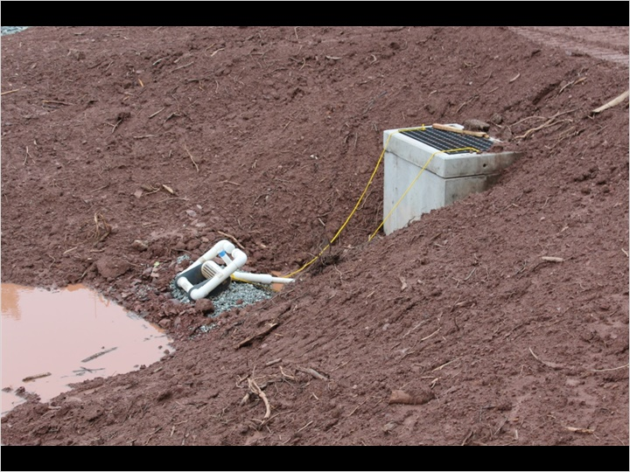
Notes:
This photo shows a sediment basin that was recently constructed and will be converted to a permanent post-construction stormwater management basin when construction is completed. It can be observed that the water level in the basin is not up to the level of the dewatering skimmer so there should be no discharge occurring.

This photo, taken immediately after the previous photo, shows the sediment-laden discharge that is coming through the outlet pipe on the other side of the basin. Since the water level in the basin was not at the elevation of the discharge skimmer, it is easily determined that the basin outlet riser or piping is leaking and not watertight as required. After looking down the outlet riser it was determined that the leak was not in the riser structure so it must have been in the outlet piping within the basin berm. It was subsequently found that the contractor failed to install the required concrete cradle at the bottom half of the outlet piping through the basin berm as was shown in the plan details. Although the concrete cradle is not necessarily meant for providing watertight pipe joints, it can help to seal the bottom half of the pipe joints. The concrete outlet piping was installed using the required rubber gaskets but the gaskets did not create a watertight joint. This is a common occurrence when working with concrete pipes when no other means of assuring watertight piping is implemented. Using a flashlight and shining it up the outlet pipe from the discharge side will often show where the water is seeping in through the unsealed pipe joints. Observation of leaking outlet piping should be documented as soon as it is observed so it can be repaired quickly, hopefully before disturbance of upslope construction areas commences. Repairs of leaking outlet piping generally requires the berm to be excavated for proper watertight pipe installation and concrete cradle placement.

1.11 Example 7: Emergency Spillway
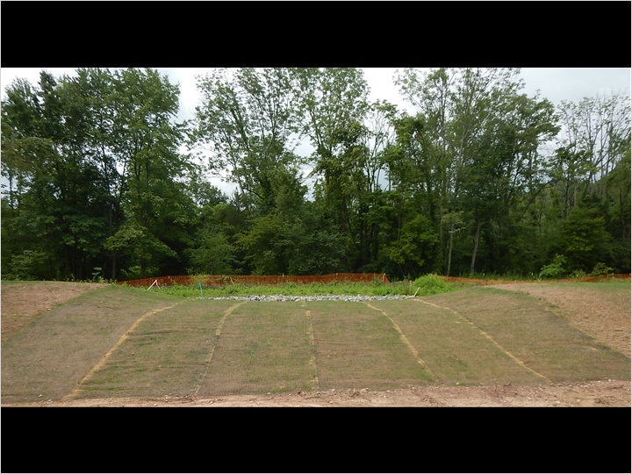
Notes:
When inspecting an emergency spillway, make sure that the spillway is channelized on top of the berm and down the back slope as shown in the construction detail. Make sure the correct lining has been installed up to the top of the channel side slopes on each side. Some permanent turf reinforcement mattings have an extended grass grow-in period due to the density of the matting. Look for 70% uniform grass growth through the spillway lining. It is very common that the contractor fails to provide the channelized grading on the outside slope of the basin. Try to catch this issue early in the construction when the basins are often used as a sediment basin so that it is corrected before the time comes for a final inspection.

1.12 Example 8: Constructed Wetlands Berm
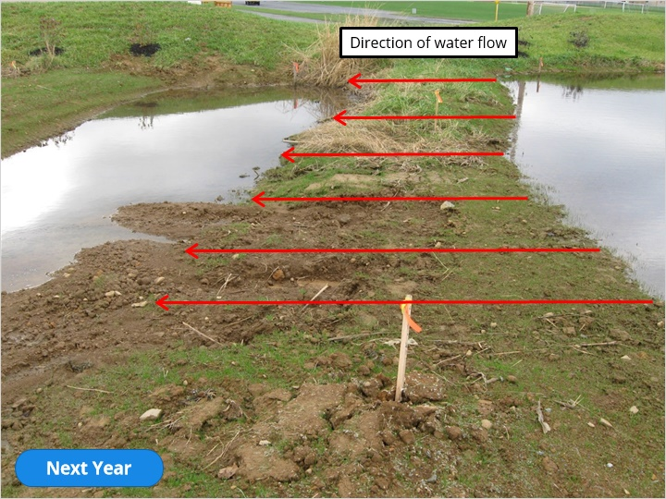
Notes:
This photo shows a constructed wetlands basin that was recently converted from a sediment basin. The forebay berm in the middle of the photo has signs of erosion where runoff is flowing over the berm from the right side of the photo towards the left side. The plans specified the use of a permanent turf reinforcement matting on the forebay berm spillway but it was not implemented as required. The project plans specified a wetland seed mixture to establish the wetland vegetation. These seed mixes often take an extended period of time to establish and often wash away due to the concentrated runoff flows in basin BMPs. Inspection personnel should be looking for establishment of the specified vegetation prior to terminating the NPDES permit.

Example 8: Constructed Wetlands Berm (One Year Later)
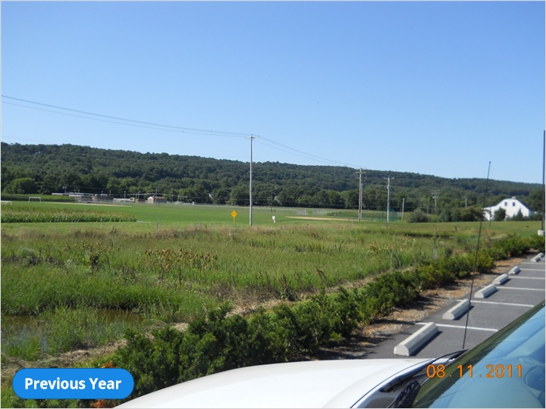
Inspection personnel should observe the vegetation, attempt to identify what is established and compare it to what is specified. Photos of specified wetland vegetation can be easily found on the internet to assist inspection personnel in identifying what is proposed as the permanent vegetation.

In this case, the established vegetation within the constructed wetland is predominantly cattails and reed canary grass. These are typically invasive wetland plants and generally not specified as the proposed permanent vegetation. In many cases the project plans will require removal of invasive species as part of the BMP operations and maintenance. The NPDES permit should not be terminated until the proposed permanent vegetation is established.

1.13 Example 9: Erosion Gullies
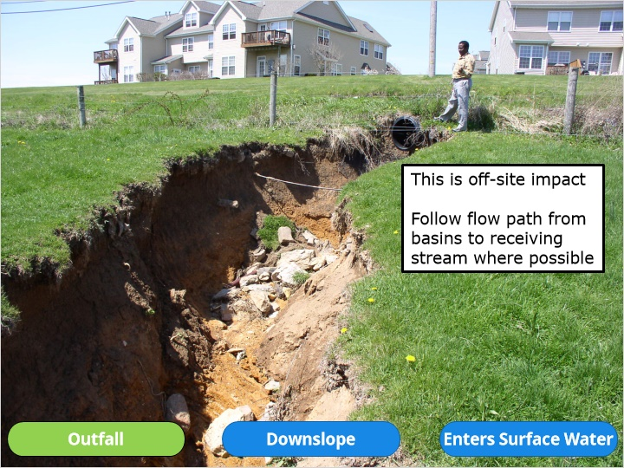
Notes:
Erosion gullies are common at basin outfalls where newly concentrated flows are created by the basin and its outlet piping. In this situation, a stormwater basin is located on the upslope side of a road culvert, generating a situation where the existing culvert is now receiving much more flow volumes than in the pre-development condition. The increased flows have created a severe erosion gully on a neighboring property. Inspection personnel should attempt to follow the basin discharge paths the entire way to the receiving surface water or where it enters existing storm sewer whenever possible to look for signs of accelerated erosion. This gully is up to eight feet deep in some areas and is continuing to erode.

Example 9: Erosion Gullies (Downslope)
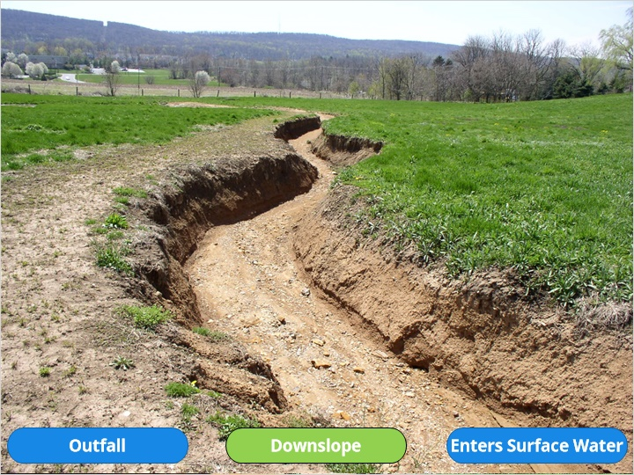
Further downslope we can see concentrated flows continue to erode the sides of the gully during runoff events.

Example 9: Erosion Gullies (Enters Surface Water)
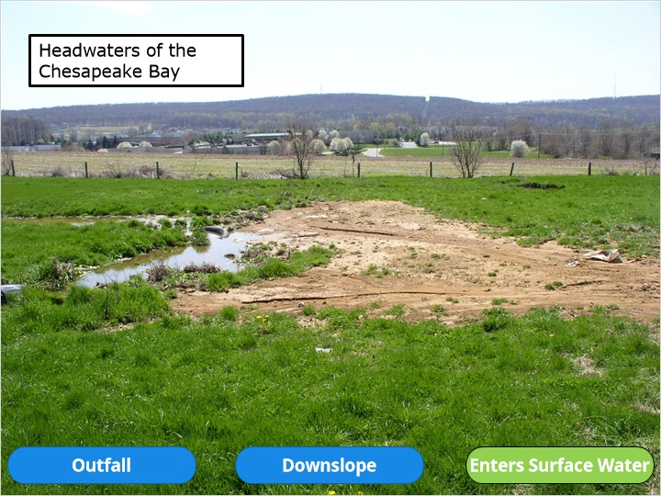
This is the sediment deposit at the end of the erosion gully where it enters the receiving surface waters. When possible, it is recommended that a lined channel is provided the entire way to the receiving surface water where newly concentrated basin discharges are proposed. The PA erosion and sediment pollution control manual provides a method of analysis for designers to prove no erosion potential when new concentrated sediment basin discharges are proposed where concentrated flows did not exist in the pre-development condition or when flows to the discharge point have been increased.

1.14 Level Spreaders
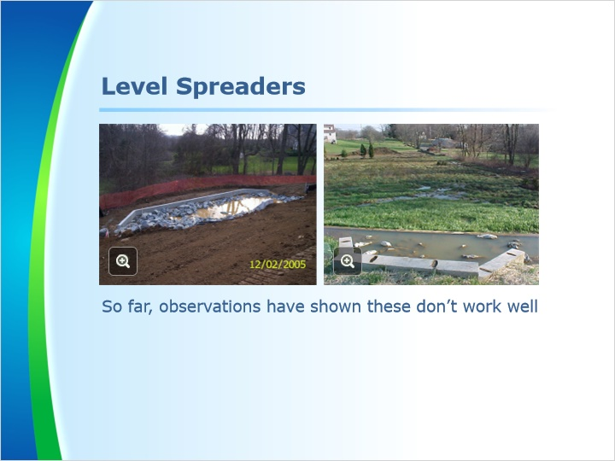
Notes:
Many designers will choose to use a level spreader at the end of a basin discharge pipe in an attempt to return flows to a non-erosive sheet flow condition. In Pennsylvania, sheet flow conditions over vegetated areas generally does not extend further than 150 feet, and in most cases 50 feet or less before flows become re-concentrated. Numerous issues have been discovered with level spreader construction during previous inspections and in most cases the level spreader fails to provide the intended sheet flow result. In general, it is usually best to design development plans to have more spread-out stormwater BMPs with multiple points of discharge rather than sending the runoff to a regional basin with one, large concentrated discharge area.

1.15 Example 10: Level Spreaders
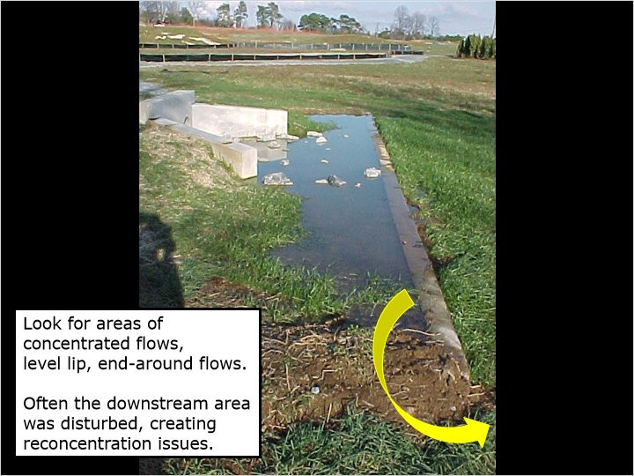
Notes:
Inspection personnel should look for signs of concentrated flows, look for a level lip and areas where end-around flows or undermining of the structural lip may be occurring. In this situation, the concrete lip is level as can be seen by the water level, but a new earthen berm was placed at each end where discharged runoff was flowing around the level lip at the yellow arrow instead of over it as intended. This photo shows that the area immediately downstream of the level lip is well vegetated. Often the downstream areas are disturbed during construction of the level spreader and can lead to issues with water re-concentrating immediately downstream of the level spreaders. Again, inspection personnel should attempt to follow the discharge path the entire way to the receiving surface waters whenever possible to look for signs of new erosion prior to terminating the NPDES Permit.

1.16 Example 11: Leaking Level Spreader
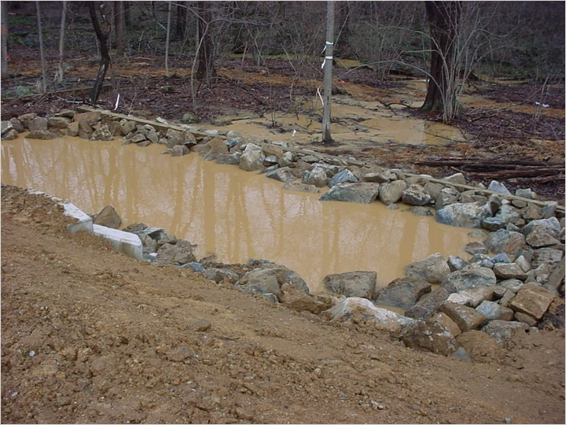
Notes:
In this level spreader it can be observed that the runoff is flowing under the wooden level lip instead of over it. The runoff is simply following the path of least resistance after it leaves the level spreader and is not spread over the entire width of the level spreader as intended. It is likely that the flow path on the outside of the level spreader would be the same even if the water was flowing over the level lip due to the existing topography tending to re-concentrate flows.

1.17 Example 12: Rock Level Spreader
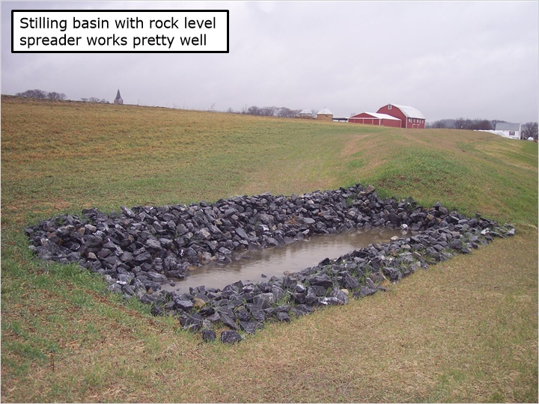
Notes:
This level spreader incorporates a stilling basin to slow flows and the rock is used instead of a structural level lip. The discharged water finds small flow paths through the rock to help spread the flows instead of relying on a structural level lip that often experiences issues with staying level after freeze and thaw cycles during the winter months. So far, field observations have shown better results using this type of level spreader when compared to structural level lip spreaders. In every case with level spreaders, inspection personnel should look at the discharge path below the level spreader for signs of erosion due to newly concentrated flows.

1.18 Example 13: Muddy Basin
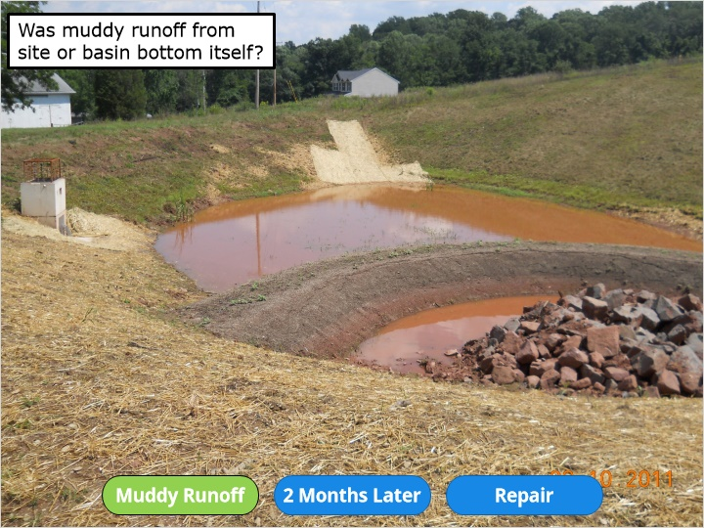
Notes:
This photo shows an infiltration basin that was recently converted from a sediment basin. The sediment basin served for nearly five years as the primary sediment control for a residential subdivision with several new homes. As part of the conversion, the flow-through sediment forebay filter berm was added and the temporary riser used for sediment control was removed and replaced with an orifice plate. The basin bottom was partially excavated to remove accumulated sediment buildup back to the original basin bottom elevation. It is noted that the bottom elevation for the sediment basin and infiltration basin was the same elevation in the plan drawings with no requirement to over-excavate clogged basin bottom soils. It was quickly discovered after conversion that the infiltration basin failed to infiltrate the captured runoff and needed to be repaired.

Notice the muddy water within the basin. The site is supposed to be completed and stabilized prior to converting the sediment basin to a stormwater management basin. Often times, after a basin conversion, the disturbed soils on the basin bottom can be a source of sediment suspended in the captured runoff. In this case, despite the completed and majority of upslope grassed areas meeting the 70% uniform grass growth criteria, the majority of sediment seen in the captured runoff came from the upslope drainage area. The site appeared to have adequate grass growth but would certainly not be considered exceptional growth or coverage. Many of the lots had been completed for a few years with only a few that had been recently completed and stabilized with new grass growth. The lack of excellent grass growth throughout the subdivision was likely due to the lack of using high quality topsoil and/or associated fertilizer. The site also had a soil limitation for poor source of topsoil. The prescribed resolution in the project plans was simply to import topsoil as needed. Since importing topsoil can become rather expensive, it’s likely that the developer simply used what soil they had onsite instead of importing higher quality topsoil. The buttons at the bottom of the screen will show a case study of this failing infiltration basin and how it was repaired.

Example 13: Muddy Basin (Two Months Later)
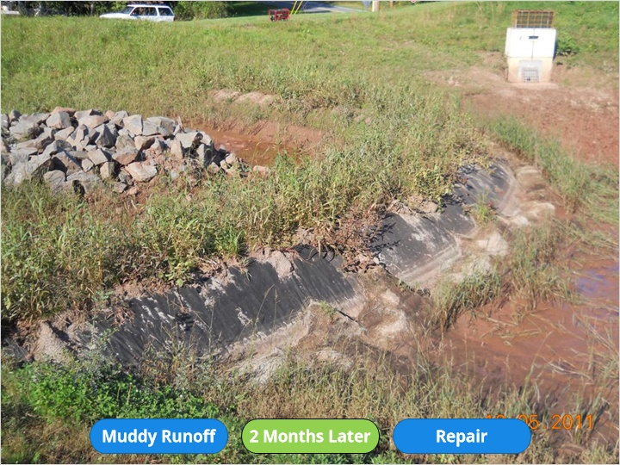
This photo was taken approximately two months after the previous photo and shows the compost filter media on the backside of the forebay berm has washed off the underlying geotextile. The remaining runoff water retained in the failing infiltration basin was pumped out in preparation for repair work.

Example 13: Muddy Basin (Repair)
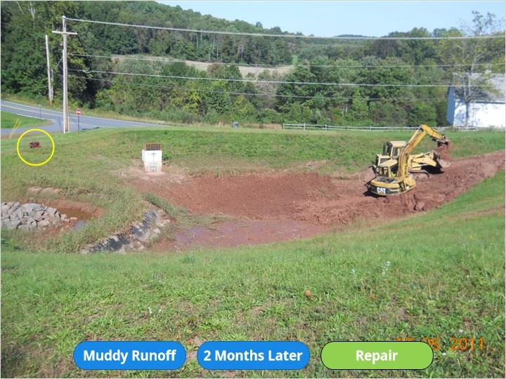
It was determined after converting the basin from a long-term sediment basin to an infiltration basin that it would need the clogged soils in the basin bottom to be removed to a depth where more suitable soils were uncovered. The contractor did a good job of keeping the heavy equipment off the final basin bottom elevation by using the reach of the track hoe boom to excavate clogged soils to a depth where dry, unclogged soils were found. The track hoe loaded the excavated soil into a loader for removal while keeping all equipment off the excavated bottom to prevent compaction.

The yellow circle shows the pump that was used to dewater the basin. Nearly every contractor has a pump to use for basin or trench dewatering purposes so the use of underdrains in infiltration BMPs is generally not necessary and most often leads to the underdrain valve being erroneously left open instead of closed so that the basin function as intended. If an infiltration BMP has an underdrain and valve, the operations and maintenance notes should clearly indicate that the valve will remain closed at all times with exception of needing to drain the basin for required repair or maintenance. The operations and maintenance notes should also indicate what must be done to repair the basin in the event of failure to restore the infiltration as credited. The notes should not simply state that the underdrain valve be left open to drain the basin runoff in the event of failure to infiltrate within 72 hours. That does not meet NPDES permit requirements. In this case there was no underdrain, so a pump was simply used.

1.19 Remove Clogged Soils
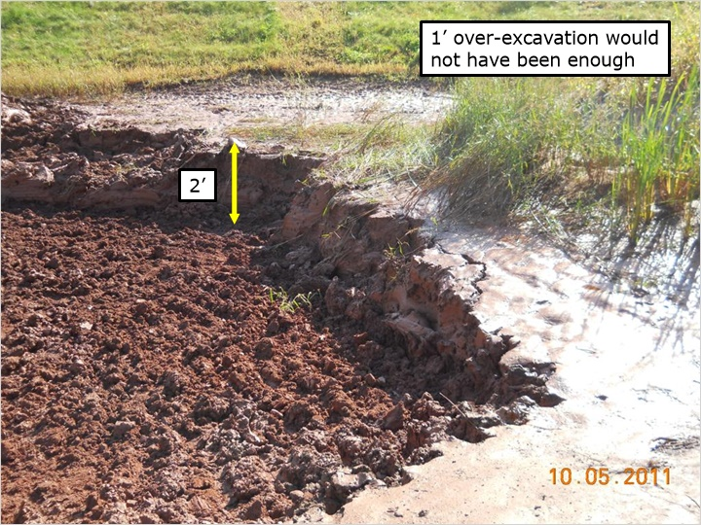
Notes:
As discussed earlier, the PA Stormwater BMP Manual recommends sediment basin bottom elevations be left at least one foot above the final infiltration basin bottom elevations so that clogged soils can be removed during conversion. In many cases one foot may be enough. In this case it was found that approximately two feet of clogged soils needed to be removed to expose the dry, underlying soils that were capable of infiltration as originally designed.

1.20 Example 14: Forebay
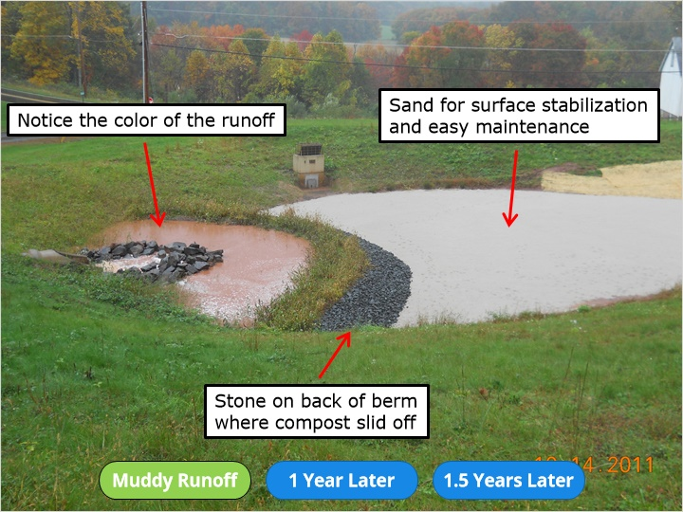
Notes:
In this basin, stone was placed on the back side of the forebay berm where the previous compost mixture had washed off. The excavated basin bottom was backfilled without compaction to the planned basin bottom elevation using suitable onsite soils and topped with six inches of pure sand. The suitable onsite soils were comprised mainly of sand but had some silts and was determined to be sufficient for an infiltration basin bottom if placed lightly and not compacted. Pure sand was used on top to break up the erosive impact of falling rain drops which can lead to soil particles breaking into smaller particles that can infiltrate with the captured runoff and lead to clogging of open soil pores below. Notice that the color of the incoming runoff is still rather turbid and sediment-laden. Better quality topsoil should have been used on upslope grassed areas. Better grass growth upslope would limit the amount of sediments in the runoff water. Continued sediment load in the captured runoff can eventually lead to the clogging of the soils in the infiltration basin.

Example 14: Forebay (1 Year Later)
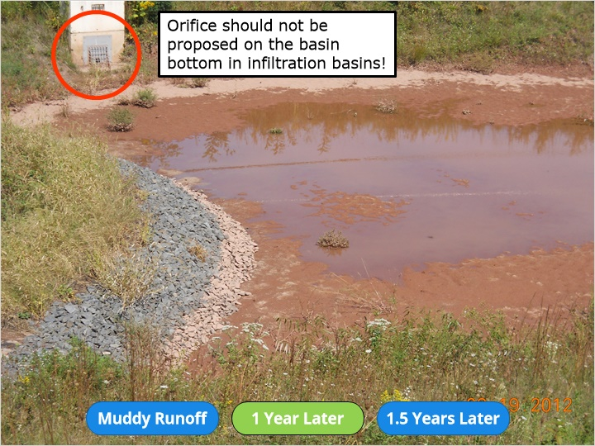
This photo was taken approximately one year after the basin was repaired. The white sand has been stained red from the incoming sediment-laden runoff flows, but the basin is still infiltrating as designed after being properly repaired. You can see the staining on the rock where the previous water level had been prior to infiltrating into the underlying soil mantle.

It is noted that the bottom orifice in infiltration basins should not be located on the basin bottom. It should be raised off the bottom to allow ponding of captured runoff so that it has time to infiltrate into the soils and replenish the groundwater supplies as intended. In this case the lowest dewatering orifice is approximately two feet above the basin bottom so that the captured runoff is properly infiltrated and treated for water quality purposes.

Example 14: Forebay (1 ½ Years Later)
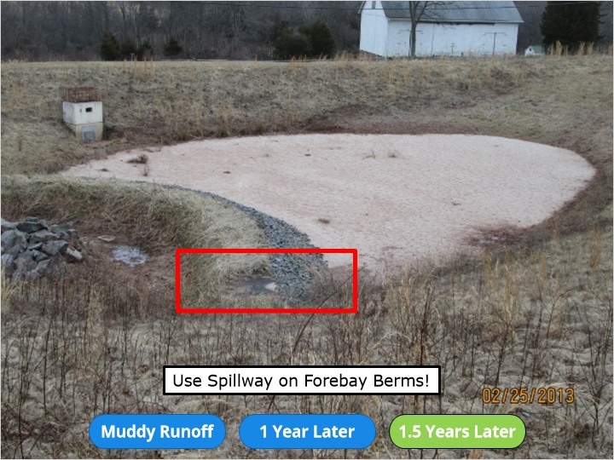
This photo shows the same basin approximately one and a half years after being repaired. It is still infiltrating as desired but some of the compost has washed off the top of the forebay berm.

The erosion of the compost on the top of the forebay berm can be seen where highlighted but stopped at underlying geotextile. It is always recommended that a reinforced spillway be placed on forebay berms to allow the high-flow conditions to flow over the berm without resultant erosion. In this case, mother nature has dictated where the spillway should be on the berm and it is simply a matter of placing some concrete or rock as a stabilized overflow area in the berm. This case study shows that failing infiltration basins can be repaired but must be done carefully so that all clogged soils are removed and that the removal of the clogged soils does not result in the compaction of the underlying soils. It is incredibly important to note that the basin bottom be stabilized immediately after conversion or repair to prevent damage from the impacts of falling rain drops and resultant clogging of the basin bottom soils before the permanent vegetation an be established. In this case, pure sand was used to immediately stabilize the basin bottom and to help prevent potential migration of finer soil particles further down into the soil profile where clogging issues could result.

1.21 Example 15: Basin Bottom Unstabilized
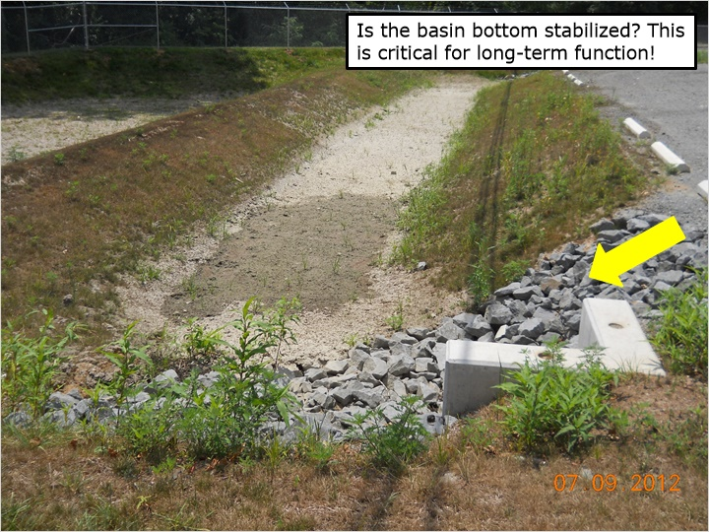
Notes:
This infiltration basin appears to be working since it is drying out but the permit cannot be terminated since the basin has not achieved stabilization of the basin bottom. As mentioned previously, it is crucial that the soils on the bottoms of infiltration BMPs be immediately stabilized and protected from the impacts of falling rain drops. The use of sand or rock would provide quick and reliable stabilization. The use of attractive rock like a river rock channel along the basin bottom is recommended in areas where concentrated inflows can wash away any newly placed seeds for vegetative establishment. In this case, the concentrated inflows enter a sediment forebay through an incoming pipe and via overland flow where a rock lined channel at the yellow arrow has provided a stable path for incoming flows. It is important to note that sediment forebays are generally used as a pre-treatment area to keep the majority of pollutants out of the main infiltration area and in most cases are not expected to infiltrate. Sediment forebays can be considered a sacrificial lamb, they often hold runoff water and fail to infiltrate rather quickly when compared to the main basin since that is where the majority of incoming pollutants will be captured and stored. If the main infiltration area appears to be functioning but a sediment forebay is holding runoff for extended periods, the permit can likely be terminated since the sediment forebays are generally considered sacrificial unless the plans clearly indicate that infiltration within the forebay is expected.

1.22 Example 16: Algae in Infiltration Basin
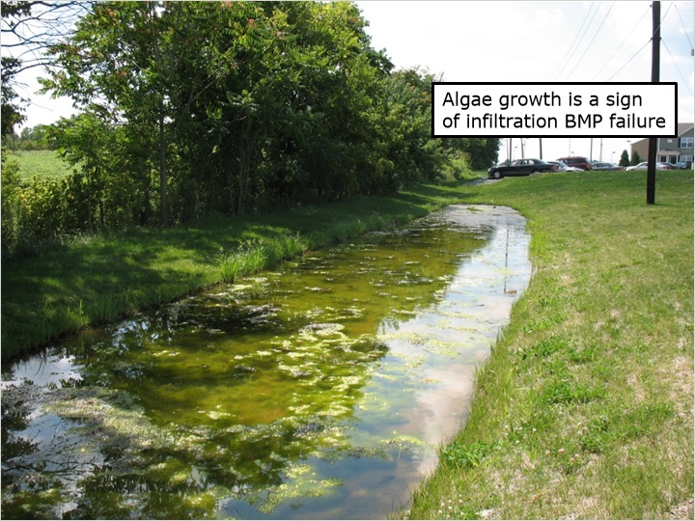
Notes:
This small infiltration basin is holding water for periods long enough for algae to develop. Algal growth is another sign of potential infiltration failure since algae will generally not flourish if the infiltration basin is drying out between runoff events due to proper function. In this situation the contractor was caught with large construction equipment in the basin during construction despite the plan notes indicating the basin bottom cannot be compacted. Compaction of the soils can cause infiltration failure. Another factor of failure in this situation is the fact that the soil infiltration test was done over 100 feet from the basin location and the soil test results indicated that a sand soil was present. A test pit was excavated in the bottom of this basin after it failed and historic clayey fill soil was found in this location instead of the sandy soils nearby where the infiltration test was conducted. The clayey fill soils were found to be insufficient to support adequate infiltration rates so a modified stormwater management plan was necessary to repair the basin and replace stormwater credits taken in the permit application.

1.23 Example 17: Pervious Paving
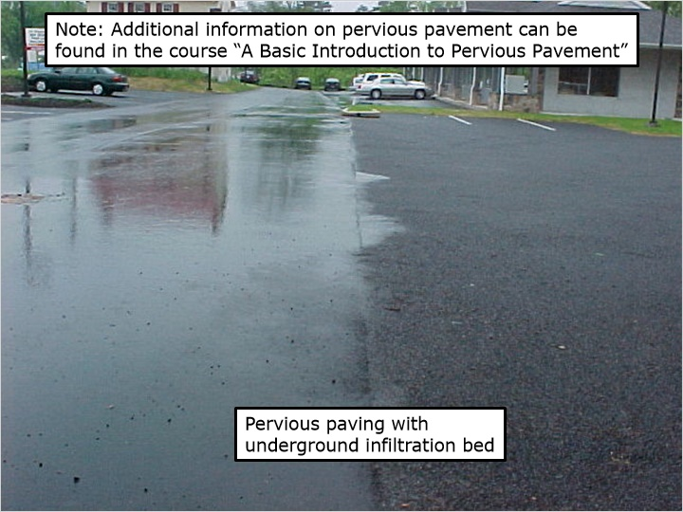
Notes:
This photo shows pervious paving with an associated underground infiltration bed on the right side of the photo and traditional asphalt paving on the left side. The runoff can be clearly seen on the traditional asphalt and the pervious paving has drained as designed. For final inspection purposes, an inspector can do the site inspection during a rain event in order to best observe the function of the pervious paving. Another way to test the pervious paving is to take a 5-gallon bucket filled with water and dump it on the surface. If it fails to drain through the pervious asphalt it has either failed or the wrong asphalt mix may have been used. Remember, the pervious paving is just part of the BMP. The underground infiltration bed is the other main component. If inspection ports are provided, inspection personnel can look down the ports to determine if captured runoff is infiltrating or simply holding runoff. The underground stone bed should be designed with an overflow to allow runoff out of the bed during large rain events. Try to find the overflow areas and look for signs of frequent flows coming from the overflow devices. Frequent overflows of infiltration BMPs is generally a sign of infiltration failure unless several large runoff events had occurred recently.

1.24 Example 18: Pervious Paving Surface Overflow
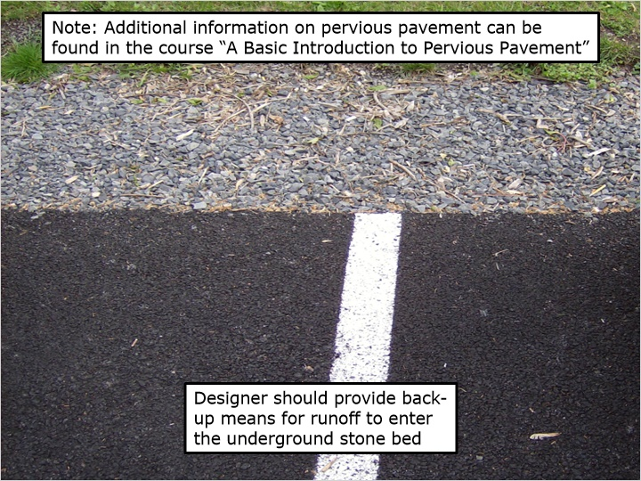
Notes:
The PA Stormwater BMP Manual encourages the use of a back-up means of getting runoff from pervious asphalt into the underground infiltration bed in the event that the pervious paving fails to drain or is subsequently sealed with an asphalt sealant. In this case the underground stone bed is simply extended approximately two feet beyond the edge of paving. If the asphalt is sealed, the runoff can still enter the underground stone bed.

1.25 Example 19: Underground Infiltration Beds
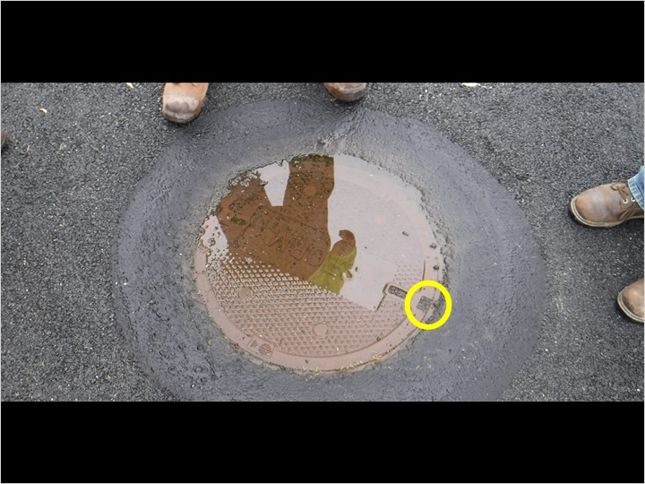
Notes:
Underground infiltration beds can be especially difficult to inspect since they can no longer be fully seen if not observed for proper installation during construction. Inspection personnel should attempt to determine if the underground bed is infiltrating as designed or if it is holding water beyond the infiltration period. In many cases a manhole or inlet will house the outlet structure. In some cases an observation port is installed. In the absence of an observation port, the outlet structure is most often the best place to look for signs of infiltration failure and is where inspection personnel should attempt to look for the proper elevation of discharge orifices, overflow weirs or other design criteria for the outlet structure as compared to the plan detail. If stored water is up to the level of the lowest discharge orifice a day or more after a runoff event it is likely that the infiltration bed is not infiltrating as designed and credited. In many cases inspection personnel will need to coordinate the inspection of the underground bed with construction personnel who can bring a manhole hook to remove the manhole cover so the underground outlet can be observed. In this photo, one of the two lift holes in the manhole cover is shown within the circle. The other lift hole is on the opposite side of the manhole cover. It can be observed that the lift hole is filled with asphalt from the paving operation that had been done at least two years prior. Asphalt will need to be removed from the lift hole in order to fit the manhole hook into the slot as needed to lift the lid. Lift holes filled with asphalt, and tar covering the outside ring of the manhole cover are clues that the observation and maintenance of the BMP is not occurring since it can be determined that the manhole cover has not been removed since the paving was completed. Inspection personnel can request that the applicant’s designated licensed professional prove that the underground infiltration bed is functioning properly when signs exist that the bed may not be infiltrating, or it can be determined that the manhole access cover has never been opened to observe for signs of failure as per the operations and maintenance notes.

1.26 Example 20: Curb Cut
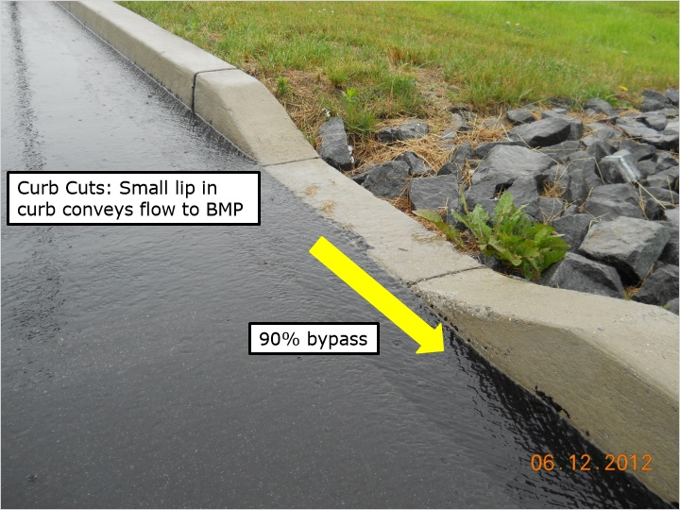
Notes:
Curb cuts are often used by designers to convey runoff to stormwater BMPs. Curb cuts work well when located at the bottom of the slope where runoff cannot go anywhere else but lots of problems have been observed with curb cuts along sloped areas such as the one shown in the photo. The arrow shows the direction of the water flow and it can be seen that the majority of the runoff is bypassing the curb cut and flowing downslope and eventually offsite. A small lip on the curb above the elevation of the asphalt creates a condition where much, if not all, runoff is conveyed past the curb cut instead of into the curb cut as intended. In this case, approximately 90% of the runoff is bypassing this curb cut. This curb cut provides the sole conveyance to the site’s only stormwater BMP. The concrete curb will need to be ground down so that runoff can enter the curb cut as intended. A 5-gallon bucket of water can be dumped along the curb upslope of the curb cut to determine if it is working or not if inspection personnel can’t visit the site during a runoff event.

1.27 Example 21: Infiltration Trench
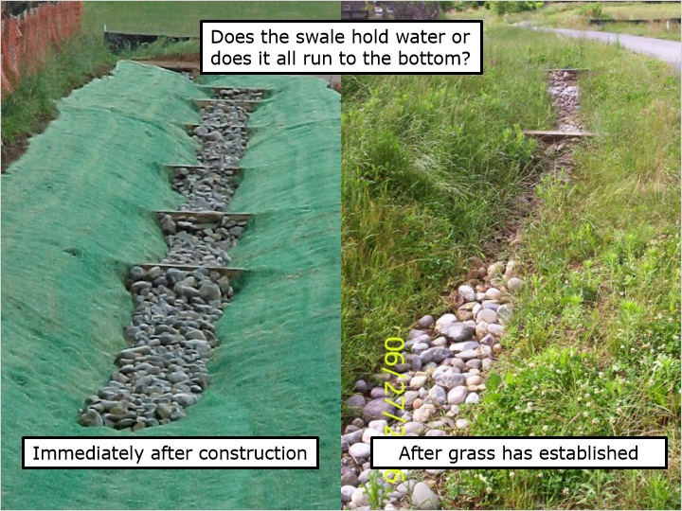
Notes:
These photos show the same infiltration trench along a new road installed for the construction of new residential homes. The left photo was taken immediately after construction while the right photo shows it after the grass has established.
Credits were taken assuming the underground trench will fill completely to allow captured runoff to infiltrate as designed and credited. The designer proposed cutoff walls within the infiltration trench to prevent runoff from simply running along the bottom of the trench to the downslope end where much of the water intended for infiltration overflows at the bottom side of the trench. Another way to ensure that the required infiltration volume stays within the infiltration trench is to specify a level trench bottom. But, this can lead to a situation where the trench is only two feet deep at the bottom side and potentially unrealistically deep on the upslope side in order to maintain the level trench bottom.

1.28 Is the Infiltration Trench Bottom Level?
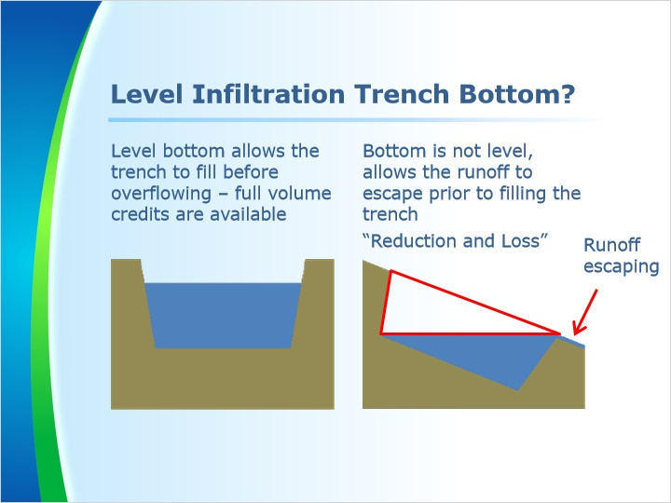
Notes:
This schematic shows an infiltration trench with a level bottom on the left side where it can completely fill the trench with runoff as shown in blue before overflowing as shown by the blue arrows. The scenario on the right shows an infiltration trench where it is installed on a slope and a level bottom is not specified. The runoff water may be allowed to simply run to the bottom of the trench where much of the water credited for infiltration can escape as overflow. The blue triangle in this scenario would be the applicable infiltration volume credits since this runoff cannot escape the trench via the overflow. The white area within the trench is the area in the trench that will not retain stormwater runoff for infiltration.

The highlighted area shown within the trench on the scenario on the right is often mistakenly credited for infiltration, but the design will not allow for the capture and retention of the credited infiltration volume. This false crediting scenario most often occurs where the infiltration trench is installed along a road or within a swale since these areas are generally designed to maintain a slope for runoff purposes. Review staff should look for these erroneous credits and make deficiency comments in the administrative completeness reviews to require the designer to provide additional information to support the credited infiltration volume or simply provide a detail showing a level trench bottom to support the credited infiltration volume. The steepness of the trench on the right scenario would make a level trench bottom impractical. Breaking up the trench into segments or using cutoff walls as seen on the previous slide are ways to alter the design to allow for more runoff retention volume within the trench for infiltration purposes.

1.29 Example 22: Rock Check Dams
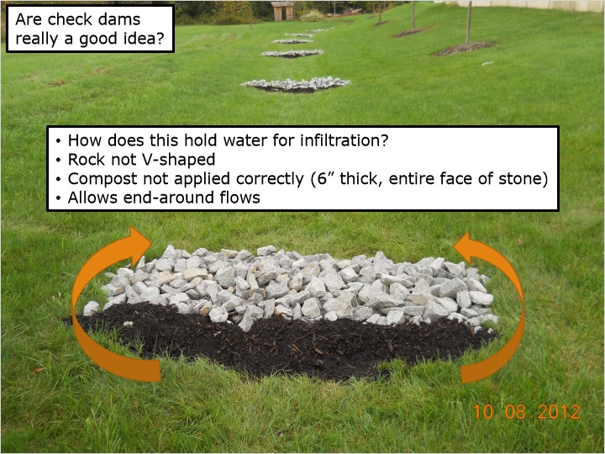
Notes:
This photo shows a swale with rock check dams designed to retain runoff and allow it to infiltrate. These check dams can be effective in storing and infiltrating runoff if designed and constructed properly but also can create obstacles to mow around when mowing the grass. For this reason, the use of check dams in swales is recommended to be limited to areas where frequent mowing and lawn establishment is not proposed.

The design of these check dams uses porous stone and garden mulch to slow runoff flows but not necessarily retain runoff volumes for infiltration purposes. The rock check dams are not installed in a V shape to keep overflow to the center of the swale. The garden mulch or compost is not applied thickly enough to provide sufficient water quality filtering.

The ends of the check dam also do not extend far enough upslope at each side to prevent end-around flows as shown by the arrows. End-around flows often create problems with erosion at the sides of the check dams where runoff flows can be concentrated outside of the proposed swale lining. In this situation, the check dams were added after swale establishment and only as a corrective action to recapture some of the infiltration credits lost due to the failure of the infiltration basin downslope of the swale.

1.30 Summary
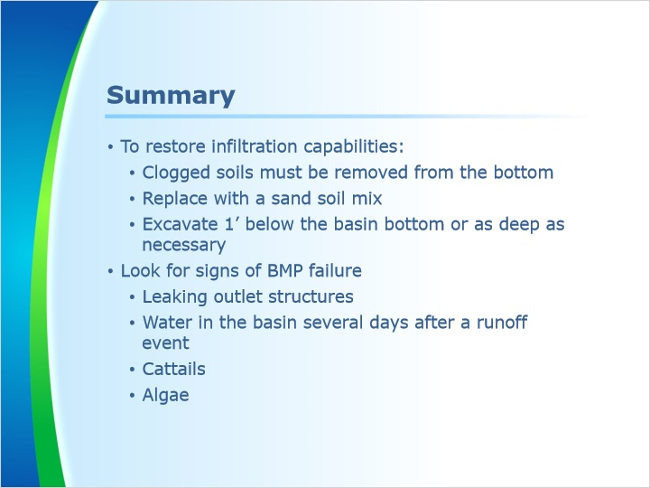
Notes:
This concludes Module 3. To review, basins must have clogged soils removed and replaced with a sandy soil mix to restore infiltration capabilities. Soils should be removed to at least 1’ below the basin bottom, but often times a deeper depth is necessary. Look for signs of BMP failure such as leaking outlet structures, water in the basin several days after a runoff event, cattails, and algae.

Next is a knowledge check.

