Introduction to Channels
09-29-2020

1.3 Learning Goals
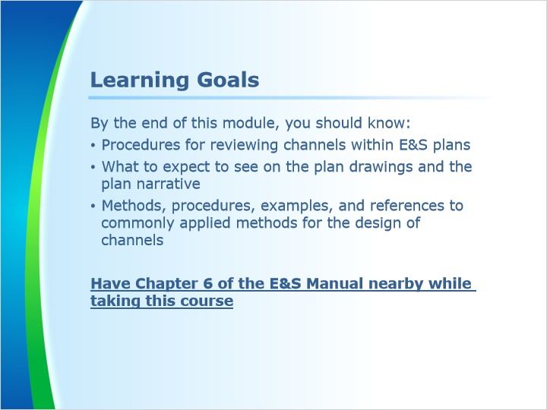
Notes:
This module will discuss procedures for the design of channels for erosion and sediment pollution control plans. We will also focus on what plan reviewers should expect to see on the plan drawings and in the supporting calculations in the plan narrative.

Channels are discussed in detail in chapter 6 of the erosion and sediment pollution control manual.

The Department encourages the use of methods and procedures listed or referenced in this manual. Such use will facilitate the review of E&S plan drawings by the Department or a conservation district. However, the listed or referenced materials are not all inclusive and the Department will, on a case-by-case basis, accept other alternative methods and procedures that are correctly selected and applied by persons qualified to perform such computations.

Please note this course shows many details from the E&S manual. You may find it helpful to have Chapter 6 of the manual nearby before continuing.

1.4 Menu
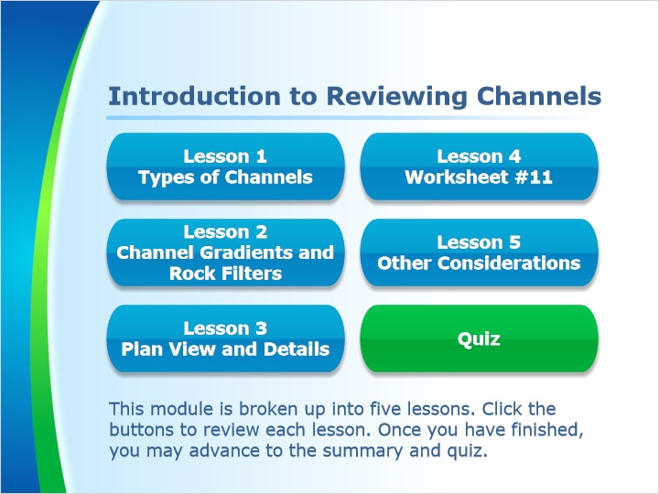
Notes:
This module is broken up into five lessons. Click the buttons to review each lesson. Please take each lesson in order. Once you have finished, you may advance to the summary and quiz.

2. Lesson 1 - Types of Channels

2.1 Lesson 1 Intro
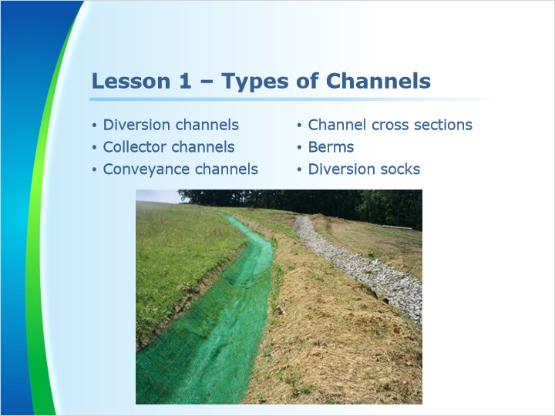
Notes:
Welcome to Lesson 1. In this lesson, we will discuss diversion, collector, and conveyance channels as well as their cross sections. We will also examine berms and diversion socks.

2.2 Diversion Channel
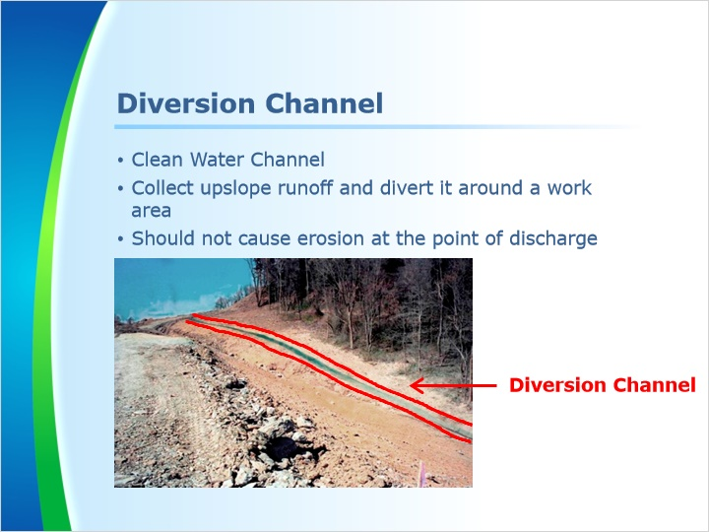
Notes:
Diversion channels are constructed above the proposed disturbance. They collect the clean water from above the work area, divert it around the disturbance, and discharge it to a natural ditch or surface water.

They can be used to reduce the drainage areas to sediment removal and conveyance BMPs.

Diversion channels must discharge to a receiving water in such a manner that it does not cause accelerated erosion.

In the photo above, a diversion channel is constructed above the disturbed area. It is used to divert the clean water around the disturbed area.

2.3 Collector Channel
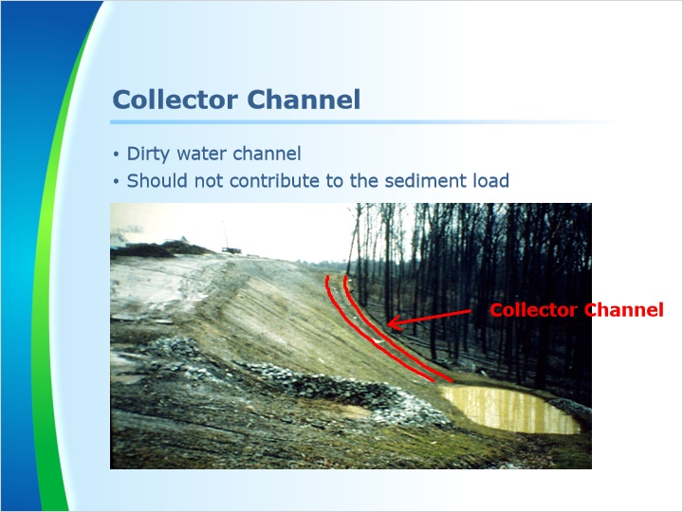
Notes:
A collector channel is used to collect runoff from a disturbed area and convey it to a sediment removal facility, such as a sediment basin or trap.

Collector channels, like all channels, should be properly lined to minimize accelerated erosion.

In the photo above, a collector channel is shown discharging sediment laden runoff to a sediment trap for treatment.

2.4 Conveyance Channel
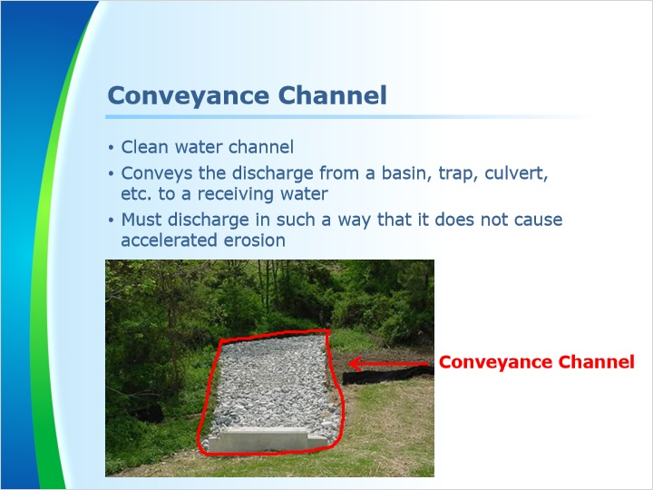
Notes:
Conveyance channels are used to convey discharges from sediment removal facilities or stormwater outfalls to receiving surface waters.

In the photo above, a riprap conveyance channel is shown at the discharge end of a basin. It conveys treated stormwater to an existing surface water.

2.5 Channel Shapes
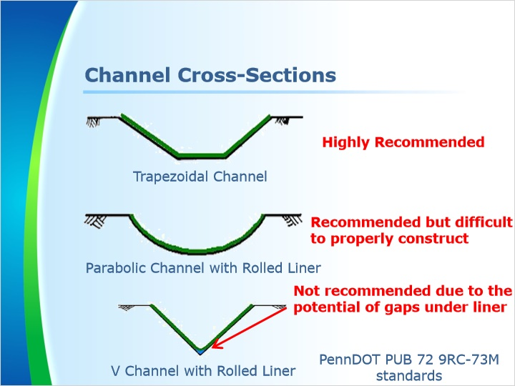
Notes:
Proposed channels should be either trapezoidal or parabolic in cross-section. However, the trapezoidal channel is more desirable, because a parabolic channel is harder to properly construct.

V-shaped channels are not recommended for channels having fabric or geotextile liners due to the tendency for gaps to be left under the lining at the bottom of the channel. Where it is necessary to construct V-shaped channels with fabric or geotextile liners, manufacturer’s recommendations or PennDOT standards should be strictly followed.

2.6 Berms
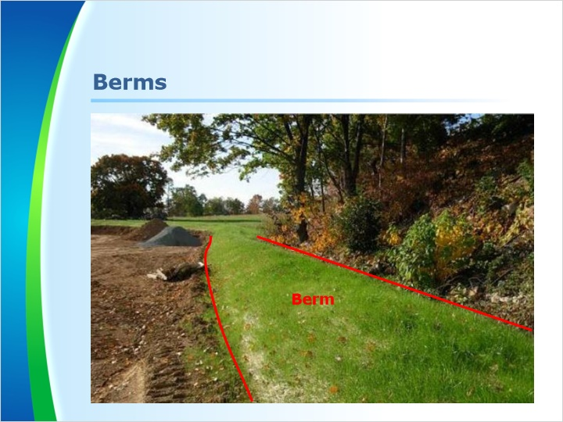
Notes:
Another type of constructed channel is a berm.

Berms may be used in a similar manner as channels as long as flow can be maintained along the upslope side of the berm. The maximum tributary area to a berm should be 5.0 acres unless otherwise permitted by the reviewing agency. Objectionable materials that could prevent adequate compaction, such as woody debris or large rocks, should be removed from the berm prior to construction. All berms must be properly compacted.

Whether a berm is used as a diversion, collector or conveyance channel, it should be designed and stabilized in the same manner as standard constructed channels.

Additional information on berms can be found on pages 150, 151 and 152 of the Erosion and sediment pollution control program manual.

In the photo above, a diversion berm is constructed above the disturbed area. It is used to divert the clean water around the disturbed area.

2.7 Diversion Socks
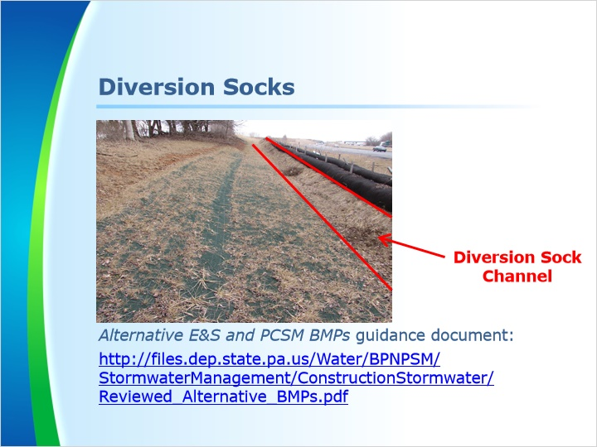
Notes:
Another type of constructed channel is a diversion sock. This bmp is not found in the erosion and sediment pollution control manual. It was approved after the printing of the manual and can be found in the “Alternate E & S and PCSM BMPs” guidance document.

Diversion socks may be used in a similar manner as diversion channels as long as the flow can be maintained along the upslope side of the sock. The maximum tributary area to a diversion sock should be 5 acres, the same as berms, unless otherwise permitted by the reviewing agency. The infill material for diversion socks should reduce permeability and promote vegetative growth.

Whether a diversion sock is used as a diversion or conveyance channel, it should be designed and stabilized in the same manner as standard constructed channels.

In the photo above, a diversion sock is constructed above a proposed highway construction site. It is used to divert the clean water around the disturbed area.

2.8 Lesson 1 Outro
Notes:
This concludes Lesson 1. In this lesson, we discussed diversion, collector, and conveyance channels as well as their cross sections. We also examined berms and diversion socks.

3. Lesson 2 - Channel Gradients and Rocks Filters

3.1 Lesson 2 Intro
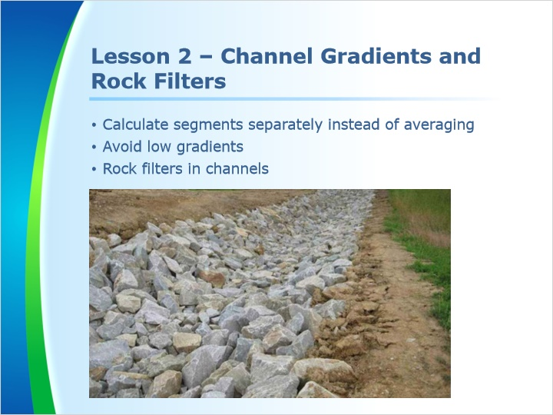
Notes:
Welcome to Lesson 2. In this lesson, we will discuss how a channel with different slopes should be calculated separately instead of averaged. We will also explain why low gradients should be avoided and examine rock filters in channels.

3.2 Channel Gradients
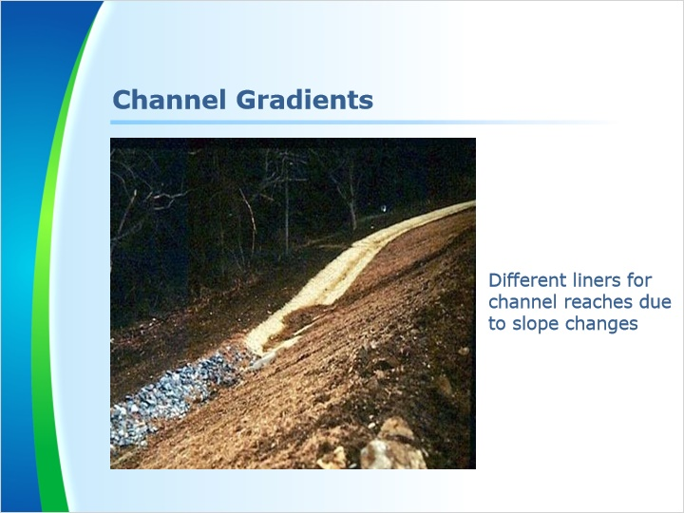
Notes:
Channels typically require protective linings since soil alone has very little shear strength.

SLOPES MAY NOT BE AVERAGED. When a proposed channel will intercept a significant change in slope, each segment of the channel should be designed separately. An acceptable alternative is to design the entire channel with sufficient capacity for the mildest slope and design the protective liner suitable for the steepest slope. Either procedure is acceptable.

If a channel with two significantly different slopes were allowed to be averaged, the result would be a channel with an undersized liner for the steeper portion of the channel since the design was based on a lesser slope. The capacity could also be undersized since the design was based on a steeper slope.

Additional information on channel design relating to channel slope can be found on page 129 of the Erosion and sediment pollution control program manual.

In the photo above, the channel starts out with a mild slope. A straw liner is used for this portion. At a certain point, the slope steepens. A riprap liner is used for this portion. The riprap provides better resistance to shear forces than the straw liner.

3.3 Channel Gradients
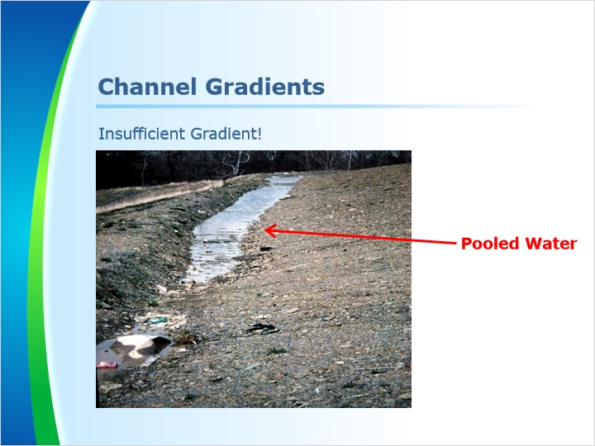
Notes:
Channels and berms should be designed to provide positive drainage throughout. Sharp turns and gradients less than 1% should be avoided wherever possible.

If sharp turns cannot be avoided, the outside side slope of the channel may require a higher level of protection, such as rip rap, to minimize accelerated erosion.

Low gradient channels are difficult to construct and can result in flat sections with pooled water as shown in the photo above.

3.4 Rock Filters In Channel
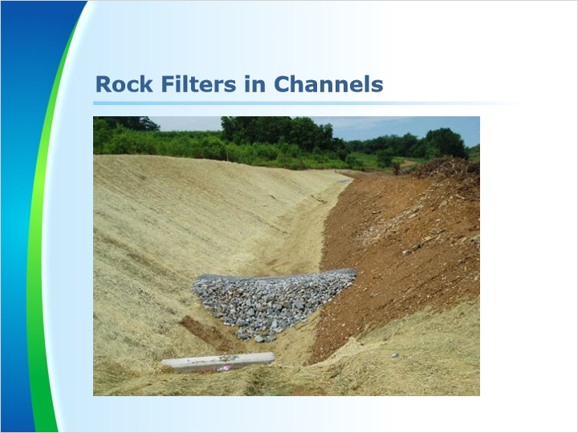
Notes:
Rock filters may be used to control runoff prior to installing the protective liner or during a temporary disturbance within the channel. They can also be used as a filter at the downstream end of a channel.

Rock filters may not be used in place of appropriate channel linings. This practice often results in overtopping of the channel during storm events, scouring of the channel bottom below the filter, or erosion of the channel side slopes as sediment deposits build up behind the filter.

Rock filters may not be used in roadside ditches in place of a suitable temporary liner until vegetation is established. An exception to this is at the inflows to ditch relief culverts on dirt or gravel roads or on temporary or permanent access roads.

For more information on rock filters, see page 92 of the manual.

3.5 Lesson 2 Outro
Notes:
This concludes Lesson 2. In this lesson, we discussed how a channel with different slopes should be calculated separately instead of averaged. We also explained why low gradients should be avoided and examined rock filters in channels.

4. Lesson 3

4.1 Lesson 3 Intro
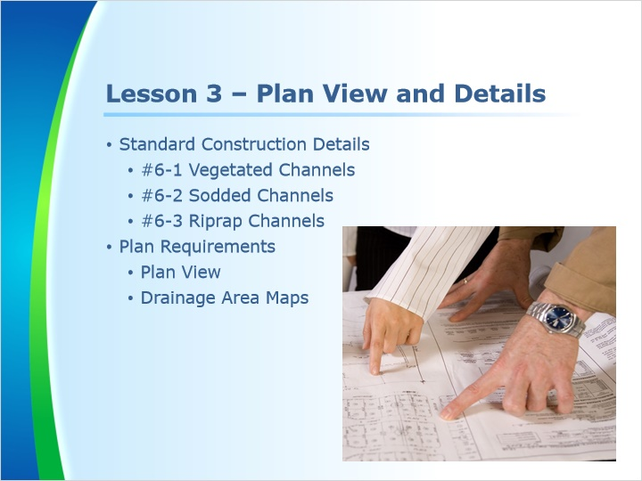
Notes:
Welcome to Lesson 3. In this lesson, we will discuss the standard construction details for vegetated, sodded, and riprap channels. We will also discuss the requirements for the plan view and drainage area maps.

4.2 Shown and Labled on Plan Maps
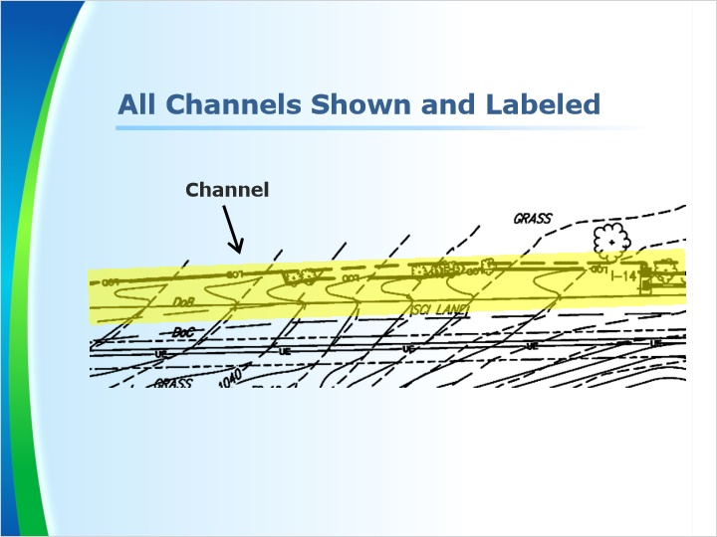
Notes:
All channels should be clearly shown and labeled on the plans drawings. Channels shown on the plan drawings should also have a corresponding detail on the detail sheets.

4.3 Vegetated Channel
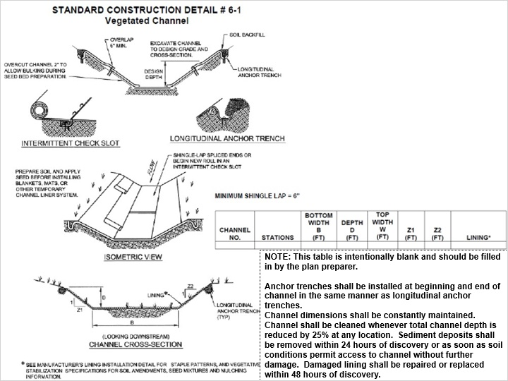
Notes:
If vegetative channels are proposed, the plan sheets should include Standard Construction Detail #6-1, vegetative channel, as shown on page 146 of the manual. Standard details are not required to be used as long as the detail being used contains the same information as the standard detail.

This detail, along with the notes, provides sufficient information to construct the channel.

This detail can be used for one channel or several channels.

4.4 Sodded Channels
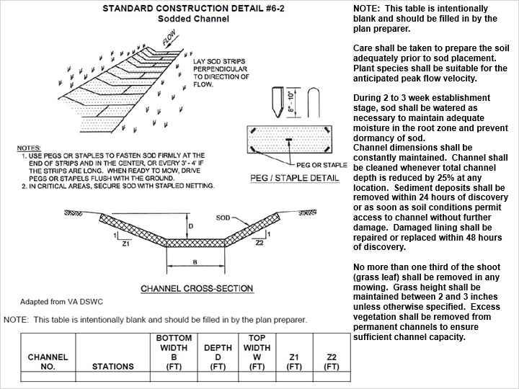
Notes:
Although sodded channels are rare, they are used when immediate vegetative stabilization is desired.

If sodded channels are proposed, the plan sheets should include Standard Construction Detail #6-2, sodded channel, as shown on page 148 of the manual.

This detail, along with the notes, provides sufficient information to construct the channel.

This detail can be used for one channel or several channels.

4.5 Riprap Channel
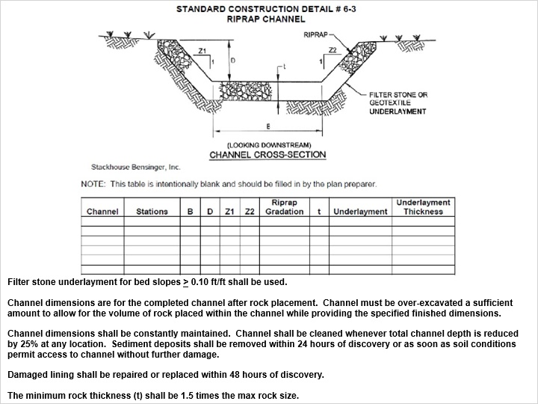
Notes:
If riprap channels are proposed, the plan sheets should include Standard Construction Detail #6-3, riprap channel as shown on page 149 of the manual.

This detail, along with the notes, provides sufficient information to construct the channel.

This detail can be used for one channel or several channels.

4.6 Plan View
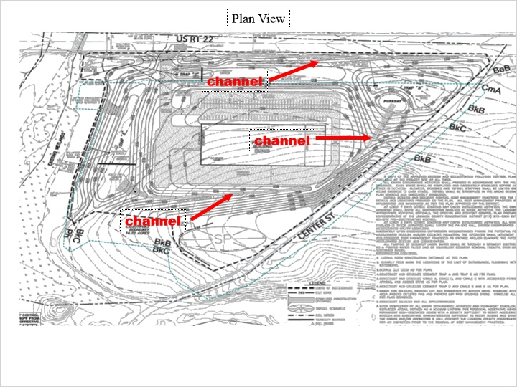
Notes:
Regardless of what type of channel is proposed, all channels should be shown on the plan sheets.

Proposed contours must be included to identify the construction of the channel. This is necessary to ensure that the channel can be properly constructed and to properly delineate the limits of disturbance. The proposed contours should match the slope of the channel as shown on worksheet #11.

Using only flow directional arrows and not proposed contours is not acceptable. Only proposed contours can allow a complete review and show if the design will function properly.

4.7 Drainage Area Map
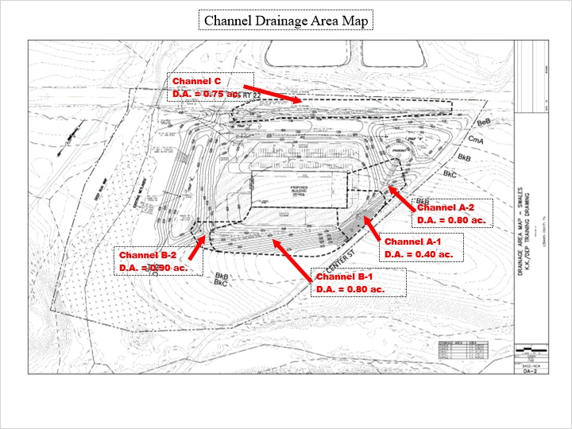
Notes:
Projects proposing channels should include a channel drainage area map. The drainage area map should clearly show the maximum drainage area to each proposed channel.

If the proposed channel will collect drainage from off-site areas, the offsite areas will need to be delineated.

Drainage areas may change as construction progresses. The drainage area to be used should be the maximum drainage area that will be tributary to the channel during construction. Since watersheds often change during grading operations, roadway construction, installation of sewer lines, and construction of buildings and parking lots, the maximum drainage area is not necessarily the pre- or post-construction drainage area. Areas may overlap an adjacent drainage area to another channel. It is the project designer’s responsibility to ensure the channels are designed for the maximum drainage area.

All drainage area mapping should have a scale and the scale should be clearly shown on the drainage area maps.

NOTE: DRAINAGE MAPS CAN EITHER BE INCLUDED WITH THE PLAN DRAWINGS OR IN THE PLAN NARRATIVE. EITHER PLACE IS ACCEPTABLE.

4.8 Lesson 3 Outro
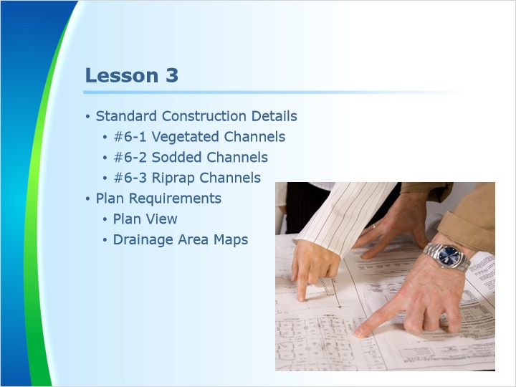
Notes:
This concludes Lesson 3. In this lesson, we discussed the standard construction details for vegetated, sodded, and riprap channels. We also discussed the requirements for the plan view and drainage area maps.

5. Lesson 4 - Worksheet #11

5.1 Lesson 4 Intro
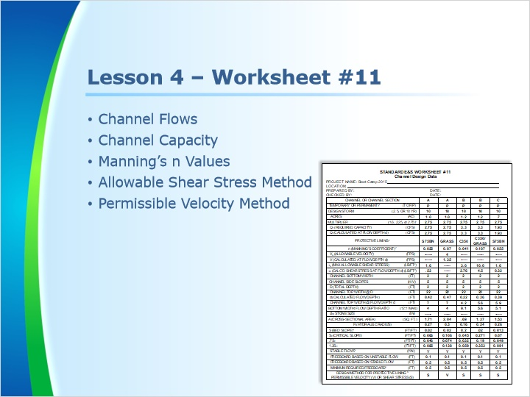
Notes:
Welcome to Lesson 4. In this lesson, we will discuss Worksheet #11, Channel Design Data. Specifically, we will discuss channel flow and capacity, Manning’s n values, the allowable shear stress method, and the permissible velocity method.

5.2 What is Recommended in the E&S Plan Narrative?
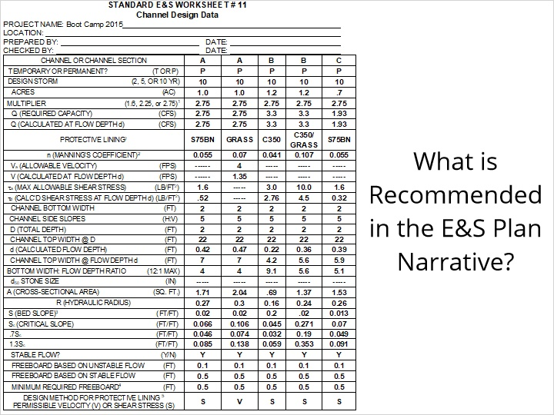
Notes:
Standard Worksheet #11 is used for channel design. Each column represents one design. Each liner and each significant change in design such as a change in slope, flow, shape, etc, should have a separate column.

A typical vegetative channel established by seeding will require a temporary liner until the vegetation is permanently established. In this case, a separate column for the temporary liner and a separate column for the permanent vegetative liner is required.

Remember, for channels that will have segments with different slopes, each segment of the channel should be designed separately. The alternative is to design the entire channel with sufficient capacity for the gentlest slope and a protective liner suitable for the steepest slope.

5.3 Channel Flows
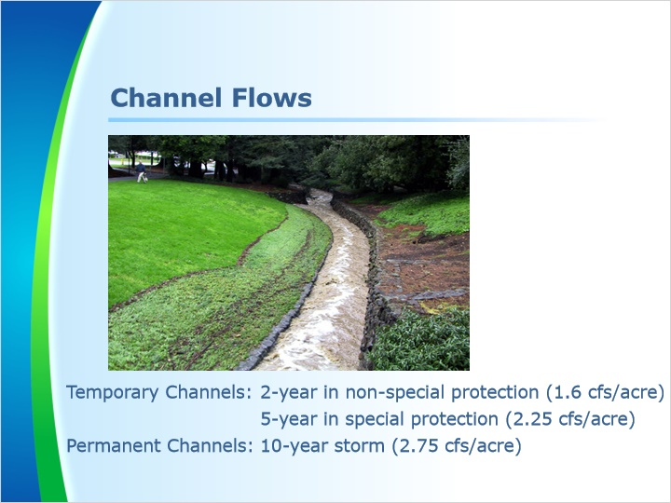
Notes:
Temporary channels should be designed to convey the required capacity, which is either 1.6 cfs/acre or the calculated peak discharge from a 2-year/24-hour storm event.

In special protection watersheds, temporary channels should be designed to convey 2.25 cfs/acre or the peak discharge from a 5-year/24-hour storm.

Permanent channels should be designed to convey either 2.75 cfs/acre or the calculated peak discharge from a 10-year/24-hour storm event for stability purposes. For capacity purposes, channels may need to be designed to the 100-year/24-hour storm event to ensure the stormwater will be safely conveyed to the PCSM bmps.

Refer to page 127 of the Manual for additional discussion on flow requirements.

Some channels may be designed for higher storms such as the 25-year/24 hour or 100- yr/24 hour storm. This may be due to the local municipal requirements or designer’s preference. In any event, this is acceptable since these storm events are above the minimum design criteria.

If the Rational Method is used, it is recommended that Standard E&S Worksheets # 9 and # 10 be used to determine the required capacity.

5.4 Channel Capacity
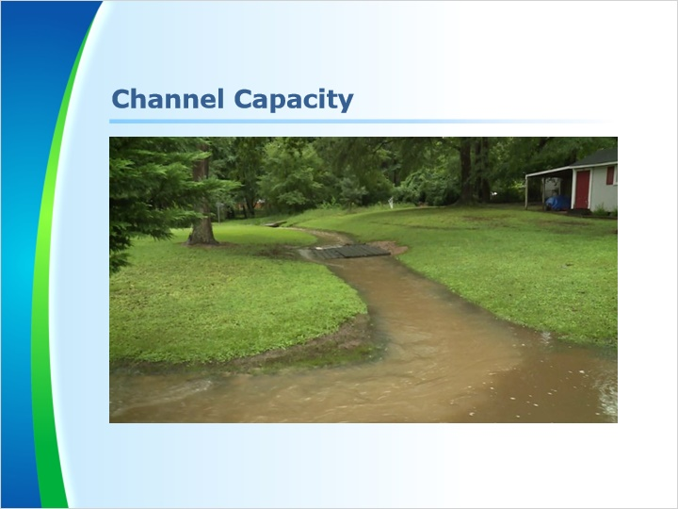
Notes:
Channel capacity is accomplished by adding the minimum freeboard onto the calculated flow depth “d”.

Freeboard in a channel is defined as the vertical distance between the calculated flow depth, d and the top of the channel.

The minimum freeboard is 6 inches or 25% of the calculated flow depth “d”, whichever is greater.

Refer to page 139 of the Manual for additional discussion on freeboard requirements.

5.5 Manning's n Value for Liners
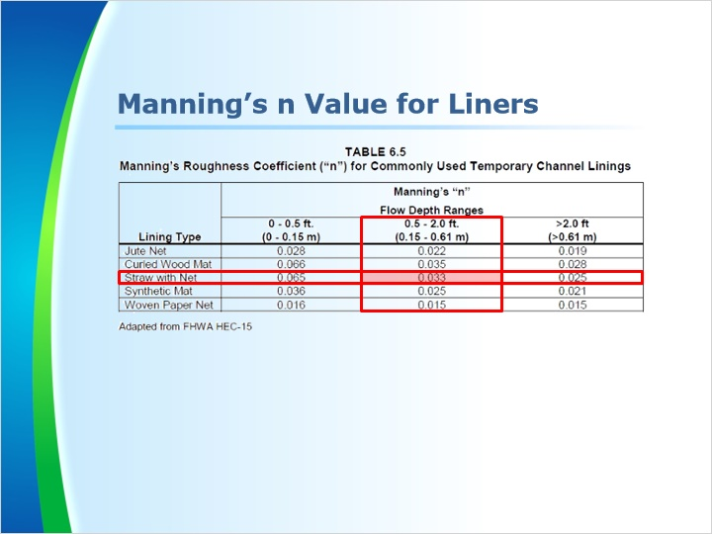
Notes:
When generic manufacturer’s liners are proposed, table 6.5 on page 133 of the manual can be used to check the Manning’s n value. This is accomplished by using the calculated flow depth, “d” from worksheet #11 and the lining type.

For example, if the calculated depth, d is listed on worksheet #11 as 0.79 feet and the protective lining is indicated as “straw with net”, then the Manning’s n value used on worksheet #11 should be 0.033.

In some cases, a specific manufacturer’s liner will be proposed. When this occurs, the project designer should provide proper documentation to support the Manning’s n value being used. This documentation should be provided in the plan narrative.

5.6 Manning's n Value for Vegetation
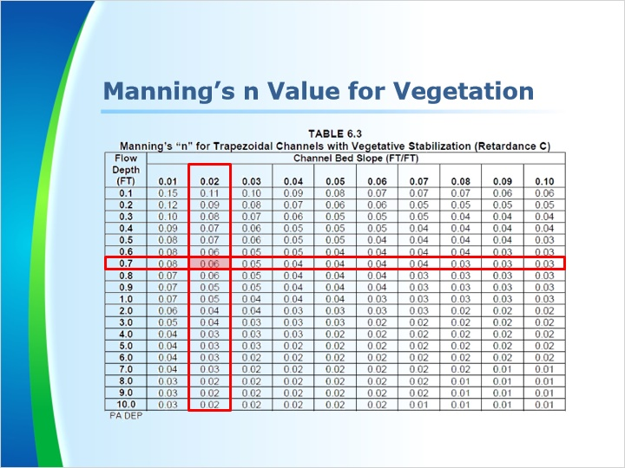
Notes:
When vegetative channels are proposed, table 6.3 on page 131 of the manual should be used to check the Manning’s n value. This is accomplished by using the calculated flow depth, “d” and the bed slope from worksheet #11.

In the example above, d is listed on the worksheet #11 as 0.7 feet and the bed slope is listed as 2%. The Manning’s n value used on worksheet #11 should be 0.06.

5.7 Manning’s n Value for Riprap
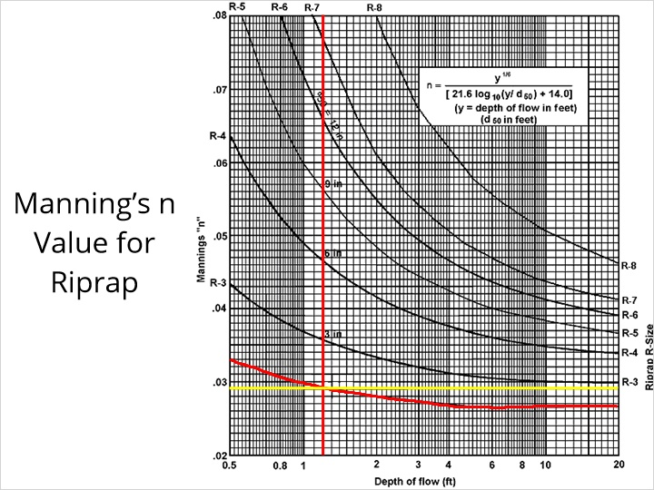
Notes:
When riprap channels are proposed, Figure 6.2 on page 138 of the manual should be used to check the Manning’s n value. This is accomplished by using the calculated flow depth, “d” from worksheet #11 with the selected riprap size.

In the example above, d is listed on the worksheet #11 as 1.2 feet and R-2 riprap is proposed. The Manning’s n value used on worksheet #11 should be 0.029.

5.8 Channel Design
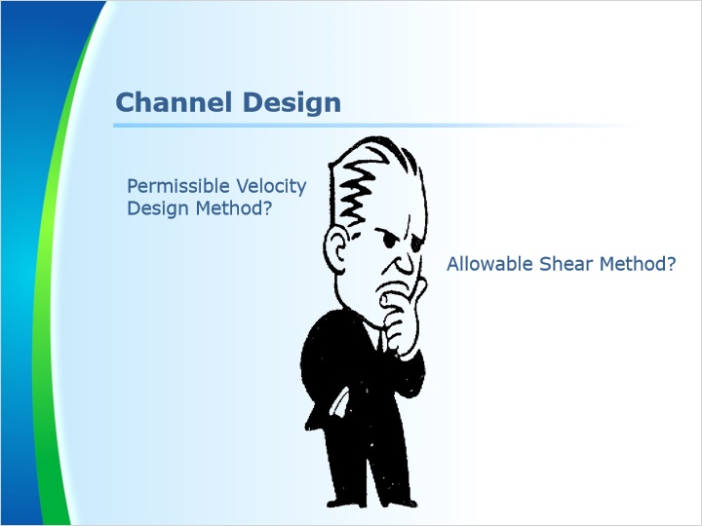
Notes:
There are two methods discussed in the manual that are used in channel design to determine if a channel will be stable or not. They are the Permissible Velocity Design Method and Allowable Shear Method.

The permissible velocity design method may be used for linings of channels with bed slopes less than 10%, while the allowable shear method is acceptable for all channel bed slopes. Refer to page 127 of the Manual.

Plan reviewers should check on Worksheet #11 to verify that the appropriate method is used.

5.9 Maximum Permissible Shear Stress
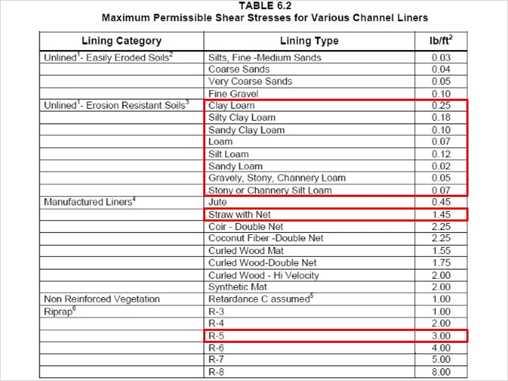
Notes:
When channels are proposed and the shear method is used to determine stability, reviewers should refer to Table 6.2 on page 130 of the manual for maximum permissible shear stresses .

Soil alone offers very little shear strength. This is clear as we look at the maximum permissible shear stresses listed for the different soils as compared to the other liners listed on Table 6.2. For example, Loam has a maximum permissible shear stress of 0.07 lb/sf where a straw with net liner has a maximum permissible shear stress of 1.45 lb/sf. That is quite a large difference.

DEP recommends using 1.0 lb/sf for the maximum permissible shear stress for vegetative channels as shown on Table 6.2 on page 130 of the manual.

If a turf reinforced mat is used, the project designer should provide proper documentation to support the maximum permissible shear stress being used. This documentation should be provided in the plan narrative.

DEP recommends using the maximum permissible shear stress values listed in Table 6.2 on page 130 of the manual for manufactured liners unless the project designer uses a proprietary or specific liner and provides proper documentation to support the maximum permissible shear stress being used. This documentation should be provided in the plan narrative.

DEP recommends using the maximum permissible shear stress values listed for riprap in Table 6.2 on page 130 of the manual. For example, if R-5 riprap is proposed, the maximum permissible shear stress used should be 3.0 lb/sf.

5.10 Untitled Slide
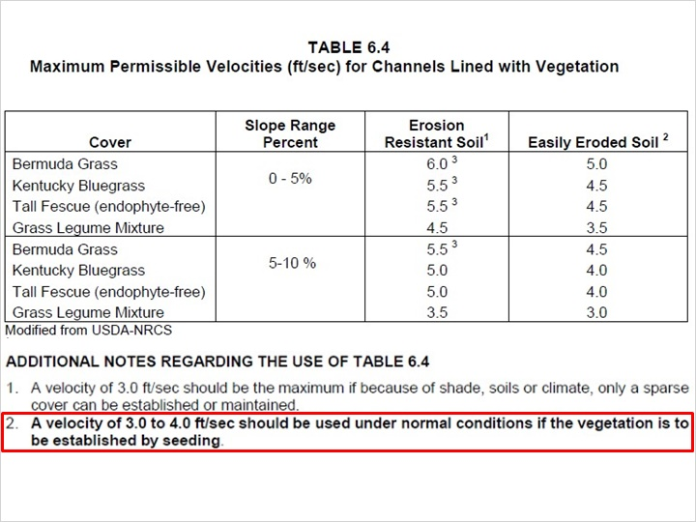
Notes:
When vegetative channels are proposed and the velocity method is used to determine stability, reviewers should refer to note # 2 on Table 6.4 on page 132 of the manual for maximum permissible velocity. Since nearly all proposed vegetative channels will be established by seeding, DEP further recommends using 4.0 fps for the maximum permissible velocity for vegetative channels if the vegetation is to be established by seeding.

If a turf reinforced mat is used, the project designer should provide proper documentation to support the maximum permissible velocity being used for the vegetative condition. This documentation should be provided in the plan narrative.

5.11 Maximum Permissible Velocity
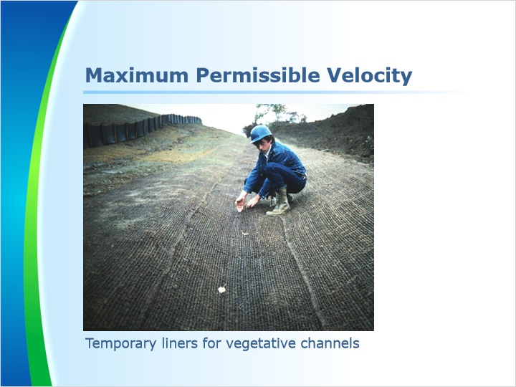
Notes:
As discussed earlier in this module, most channels will be vegetated and will require a temporary liner to be installed during the initial construction of the channel. This temporary liner will provide stability until the vegetation can be permanently established.

When temporary liners are proposed initially for vegetative channels and the velocity method is used to determine stability, the project designer should provide proper documentation to support the permissible velocities for the manufactured liners being proposed. This documentation should be provided in the plan narrative.

DEP recommends that temporary liners have a minimum longevity of one year. This will ensure at least one growing season.

5.12 Maximum Permissible Velocity
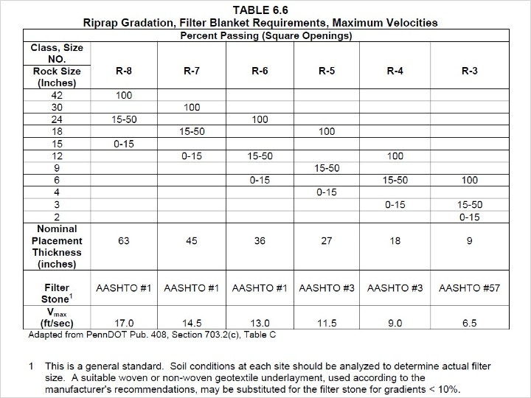
Notes:
When riprap channels are proposed and the velocity method is used to determine stability, reviewers should use table 6.6 on page 135 of the manual for determining the maximum permissible velocities and placement thickness of the riprap.

For example, if R-6 riprap is proposed, the calculated velocity at flow depth “d” should not exceed 13 fps and the minimum placement thickness is 36 inches.

The maximum velocity for a riprap channel is 17 fps which would require R-8 riprap. Grouting of riprap is not recommended for most situations. Grouting the riprap is not an effective way of addressing velocity or shear stress problems with riprap as discussed on page 233 of the manual.

5.13 Lesson 4 Outro
Notes:
This concludes Lesson 4. In this lesson, we discussed Worksheet #11, Channel Design Data. Specifically, we discussed channel flow and capacity, Manning’s n values, the allowable shear stress method, and the permissible velocity method.

6. Lesson 5 - Other Considerations

6.1 Lesson 5 Intro
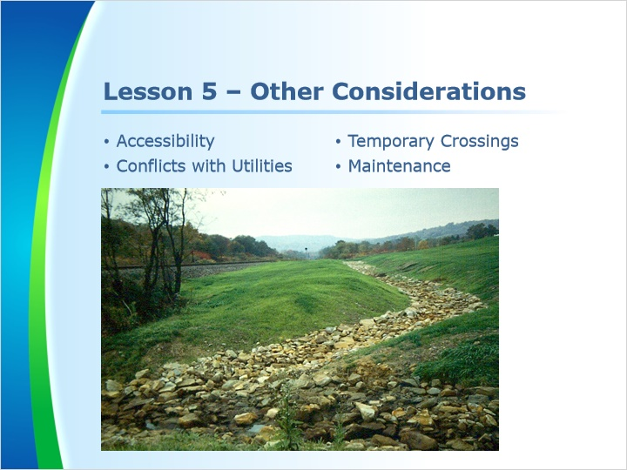
Notes:
Welcome to Lesson 5. In this lesson, we will discuss other considerations with channels. Specifically, we will discuss accessibility, conflicts with utilities, temporary crossings, and maintenance.

6.2 Accessibility
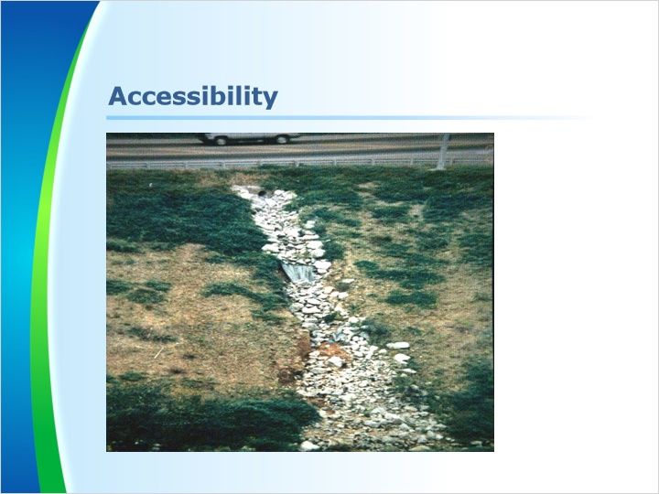
Notes:
Accessibility is important for both the construction of the channel and future maintenance.

The channel shown in this photo is in obvious need of repair but maintenance is difficult due to its location. A solution to this maintenance issue would have been to install a pipe instead of a riprap channel in this location since a pipe on this slope would require very little maintenance.

6.3 Conflicts with Utilities
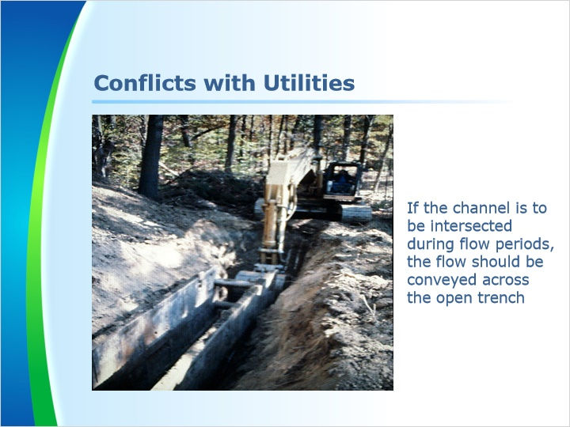
Notes:
As a reviewer, we need to see if there could be potential issues with a channel. For example, it is sometimes necessary to install underground utilities such as water and sanitary sewer that intersect existing channels. In these cases, provisions for flow in the channel to cross the trench should be detailed on the plans.

If the proposed underground utilities will intersect a proposed channel, the underground utilities should be installed before the proposed channel. This should be described clearly in the construction sequence.

After channels have been constructed, it is recommended that they not be disturbed by construction equipment or other construction operations.

6.4 Temporary Crossings
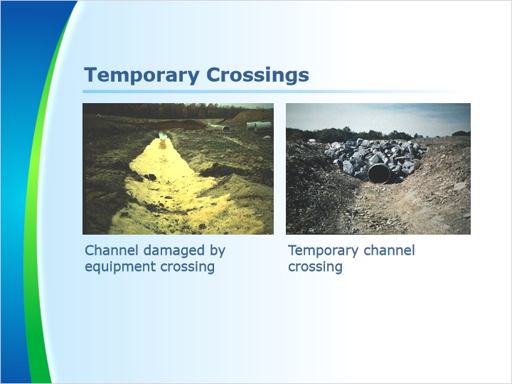
Notes:
Crossing channels with construction equipment should always be avoided. If a crossing must occur, temporary crossings should be shown and detailed on the plans.

The photo on the left shows a newly constructed channel that was crossed by construction equipment. This is a problem since the required freeboard is diminished due to tire ruts which lowers the channel’s capacity. The channel will also require additional stabilization.

The photo on the right shows how to properly cross a channel with a temporary crossing spanning the newly constructed channel. This crossing should remain in place until it is no longer needed. After removal of the crossing, the channel should be reconstructed as required per plan.

6.5 Maintenance
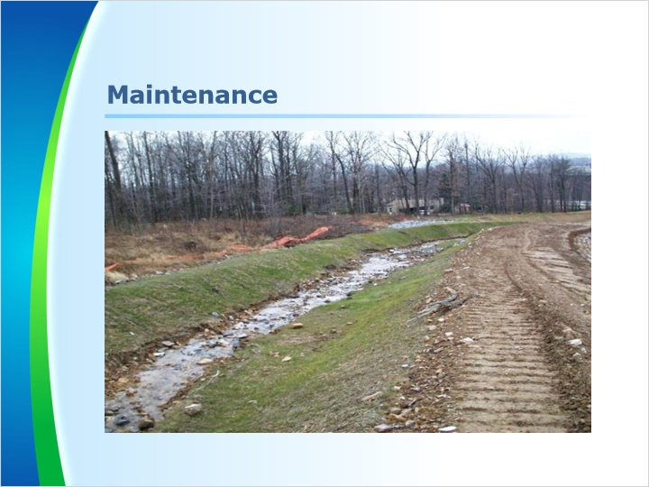
Notes:
Channels should be maintained to ensure that the specified design dimensions and protective linings are functioning at all times.

Channels shall be cleaned whenever the total channel depth is reduced by 25% at any location. Sediment deposits shall be removed within 24 hours of discovery or as soon as soil conditions permit access to the channel without further damage.

Damaged linings shall be repaired or replaced within 48 hours of discovery.

If the standard details in the manual are used for channels, these required maintenance notes will already be included.

6.6 Lesson 5 Outro
Notes:
This concludes Lesson 5. In this lesson, we discussed other considerations with channels. Specifically, we discussed accessibility, conflicts with utilities, temporary crossings, and maintenance.

