E&S Manual Chapter 9: Riprap Apron Design & Review
Ver. 10/02/2020

1.3 Welcome

Notes:
Welcome to this course on riprap apron design.

This course closely follows Chapter 9 of the Erosion & Sediment Pollution Control Program Manual. It is recommended to have a copy of the manual nearby while taking this course since this training references many figures, tables, and details found in the manual. Digital copies can be found in the Chapter 102 Resources page of Clean Water Academy. Note that completing this training does not replace the need to read and be familiar with Chapter 9 of the manual.

1.4 Welcome

Notes:
This training contains many examples and practice problems. Before continuing, it is recommended to also have paper, writing utensils, and a calculator nearby. For the purposes of this training, we will do all calculations by hand. Do note that computer programs or spreadsheets are often used to automate many of the calculations you will see throughout this training.

1.5 Learning Goals
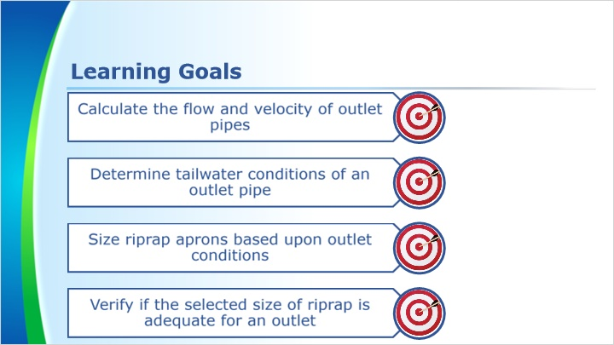
Notes:
By the end of this course, you should be able to calculate the flow and velocity of outlet pipes, determine tailwater conditions of an outlet pipe, size riprap aprons based upon outlet conditions, and verify if the selected size of riprap is adequate for an outlet.

1.6 Outlet Protection
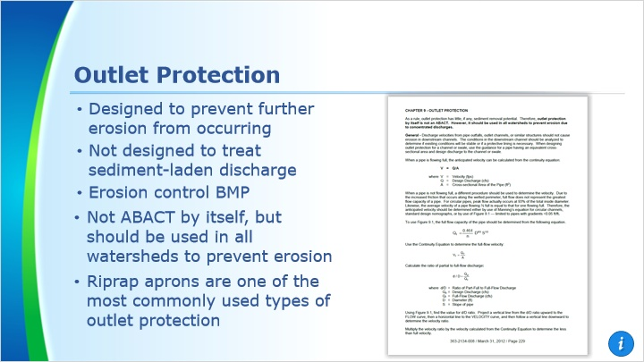
Notes:
Chapter 9 of the Erosion & Sediment Pollution Control Program Manual discusses outlet protection. Outlet protection is designed to prevent further erosion from occurring near the outlet. It is not designed to treat sediment-laden discharge. This means that it is an erosion control BMP and not a sediment control BMP. Outlet protection by itself is not ABACT, but it should be used in all watersheds to prevent erosion due to concentrated discharges.

In this course we will focus on riprap aprons. Riprap aprons are one of the most widely used outlet protection BMPs.

1.7 Designing Riprap Aprons
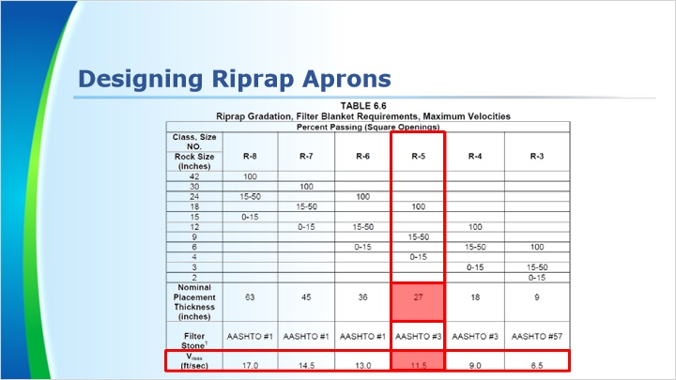
Notes:
Here is Table 6.6 on page 135 of the manual. We will reference it throughout this course, you may want to bookmark this page.

Information that is found in this table include the maximum velocities that are permissible for the various rock sizes, placement thickness of the stone, and gradations for the stone.

This row on the table shows the allowable velocity that the stone can handle before being dislodged. If a pipe velocity is calculated to be 10 fps then the proper rock size for that pipe would be R-5, which can handle velocities up to 11.5fps. The nominal thickness for a riprap apron using R-5 would be 27” according to the table.

1.8 Designing Riprap Aprons
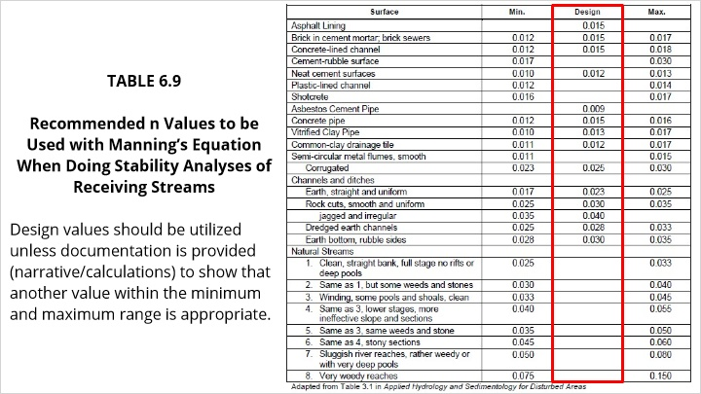
Notes:
Here is Table 6.9 on page 137 of the manual. It gives a range of Manning’s n value for various materials. Design values should be utilized unless documentation is provided (narrative/calculations) to show that another value within the minimum and maximum range is appropriate.

We will use it throughout this course, so you may want to bookmark this page as well.

1.9 Designing Riprap Aprons
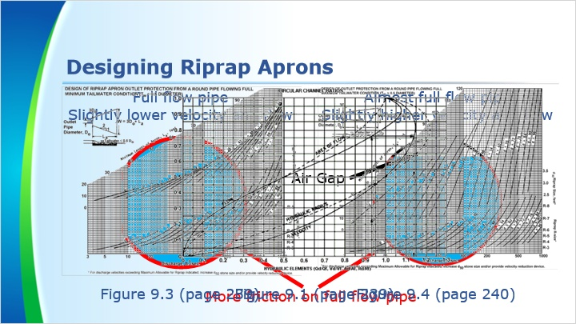
Notes:
Figures 9.3 and 9.4 are nomographs for designing a riprap apron when the pipe is flowing full.

Full flow is not the normal condition for most pipes as they typically only handle lower flows. A full flow in a pipe has a slightly lower velocity and flow compared to a pipe that is flowing around 98% full. This is due to the reduced friction losses at the top air gap. When the air gap is closed or non-existent, the friction losses surround the entire flow which reduces the overall velocity in the pipe. Pipes not flowing full should have the velocity of the flow adjusted by using Figure 9.1.

We will examine Figures 9.1, 9.3, and 9.4 in more detail throughout this course. You may want to bookmark those pages.

1.10 Designing Riprap Aprons
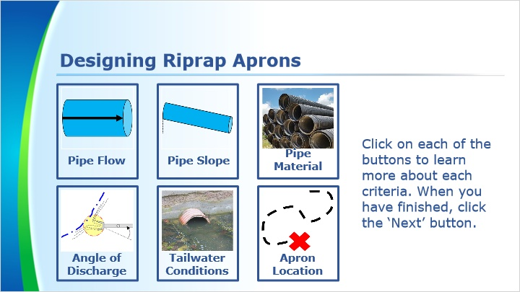
Notes:
When designing riprap aprons, you will need to know the following criteria:
- The design flow (Q) that the pipe will be required to handle.
- The slope of the pipe - this greatly affects the velocity of the flow.
- The pipe material - As shown in Table 6.9, Manning’s n value varies for different material. Changes in Manning’s n value can affect the velocity and carrying capacity of a pipe along with the size of ripap needed for outlet protection.
- The angle the pipe discharges into a channel or stream should also be considered.
- The tailwater conditions of the pipe. Will the end mostly be submerged or will it be free flowing?
- The apron location. This is important in because the dimensions of an apron can be adjusted if an outlet discharges to a stream or channel.

Click on each of the buttons to learn more about each criteria. When you have finished, click the ‘Next’ button.

2. Pipe Flow

2.1 Pipe Flow
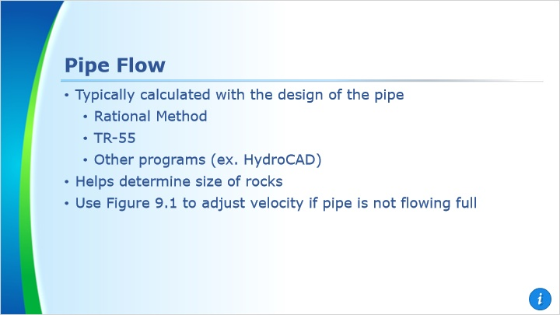
Notes:
The design flow is typically calculated with the design of the pipe. This flow is calculated using the rational method, TR-55 or other appropriate program such as HydroCAD. The velocity of the flow is needed to help determine the size of the rock for the apron. The rock needs to be able to withstand the shear forces and/or the velocity of the flow exiting the pipe.

This information will be compared to the full flow capacity to help calculate an exit velocity for the flow.

Figure 9.1 shows a velocity adjustment factor for pipes that are flowing less than full. This may allow for a reduced rock size for the apron or it may cause the rock to be larger than what is found from the design figures in the manual.

2.2 Pipe Flow
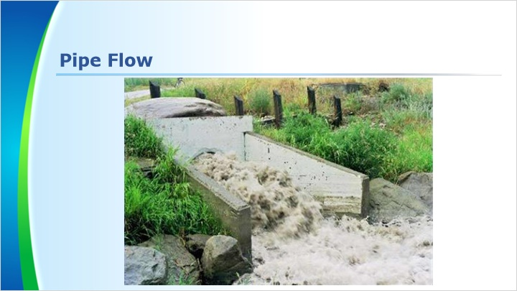
Notes:
Here is an example of a pipe flowing full. A pipe flowing full is not a normal case on most sites. As such, we will need to determine the anticipated flow velocity of a pipe which is only partially flowing full.

2.3 Pipe Flow

Notes:
There are two methods we can use to determine flow velocity. If the slope of the pipe is less than 0.05 ft/ft, or 5%, you can use Figure 9.1. For slopes greater than 0.05 ft/ft, Manning’s equation should be used.

Click the buttons to view each method. When you are finished, click the ‘Next’ button.

2.4 Figure 9.1
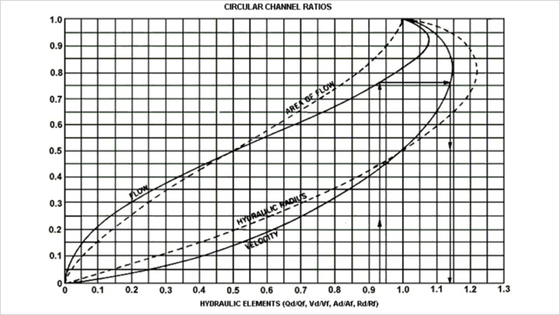
Notes:
Figure 9.1 is a nomograph which allows us to determine the velocity of a partially flowing pipe given the velocity of the pipe when flowing full. As you can see, there are curves labeled flow, area of flow, hydraulic radius, and velocity.

2.5 Figure 9.1

Notes:
Before we use Figure 9.1, we need two pieces of information. The first is the velocity of the pipe when flowing full. The second is the ratio of partial to the full for either the flow, flow area or hydraulic radius.

The ratio of the design flow to the full flow is one of the simpler ratios to calculate as the design flow is calculated for the pipe. We will use this for our examples.

2.6 Figure 9.1

Notes:
The design flow would be known in most cases. So we start by calculating the full flow capacity of the pipe using the equation shown on this slide. Then we want to calculate ratio of part-full to full-flow discharge.

Also, the velocity of full flow is needed for comparing the ratios. The full flow velocity is calculated by using the Continuity Equation, velocity equals flow divided by the flow area.

2.7 Figure 9.1 - Example
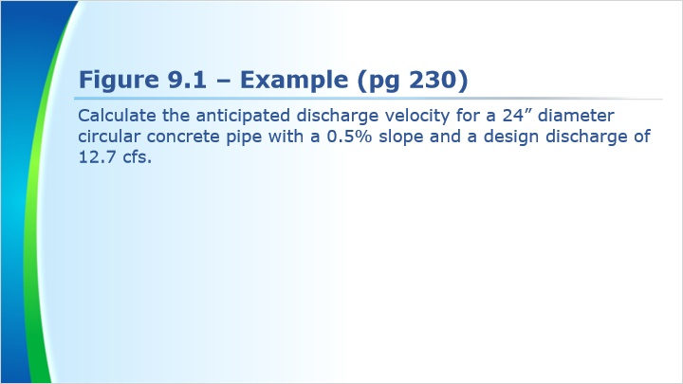
Notes:
Let’s go through an example together. This one is from page 230 of the manual.

Calculate the anticipated discharge velocity for a 24” diameter circular concrete pipe with a 0.5% slope and a design discharge of 12.7 cfs.

2.8 Figure 9.1 - Example
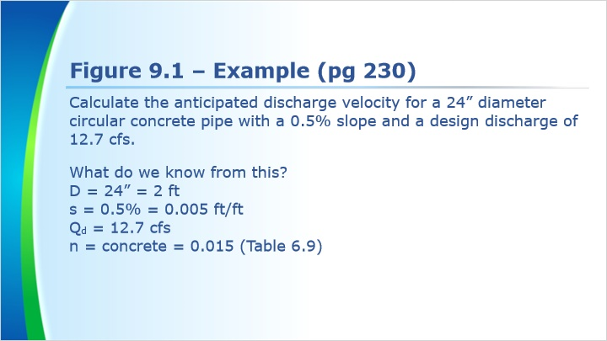
Notes:
Let’s start by determining what our known variables are from this word problem.

First, we are told the diameter of the pipe is 24 inches. Since the rest of our quantities use units of feet, we will convert the diameter from inches to feet.

Next, we are given a slope of 0.5%. Since this is less than 5%, we can use Figure 9.1. Remember to convert this to decimal form. 0.5% = 0.005 ft/ft.

The design discharge flow is stated to be 12.7 cubic feet per second, or cfs.

The pipe material is stated to be concrete. According to Table 6.9, concrete has a Manning’s n value of 0.015.

2.9 Figure 9.1 - Example

Notes:
Now we can begin calculating each of the values we need.

As we just discussed, the design flow capacity is 12.7 cfs.

If we insert our values of Manning’s n, diameter, and slope into the full flow discharge equation, the result is a full flow discharge of 13.7 cfs.

The part-full to full-flow discharge ratio is simple to calculate. We determine this is 0.93.

Before we use the continuity equation, we need to calculate the cross-sectional area of the discharge. Since we are solving the continuity equation for discharge velocity of a full pipe, we want the cross-sectional area of the pipe. Luckily this is a circle, so using basic geometry yields us an area of 3.14 square feet.

Now we can use the continuity equation. We end up with a full pipe discharge velocity of 4.4 feet per second.

2.10 Figure 9.1 - Example
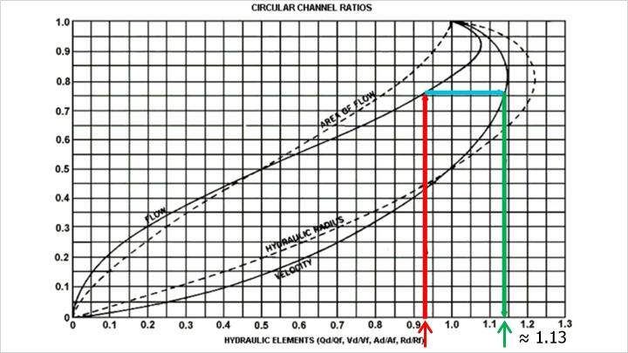
Notes:
Now that we have the values we need, we can use the nomograph in Figure 9.1 to determine the part-full velocity.

Find 0.93 along the x-axis on the figure. From there, project a vertical line up to the curve for the ratio which was calculated. Since we used flow for our ratio, we will use the FLOW curve. If we used area or hydraulic radius instead, we would use that curve instead. From where the vertical line we drew intersects the FLOW curve, draw a line horizontally from the FLOW curve to the VELOCITY Curve. From that intersection point, we will draw another vertical line down to the hydraulic elements axis. This is the ratio that will be a multiplier for the full discharge velocity.

For our example, the multiplier for the velocity is approximately 1.13.

2.11 Figure 9.1 - Example

Notes:
To calculate the velocity of the partial flow, the velocity of the full flow is multiplied by the result from Figure 9.1.

The end result is 5.0 fps. That means the riprap apron will have to be designed to withstand a velocity of 5.0 feet per second from the pipe.

This calculation is done to verify that the downstream channel lining or the riprap apron can withstand the force of the flow exiting the pipe.

2.12 Practice Problem
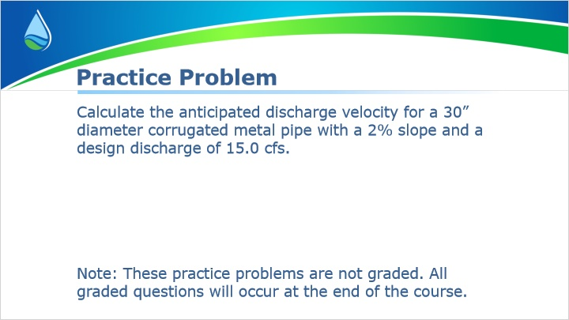
Notes:
Now let’s have you walk through a practice problem. This is similar to the example I just went through. Note that these questions are not graded and are simply here for extra practice.

2.18 Manning’s Equation
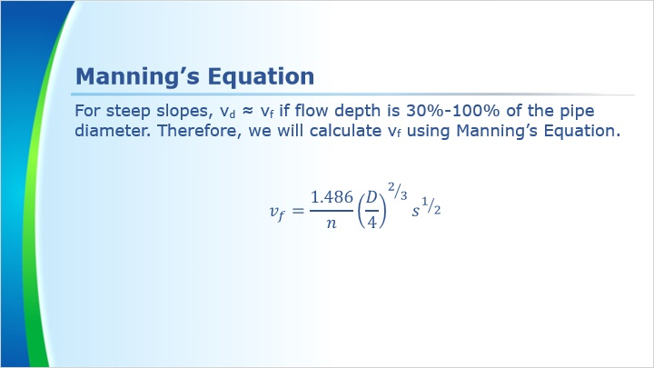
Notes:
When using Manning’s equation for determining pipe flow, the velocity is calculated for full flow conditions even though the pipe is typically flowing only partially full. Partial flows will be very close to the full flow velocity for depths of flow between 30 percent and 100 percent of the pipe diameter in steep slope conditions. Manning’s equation for full pipe flow is shown on the screen. Note that this version of Manning’s Equation is slightly different from the one used for channel design. Make sure you are using the correct version

2.19 Manning’s Equation - Example
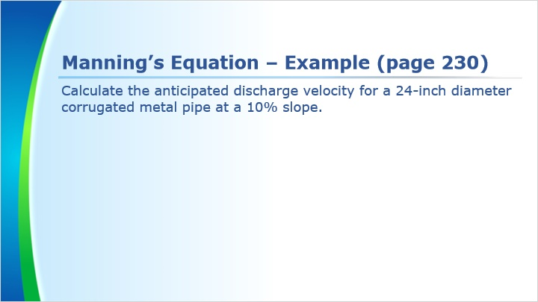
Notes:
Let’s go through an example together. This one is found on page 230 of the manual.

Calculate the anticipated discharge velocity for a 24-inch diameter corrugated metal pipe at a 10% slope.

2.20 Manning’s Equation - Example
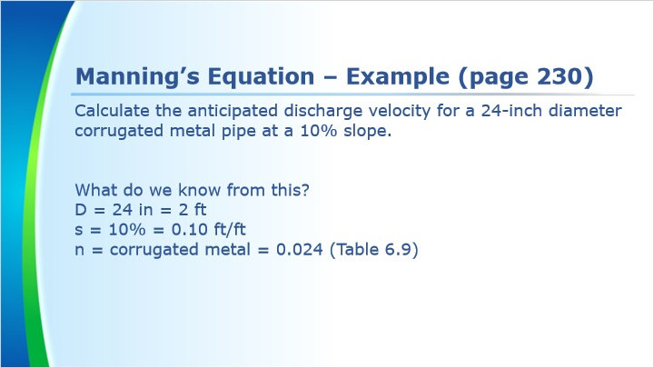
Notes:
Let’s start by determining what our known variables are from this word problem.

First, we are told the diameter of the pipe is 24 inches. Since the rest of our quantities use units of feet, we will convert the diameter from inches to feet.

Next, we are given a slope of 10%. Remember to convert this to decimal form. 10% = 0.10 ft/ft.

According to Table 6.9, corrugated metal has a Manning’s n value of 0.024.

2.21 Manning’s Equation - Example

Notes:
Inserting these values into Manning’s Equation is simple. Doing so yields a flow velocity of 12.5 feet per second.

2.22 Practice Problem

Notes:
Now let’s have you walk through a practice problem. This is similar to the example I just went through. Note that these questions are not graded and are simply here for extra practice.

3. Pipe Slope

3.1 Pipe Slope
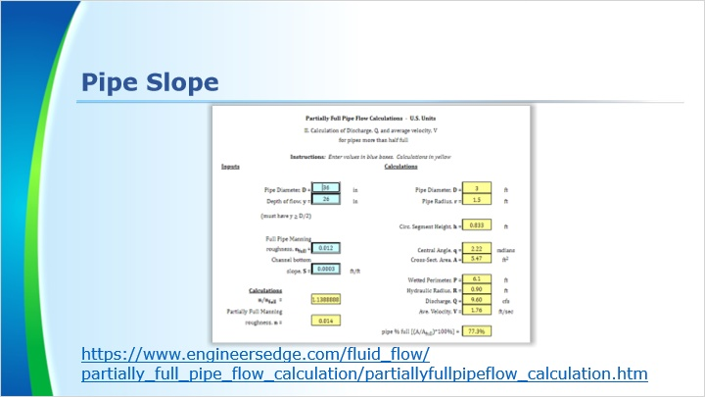
Notes:
The slope of the pipe must be considered when determining apron design. The design nomographs, Figures 9.3 and 9.4, are calculated for pipes flowing full. This will give you a basis for the velocity but a pipe that is not flowing full may actually have a greater velocity.

Pipes with steep slopes and smooth bores are at the greatest risk of having high velocity discharges. A concrete pipe may have up to twice the capacity of a corrugated metal pipe given all the same conditions otherwise.

The link takes you to a calculator for partially full pipes more than half full. Take some time to play around with it. Adjust the slope value and see what effect it has on the flow velocity. Once you are finished, click the ‘Next’ button.

3.2 Pipe Slope
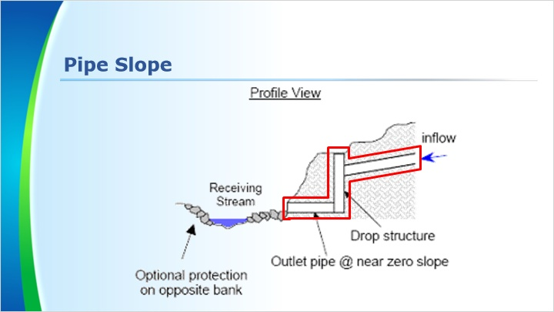
Notes:
If the pipe slope is steep, a drop structure may be needed to help reduce the outlet velocity. A drop structure helps velocities by reducing the slope of the outlet pipe before it discharges to the stream. A steep sloped pipe connects to a vertical drop area. Then the exit pipe can have a slope which is greatly reduced or even zero. This in turn greatly reduces the velocity of the flow coming out of the pipe. The maximum outlet velocity for a standard riprap apron is 17 ft/s. 17 ft/s is the velocity that R-8 rock can withstand, anything greater than 17 feet per second would require a special outlet protection design.

4. Pipe Material

4.1 Pipe Material
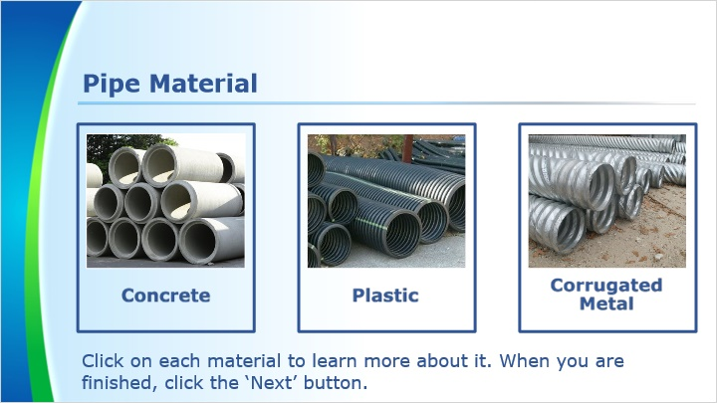
Notes:
When calculating the flow velocity using Manning’s equation, the material a pipe is made from can cause a large swing in the outlet velocity. The outlet velocity for a smooth bore plastic pipe can be twice that of the corrugated metal, and concrete is normally very near the values for plastic. This is because of how smooth plastic and concrete are compared to the corrugated metal. Beware though some corrugated metal can have a smooth bore in it and some plastic pipe does not have the smooth bore but are corrugated on the inside.

Manning’s n values for various pipes can be found in Table 6.9 on page 137 of the manual.

Click on each material to learn more about it. When you are finished, click the ‘Next’ button.

Corrugated Metal
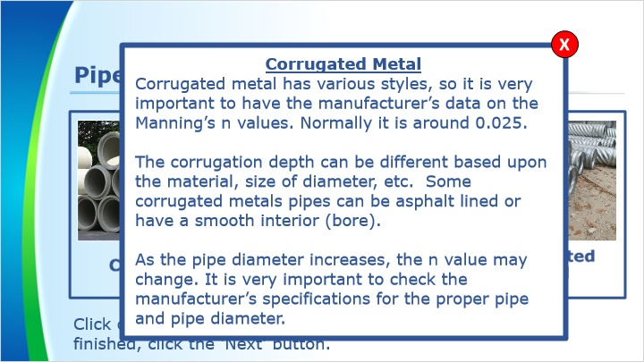

Plastic


Concrete


5. Angle of Discharge

5.1 Angle of Discharge
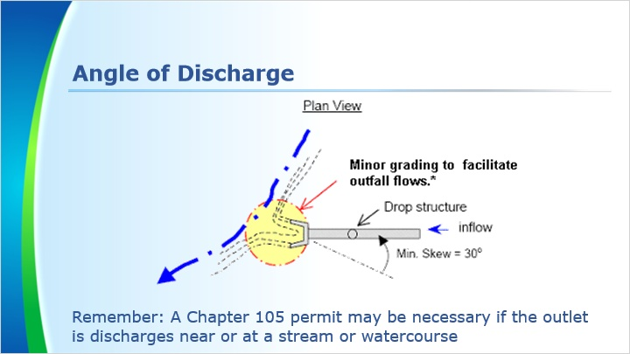
Notes:
The angle of the discharge does not normally effect the dimensions or the size of rock for an apron but it should be verified that the apron is perpendicular to the stream or pointed downstream at an angle less than 90 degrees. This ensures that the discharge will not slow any flows in the stream and cause issues with settling at the junction. The outlet flow should not disrupt the flow of the stream by discharging against the flow.

Remember that a Chapter 105 permit may be necessary if the outlet is discharges near or at a stream or watercourse

5.2 Angle of Discharge
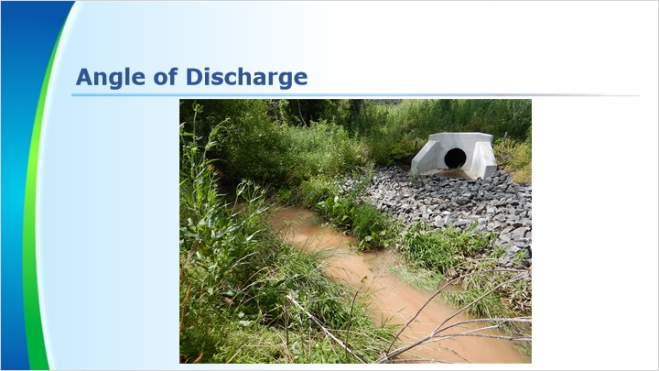
Notes:
Shown here is an outlet that is oriented to point downstream and the apron does not extend through the stream. The flow coming from the pipe can flow across the apron and join with the flow in the stream without slowing the stream’s velocity.

6. Tailwater Conditions

6.1 Tailwater Conditions
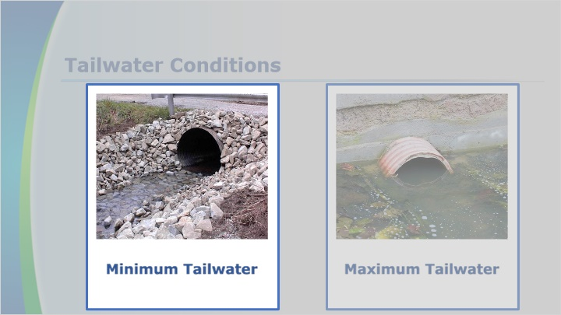
Notes:
There are two different tailwater conditions.

The first is the Minimum tailwater condition where the pipe can freely drain with little to no possibility of causing the flow to back up. This would be where the pipe and apron discharge to an outlet channel that is only conveying the discharge from the pipe. There is no standing water or the water elevation is below the mid point elevation of the pipe outlet.

When the water level at the discharge point of the pipe is equal to or greater than the midpoint elevation of the discharge pipe, it is considered to be the maximum tailwater condition.

Click on each of the tailwater conditions to learn more about them. When you are finished, click the ‘Next’ button.

6.2 Minimum Tailwater
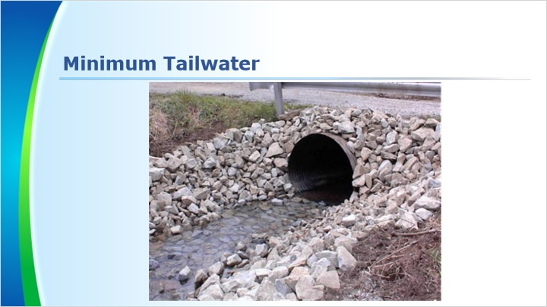
Notes:
Minimum tailwater is when the water level is less than half of the pipe’s diameter at the outlet. The outlet flow is free flowing and will not likely back up. This example is discharging to a stream so the riprap apron may be designed to the stream dimensions. A long riprap apron might not be feasible in this case as it could extend beyond the stream bed and up the streambank on the other side.

6.3 Figure 9.3
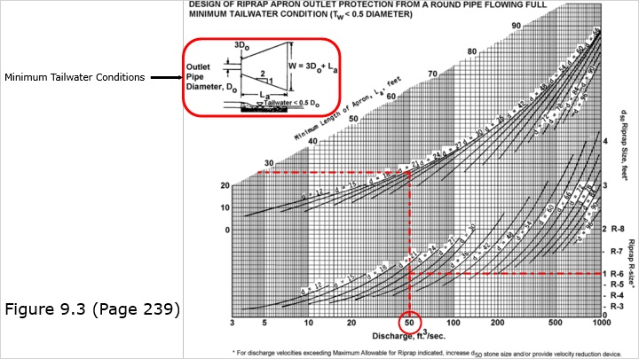
Notes:
This is Figure 9.3 on page 239 of the manual. This figure should be used when minimum tailwater conditions exist.

If you look at the illustration in the top left corner of Figure 9.3, you can see the dimensions for an apron. L_{a} stands for the length of the apron and D_{O} denotes the outlet pipe diameter. The width of the apron is given by the formula W = 3D_{O} + L_{a}. The initial width of the apron is 3D_{O}.

To use this nomograph, start by finding the discharge (in cfs) along the x-axis. From here, draw a line until you reach the line labeled with the pipe’s diameter. Then you will draw a line from that point to the right until you reach the riprap size. This process is repated for minimum apron length, which uses the set of lines above the riprap nomograph.

If your discharge line does not intersect with the pipe diameter curve the curve should not be extrapolated to the discharge line. The bottom of the curve is the lowest point a horizontal line to the rock size should be drawn from. The same goes for the upper curve to the minimum apron length also.

One thing to remember is that when using Figure 9.3 for the design of a riprap apron is this chart is for when the pipe is flowing full. If the pipe is not flowing full then the velocity should be adjusted using Figure 9.1.

6.4 Minimum Tailwater - Example
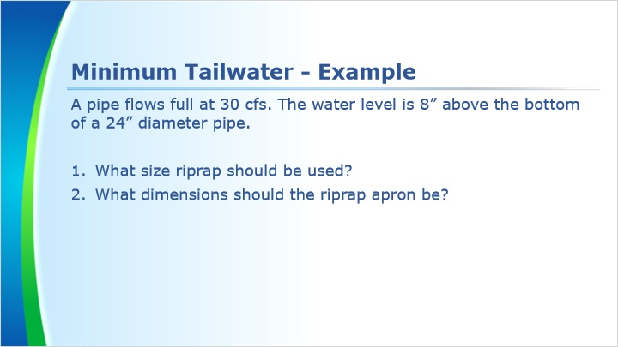
Notes:
Let’s look at an example. A pipe flows full at 30 cfs. The water level is 8” above the bottom of a 24” diameter pipe. What size riprap should be used and what dimensions should the riprap apron be?

6.5 Minimum Tailwater - Example
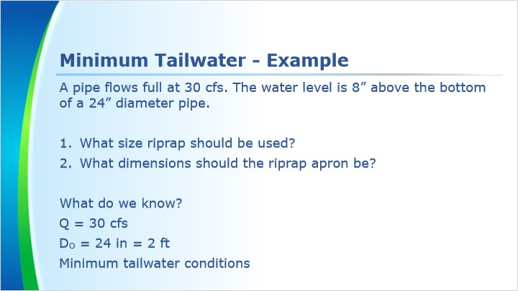
Notes:
From this problem, we know the discharge is 30 cfs. The pipe diameter is 24 inches, or 2 feet. We will need quantities in both units. Half the diameter of the pipe is 12 inches. The water level being 8 inches above the bottom of the pipe, and therefore 4 inches below half its diameter, tells us this outlet will experience minimum tailwater conditions.

6.6 Minimum Tailwater - Example
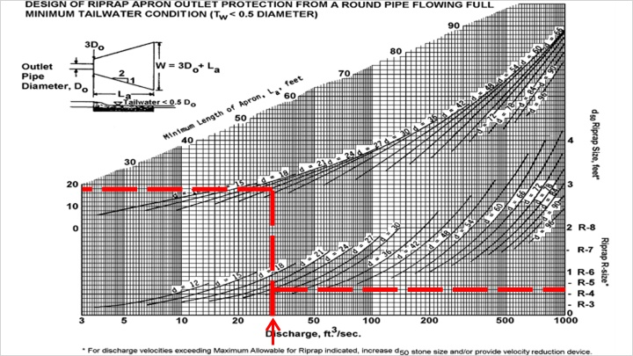
Notes:
Using Figure 9.3 we find the discharge of 30 cfs along the horizontal axis.

We follow this up to the pipe diameter size of 24 inches. Once the 30 cfs line and the 24 in pipe diameter line intersect, we then follow that point to the right to find the riprap size. In this case it falls between the R-4 and R-5 sizes, so you would take the higher of the two. R-5 rock will be used for the example.

Next, we take the 30 cfs line and continue it up to the top d=24 line. Once you intersect with the d=24 line you turn and go to the left side of the graph. In this case, the minimum apron length is 18 ft.

6.7 Minimum Tailwater - Example
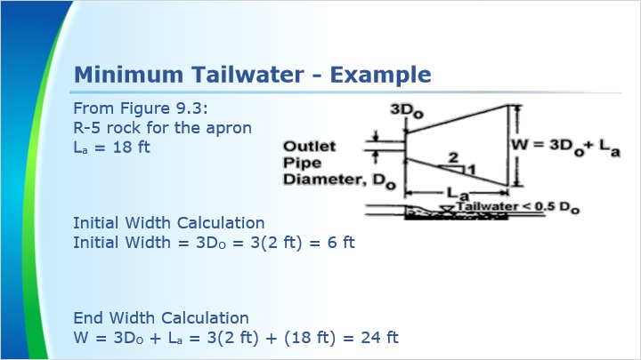
Notes:
From Figure 9.3 we determined that the apron should consist of R-5 rock and be 18 ft in length.

The initial width of the apron is three times the pipe diameter. For our example this is 6 ft.

Next we need to calculate the end width of the apron. The end width is calculated by using the equation 3 times the diameter of the pipe plus the length of the apron. This yields us a result of 24 ft.

6.8 Minimum Tailwater - Example
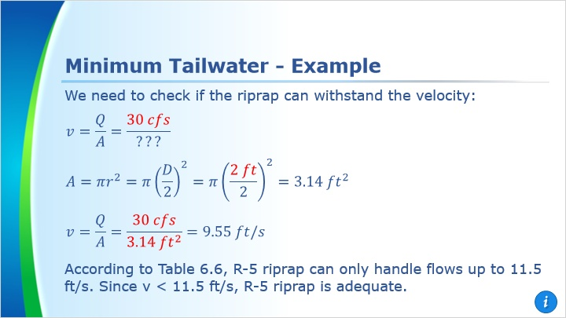
Notes:
The rock size for the apron should be checked to see if it is adequate for the velocity of the flow exiting the pipe.

We use the continuity equation to find the velocity of the discharge from the pipe. The discharge was given as 30 cfs. Before continuing, we must calculate the cross-sectional area of the pipe.

Using the geometric formula for the area of a circle, we determine the cross-sectional area of the pipe is 3.14 ft².

When we insert our area of 3.14 square feet into the continuity equation, we see that the velocity of water coming out of the pipe is 9.55 ft/s.

Now we need to check that our selected riprap can withstand the design flow velocity of 9.55 ft/s. This is done by checking the v_{max} row in Table 6.6. According to that table, R-5 riprap can handle flow velocities up to 11.5 ft/s. Therefore R-5 rock will be large enough to handle the flow.

6.9 Minimum Tailwater - Solution
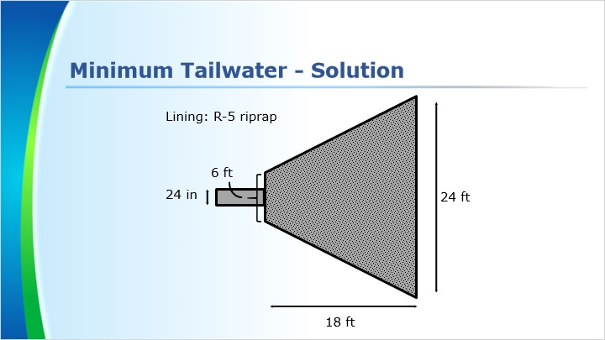
Notes:
Here we can see a visual graphic of the solution of our example problem. This is not exactly to scale, but the proportions are fairly close.

6.10 Practice Problem
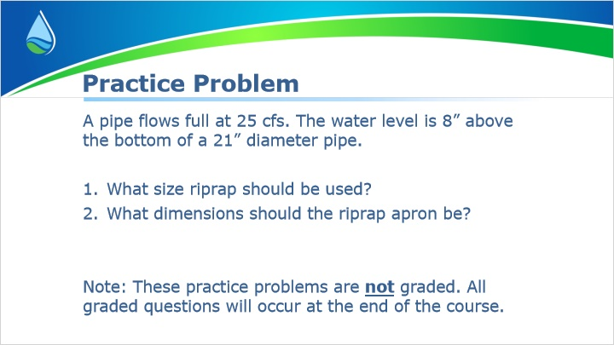
Notes:
Now let’s have you walk through a practice problem. This is similar to the example I just went through. Note that these questions are not graded and are simply here for extra practice.

6.17 Maximum Tailwater
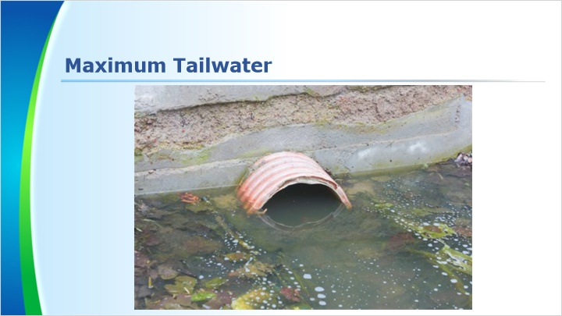
Notes:
For maximum tailwater conditions, water level is greater than half of the diameter of the pipe. The outlet flow is impeded by deep water.

6.18 Figure 9.4
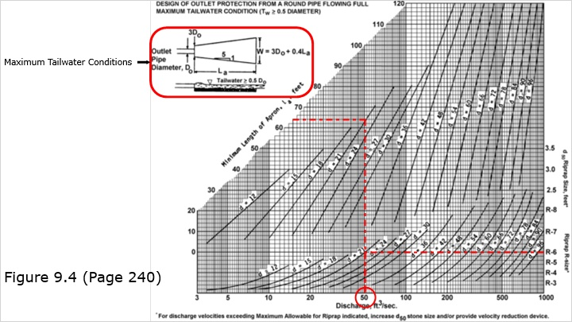
Notes:
This is Figure 9.4 on page 240 of the manual. This figure should be used when maximum tailwater conditions exist.

If you look at the illustration in the top left corner of Figure 9.4, you can see the dimensions for an apron. L_{a} stands for the length of the apron and D_{O} denotes the outlet pipe diameter. The width of the apron is given by the formula W = 3D_{O} + 0.4L_{a}. The initial width of the apron is 3D_{O}.

To use this nomograph, start by finding the discharge (in cfs) along the x-axis. From here, draw a line until you reach the line labeled with the pipe’s diameter. Then you will draw a line from that point to the right until you reach the riprap size. This process is repated for minimum apron length, which uses the set of lines above the riprap nomograph.

If your discharge line does not intersect with the pipe diameter curve the curve should not be extrapolated to the discharge line. The bottom of the curve is the lowest point a horizontal line to the rock size should be drawn from. The same goes for the upper curve to the minimum apron length also.

One thing to remember is that when using Figure 9.4 for the design of a riprap apron is this chart is for when the pipe is flowing full. If the pipe is not flowing full then the velocity should be adjusted using Figure 9.1.

6.19 Maximum Tailwater - Example
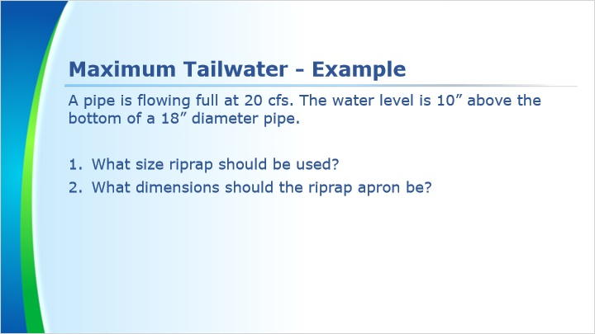
Notes:
Let’s look at an example. A pipe is flowing full at 20 cfs. The water level is 10” above the bottom of a 18” diameter pipe. What size riprap should be used and what dimensions should the riprap apron be?

6.20 Maximum Tailwater - Example
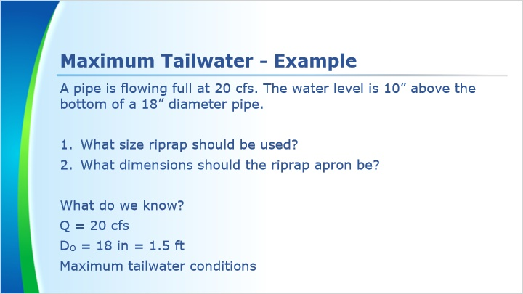
Notes:
From this problem, we know the discharge is 20 cfs. The pipe diameter is 18 inches, or 1.5 feet. We will need quantities in both units. Half the diameter of the pipe is 9 inches. The water level being 10 inches above the bottom of the pipe, and therefore 1 inch above half the diameter, tells us this outlet will experience maximum tailwater conditions.

6.21 Minimum Tailwater - Example
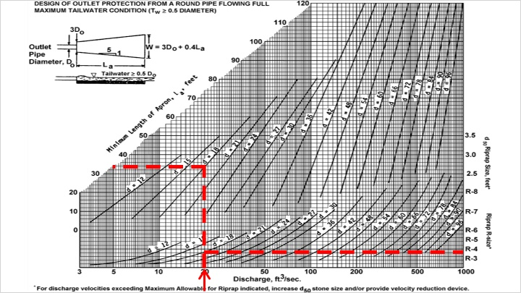
Notes:
Using Figure 9.4 we find the discharge of 20 cfs along the horizontal axis.

We follow this up to the pipe diameter size of 18 inches. Once the 20 cfs line and the 18 in pipe diameter line intersect, we then follow that point to the right to find the riprap size. In this case it falls between the R-3 and R-4 sizes, so you would take the higher of the two. R-4 Rock will be used for the example.

Next, we take the 20 cfs line and continue it up to the top d=18 line. Once you intersect with the d=18 line you turn and go to the left side of the graph. In this case, it takes you to a minimum apron length of 34 ft.

6.22 Maximum Tailwater - Example
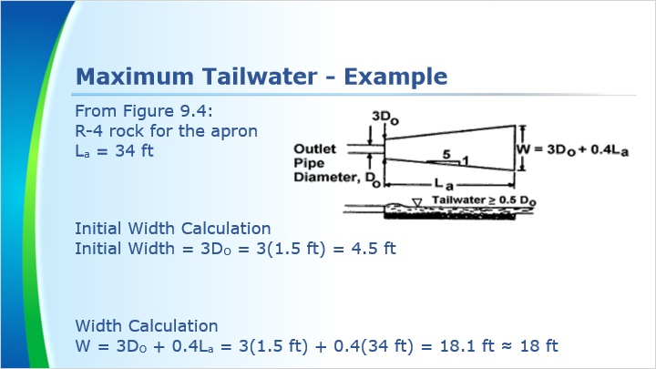
Notes:
From Figure 9.4 we determined that the apron should consist of R-4 rock and be 34 ft in length.

The initial width of the apron is three times the pipe diameter. For our example this is 4.5 ft.

Next we need to calculate the end width of the apron. The end width is calculated by using the equation 3 times the diameter of the pipe plus 0.4 times the length of the apron. This yields us a result of 18.1 ft. We round this to the nearest foot, which is 18 ft.

6.23 Maximum Tailwater - Example
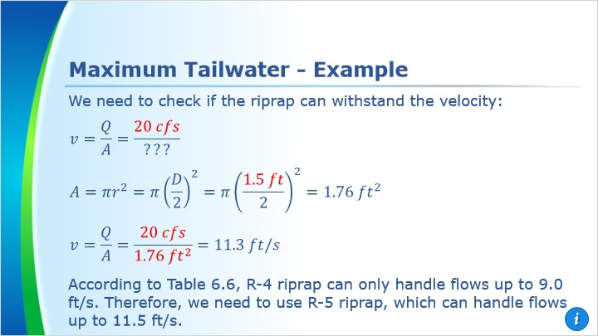
Notes:
The rock size for the apron should be checked to see if it is adequate for the velocity of the flow exiting the pipe.

We use the continuity equation to find the velocity of the discharge from the pipe. The discharge was given as 20 cfs. Before continuing, we must calculate the cross-sectional area of the pipe.

Using the geometric formula for the area of a circle, we determine the cross-sectional area of the pipe is 1.76 square feet.

When we insert our area of 1.76 square feet into the continuity equation, we see that the velocity of water coming out of the pipe is 11.3 feet per second.

Now we check that velocity with the values for the R-4 rock on Table 6.6 for the maximum velocity it can handle. According to that table, R-4 can handle flow velocities up to 9.0 fps. Therefore R-4 rock will not be large enough to handle the flow. We move up the table until we find a rock size that has a v_{max} greater than 11.3. That happens to be the next size up R-5 rock with a v_{max} of 11.5 fps.

6.24 Maximum Tailwater - Solution
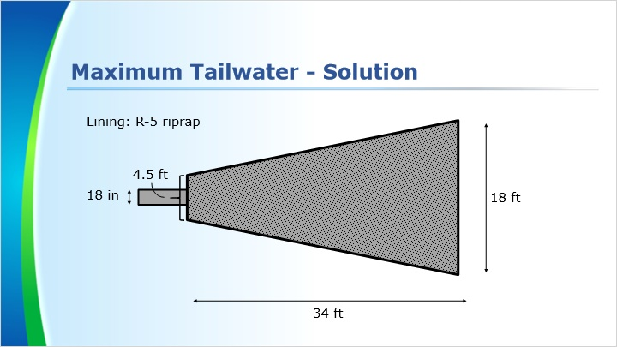
Notes:
Here we can see a visual graphic of the solution of our example problem. This is not exactly to scale, but the proportions are fairly close.

6.25 Practice Problem
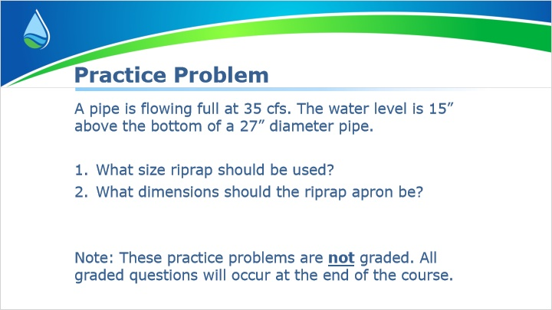
Notes:
Now let’s have you walk through a practice problem. This is similar to the example I just went through. Note that these questions are not graded and are simply here for extra practice.

9. Apron Location

9.1 Apron Location
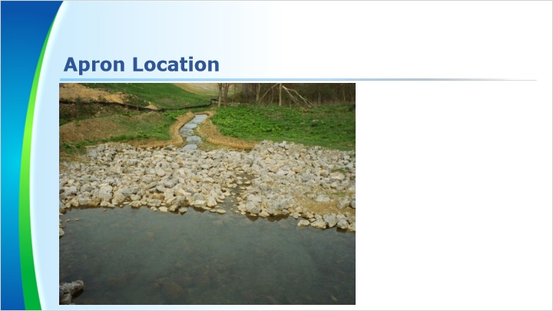
Notes:
If the pipe and apron are in a channel or stream, the size of the apron can be adjusted to fit the site conditions. The apron should not spill over a channel or stream’s bottom and side slopes. Let’s take a look at a few examples.

9.2 Apron Location - Channel
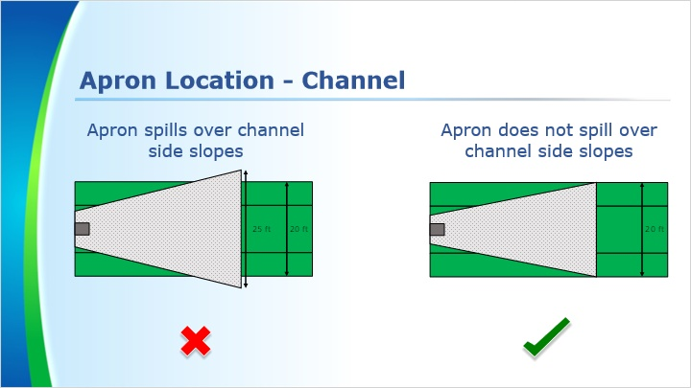
Notes:
For our first example, a pipe and apron are in a channel. The apron should be 25’ wide at the wide end. However, the channel is only 20’ wide. It would not be appropriate to have the apron spill over the channel to the surrounding area. Therefore, the apron can be 20’ wide instead of 25’ wide.

9.3 Apron Location – Channel
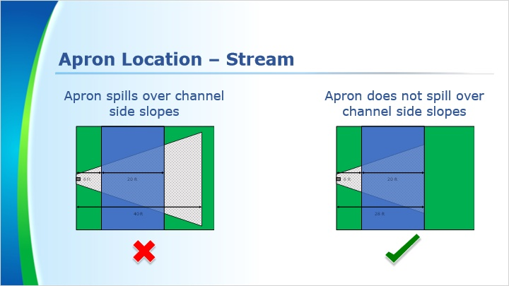
Notes:
For the second example, a pipe is directed to a stream. The apron should be 40’ in length, but it is 8’ to the stream and the stream is 20’ wide. You would not want the apron to continue on the other side of the stream, so the apron can be 28’ long in this case.

1.11 Designing Riprap Aprons
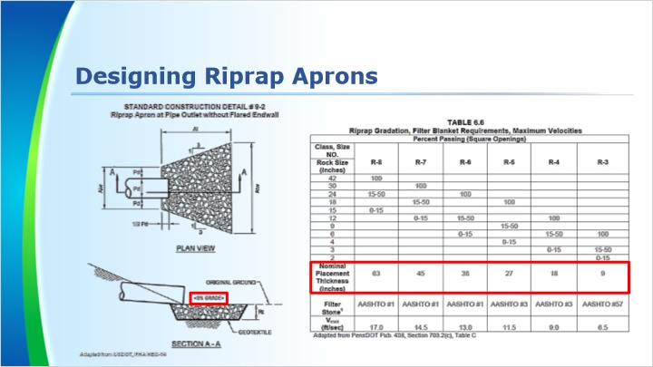
Notes:
Rip rap aprons should be installed with a 0% slope so they do not add any velocity to the discharge.

The thickness for the apron is based on the rock size used for the apron. The nominal placement thickness for the riprap can be found in Table 6.6

1.12 Designing Riprap Aprons
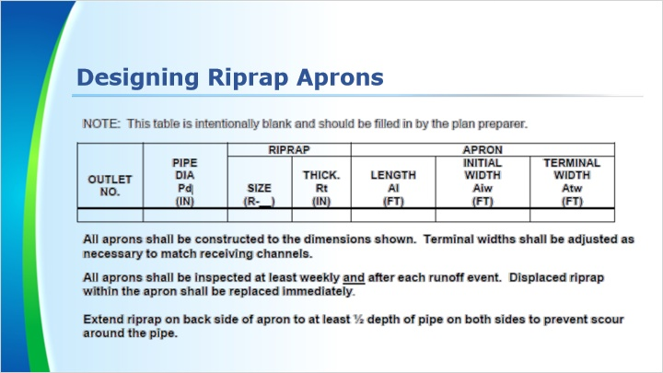
Notes:
This should be filled out on the drawings. There should be a row for each apron. This information is needed on the plan so that the contractor knows the dimensions of each apron and does not have to search in the narrative for the dimensions.

1.13 Problems
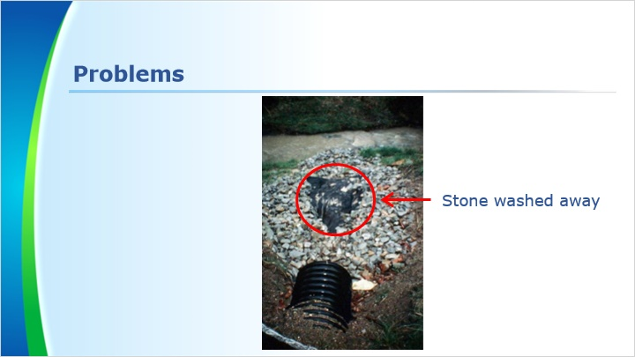
Notes:
In this photo, the riprap was not sized properly for the velocity of the flow leaving the pipe. This caused the stone to be washed downstream from the area that needs protection.

1.14 Problems
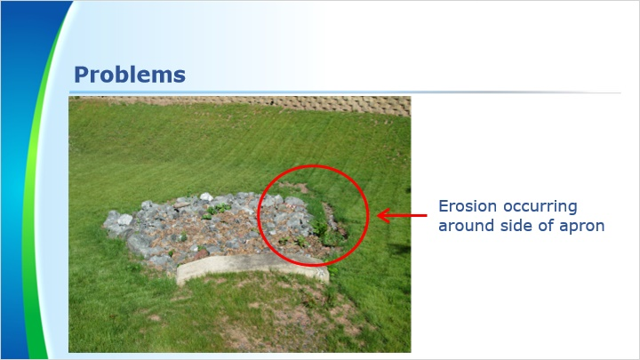
Notes:
In this picture there is a problem with erosion around the right side of the apron. This could be due to not having the proper embedment depth of the rock or possibly the apron was not installed on a zero slope from side to side. Further site investigation would be needed.

1.15 Designing Riprap Aprons
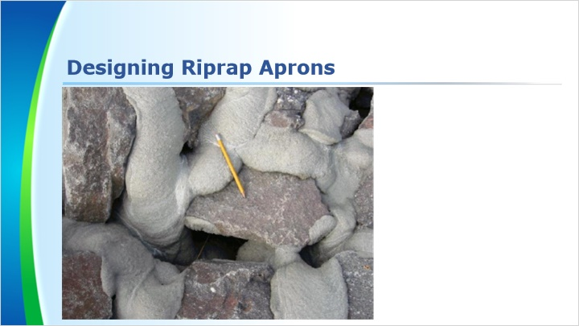
Notes:
Grouting of the riprap can help it withstand higher velocities, but it is a practice that is generally discouraged. The grout will normally break up from Pennsylvania’s freeze thaw cycles. Uncured concrete should not be allowed to come into contact with a surface water. The grouting of the riprap is a very time-consuming process due to all the voids that must be filled to a thickness equivalent to the d50 of the stone used.

1.16 Problems
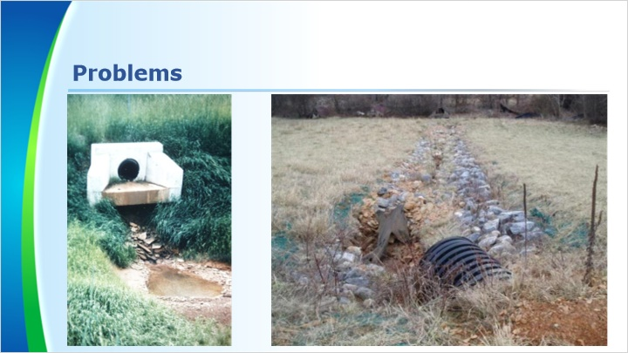
Notes:
Erosion which occurs at a pipe outlet is called a scour hole. Scour holes can cause many issues.

The pipe can fall off and fall into the scour hole. This typically happens with concrete pipes because they have shorter sections than plastic or metal pipes.

Pipe outlets are typically part of an embankment. If the scour hole grows large enough, the embankment could fail. This can be very troublesome, especially if the embankment is holding up a roadway.

1.17 Reviewing Riprap Aprons
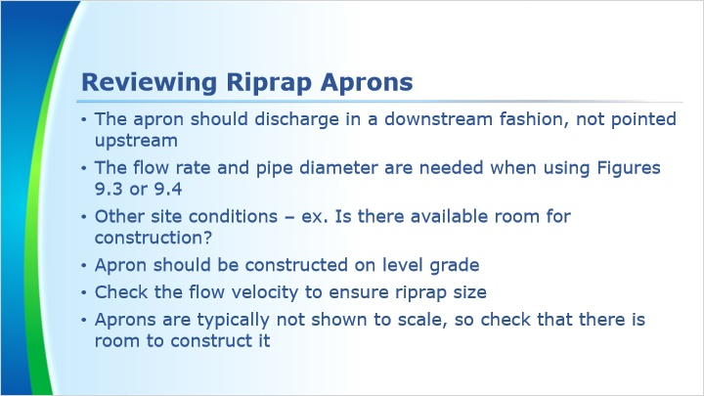
Notes:
Here are some important points to remember when reviewing riprap aprons.

1.18 Summary
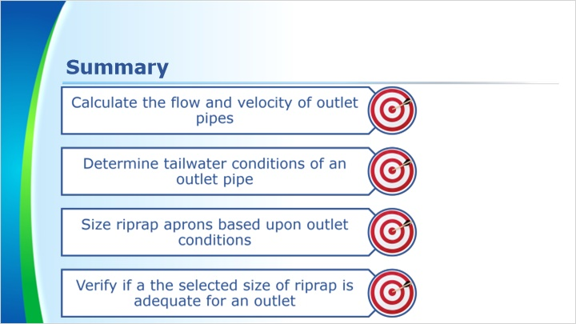
Notes:
This concludes the training. To summarize, we discussed how to calculate the flow and velocity of outlet pipes, determine tailwater conditions of an outlet pipe, size riprap aprons based upon outlet conditions, and verify if the selected size of riprap is adequate for an outlet.

We will finish up the course with a knowledge check.

