E&S Manual Chapter 10: Low Hazard Individual Lot E&S Plans (Printout)
Revised 09-01-2020

1.3 Welcome
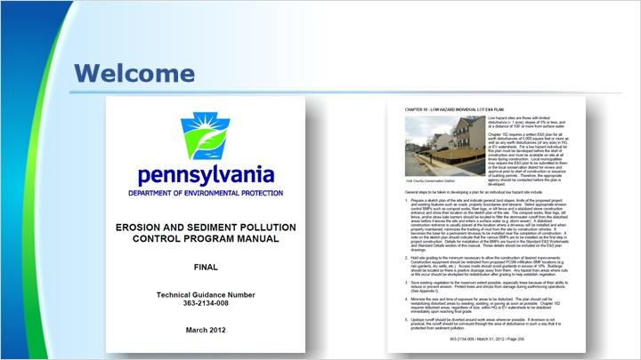
Notes:
Welcome to this course on Low Hazard Lot Individual E&S Plans. This training closely follows Chapter 10 of the Erosion and Sediment Pollution Control Program Manual. It is recommended to have a copy of the manual nearby while taking this training as it is referenced throughout the course.

This training does not replace the need to read and be familiar with the manual.

1.4 Learning Goals
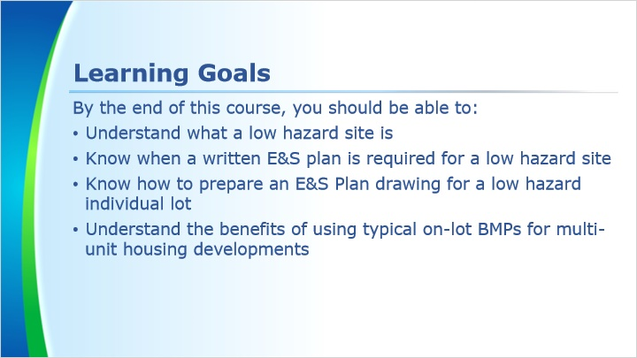
Notes:
In this course, we will discuss what a low hazard site is, when a written E&S plan is required for one, how to prepare an E&S Plan drawing for a low hazard individual lot, and the benefits of using typical on-lot BMPs for multi-unit housing developments.

1.5 What Is a Low Hazard Site?
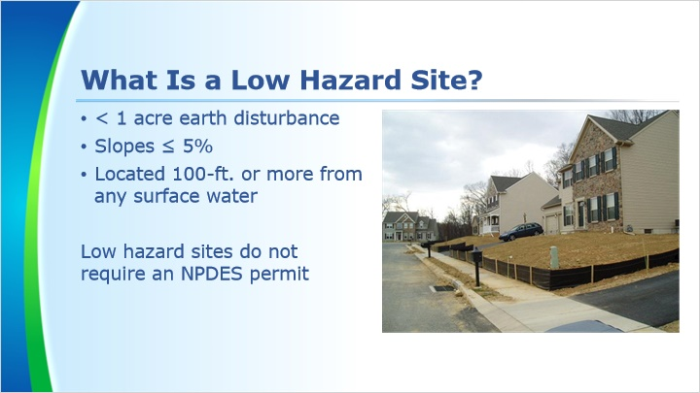
Notes:
Low hazard sites are sites with less than 1 acre of earth disturbance, slopes of 5% or less, and located 100 ft or more from any surface water. These sites do not require an NPDES (National Pollutant Discharge Elimination System) permit.

1.6 When Is a Written E&S Plan Required for Low Hazard Sites?
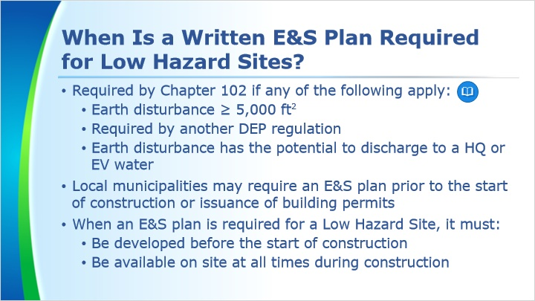
Notes:
Even though NPDES permits are not required for Low Hazard Sites, a written E&S plan is sometimes required.

Chapter 102 requires a written E&S plan for all earth disturbances of 5,000 square feet or more, when it is required elsewhere in another DEP regulation, or when earth disturbances, regardless of size, has the potential to discharge to a High Quality or Exceptional Value water.

Local municipalities may also require the E&S plan to be submitted to them or the local conservation district for review and approval prior to start of construction or issuance of building permits. Therefore, the appropriate agency should be contacted before the plan is developed.

Low hazard sites which require an E&S plan must have it developed before the start of construction and must be available on site at all times during construction.

1.7 How to Develop an E&S Plan for a Low Hazard Individual Lot
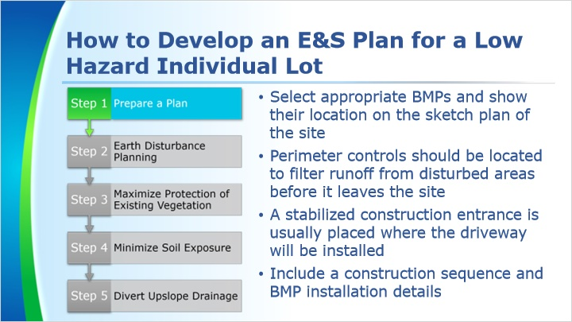
Notes:
The first step in developing a low hazard individual lot E&S plan is to prepare the E&S plan drawing.

Select appropriate perimeter control BMPs (such as compost socks, fiber logs, or silt fence) and a stabilized rock construction entrance. Show their location on the sketch plan of the site.

The compost socks, silt fence or other perimeter control should be located to filter runoff from the disturbed areas before it leaves the site and enters a surface water or storm sewer.

A stabilized construction entrance is usually placed at the location where a driveway will be installed. When properly maintained, this BMP can minimize the tracking of mud from the site by construction vehicles. This will also become the base for a permanent driveway installed near the completion of construction.

A construction sequence on the sketch plan should indicate which BMPs should be installed during the first steps in the project. Details for installation of BMPs are found in the manual. Those details should be included on the sketch plan or the detail sheet.

1.8 How to Develop an E&S Plan for a Low Hazard Individual Lot
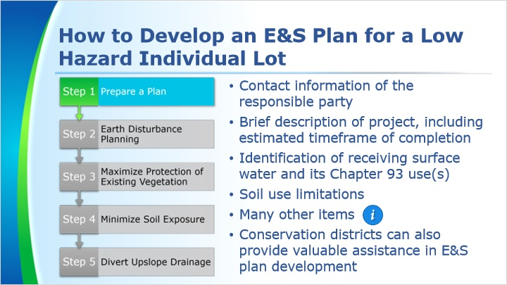
Notes:
The E&S plan should include information such as the name, address, and phone number of the person(s) responsible for the project.

A brief description of the project including the estimated time frame for its installation should also be included. If this information cannot be provided on the sketch plan of the site, a supplemental sheet with this information should be attached.

Published USGS topographic maps should be consulted to determine the name of the nearest stream receiving runoff from the site. If the stream is in a special protection watershed, non-discharge alternatives or ABACT BMPs are encouraged for low-hazard individual lots but not required. Non-discharge alternatives or ABACT BMPs are required for permitted sites in special protection watersheds.

The NRCS website should be consulted to determine what soil use limitations can be expected on the site. A means to deal with those limitations should be included in the E&S plan.

There are many other items that should be included on the E&S plan. Click on the pulsing marker to see a list of some of these items.

The conservation districts can also provide valuable assistance in E&S plan development.

1.9 How to Develop an E&S Plan for a Low Hazard Individual Lot
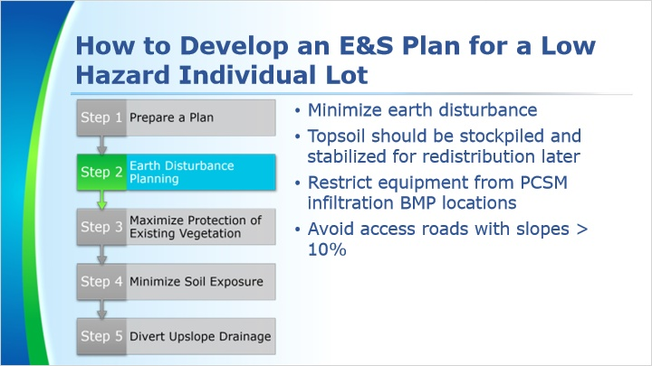
Notes:
The second step in developing a low hazard individual lot E&S plan is to hold the site grading to the minimum necessary for the construction of the desired improvements.

Any topsoil from areas where cuts or fills occur should be stockpiled and stabilized for redistribution after grading to help establish vegetation.

Construction equipment should be restricted from operating over proposed PCSM infiltration BMP locations. Equipment can compact the soils in these areas and negatively effect the infiltration in these areas.

The rate of erosion increases as the slope of the disturbed area increases, Therefore, access roads with slopes greater than 10% should be avoided if possible. Stabilization is also more difficult to achieve on steeper slopes.

1.10 How to Develop an E&S Plan for a Low Hazard Individual Lot
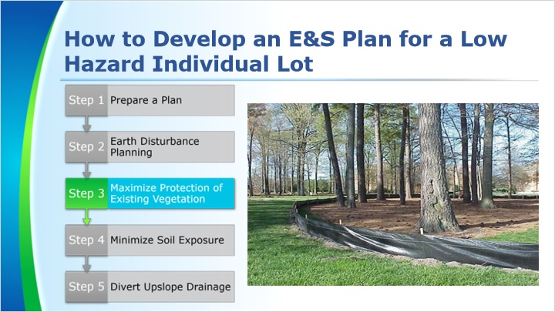
Notes:
The third step in developing a low hazard individual lot E&S plan is to save existing vegetation to the maximum extent possible. Trees are especially important due to their ability to reduce or prevent erosion and provide thermal protection to surfaces. Existing trees and shrubs which will not be removed should be protected from damage during earthmoving operations by clearly marking the limits of disturbance.

1.11 How to Develop an E&S Plan for a Low Hazard Individual Lot
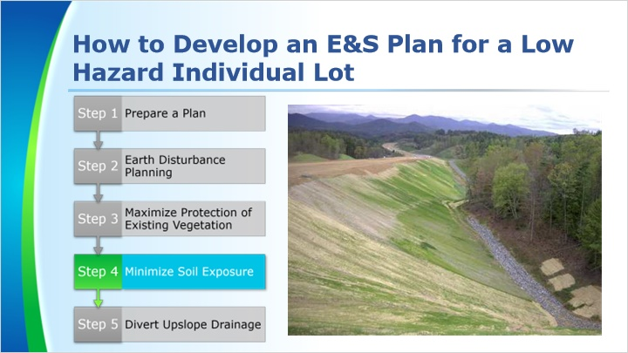
Notes:
The fourth step in developing a low hazard individual lot E&S plan is to minimize the size and time of exposure for areas to be disturbed. The plan should call for restabilizing disturbed areas by seeding, sodding, or paving as soon as possible. Chapter 102 requires disturbed areas, regardless of size, to be permanently stabilized upon reaching final grade and to be temporarily stabilized if there is a temporary stoppage of earth disturbance activity for more than four days. Waiting for an entire phase to reach final grade before seeding and mulching is not acceptable.

This photo shows a fill embankment stabilized with erosion control blankets in 15 ft vertical increments. As you can see in the photo, the lower sections of the fill were blanketed once they reached final grade and are already approaching 70% permanent stabilization.

1.12 How to Develop an E&S Plan for a Low Hazard Individual Lot
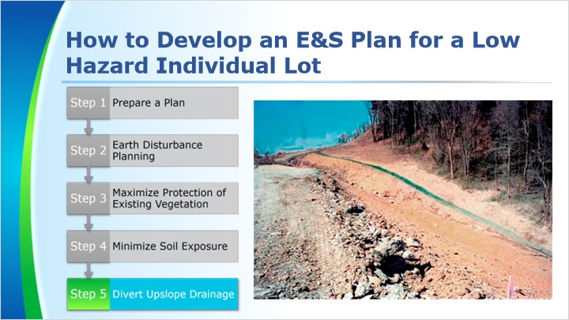
Notes:
The fifth step in developing a low hazard individual lot E&S plan is to divert upslope runoff around work areas wherever possible. If diversion is not practical, the runoff should be conveyed through the area of disturbance in such a way that it is protected from sediment pollution.

As you can see in the photo, a clean water diversion channel was constructed to divert the clean water around the disturbed areas. This practice can also reduce the size and cost of other BMPs such as sediment traps, sediment basins and channels by reducing their drainage areas.

1.13 On-Lot BMPs
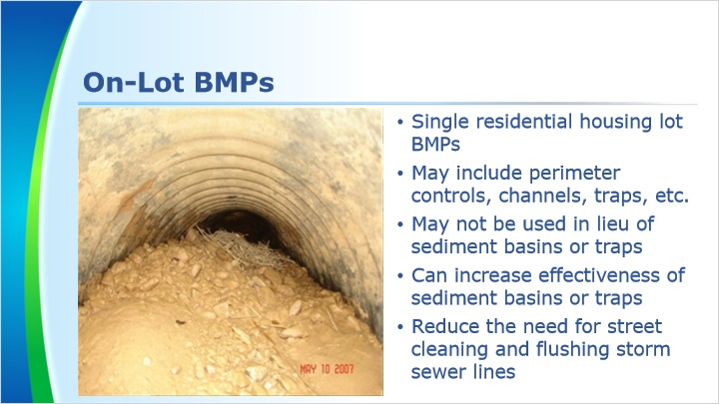
Notes:
The BMPs used to control runoff from disturbed areas on a single residential housing lot during house construction are often referred to as “on-lot Controls.” Depending on the size of the lot & the amount of disturbance, on-lot BMPs may range from sediment barriers to channels and traps.

On-lot BMPs may not be used in lieu of controls such as sediment basins or sediment traps where such facilities are appropriate (for example, a residential housing development). However, on-lot controls can increase the effectiveness of sediment basins and sediment traps by reducing sediment load conveyed to them.

On-lot BMPs can also reduce the need for street cleaning, flushing of storm sewer lines and repairs to adjacent lots damaged by uncontrolled runoff.

1.14 Typical Configurations
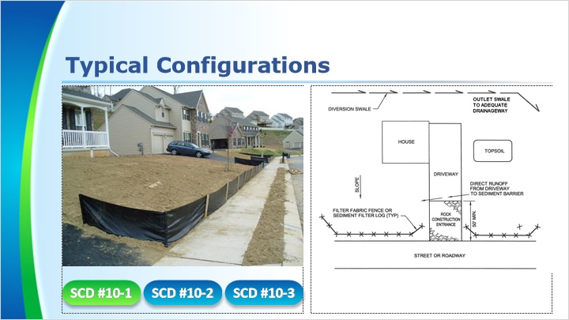
Notes:
Where on-lot BMPs are proposed as part of the overall E&S Plan for a multi-unit housing development, appropriate construction details should be placed on plan drawings.

On larger E&S Plans, it may not be necessary to show the on-lot BMPs on each individual lot on the plan. In most situations the exact home locations are not known during the permitting process and are often determined by the home builder.

STANDARD CONSTRUCTION DETAIL #10-1 can be used for housing developments where the lots slope to the roadway.

STANDARD CONSTRUCTION DETAIL #10-2 can be used for housing developments where the lots slope away from the roadway and to the rear of the lot.

STANDARD CONSTRUCTION DETAIL #10-3 can be used for housing developments where the lots slope to the side of the lot.

These details can be found on pages 257-259 of the manual.

1.15 Summary
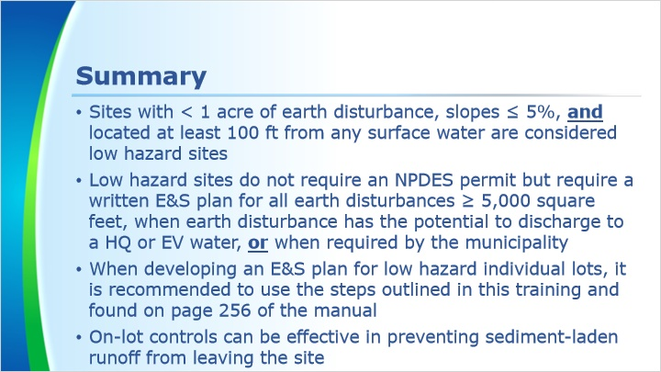
Notes:
This concludes the training. To review, sites with less than 1 acre of earth disturbance, slopes of 5% or less, and located at least 100 ft from any surface water are considered low hazard sites.

Low hazard sites do not require an NPDES permit but require a written E&S plan for all earth disturbances of 5,000 square feet or more, when earth disturbance has the potential to discharge to a High Quality or Exceptional Value water, or when required by the municipality.

When developing an E&S plan for low hazard individual lots, it is recommended to use the steps outlined in this training and found on page 256 of the manual.

On-lot controls can be effective in preventing sediment-laden runoff from leaving the site and entering a storm sewer or surface water.

We will finish the course with a brief knowledge check.
Revision History
05-21-20 | First publication
09-01-20 | Slide 1.8 How to Develop an E&S Plan for a Low Hazard Individual Lot  Original:  If the stream is in a special protection watershed, nondischarge or ABACT BMPs must be used.  Revision:  If the stream is in a special protection watershed, non-discharge alternatives or ABACT BMPs are encouraged for low-hazard individual lots but not required. Non-discharge alternatives or ABACT BMPs are required for permitted sites in special protection watersheds.

