W
atershed Implementation Plans (WIPs) are developed by the seven Chesapeake Bay watershed jurisdictions to help guide their actions as they work to meet the pollutant reduction goals outlined in the Chesapeake Bay Total Maximum Daily Load (Bay TMDL) by 2025. These plans consider such things as ecological restoration and sustainability while allowing for greater transparency and accountability for improved performance. Each Bay jurisdiction is currently developing its third WIP (Phase III) since the Bay TMDL was established in 2010. Phase III WIPs are expected to include the specific steps that each of the seven jurisdictions intends to implement between 2019 and 2025 to meet Bay restoration goals.

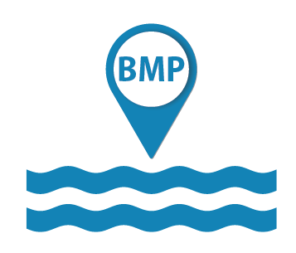
Why are Watershed Implementation Plans developed?
Established in 2010, the Bay TMDL set allocations for major sources of nitrogen, phosphorus and sediment entering the Chesapeake Bay. This represents the maximum amount of those pollutants that can enter the Bay while still meeting water quality standards. To meet the allocations specified by the Bay TMDL, jurisdictions needed to make an overall reduction of 25 percent of nitrogen, 24 percent of phosphorus and 20 percent of sediment entering the Chesapeake Bay.
Keeping WIP Progress on Track
Under the Bay TMDL, Bay jurisdictions and the U.S. Environmental Protection Agency (EPA) agreed to develop short-term goals, called two-year milestones, to check in on the progress.
A 2017 midpoint assessment was conducted to review progress toward meeting pollutant load reductions identified in the Bay TMDL, Phase I and Phase II WIPs, and two-year milestones. The midpoint assessment looked at each jurisdiction’s final 2016–2017 milestones and 2017 progress data to determine if the jurisdictions had the necessary practices in place to achieve 60 percent of the reductions. The data and feedback gathered during the midpoint assessment is helping jurisdictions prepare their Phase III WIPs.
These pollutant allocations were divided across the seven Chesapeake Bay jurisdictions—Delaware, the District of Columbia, Maryland, New York, Pennsylvania, Virginia and West Virginia—and were set using state-of-the-art modeling tools, extensive monitoring data and peer-reviewed science.

The seven watershed jurisdictions prepare WIPs that outline detailed, specific steps they will take by 2025 to reduce their loads. The Phase I WIPs supported the development of the Bay TMDL. The Phase II WIPs further refined the Phase I WIPs based on additional scientific information and outreach to local communities.

What are Phase III WIPs?
In 2019, the seven Bay watershed jurisdictions developed Phase III WIPs that provide more information on what actions the jurisdictions and their local partners and stakeholders intend to implement between 2019 and 2025 to meet their pollutant reduction goals. The Phase III WIPs consider the results of the Bay TMDL midpoint assessment as well as future population growth based on estimates of how the land in the Chesapeake Bay watershed will be used in 2025. If jurisdictions need to update their commitments during the 2019–2025 timeframe, they can do so via their two-year milestones.

What elements must be included in the Phase III WIPs?
In June 2018, EPA provided expectations for the jurisdictions’ Phase III WIPs to maintain accountability, encourage continued adaptive management to the new information generated during the Bay TMDL midpoint assessment, and lay the groundwork for implementation of the next generation of innovative practices. These expectations are directed towards ensuring the CBP partnership and the public have confidence that the seven jurisdictions and their local and federal partners are committed to put in place the funding, technical assistance, policy, programmatic, legislative, and regulatory infrastructures necessary to achieve their 2025 target goals.
The seven jurisdictions agreed to describe in their respective Phase III WIPs how they, in collaboration with local and federal partners, will:
- Specify the programmatic and numeric implementation commitments between 2019 and 2025 needed to achieve their 2025 goals.
- Commit to comprehensive strategies for engagement of the full array of their local, regional, and federal partners in WIP implementation.
- Account for changing conditions due to climate change, Conowingo Dam infill, all population growth, and changes in land uses—and offset all resultant new or increased pollutant loads.
- Consider adjusting their existing source sector goals to factor in the new information developed through the Bay TMDL’s midpoint assessment.
- Develop and implement local planning goals at the scales and in the form best suited for directly engaging local and federal partners in WIP implementation.

Ensure local engagement during Phase III WIP process
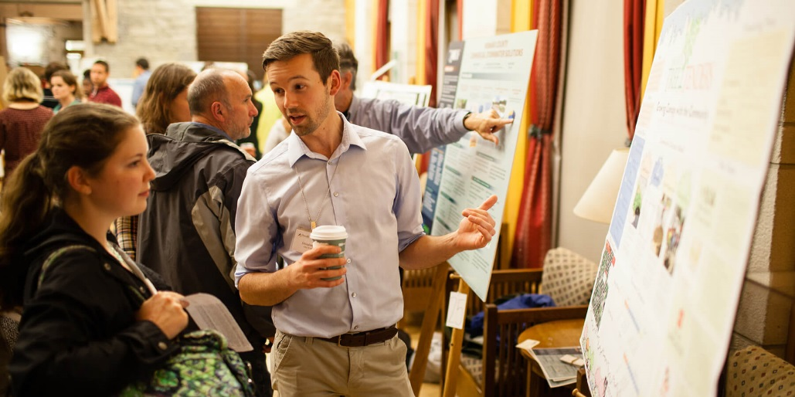
Jurisdicitions are expected to carry out WIP development and implementation in partnership with federal agencies, regional and local governments, non-governmental organizations and the private sector, including businesses, farmers and individual citizens. The Phase III WIP should clearly document how local, regional and federal partners will be engaged in implementation.
Photo: Will Parson/Chesapeake Bay Program

View Phase III WIP information at
https://www.chesapeakebay.net/what/programs/watershed_implementation

