FOR IMMEDIATE RELEASE  Date: (insert date) | Contact: Carla Coordinator  Telephone: (987) 654-3210  E-mail: carla.coordinator@county.gov  Website: www.localcounty.gov

NEWS: Cost Share Program Makes Planting a Native Garden Affordable
Project provides low-cost native plants in support of community gardens

(YOUR COUNTY, Pennsylvania) The YOUR COUNTY Clean Water Partnership is now accepting orders for it’s 2nd annual native plant cost-share program. This program provides native plants to schools, community organizations, municipalities and residents within YOUR COUNTY at low cost. The program is supported by a grant from the Sweet Citizen Foundation and county stormwater fees.

“Last year I purchased several plants to attract butterflies to my yard,” said Betty Buglover. “My garden was so successful at attracting them, that I told my neighbor about it, and she's here today with me to pick up some plants for her yard, too.”

There are more than 100 native plants to choose from. They include plants that attract butterflies, bees, hummingbirds and other pollinators. Rain garden kits are also available. If you need help selecting plants to fit your landscaping needs, volunteers are on hand to help out.

Plants are $$ each. Program details and order forms are available online at www.YOURCOUNTY.gov/NATIVE PLANTS. All orders must be received no later than PICK YOUR DATE. Plants will be available for pickup at PICK UP ADDRESS on PICK YOUR DATE.

“Our community center ordered three rain garden kits. We plan to plant two on our property and one at a local school,” said Chris Communityleader. “We have some minor parking lot flooding issues we hope the rain garden will help with. The school will use the garden to teach children about rain gardens and the importance of native plants.”

Last year over 1,000 native plants were distributed to homeowners, municipalities, schools and non-profit organizations in YOUR COUNTY. This year, we expect to double that amount. This is good news for our community, as well as, the birds, butterflies, caterpillars and bees that depend on native plants.

YOUR COUNTYWIDE ACTION PLAN’S mission/goal is to protect and improve waterways throughout YOUR COUNTY. YOUR COUNTYWIDE ACTION PLAN TEAM provides resources for best management practices, and technical support. YOUR COUNTYWIDE ACTION PLAN TEAM is supported by a County Clean Water Coordinator.

Plant Distribution Event Photos Available Below and Upon Request.
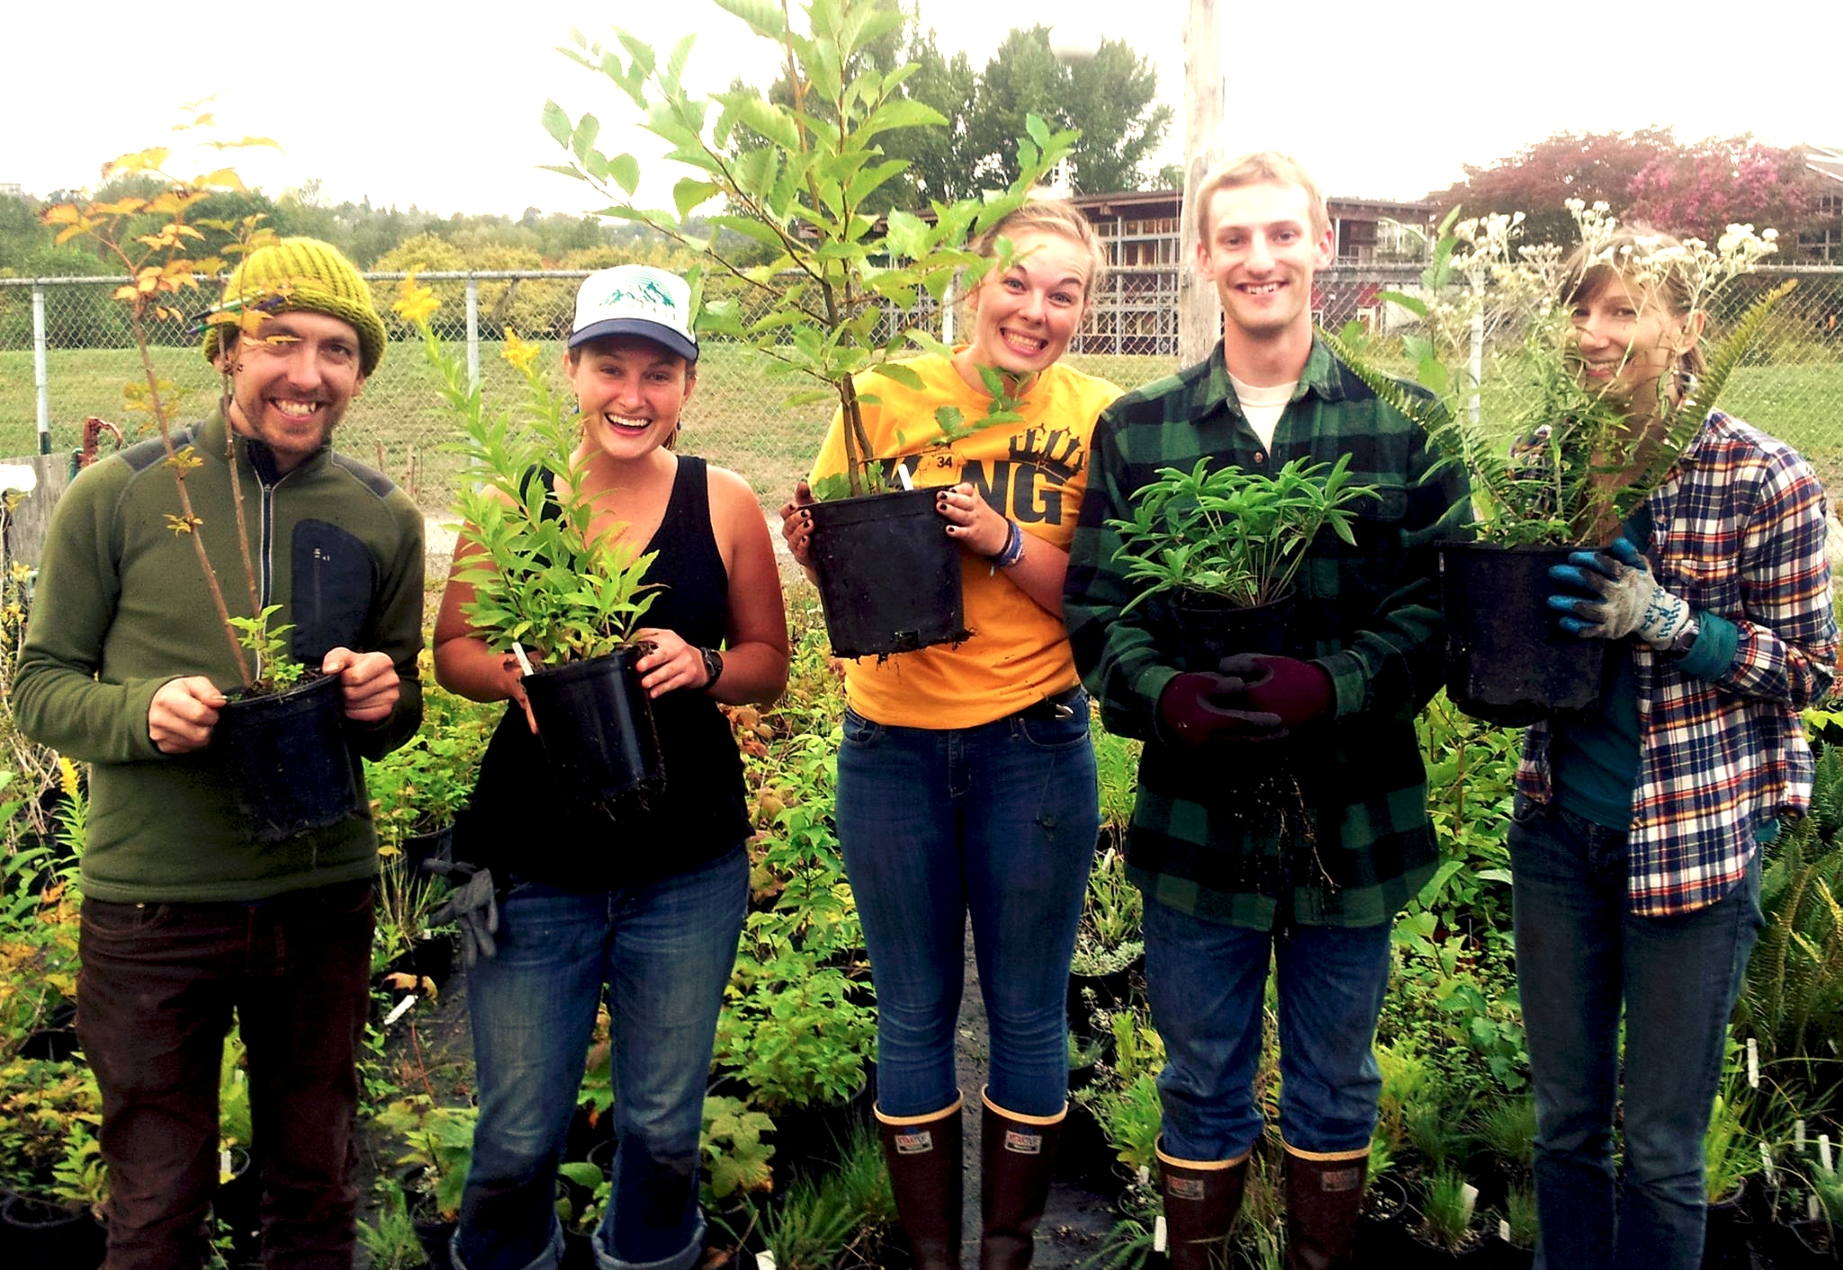
A group of students selecting plants for an on-campus native plant garden.

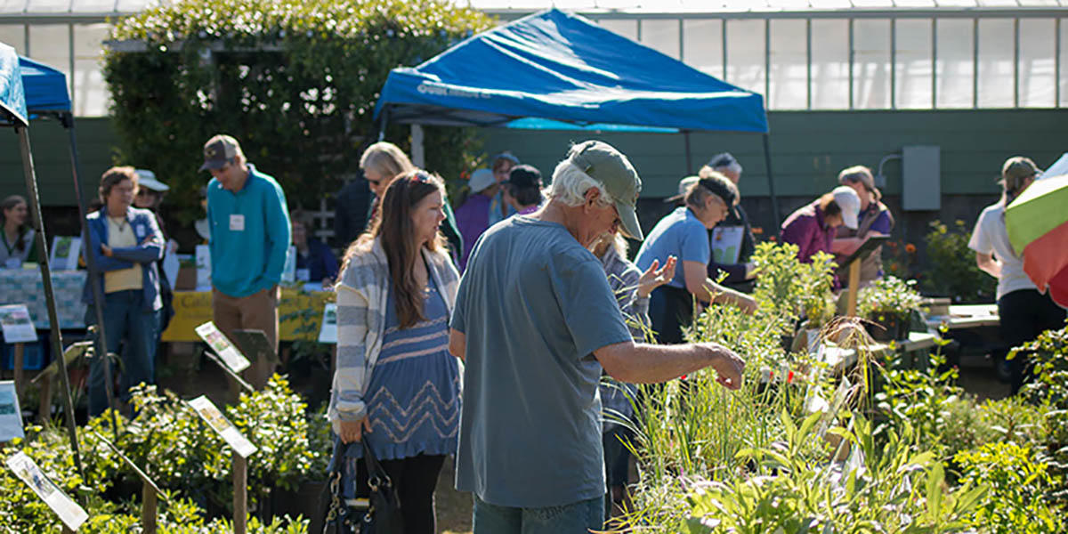
Native plant cost share program participants selecting plants for their gardens.

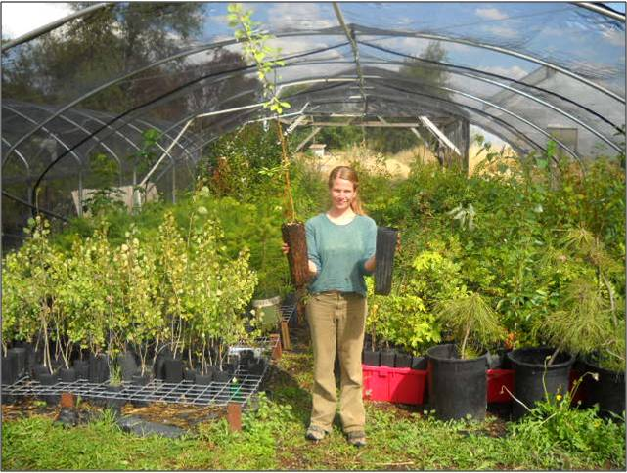
Carla Coordinator helping set up for the annual native plant cost share program plant distribution day.

###

Contact Carla Coordinator at (987) 654-3210 or carla.coordinator@county.gov

