FOR IMMEDIATE RELEASE  Date: (insert date) | Contact: Carla Coordinator  Telephone: (987) 654-3210  E-mail: carla.coordinator@county.gov  Website: www.localcounty.gov

NEWS: Cost Share Program for Farmers Makes Going Green Affordable
Agricultural cost share program supports farm conservation practices

(YOUR COUNTY, Pennsylvania) The YOUR COUNTY Clean Water Partnership is now accepting applications for its agricultural conservation practices cost-share program. This program provides funds to help agricultural land owners with the cost of installing conservation practices on farmlands. YOUR COUNTY Clean Water Partnership administers this program to help clean up local waters and reduce soil erosion. Funding is provided by YOUR COUNTY and OTHER PARTNER(S).

“My farm needed a manure management plan. I heard about this program at a local Conservation District workshop last year,” Said Farmer Frank. “I wasn’t sure if it would help cover the cost of that, so I called for more information. Turns out, this is something the program covers, and now I am in compliance.”

Landowners interested in learning how agricultural best management practices can help improve crop yield, reduce farming costs, and reduce soil erosion are encouraged to contact YOUR COUNTY Clean Water Partnership to discuss the possibility of receiving county financial assistance. This year’s application deadline is DATE. Funding is intended to support practices such as livestock exclusion fencing, riparian buffers, livestock water supplies, manure management and fuel pads. Applicants are not guaranteed cost-share financial assistance.

“Farmers who aren’t familiar with the cost-share program may think it is difficult to apply for, with lots of paperwork. Or, they’re concerned the conservation practices will cost too much and impact their operations,” says Brian Bestintentions of Family Farm. “That wasn’t our experience. Our farm added several conservation practices over the last three years with support of the cost share program. Applying was easy, and the program kept the BMP installation costs low.”

Following the application deadline each request is carefully reviewed. The proposed project is ranked according to a system developed by YOUR COUNTY Clean Water Partnership. The ranking system ensures fairness to landowners and ensures cost-share funds are used to meet local clean water and soil erosion priorities. Approved applicants are notified of the estimated amount of cost-share that will be provided. Before the work can begin the contract has to be approved by YOUR COUNTY and must be signed by the landowners.

“I encourage anyone who’s interested in the cost share program to give me a call,” says Carla Coordinator for YOUR COUNTY Clean Water Partnership. “I’m happy to answer any questions they may have and help them get started on the application. Most farmers find that the program is a great way to get financial help solving ongoing problems they’ve been having on the farm.”

YOUR COUNTYWIDE ACTION PLAN’S mission/goal is to protect and improve waterways throughout YOUR COUNTY. YOUR COUNTYWIDE ACTION PLAN TEAM provides resources for best management practices, and technical support. YOUR COUNTYWIDE ACTION PLAN TEAM is supported by a County Clean Water Coordinator.

Cost Share Project Photos Available Below and Upon Request.

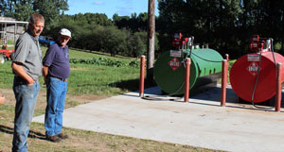
Farmer Frank stands proudly in front of his new fuel pad.

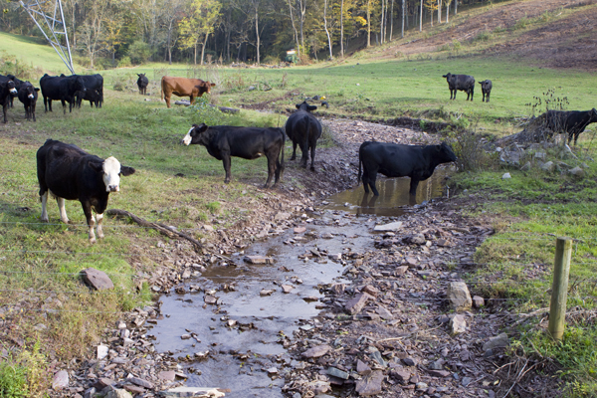
Cows in the creek before exclusion fencing installed on Cattle Ranch.
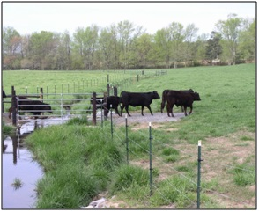
Cows walking over the creek after exclusion fencing installed on Cattle Ranch.

###

Contact Carla Coordinator at (987) 654-3210 or carla.coordinator@county.gov

