Post #9: Profile of an exceptional land/water steward


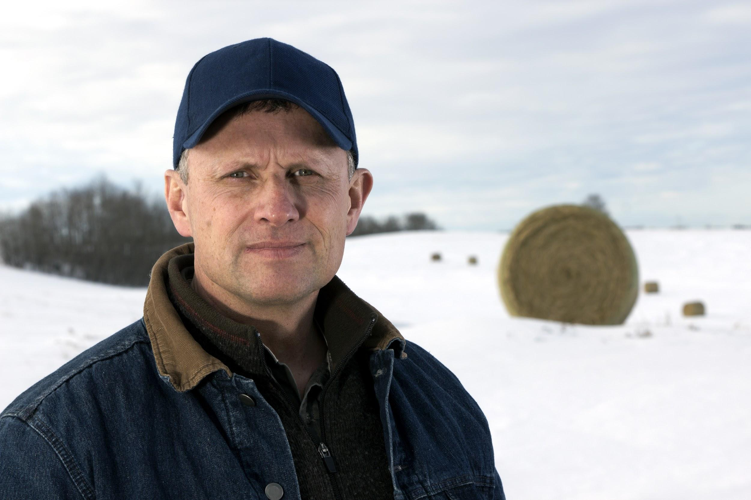
Do you know Joe? Joe Smith is an #OurCounty farmer who has improved his farm and done more than his fair share to be a good neighbor to everyone downstream. To learn more about what he did and how, visit www.ourcounty.org.

