Post #8: Event Invitation


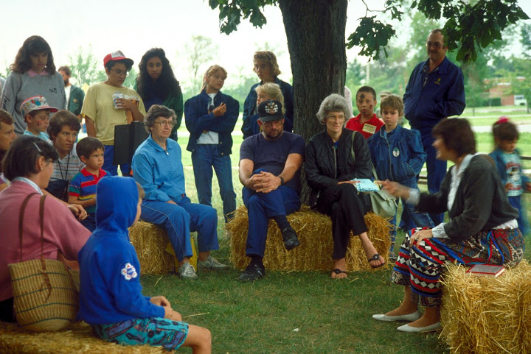

You’re invited! #OurCounty’s partners at the #OurCounty Conservation District are hosting a workshop on Wednesday, DATE/TIME, to explain how they can help area farmers develop their required manure management and conservation plans. Learn more at www.countyconservationdistrict.org.

