Post #7: Personal Behavior Tip (Pet waste, fertilizer, etc.)


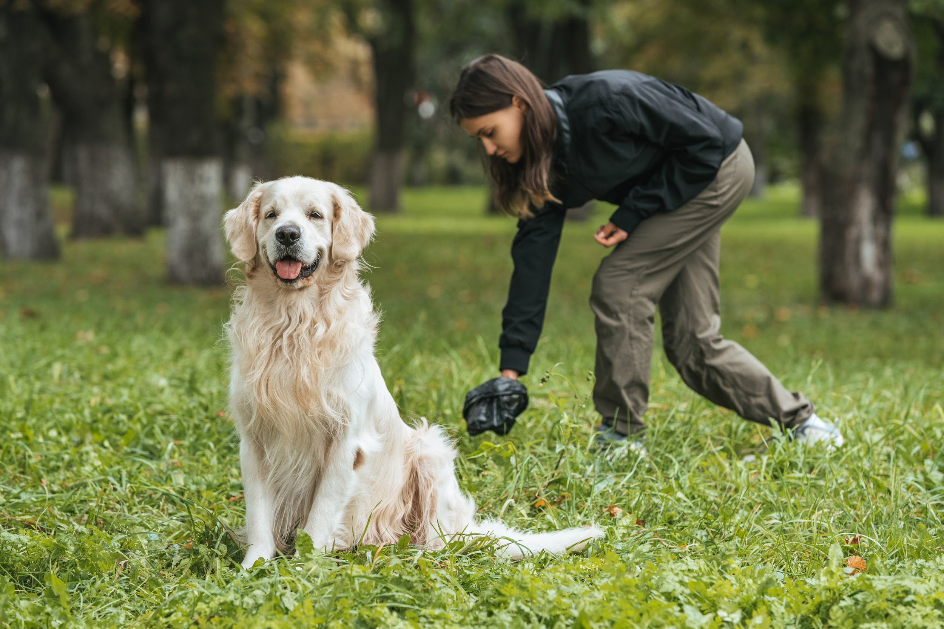
What’s she doing? The right thing! Picking up after your pet is what good neighbors do, and it’s the solution to poo-lution in our #OurCounty streams. For more clean water tips, visit www.ourcounty.org.

