Post #6: Announcing filing of annual report with highlights of accomplishments


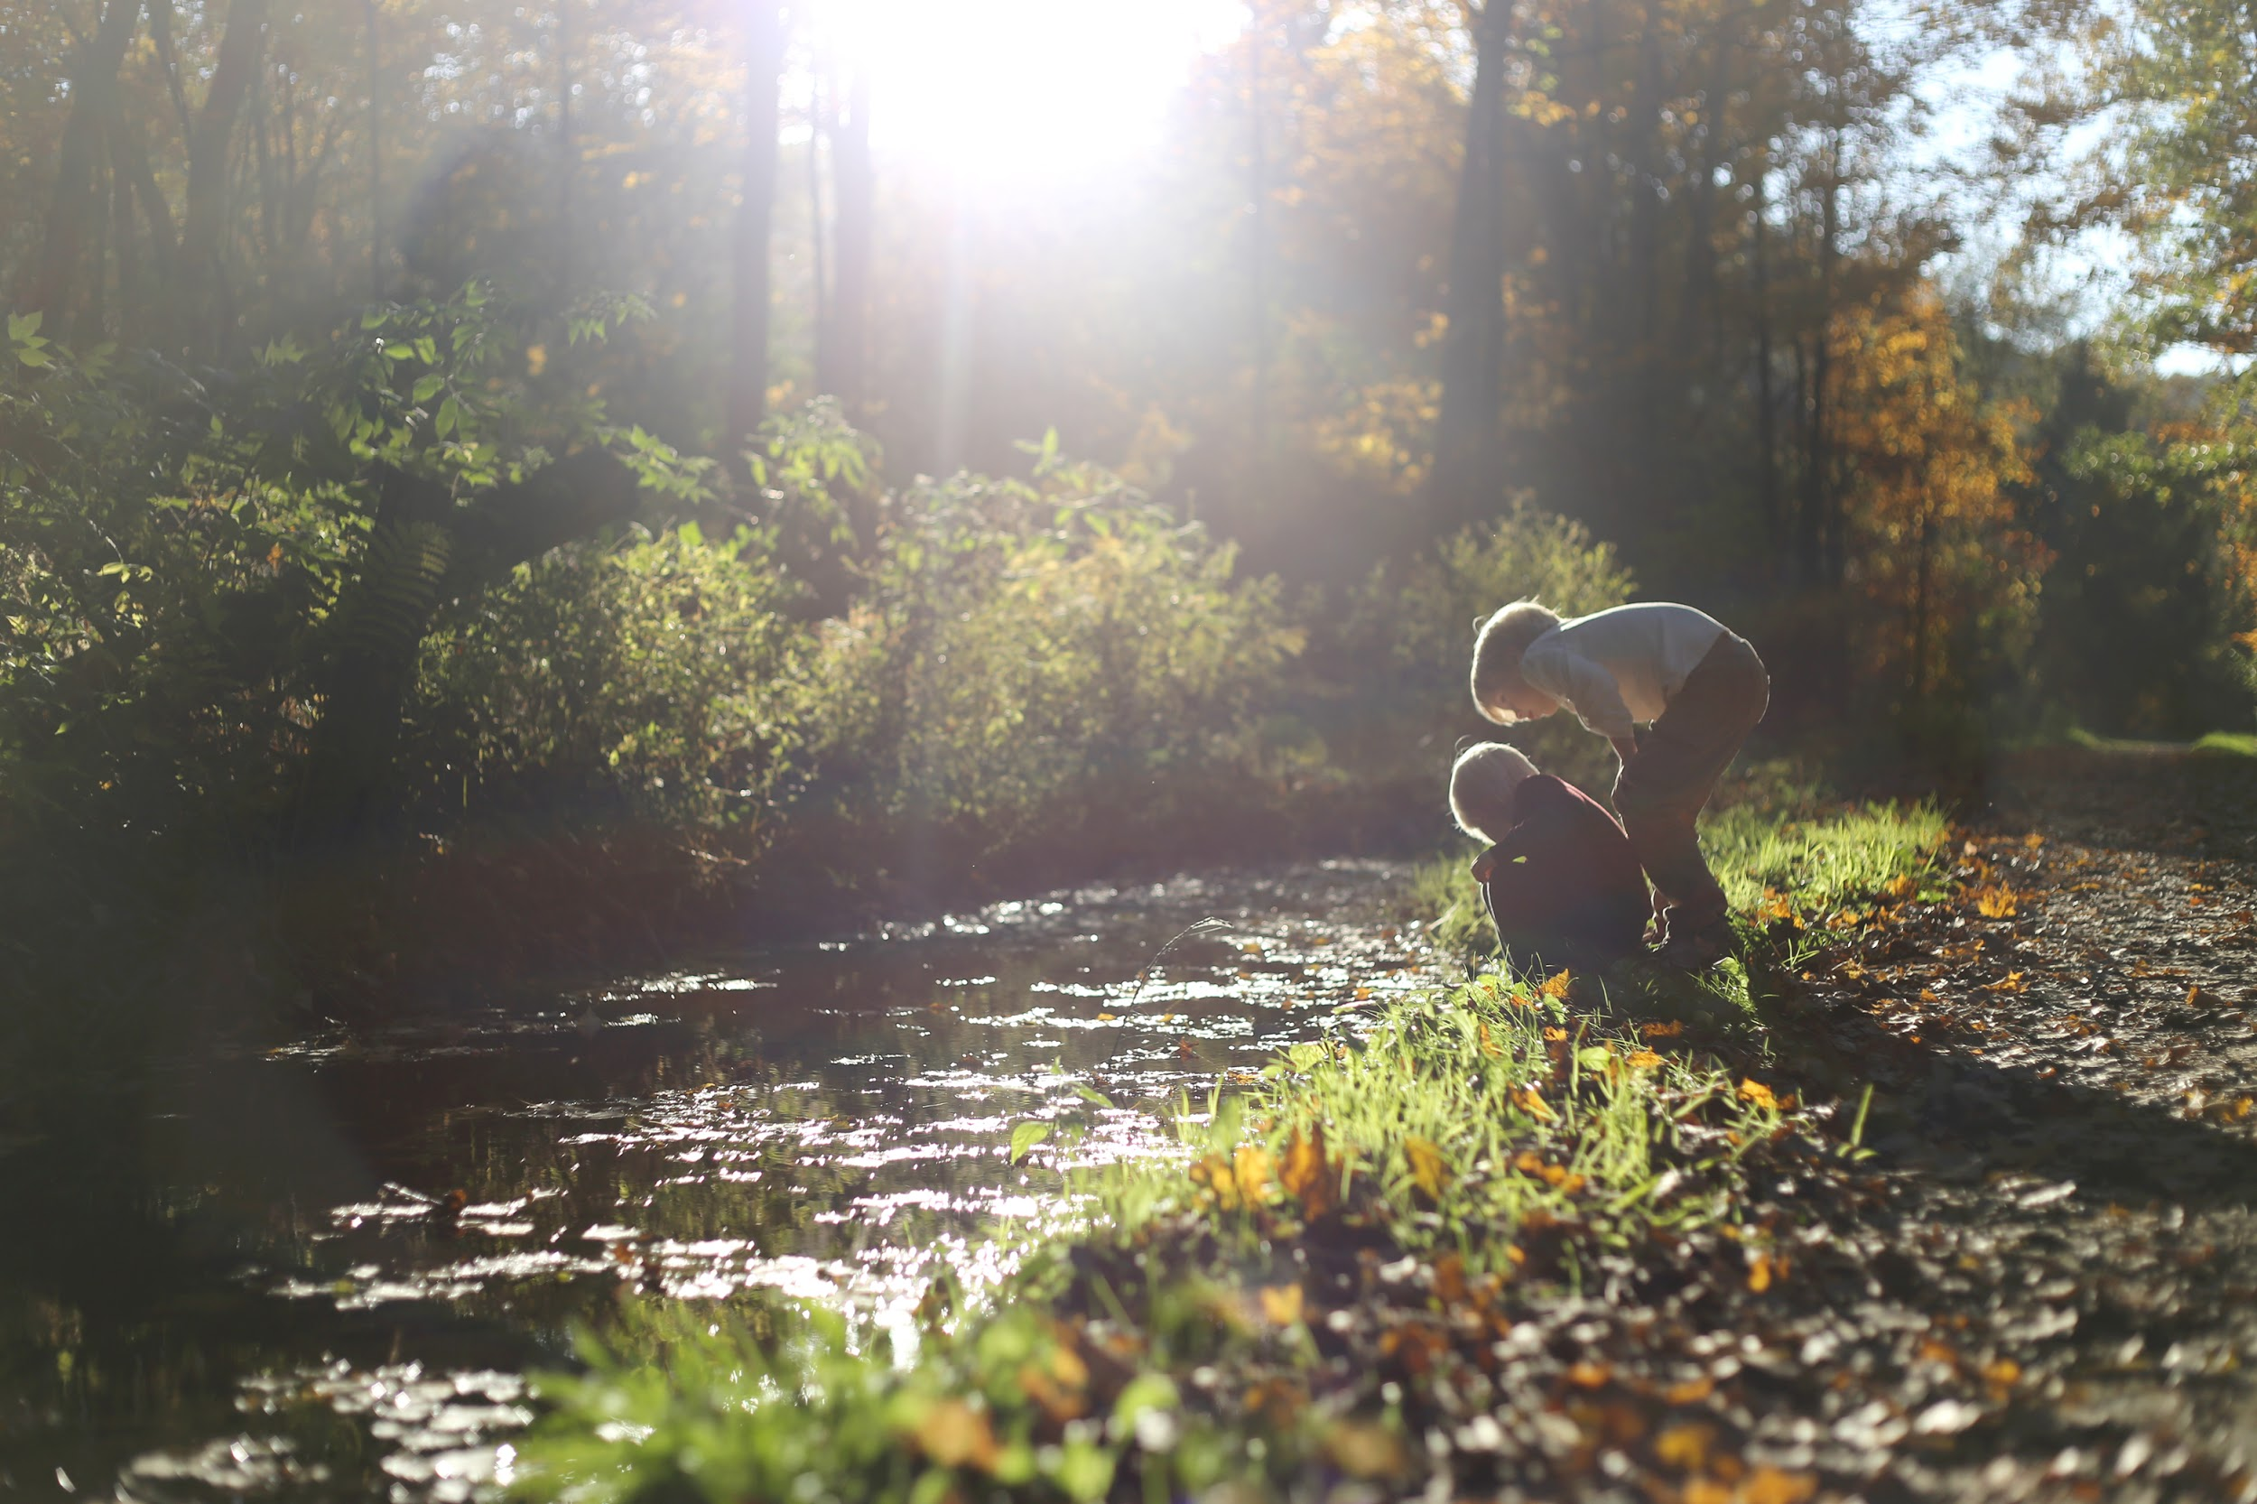
#OurCounty is making progress towards a cleaner future! We published our annual clean water action plan report today, summarizing our clean water accomplishments this year. Residents can download and review the report themselves and also get involved at www.ourcounty.org.

