Post #5: Inviting property owners to apply for cost-share/technical assistance


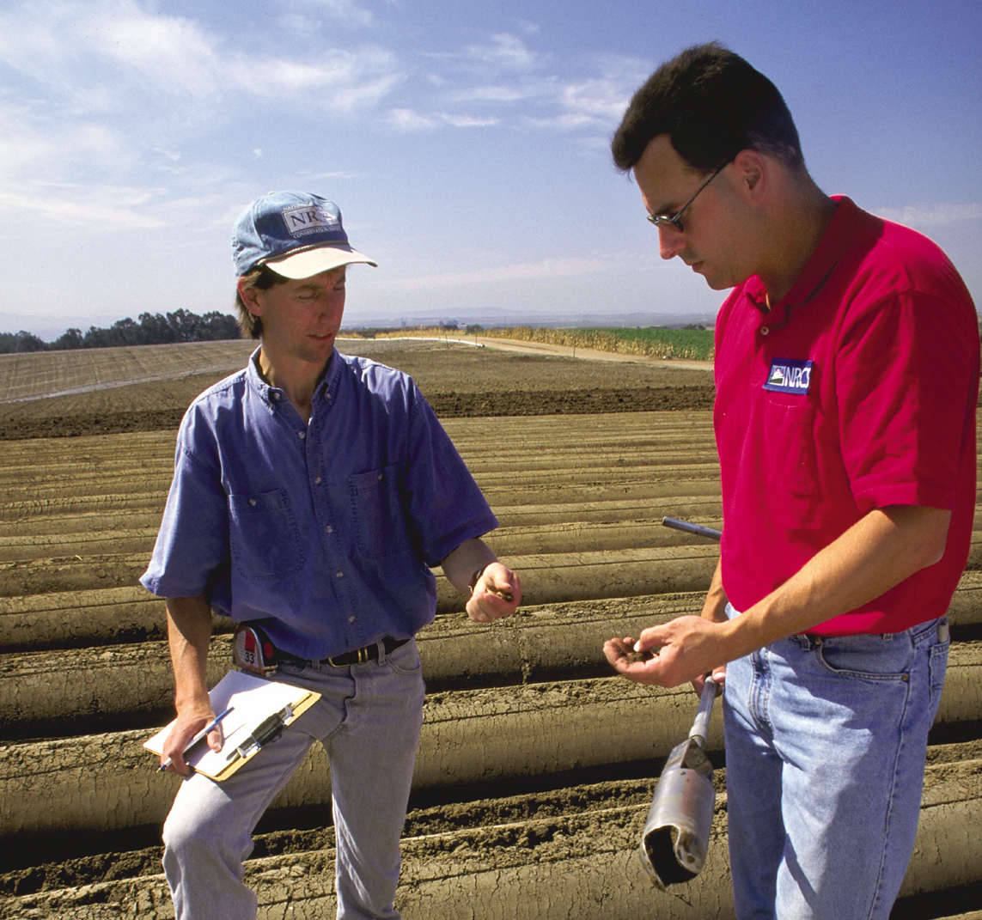
Calling all farmers! #OurCounty reminds you that the NRCS is now accepting applications for cost-share programs to help you protect your cattle from waterborne diseases, improve your soil, and make other improvements on your land. Learn more at www.nrcs.gov.

