Post #4: Regulation Reminder


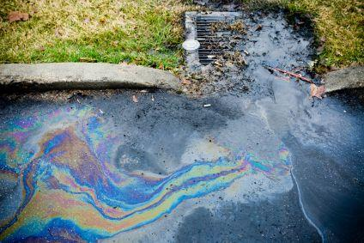

#OurCounty reminds local business owners that county regulations require annual inspection and repair of catchbasins, storm drains, and other water management features on parking lots. It’s the right thing to do because it prevents floods and water pollution! Learn more at www.ourcounty.org.

