Post #2: Announcing a BMP/restoration project groundbreaking


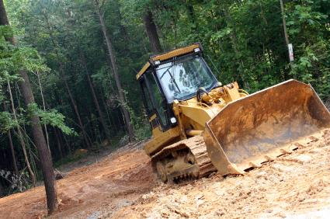

Please pardon our dust, but this is what a great start looks like! #OurCounty started work this week on a major restoration project along Piney Run Creek. When complete, residents will enjoy 10 acres of improved parkland, and the project will help reduce water pollution and flooding.

