County Action Plan Social Media Posts

Post #1: Announcing the formation of action teams, calling for volunteers and leaders




Ready to roll up your sleeves? Get your feet wet? #OURCOUNTY is seeking volunteers to serve on our clean water action plan team. Commit to one meeting and one followup assignment per month and enjoy the feeling of making a difference! Learn more at www.ourcounty.org

Post #2: Announcing a BMP/restoration project groundbreaking

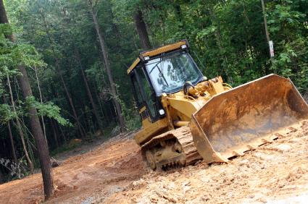

Please pardon our dust, but this is what a great start looks like! #OurCounty started work this week on a major restoration project along Piney Run Creek. When complete, residents will enjoy 10 acres of improved parkland, and the project will help reduce water pollution and flooding.

Post #3: BMP completion before/after

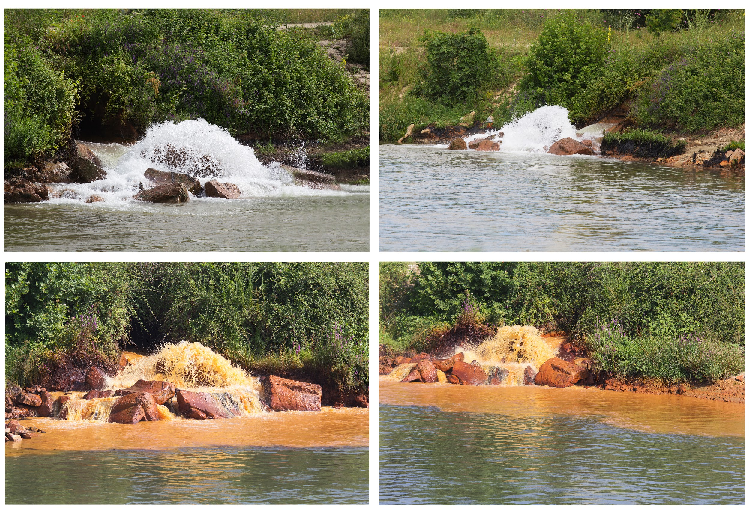

Dirty water before, but clean water after. #OurCounty celebrates the successful repair of three miles of storm sewer system in the Piney Branch neighborhood. Funded in part by a state Growing Greener grant, this project took 18 months from start to finish.

Post #4: Regulation Reminder

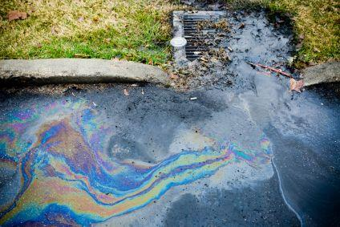

#OurCounty reminds local business owners that county regulations require annual inspection and repair of catchbasins, storm drains, and other water management features on parking lots. It’s the right thing to do because it prevents floods and water pollution! Learn more at www.ourcounty.org.

Post #5: Inviting property owners to apply for cost-share/technical assistance

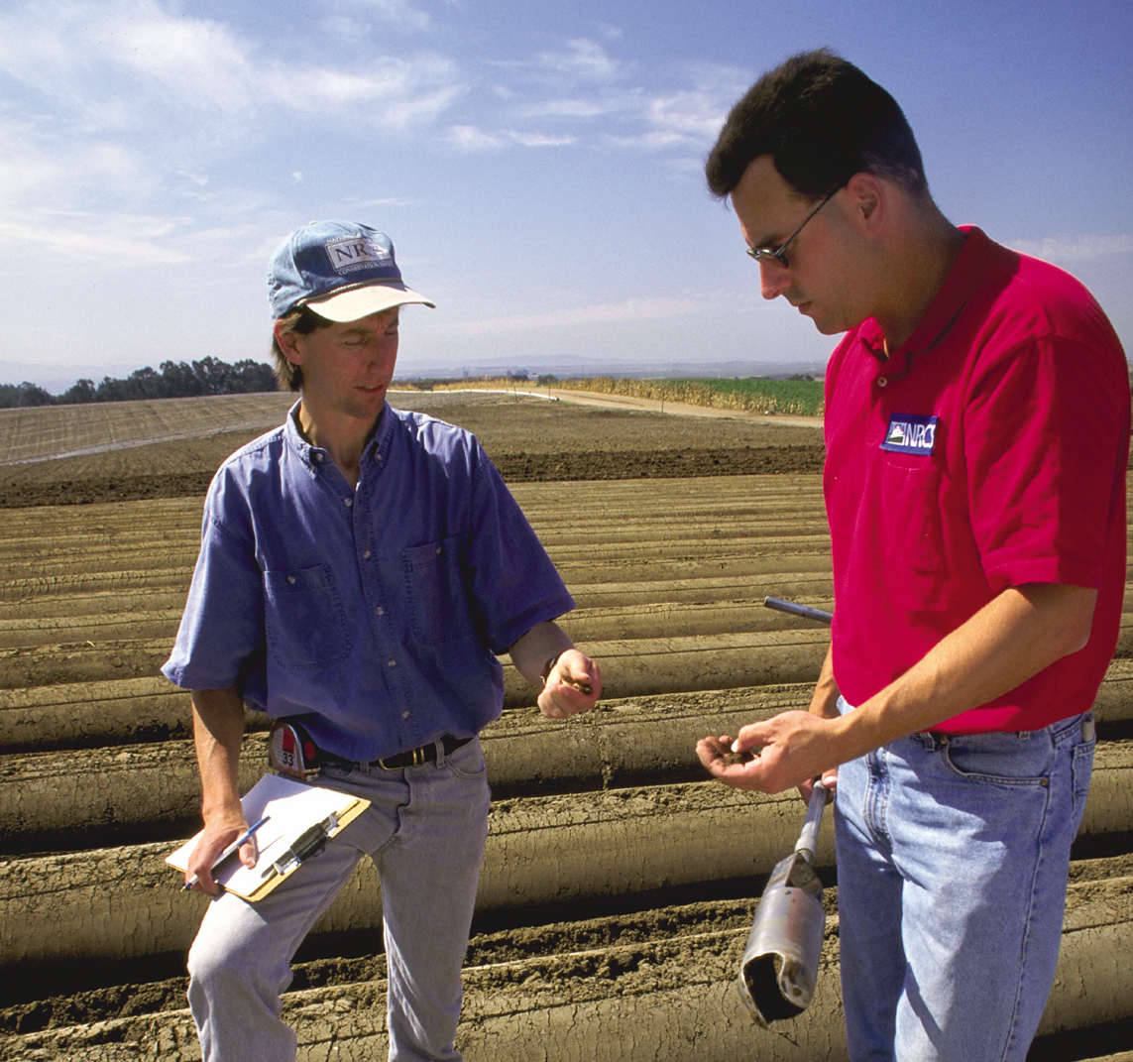
Calling all farmers! #OurCounty reminds you that the NRCS is now accepting applications for cost-share programs to help you protect your cattle from waterborne diseases, improve your soil, and make other improvements on your land. Learn more at www.nrcs.gov.

Post #6: Announcing filing of annual report with highlights of accomplishments

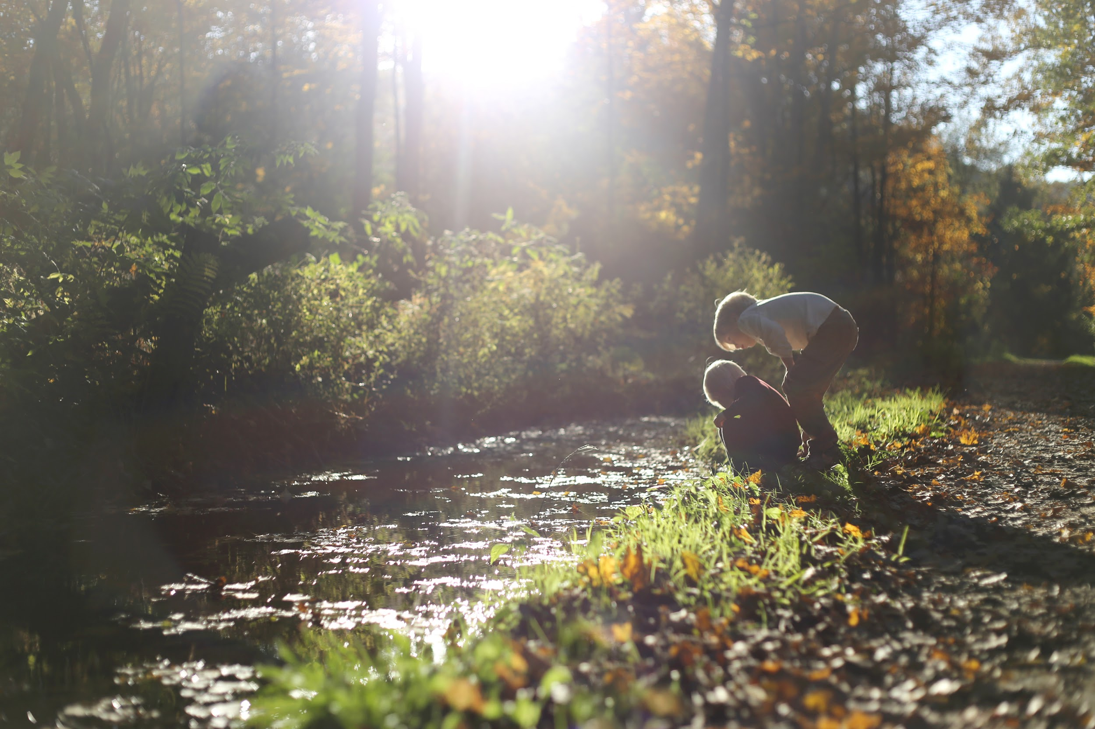
#OurCounty is making progress towards a cleaner future! We published our annual clean water action plan report today, summarizing our clean water accomplishments this year. Residents can download and review the report themselves and also get involved at www.ourcounty.org.

Post #7: Personal Behavior Tip (Pet waste, fertilizer, etc.)

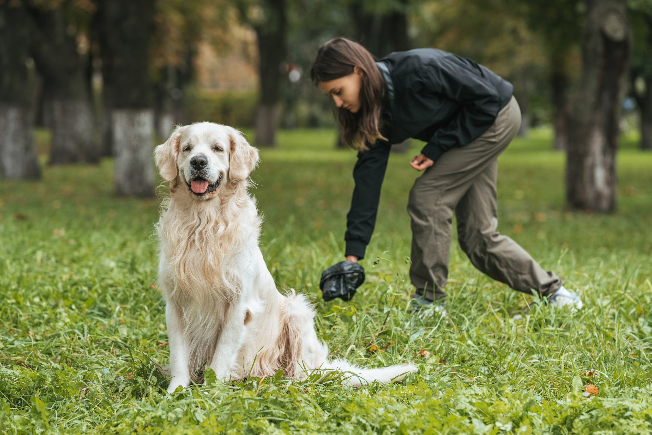
What’s she doing? The right thing! Picking up after your pet is what good neighbors do, and it’s the solution to poo-lution in our #OurCounty streams. For more clean water tips, visit www.ourcounty.org.

Post #8: Event Invitation

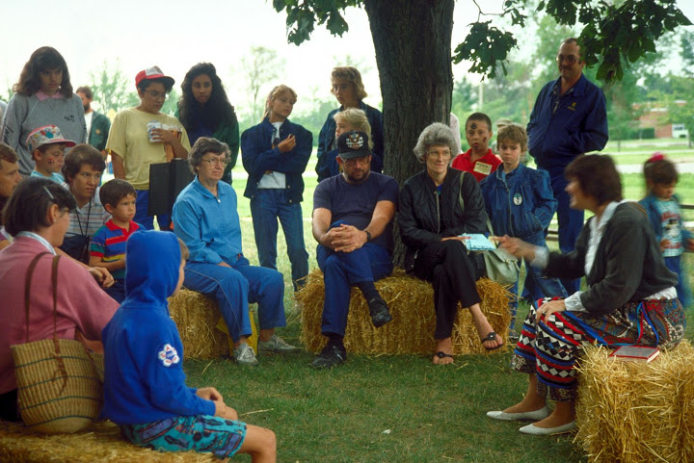

You’re invited! #OurCounty’s partners at the #OurCounty Conservation District are hosting a workshop on Wednesday, DATE/TIME, to explain how they can help area farmers develop their required manure management and conservation plans. Learn more at www.countyconservationdistrict.org.

Post #9: Profile of an exceptional land/water steward

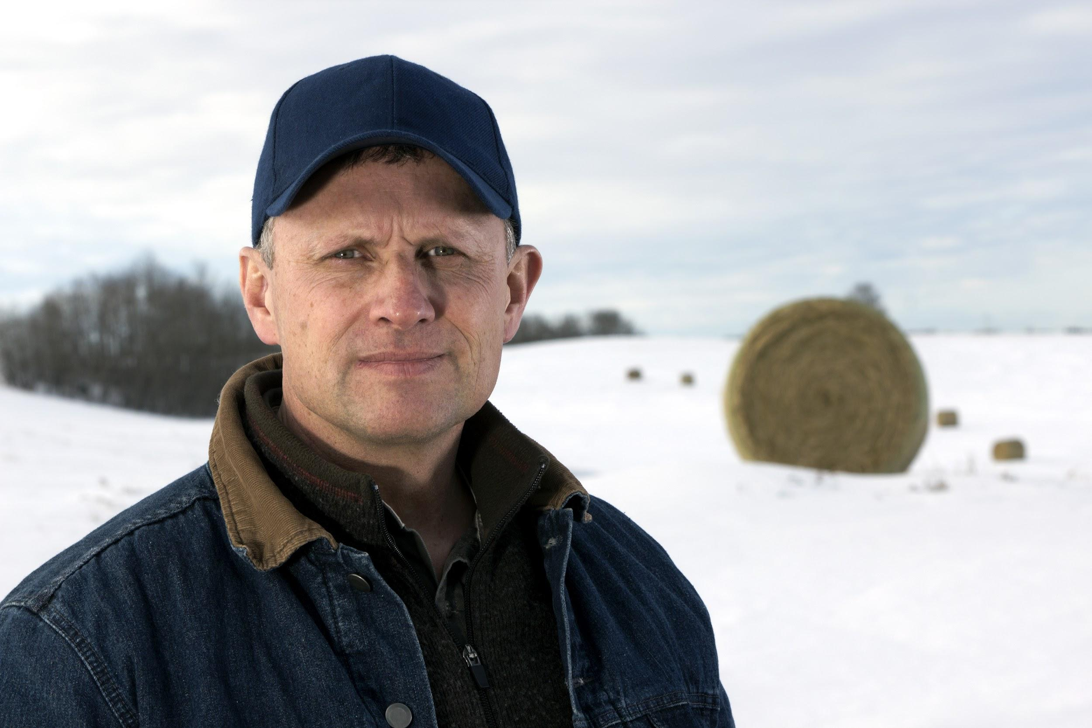
Do you know Joe? Joe Smith is an #OurCounty farmer who has improved his farm and done more than his fair share to be a good neighbor to everyone downstream. To learn more about what he did and how, visit www.ourcounty.org.

Post #10: Stream of the Month (Short profiles of the best and worst)

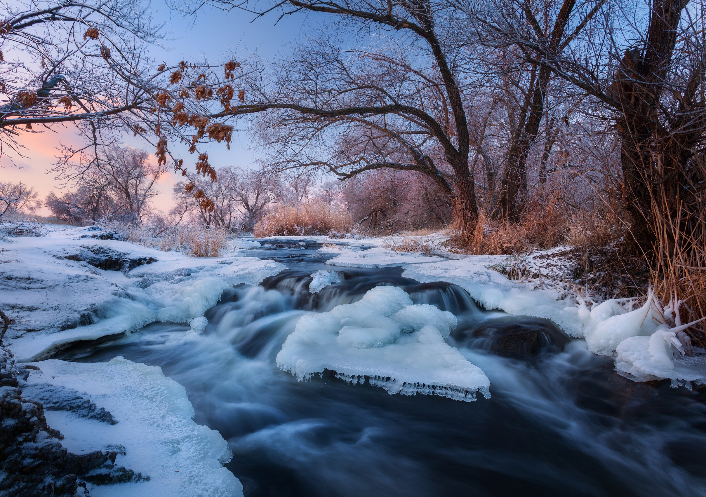

This beautiful photo of Piney Run Creek was taken at Mason District Park this morning. It’s our stream of the month! #OurCounty is working diligently to improve our waterways so residents can enjoy scenes like this in more places.

Post #11: Stakeholder Testimonial (Water utility rep., park ranger, B&B owner, about importance of clean water)


“My job is to deliver clean, safe water to your home,” says John Doe with #OurCountyWaterAuthority. John serves on the #ourcounty clean water action team. Will you join us? Learn more about rewarding volunteer opportunities at www.ourcounty.org.

