Email Subject Line: YOUR COUNTY Success Story: Green Stream Restoration

Fred Farmer has been farming corn, and raising cattle on Friendly Farm for over 50 years. One day, he hopes to pass the operation on to his children. It’s a lot of work running a farm, but for Fred it’s a labor of love.

Green Stream flows through the heart of Friendly Farm. It has always served the family well, providing plenty of water for the crops and livestock. Several years ago, Fred noticed some streambank erosion. To solve this problem, Fred worked with YOUR COUNTY’s Clean Water Partners to restore 1,000 feet of streambank.

“I’ve been watching my pasture slide into the stream for years, but I never knew what to do about it,” said Fred Farmer, owner of Friendly Farms. “I feel great knowing that my soil will stay put and my kids won’t have to deal with this when they take over the farm.”

The project does double duty, by solving erosion troubles for Frank while also reducing flood and water pollution problems for downstream neighbors. Volunteers stabilized the streambank using natural methods and planted hundreds of trees. They also installed 1,500 feet of fencing to protect the area from livestock.

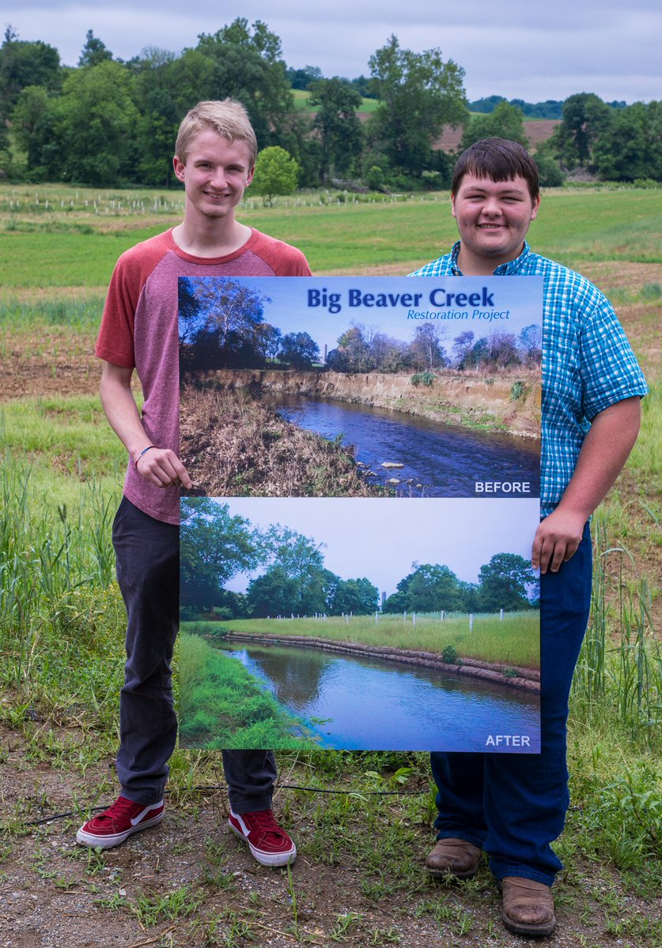
Fred Farmer’s boys Guy and Fred Jr show before and after images of Green Stream.

Teamwork was a big part of the project. Friendly Farms approved the project and provided matching funds. YOUR COUNTY provided cost-share and technical assistance. Local Construction stabilized the stream bank. Volunteers planted the trees.

“We can already measure how the water downstream of the site is cleaner than water upstream,” said Carla Coordinator with YOUR COUNTY. “As the trees mature, the stream will improve even more.”

“We cherish our rural lifestyle here in YOUR COUNTY,” said Councilman Steve Slicktalker. “This project shows how farmers and our conservation community can work together to make a difference for everyone.”

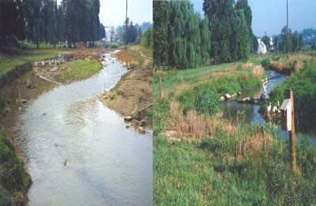
Green stream before and after restoration.

To learn more about this project or the program that funded it Contact Carla Coordinator at (987) 654-3210 or carla.coordinator@county.gov

