Email Subject Line: Order Low Cost Native Plants Before DATE

The YOUR COUNTY Clean Water Partnership is accepting orders for it’s 2nd annual native plant cost-share program. Submit your order now, quantities are limited and they go fast!

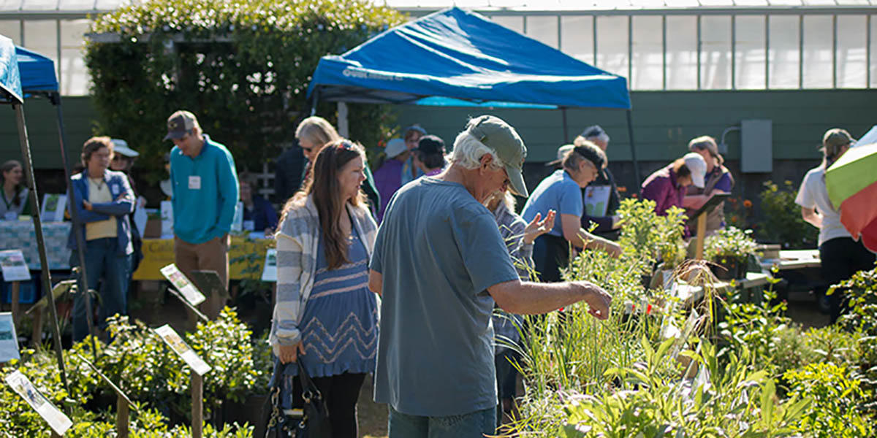
Native plant cost share program participants selecting plants for their gardens.

The native plant cost share program is an example of your stormwater fees at work. The program partners with the Sweet Citizen Foundation to offer native plants to schools, community organizations, municipalities and residents within YOUR COUNTY at low cost.

“Last year I purchased several plants to attract butterflies to my yard,” said Betty Buglover. “My garden was so successful at attracting them, that I told my neighbor about it, and she's here today with me to pick up some plants for her yard, too.”

There are more than 100 native plants to choose from. They include plants that attract butterflies, bees, hummingbirds and other pollinators. Rain garden kits are also available. Don’t worry, if you need help selecting plants to fit your landscaping needs, volunteers are on hand to help out.
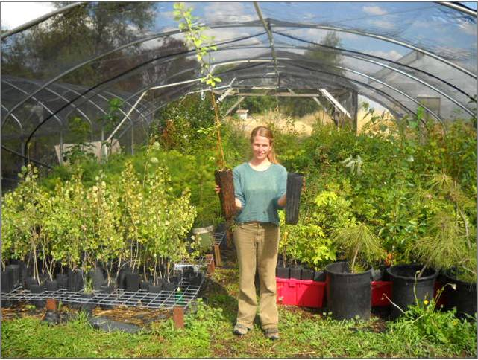
Carla Coordinator helping set up for the annual native plant cost share program plant distribution day.

“Our community center ordered three rain garden kits. We plan to plant two on our property and one at a local school,” said Chris Communityleader. “We have some minor parking lot flooding issues we hope the rain garden will help with. The school will use the garden to teach children about rain gardens and the importance of native plants.”

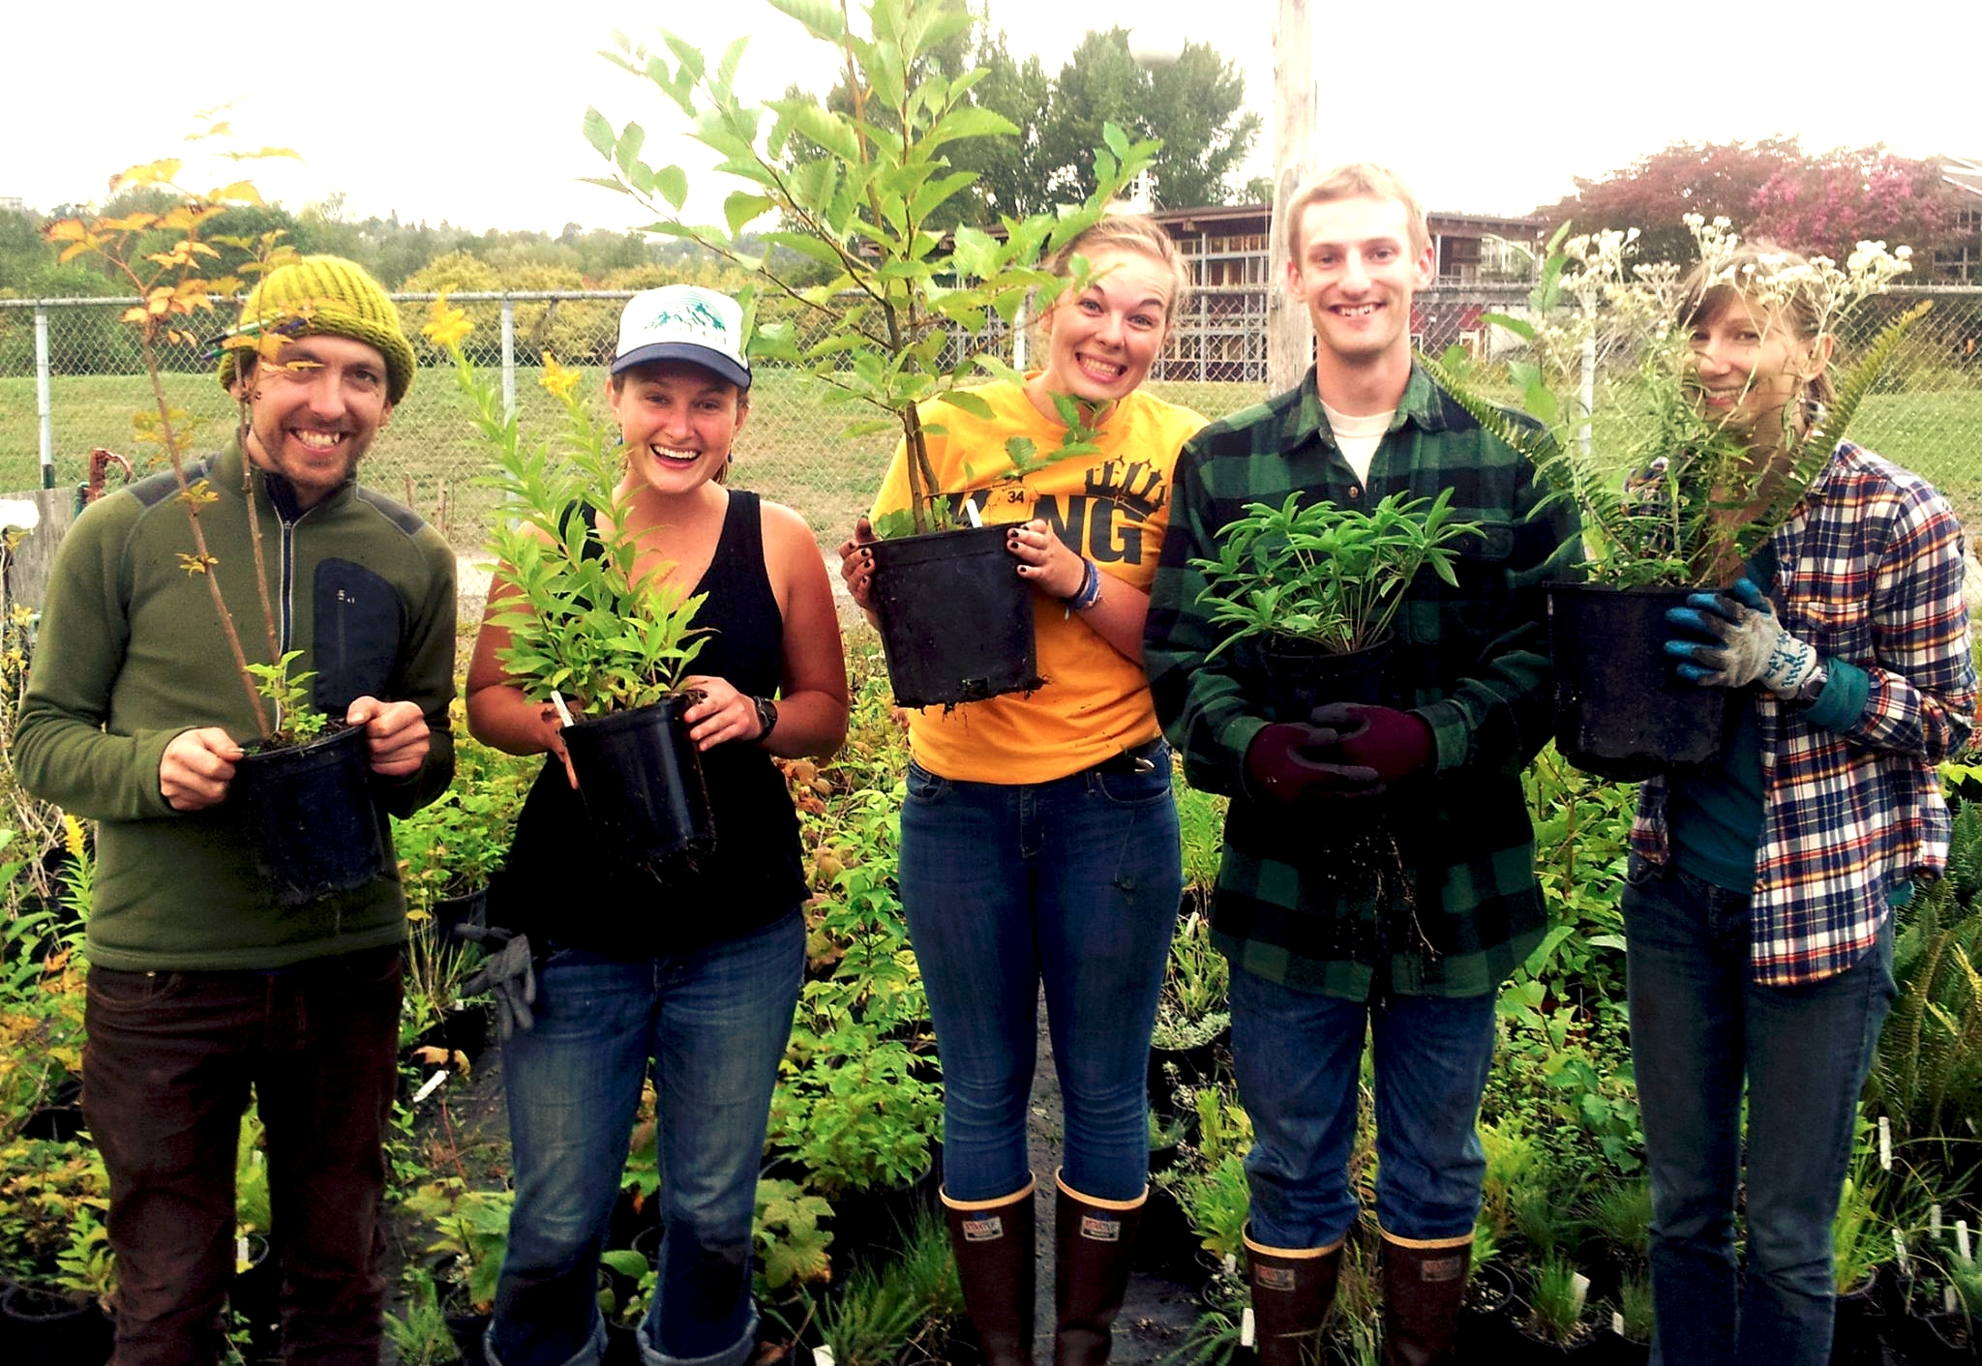
A group of students selecting plants for an on-campus native plant garden.

Last year we sold over 1,000 native plants to homeowners, municipalities, schools and non-profit organizations in YOUR COUNTY. This year, we expect to double that amount. This is good news for our community, as well as, the birds, butterflies, caterpillars and bees.

Plants are $$ each. Program details and order forms are available online at www.YOURCOUNTY.gov/NATIVE PLANTS. All orders must be received no later than PICK YOUR DATE. Plants will be available for pickup at PICK UP ADDRESS on PICK YOUR DATE.

Questions? Contact Carla Coordinator at (987) 654-3210 or carla.coordinator@county.gov

