Email subject Line: Ag Cost Share Application Deadline Approaching

Farmer Frank has deep ties to his farmland. His family has been farming the land in and around his current homestead since 1925. Caring for his land is a top priority for Frank. He wants to ensure that his farming practices don’t harm the environment or impact his neighbors.

Frank’s desire to keep his farm in tip-top shape led him to participate in the YOUR COUNTY’S Clean Water Partnership agricultural conservation practices Cost Share program. A voluntary program, the Cost Share program helps YOUR COUNTY farmers adopt cost-effective practices that reduce erosion and runoff into ponds, streams, and rivers.

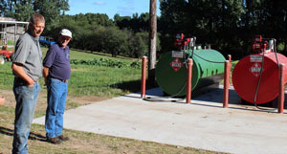
Farmer Frank stands proudly in front of his new fuel pad.

The YOUR COUNTY Clean Water Partnership invites landowners to learn about their cost share program and agricultural best management practices can help improve crop yield, reduce farming costs, and reduce soil erosion. The cost share supports practices such as livestock exclusion fencing, riparian buffers, livestock water supplies, manure management projects, and fuel pads.

“Farmers who aren’t familiar with the cost-share program may think it is difficult to apply for, with lots of paperwork. Or, they’re concerned the conservation practices will cost too much and impact their operations,” says Brian Bestintentions of Family Farm. “That wasn’t our experience. Applying was easy, and the program kept the BMP installation costs low.”

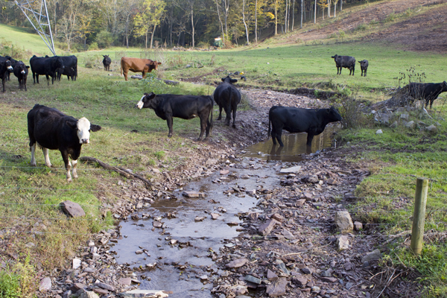  Cows in the creek before exclusion fencing installed on Cattle Ranch. | 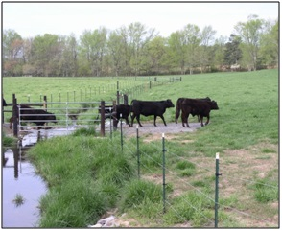  Cows walking over the creek after exclusion fencing installed on Cattle Ranch.

This year’s application deadline is approaching fast! Be sure to apply on or before DATE if you’d like to participate.

To learn more about the YOUR COUNTY agricultural conservation practices cost share program visit www.insertwebsite.com or Contact Carla Coordinator at (987) 654-3210 or carla.coordinator@county.gov

###

