Module 1: Soil and Stormwater 09-23-21

1. SOIL AND STORMWATER

1.3 Soil and Stormwater Menu
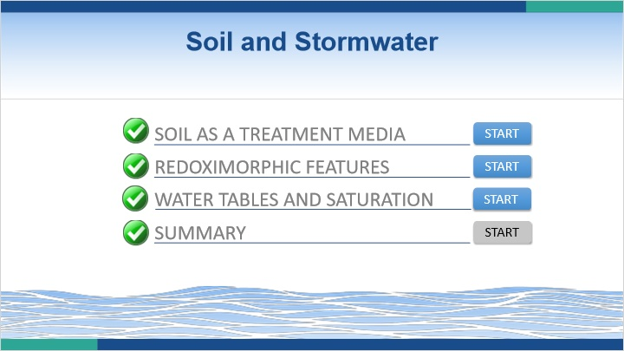
Notes:
Welcome to the Soil and Stormwater Module. In this module, you will complete three lessons related to soils and stormwater. Click on the start button for the first lesson to begin.

1.4 Soil as a Treatment Media
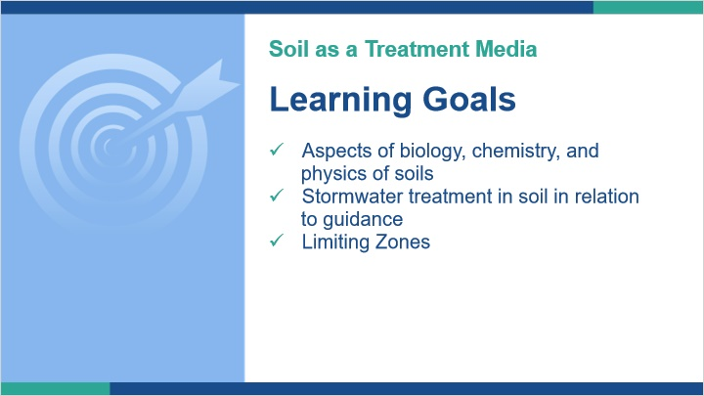
Notes:
In this course we will discuss the role soils play in stormwater management. With that goal in mind, we need to first discuss why soils are used in stormwater management. In this lesson, we will look at aspects of the biology, chemistry, and physics of soils in relation to stormwater management. We will also see how soils affect stormwater treatment as regulations and guidance create a need to balance many aspects of stormwater management in relation to soils properties.

1.5 What is the Role of Soils in Stormwater?
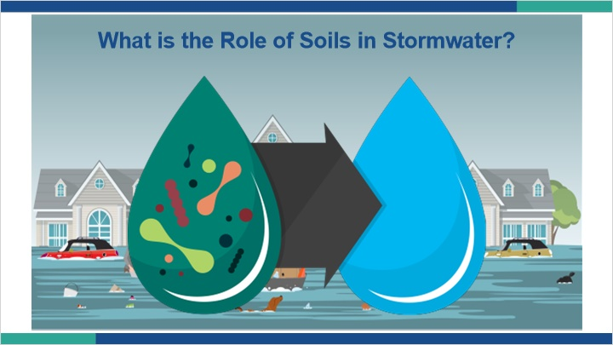
Notes:
What is the role of soils in stormwater management?

For a long time, stormwater management was based on removing stormwater from areas that it flooded as quickly as possible, with the goal of keeping it from flooding again or at least reduce the severity of flooding.

We now recognize the additional issues related to stormwater, such as water quality degradation. As such, our stormwater management goals have turned from a water rate and volume issue to also include water quality improvements.

To help address some of these issues, we’ve turned to soils for help, but why?

1.6 What is the Role of Soils in Stormwater?
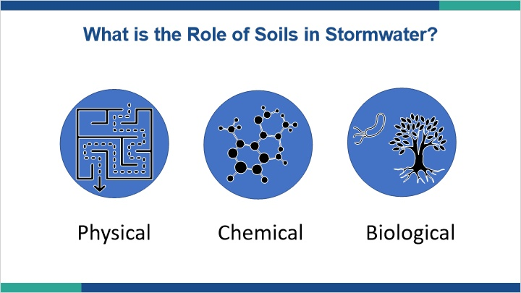
Notes:
What is it about soils that provides benefit to us when dealing with stormwater?

Soils provide us with physical, chemical, and biological benefits to stormwater.

1.7 Soil Physical Benefits
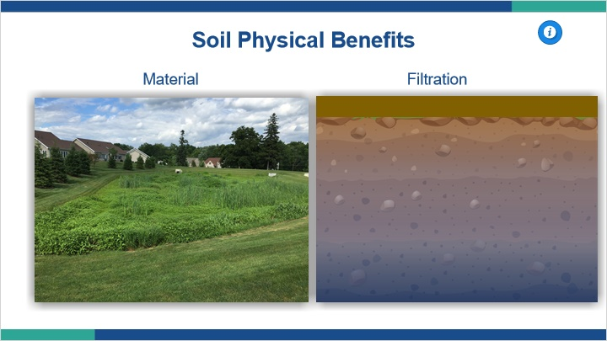
Notes:
Physical soil characteristics and their associated benefits are what we often think of first.

Soils can be a building material. We can, and often do build basins to temporarily hold stormwater. We do this to hopefully benefit the hydrograph, by minimizing peak runoff.

We also use soil as a physical filter. By allowing the water to soak into the soil, we can physically filter out debris and contaminants.

Finally, as soil acts as a filter, it other purpose is to allow the movement of water into the ground. Sometimes we focus heavily on the need to get water out of a BMP and into the ground so the BMP can accept the next stormwater event. However, as we will see, there is a delicate balance between removing water quickly and allowing adequate treatment time in the soil.

1.8 Soil Chemical Benefits
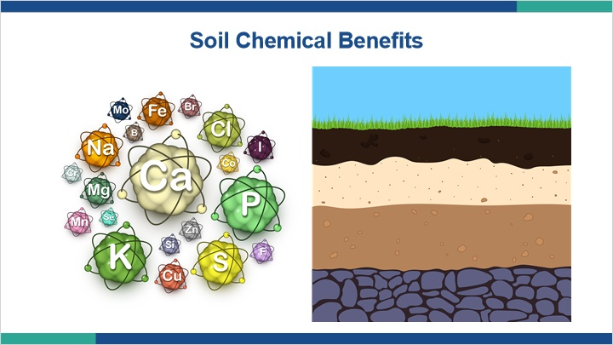
Notes:
The physical characteristics of soil are often what we focus on the most in stormwater management because they are the most obvious. However, physical benefits are not the only benefits we get from soils.

Soils are chemical factories, processing reactions all day every day. Soils contain a litany of chemicals naturally, and then are also bombarded with contaminants from things like stormwater runoff. Each soil is unique just as each soil horizon displays uniquely different characteristics. Inherent in the physical differences we can see and feel are chemical differences that can have a profound impact on how soils function.

1.9 Soil Biological Benefit
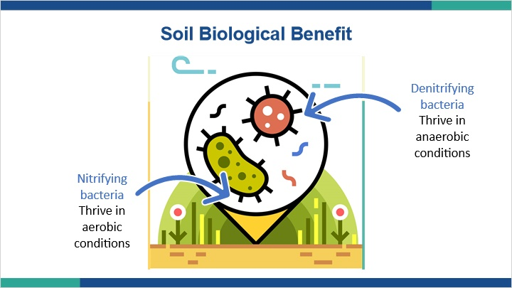
Notes:
It’s also important to remember that soils aren’t a pile of lifeless minerals. Certainly there are inert materials in soils from a physical standpoint, but soils are living ecosystems, and many of the benefits we get from soils are actually given to us by the organisms that live in the soil, not the soil minerals. For example, changes in nitrogen in the soil don’t happen spontaneously, they are driven by bacteria. In the nitrogen cycle pictured here, we see denitrifying bacteria. These bacteria help turn nitrate into nitrogen gas. These denitrifying bacteria thrive in anaerobic soil conditions, which essentially means saturated soils. On the other hand, nitrifying bacteria are the opposite, they like aerobic, or oxygen rich non-saturated soils.

1.10 Stormwater Treatment
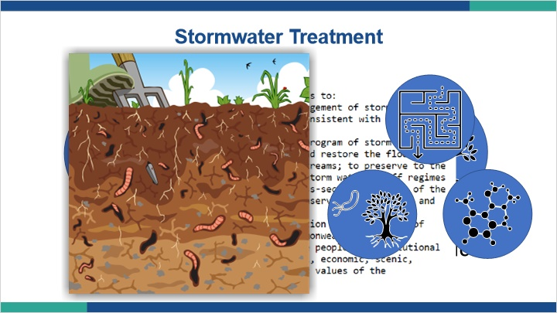
Notes:
Clearly, we rely on all three benefits of soils - physical, chemical, and biological - working together to create suitable conditions for water movement and treatment.

When we look at stormwater management as a whole, there’s not necessarily a need for soils. If you look at the stated purpose of Act 167, it doesn’t even mention the word soil. Although we know soils are a living ecosystem, we treat them like any other tool in our toolbox for stormwater management. However, tools are only effective if we know how to correctly use them. Therefore, to be an effective tool in stormwater management, soils need to be utilized understanding that they are living ecosystems, and can only do what we want them to do when those ecosystems are allowed to thrive.

1.11 Limitations to Stormwater Renovation
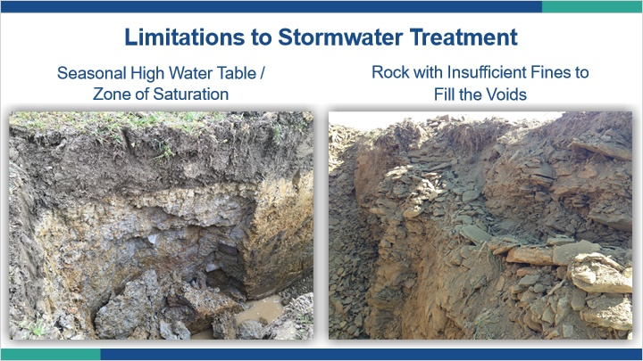
Notes:
After discussing the soils as a treatment media, let’s look at some common limitations of soils for treating stormwater.

Seasonal high water tables or zones of saturation are areas where we know the soil is having a current issue dealing with water, so adding additional water by concentrating stormwater on these soils isn’t likely going to improve things.

Conversely, fractured up rock will likely move stormwater extremely rapidly, but with rapid flow comes almost non-existent treatment. Care should be taken in situations like this to avoid impacts to nearby waters and drinking supplies.

1.12 Limitations to Stormwater Renovation
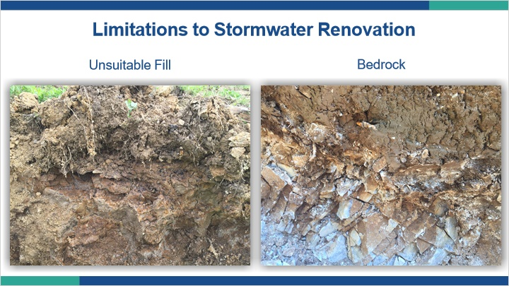
Notes:
Fill materials are not inherently prohibitive to stormwater, but there are cases where it can be. Overly compacted fill and fill with contamination are two scenarios where concentrating stormwater will not produce positive outcomes.

Finally, the presence of bedrock can create a condition of perching water or allowing water to move through too quickly depending on the characteristics of the rock. We look to soils to treat stormwater, and rock is not soil.

1.13 Soils as a Treatment Media Summary
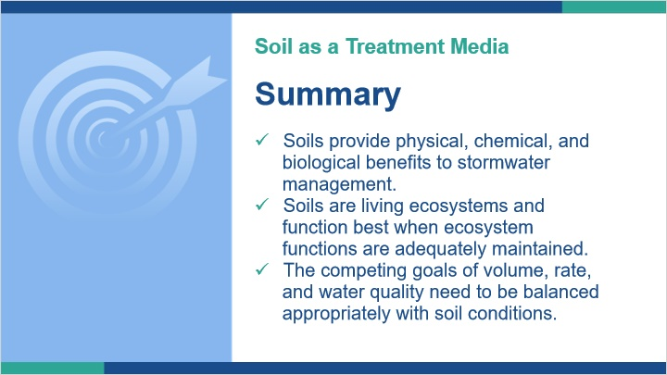
Notes:
Traditionally, our regulations, put a big focus on dealing with the volume and rate of stormwater. Over time, we have seen the additional need to focus on water quality, and therefore we have adapted modifications to our approach to stormwater management. Throughout this course we will see how understanding the functions of soils help direct us on decisions in stormwater BMP design.

In summary, soils provide physical, chemical, and biological benefits to stormwater management.

These benefits are only maximized when soils are functioning correctly. To function correctly, we need to remember that soils are living ecosystems and if we are trying to mimic the benefits soils provide natural systems, we need to design BMPs to maintain adequate ecosystem function.

The competing goals of volume, rate, and water quality are not always easily balanced with on site soil conditions. We need to do our best to strike an appropriate balance knowing the strengths and weaknesses of the soil we observe.

1.14 Redoximorphic Features
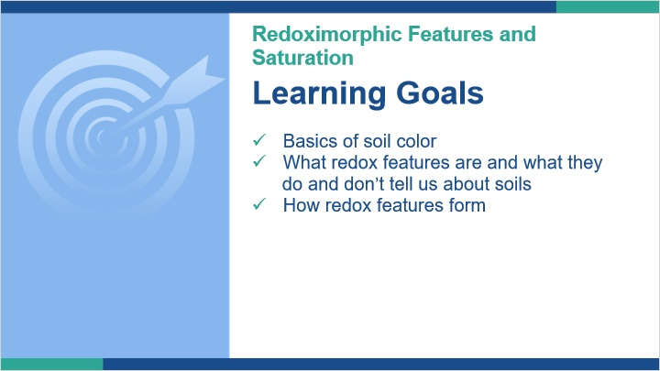
Notes:
In this lesson, we will look at some basic properties of soil color. As an extension of that discussion, we will look at what redoximorphic features are and what they do and don’t tell us about soils. To better understand redox features, we will look at how they form in soils, which can be an important tool to adequately identifying them in soil profiles.

1.15 Soil Color
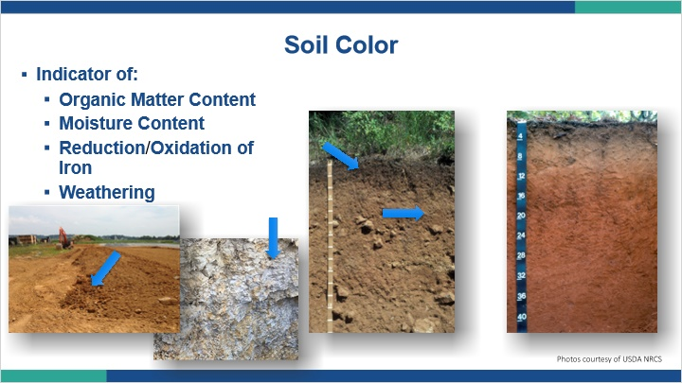
Notes:
Soil color is probably what we notice the most about soil. It can be an indicator of organic matter content, moisture content, reduction and oxidation of iron, and weathering. In Pennsylvania, the two dominant factors in soil color are organic matter and iron. Organic matter is the dark brown or black color in surface horizons and different types of iron give us the reds, oranges, yellows, and browns we see in the subsoil.

1.16 Iron Redox Reaction
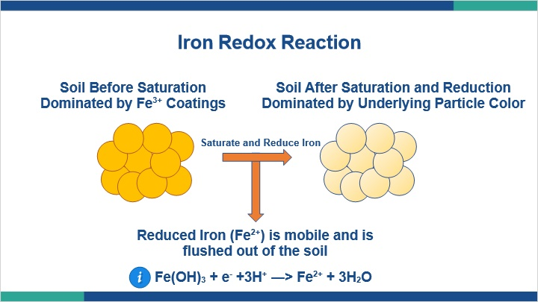
Notes:
Soil particles essentially have a coat of iron paint on them. That’s what gives soil its color. When we saturate and reduce iron it becomes mobile and enters the soil solution. So essentially, we have removed the paint on the soil particles. What we are left with is a white or gray color. That color is the color of the underlying mineral particles. The reduced iron that is now mobile either gets flushed out of the system or it moves to another part of the soil and eventually precipitates out of solution when it finds an oxygen rich environment. Because there is a lot more iron in this particular spot the color is concentrated and appears brighter than the surrounding matrix color. We call the white and gray areas redoximorphic depletions and the bright areas redoximorphic concentrations.

1.17 Redoximorphic Features
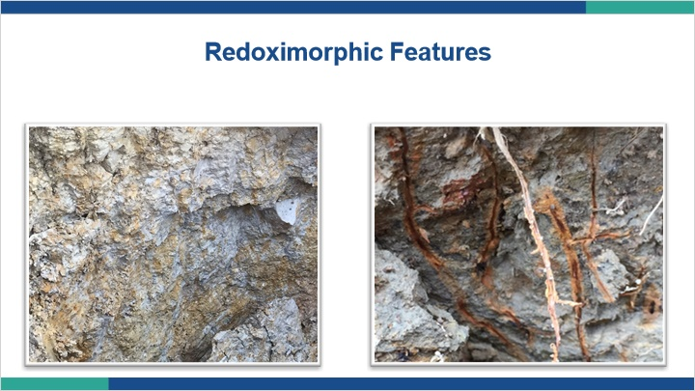
Notes:
Redoximorphic features are a visual representation of past reduced conditions. They form when a soil saturates, goes anaerobic and is reduced. As we discussed, iron is a main color agent in our soils. It is the reduction, movement, and reoxidation of iron that makes the gray and orange color patterns indicative of redoximorphic features.

1.18 Redoximorphic Feature Formation
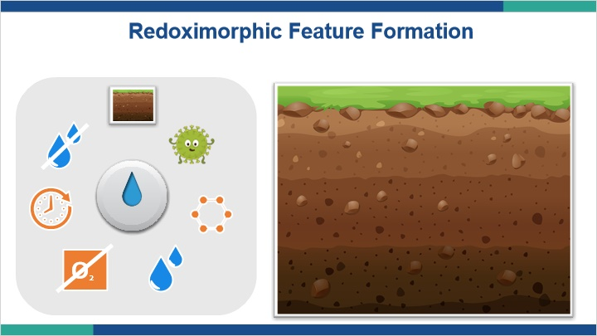
Notes:
Let’s take a look at how redoximorphic features might form in a soil. Turn the dial to progress through each step in the process.

Redox features don’t form in sterile environments because microbes are what’s doing the work.

Microbes, just like people, need to eat. A carbon source, like organic matter, gives them something to chew on.

The reduction of iron occurs in the absence of oxygen, so we need water to fill the pore spaces and exclude atmospheric oxygen from entering the system.

Water can contain dissolved oxygen, so saturation isn’t the only requirement. The dissolved oxygen needs to be consumed too.

We need saturation and reducing conditions to persist long enough for iron to reduce and become mobile. the longer the periods of reduction last, the more redox features form. The magnitude of expression increases as this process repeats.

Because we’ve changed the iron and allowed it to move and oxidize, the redox features remain in the soil even when the soil is no longer saturated and reduced. This allows us to use the presence of redox features as a proxy for determining depth of saturation.

1.19 Redoximorphic Features Summary
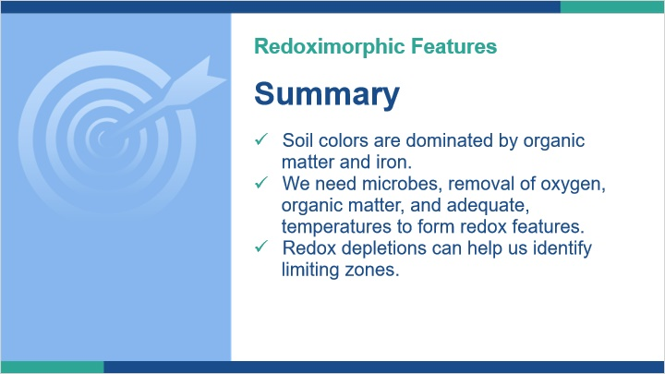
Notes:
In this lesson we explored redoximorphic feature formation so we can adequately identify redox features to help us correctly determine limiting zones in soils. We discussed that redox feature formation happens in an environment devoid of oxygen, but it is also a microbe driven process so we need microbes obviously, but also things that make microbes happy like organic matter for food and adequate temperatures. We learned that redox reactions reflect the movement of electrons which changes the characteristics of iron in the soil and allows it to become mobile, resulting in areas of depletion and areas of concentration. Finally, we discovered that we can use the presence of redox depletions to determine depth to a limiting zone, even if the soil happens to be dry during observation.

1.20 Water Tables and Saturation
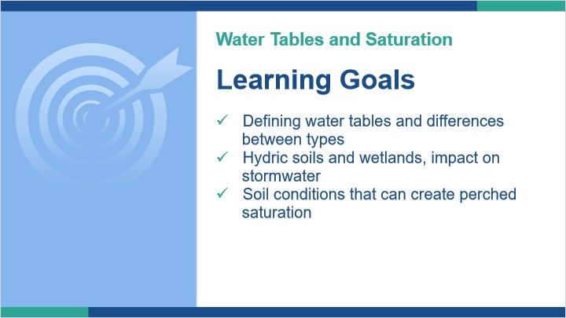
Notes:
In this lesson, we will look at defining water tables and the different types we might encounter or hear about.

We’ll look at where hydric soils fall in the discussion of water tables and what that might mean for stormwater.

Finally, we explore why water perches in some soils.

1.21 Water Tables
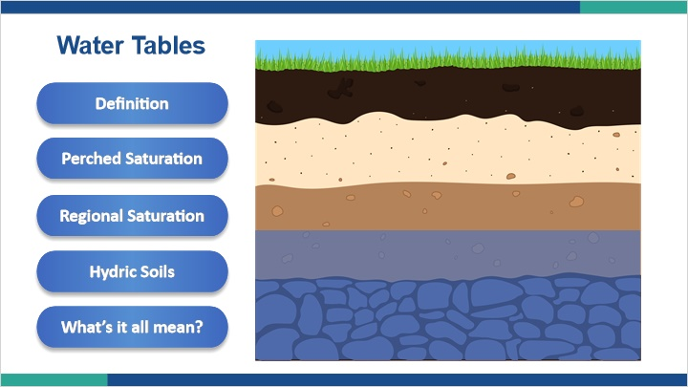
Notes:
What is a water table?

When we discuss water tables, we might hear things like, “Is it a regional water table?” “Is it a perched water table?” “Is it a seasonally high water table?” “Is it a ‘real’ water table?”.

Let’s explore different aspects of what we mean when we say “water table”.

1.22 Water Table Definitions
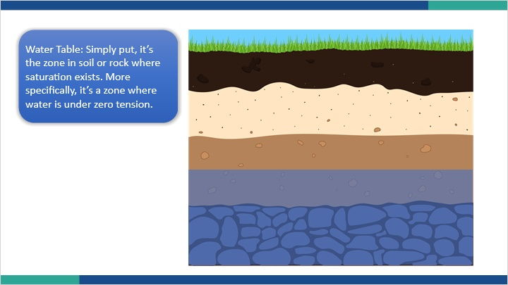
Notes:
What is a water table?

Simply put, it’s the zone in soil or rock where saturation exists. More specifically, it’s a zone where water is under zero tension. What it is not, is wetness in the soil. Water in the soil may be a water table, but it also may just be wet soil that is not an actual water table. This might happen if we dig into a soil shortly after a rainfall event.

Certainly, in theory, that is a pretty simple definition. But like most things that seem simple, the application of this theory and interpretation when examining soils for stormwater management can be complex.

As we discussed previously, we can determine the presence of a water table most readily by observation of redoximorphic features, even when no saturation is currently in the soil profile.

1.23 Perched Saturation
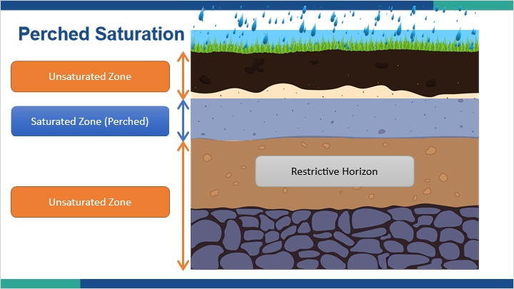
Notes:
In soil science, we talk about two types of saturation: Saturation that comes from water entering the soil profile and being perched by a restrictive horizon and saturation that comes from a rising water table from below the profile. Perched saturation or sometimes referred to as a perched water table, is saturation that is occurring because water is entering the soil profile and is being held up or perched by a restrictive horizon. It’s not to say that water cannot get through the restrictive horizon, it just means that the rate is slow enough to back the water up and create a zone of saturation. This also implies that there is a zone below that saturated zone that is unsaturated.

1.24 Regional Saturation
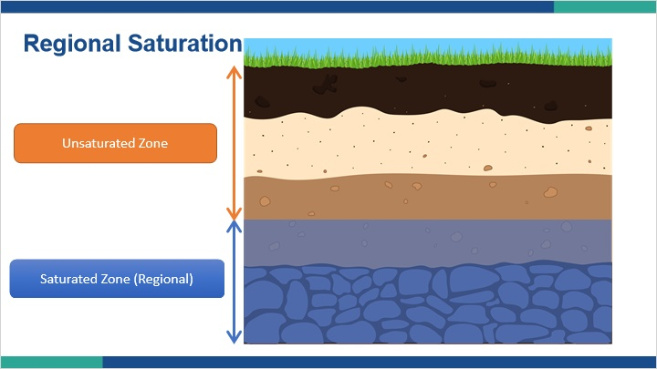
Notes:
Water can also saturate the soil profile from the presence of an underlying water table. Sometimes we hear terms like regional water table or real water table when describing this type of saturation. This type of saturation is driven by larger scale conditions, and really isn’t dependent on the physical properties of the soil.

In this scenario there might be an unsaturated zone above the saturated zone, but not below it.

1.25 Hydric Soils
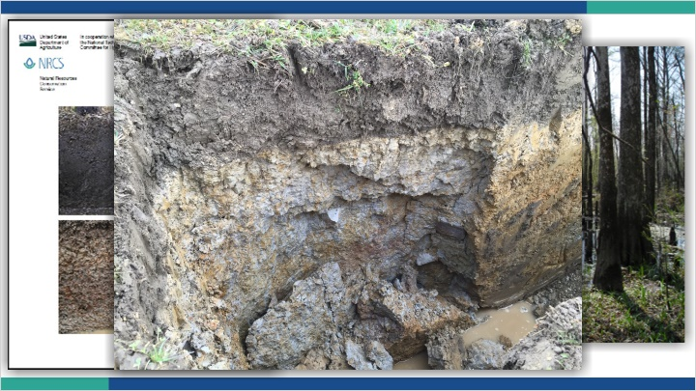
Notes:
Where do hydric soils fit into everything?

The idea of hydric soils was born out of the need for identifying soils that may be found in regulated wetlands. They have very specific identification criteria, which most commonly are presented in the published Field Indicator of Hydric Soils in the United States.

Hydric soils certainly represent soils that would have saturation at least portions of the year. Since they are typically associated with wetlands, their existence on a site would normally preclude them from use in most stormwater BMPs, as they would fall within regulated wetlands. However, some times the presence of a regulated wetland is in close proximity to a stormwater BMP and there may be concerns about impacts to the wetland. We will discuss those potential issues a little later in the training.

1.26 What's it all mean?
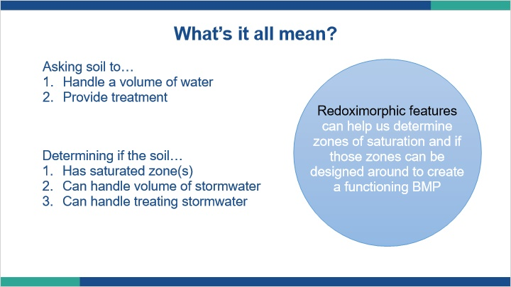
Notes:
Why does any of this matter?

Remember what we are asking the soil to do with stormwater. First, we want to get rid of a volume of water within a certain time period, usually a few days. Second, we are asking the soil to provide some treatment, both physically and chemically.

If we have water in zones of saturation naturally within the soil, adding more water to that by concentrating stormwater probably isn’t going to result in a properly functioning BMP.

Additionally, we know that saturated zones in the soil produce anaerobic conditions, which are not conducive to treatment.

If saturation is a bad thing for stormwater treatment, why do we care about the nuance of perched versus groundwater saturation?

Because we are often excavating into the soil to construct BMPs, we might actually be able to dig through a restrictive horizon that is causing a perched water table. If that’s the case, then if we remove the restrictive horizon, we remove the issue of perched saturation.

Conversely, if we dig into soil that is wet because of a regional groundwater table, nothing about removing the soil is going to improve that situation, because it’s not the soil that’s causing the saturation in the first place.

There are other things to consider when determining suitability in regards to perched saturation versus regional saturation that we’ll discuss further. But, the presence of redoximorphic features, which are a proxy to saturation, is not always a limitation that we can’t design around.

1.27 BMP Scenario 1
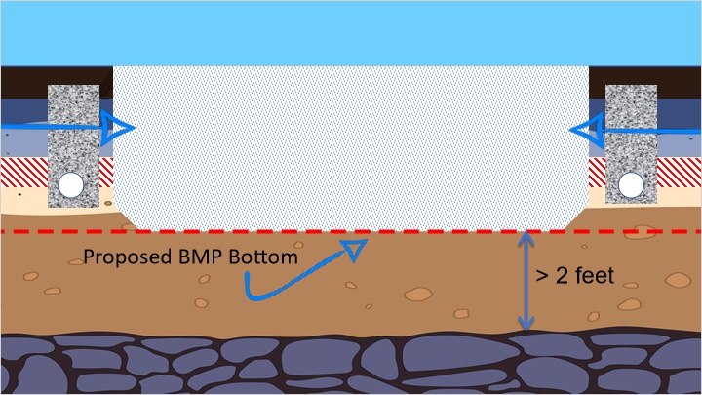
Notes:
Let’s take a look at a potential scenario where we might interact with a water table. Here we have a soil that has some kind of restriction shown as the dashed red lines. That restriction is causing water to perch and cause a zone of perched saturation. Our BMP design has the proposed bottom of the BMP below the restrictive feature in soils that have no limitation to water movement. We are also at least two feet from the bedrock below us. Can we place the BMP?

Specific site conditions will need to be reviewed, but we should be able to place the BMP and have it function correctly. Depending on the situation, we may want to intercept any potential lateral flow of water over the limitation with a rock filled drain or other means of interception.

1.28 BMP Scenario 2
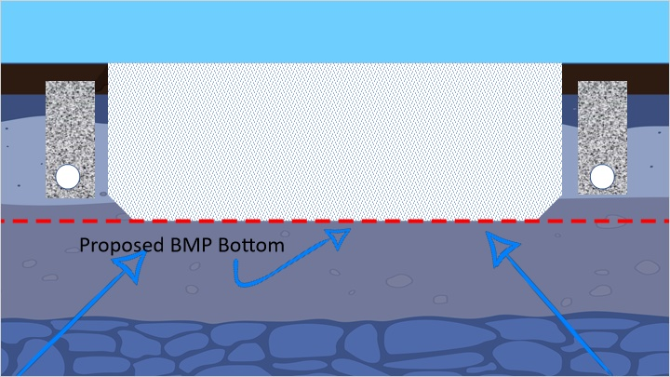
Notes:
Now let’s look at a similar scenario, except this time, the water is from regional saturation. The water is rising to the same depth in the soil, and the designer would like the proposed bottom of the BMP to be the same as it was in the last scenario. Can we place the BMP?

In this case, the water is being influenced by factors not related to specific soil conditions. If we try to place the BMP, even if we install rock drains, water is still likely going to enter the BMP from below. In addition, we are violating the minimum of two feet of separation required between the bottom of the BMP and a limiting zone.

1.29 Soil Conditions That Create Perched Saturation
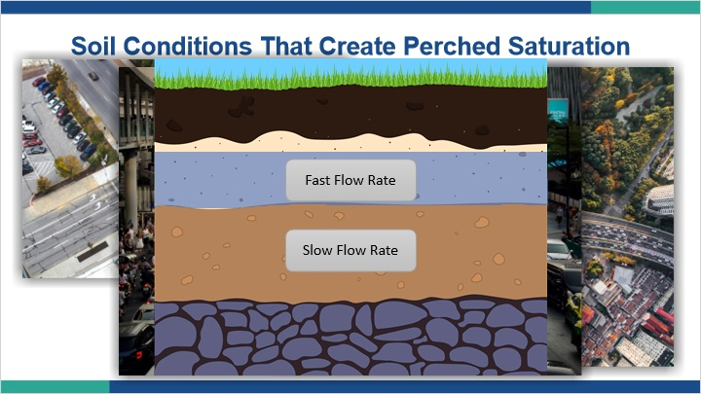
Notes:
What soil conditions might create a perched water table?

In the simplest terms, perched zones occur when a soil horizon that has a slow rate of water transmission is sitting below a horizon that has a faster rate of transmission. This creates a bottle neck of sorts, kind of like a traffic jam. If the roads are like soil pores, and vehicles are like water, we have a situation where we have either too many vehicles for the road or not enough roads for all the vehicles to get through fast enough, so a traffic jam occurs. Obviously, soils with more and bigger roads could allow more vehicles to pass through. To keep our soil water traffic moving, we need lots of soil pores.

1.30 Hagerstown Soil

Notes:
Restrictive horizons are parts of the soil where soil pore networks are inadequate to allow for the timely flow of water. Many people incorrectly link this issue to soil texture, saying things like “clay soils don’t move water”. That is in fact not true. The Hagerstown soil series is a well drained soil that has some of the highest clay content of any soil in Pennsylvania. How does a high clay soil remain well drained? The answer is in the pore network created by the soil structure. The soil structure makes up for the issues that clay alone would cause, and allows for the presence of an adequate soil pore network to move water through the soil profile.

1.31 Real Causes of Restrictive Horizons
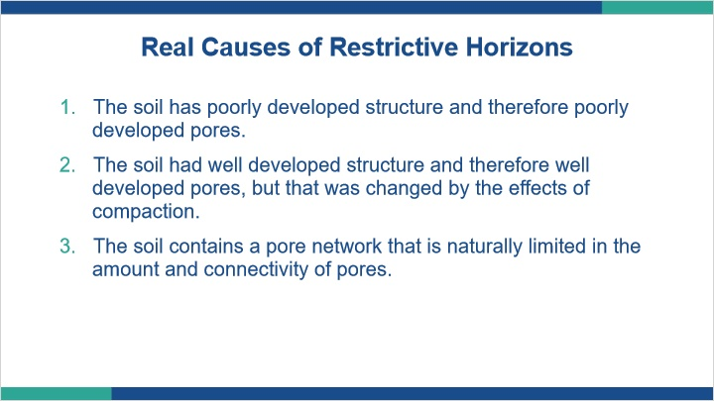
Notes:
The real cause of restrictive horizons is when the pore network is not well developed. This can happen for a number of reasons, but three main reasons are:

1. The soil has poorly developed structure and therefore poorly developed pores.

2. The soil had well developed structure and therefore well developed pores, but that was changed by the effects of compaction.

3. The soil contains a pore network that is naturally limited in amount and connectivity of pores.

1.32 Fragipans
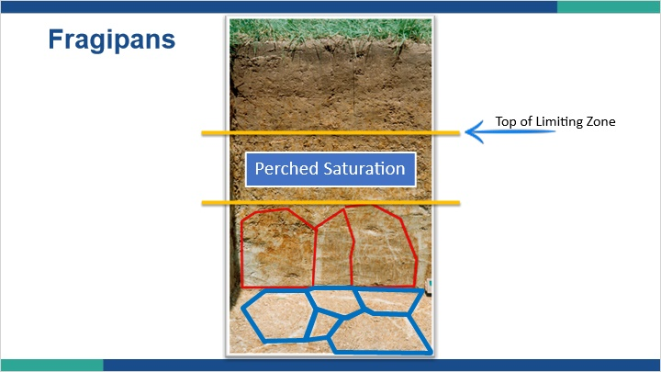
Notes:
A common restrictive horizon in Pennsylvania is the fragipan. Depending on where you are, fragipans can be very prevalent. Fragipans are dense restrictive horizons that limit the movement of water, air and roots. Fragipans typically exhibit prismatic structure and depending on degree of expression that structure can standout quite well. The prisms often have a hexagonal shape and when seen together they exhibit a honeycomb like distribution.
In the lower portion of the picture the prism faces have been highlighted red on the wall of the soil profile. The floor of the soil pit has been cleaned off and you can see that honey comb pattern expressed, as shown in blue. When a fragipan is present in a soil, water will likely perch above it and saturate the soil, resulting in the formation of a zone of redoximorphic features associated with the perched saturation, as shown in our picture. The top of that zone of saturation would be the top of our limiting zone for stormwater design.

1.34 Water Tables and Saturation Summary
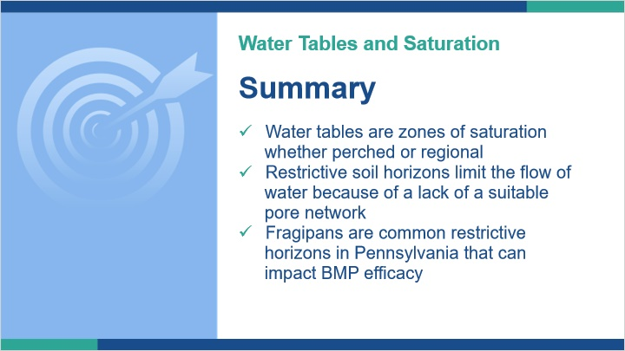
Notes:
In summary, water tables are zones of saturation whether perched or regional. However, understanding the difference may allow a designer to work around a limitation.

Restrictive soil horizons limit the flow of water because of a lack of a suitable pore network, or that network being overwhelmed by the influx of water.

Fragipans are common restrictive horizons in Pennsylvania that can impact BMP efficacy.

With all restrictive horizons, understanding why the restriction is happening can help the designer determine if a successful solution can be designed.

1.35 Summary
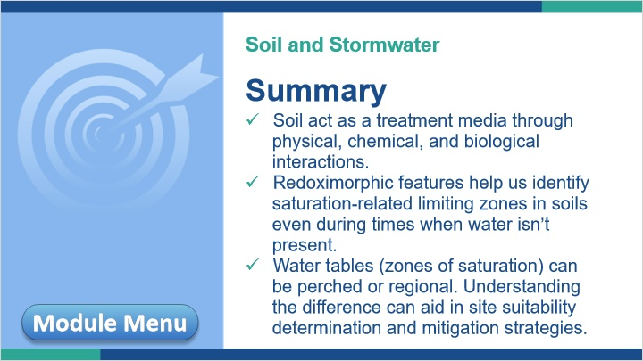
Notes:
This concludes Module 1, Soil and Stormwater.

In summary, soils act as a treatment media through physical, chemical, and biological interactions.

Redoximorphic features, sometimes called mottles, help us identify saturation-related limiting zones in soils even during times when water isn’t present.

Water tables, which are zones of saturation, can be perched or regional. Understanding the difference can aid in site suitability determination and mitigation strategies.

You may now move on to Module 2 by clicking the ’Next’ button in the bottom right or review any of the lessons of Module 1 again by clicking on the Module Menu button in the bottom left.

