Channel Design & Review Printout

1. Intro

1.1 Opening
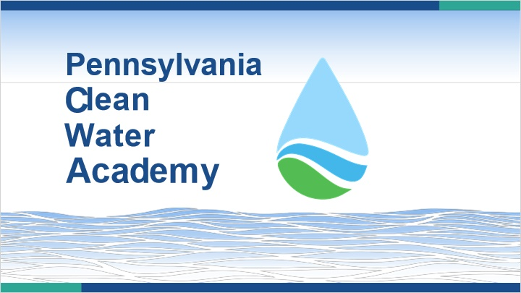

1.2 Audio Test
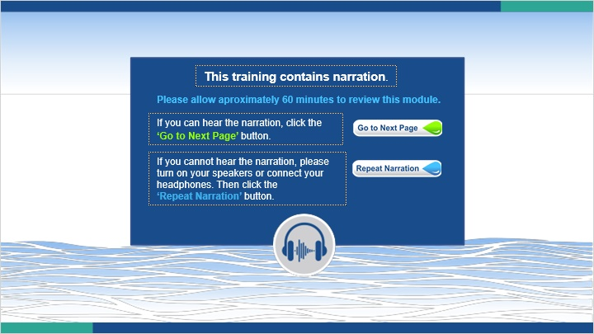
Notes:

1.3 Welcome
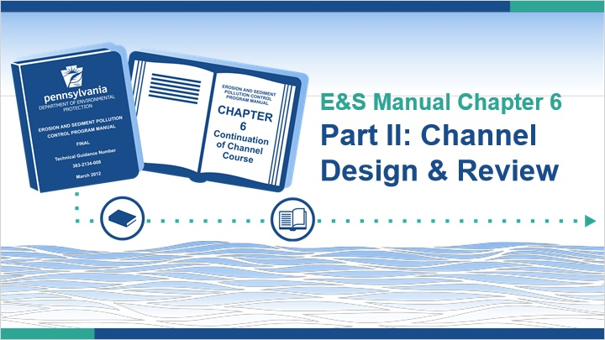
Notes:
Welcome to this course on channel design and review. This is a continuation of the Clean Water Academy course titled “Introduction to Channels”.

This training closely follows Chapter 6 of the Erosion & Sediment Pollution Control Program Manual. It is recommended to have a copy of the manual nearby while taking this course since this training references many figures, tables, and details found in the manual. Digital copies can be found on the Chapter 102 Resources page of Clean Water Academy. Note that completing this training does not replace the need to read and be familiar with Chapter 6 of the manual.

1.4 Welcome
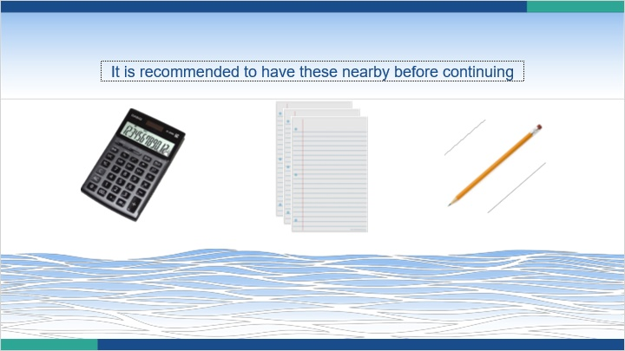
Notes:
This training contains many examples and practice problems. Before continuing, it is recommended to also have paper, writing utensils, and a calculator nearby.

1.5 Spreadsheets & Computer Software

Notes:
Before we begin, it should be noted that spreadsheets and computer software are often used to automate the calculations involved with designing and reviewing channels. This helps save time and prevents arithmetic errors. For the purposes of learning the theory, we will be doing all calculations by hand.

1.6 Course Learning Goals

Notes:
This training will be useful to DEP staff, conservation district staff, and members of the regulated community.

In this course, we will discuss the basics of open channel hydraulics, guidelines for channel design, items which should be submitted with the E&S plan, and what DEP and conservation district staff need to look for when reviewing proposed channel designs.

2. Lesson 1

2.1 Lesson 1 Learning Goals
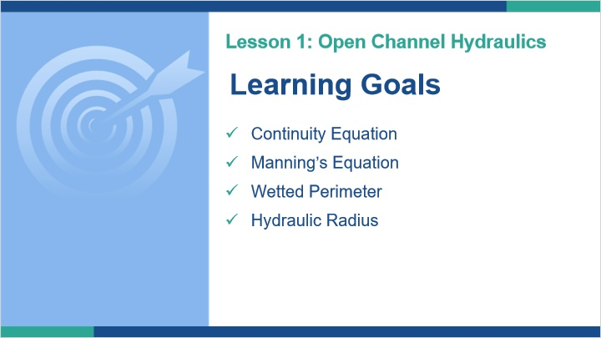
Notes:
Welcome to Lesson 1. In this lesson, we will discuss the basics of open channel hydraulics. This includes the continuity equation, Manning’s equation, wetted perimeter, and hydraulic radius.

2.2 Hydraulics
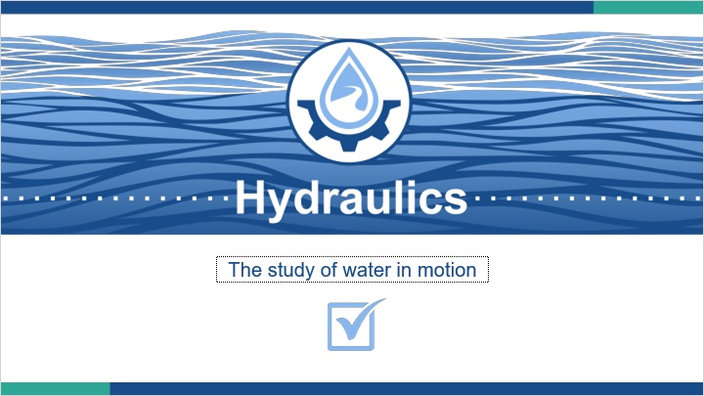
Notes:
Hydraulics is the study of water in motion. In this lesson, we will specifically look at open channel hydraulics.

2.3 Continuity Equation
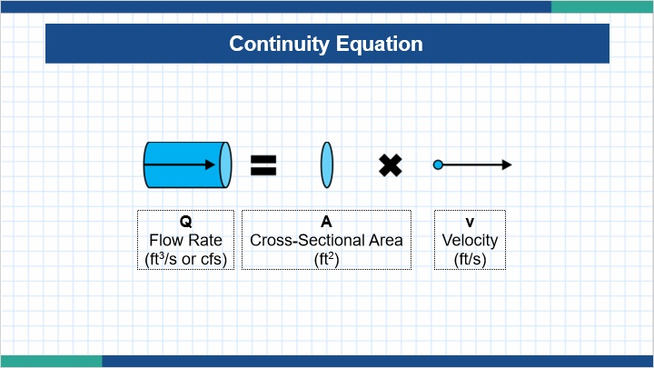
Notes:
The first equation we will look at is the continuity equation. It describes one of the most fundamental properties of fluids. The continuity equation states that the flow rate of a fluid is equal to the product of its cross-sectional area and its velocity. In channel design, the fluid is water.

For our purposes, the unit of flow is cubic feet per second, which is often referred to by the acronym cfs. The cross-sectional area is in square feet, and the velocity is given in feet per second (sometimes abbreviated fps).

2.4 Continuity Equation
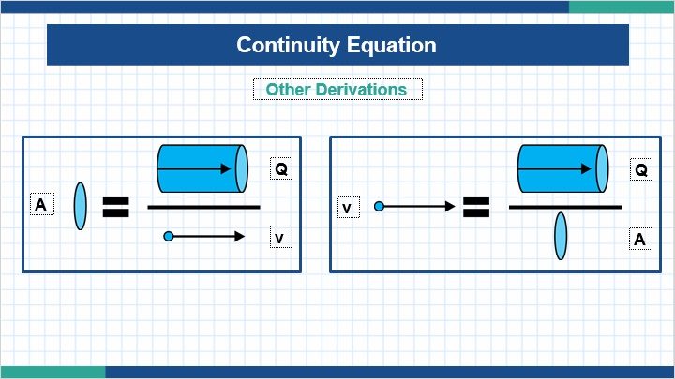
Notes:
Using division, we can rearrange the continuity equation to solve for velocity or area if necessary.

2.5 Examples: Cross-Sectional Area
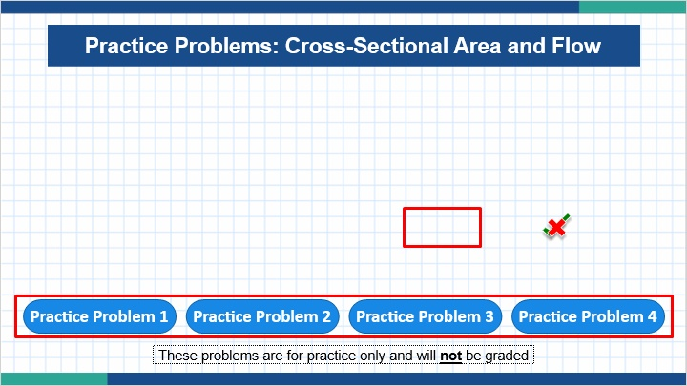
Notes:
Let’s try some practice problems. Calculating the cross-sectional area and flow of each example. Type your solution in the box. A checkmark or x will appear to tell you if your solution is correct or not. You can change your solution as many times as you need. Note that these problems are for practice only and will not be graded.

To move between the examples, click the buttons at the bottom of the page. Once you are finished, click the ‘Next’ button to continue.

2.6 Manning’s Equation
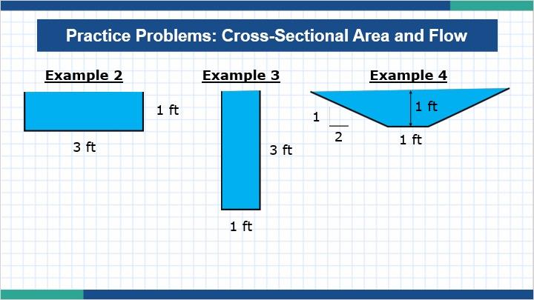
Notes:
Despite their varying shapes, you may have noticed that Examples 2, 3, and 4 have the same area and flow rate. Later in this lesson, you’ll see how the shape of each channel can affect some of its other properties.

2.7 Manning’s Equation
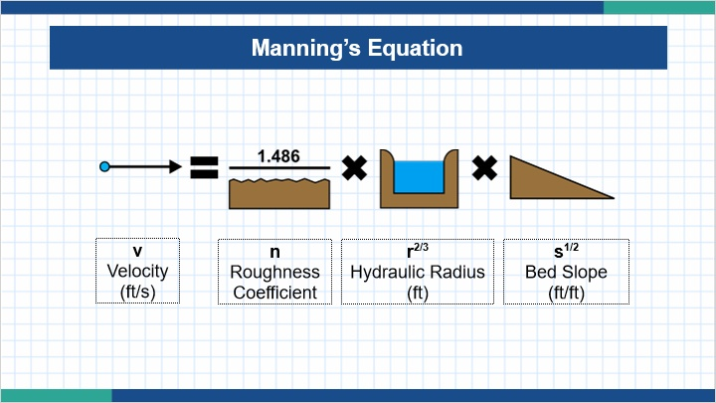
Notes:
Manning’s equation shows the relationship of water’s velocity to the roughness of the channel bed, its hydraulic radius (which we will look at shortly), and the slope of the channel bed.

2.8 Manning’s Equation
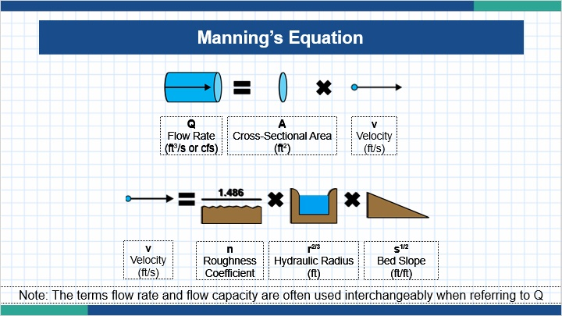
Notes:
If we substitute Manning’s equation for the velocity in the continuity equation, you can also use Manning’s equation to solve for flow capacity instead of flow velocity.

2.9 Hydraulic Radius
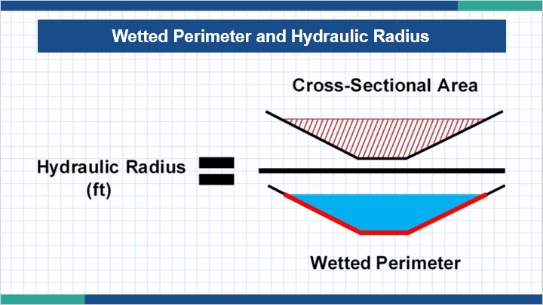
Notes:
The hydraulic radius of a channel is the ratio of its wetted perimeter to its cross-sectional area.

Wetted Perimeter is the length of the boundary between the water and the channel sides and bottom.

2.10 Hydraulic Radius
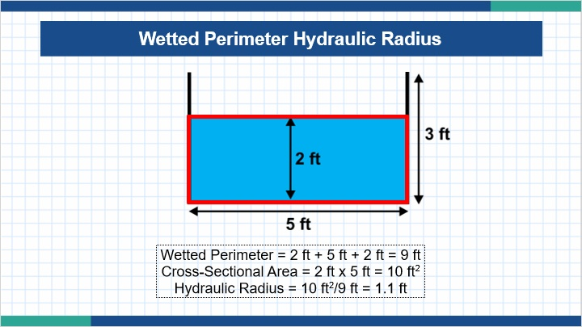
Notes:
Be careful when calculating the wetted perimeter and cross-sectional area of a channel. In this example, we see a rectangular channel which is 3 ft high and 5 ft wide. However, the water is only 2 ft deep.

In this case, the wetted perimeter is 2 ft + 5 ft + 2 ft = 9 ft. It is not 3 ft + 5 ft + 3 ft = 11 ft.

The cross-sectional area is 2 ft x 5 ft = 10ft², not 3 ft x 5 ft = 15 ft².

The hydraulic radius the cross-sectional area divided by the wetted perimeter. For our example, this is 10 ft²/9 ft = 1.1 ft.

2.11 Examples: Cross-Sectional Area
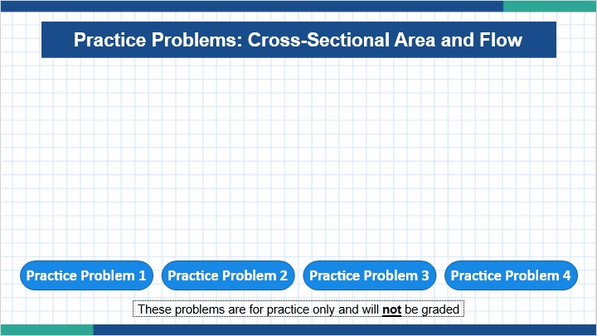
Notes:
Here’s our practice problems from earlier. Let’s calculate the wetted perimeter and hydraulic radius of each.

2.12 Examples: Hydraulic Radius
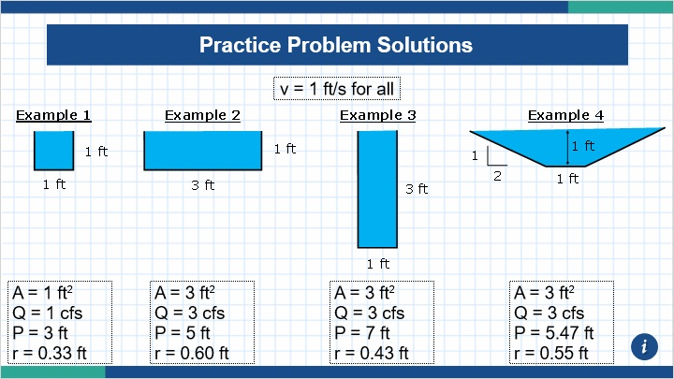
Notes:

2.13 How Do We Use Hydraulics?
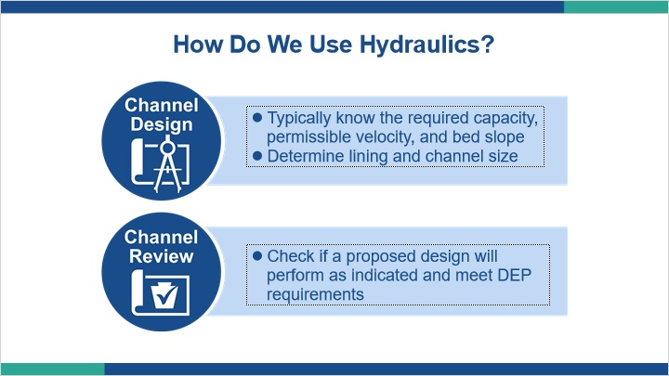
Notes:
Now that you’ve learned the basics of open channel hydraulics, it’s important to know how it is used. Engineers use hydraulics to design suitable channels based upon site conditions. DEP and conservation district staff check the proposed design to see if the calculations are correct and meet DEP requirements. We will learn more about Channel Design and Review in Lessons 2 and 3.

2.14 Lesson 1 Summary
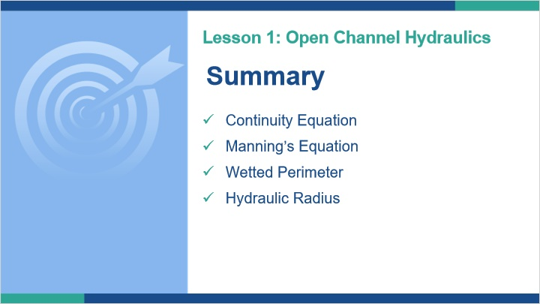
Notes:
This concludes Lesson 1. In this lesson, we discussed the basics of open channel hydraulics. Specifically, we looked at the continuity equation, Manning’s equation, wetted perimeter, and hydraulic radius.

3. Lesson 2

3.1 Lesson 2 Learning Goals
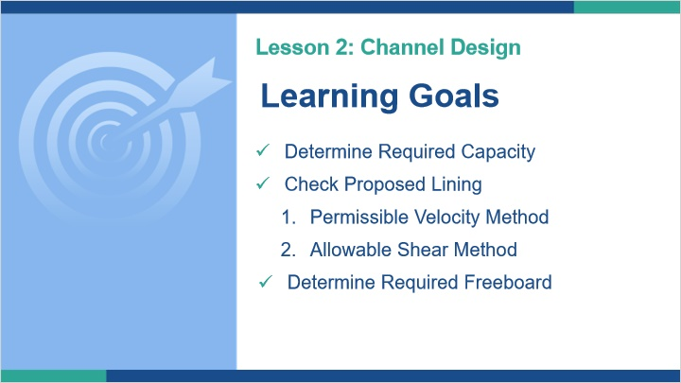
Notes:
Welcome to Lesson 2. In this lesson, we will discuss channel design. Specifically, we will show how to determine the required capacity, how to check a proposed lining using the permissible velocity and allowable shear methods, and how to determine the required freeboard.

3.2 Design Sections Separately
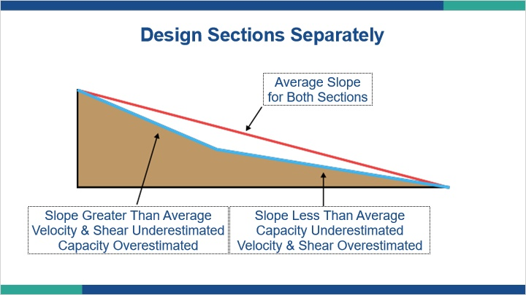
Notes:
When designing channels, it is important to design sections with different slopes separately. While averaging slopes is not allowed, we have used the average slope in this figure to make a comparison for training purposes only.

The figure shows two connecting sections of a channel with different slopes. These red line shows the average of these two slopes. The capacity, velocity, and shear stress were calculated using the average slope. This resulted in the velocity and shear stress being underestimated for the steeper segment while the flow capacity was overestimated. For the gentler slope, the flow capacity was underestimated while the velocity and shear stress were overestimated.

Channels can also be designed based on the maximum and minimum slopes. The maximum slope will determine the necessary liner strength, while the minimum slope will indicate the required capacity.

3.3 Known Quantities
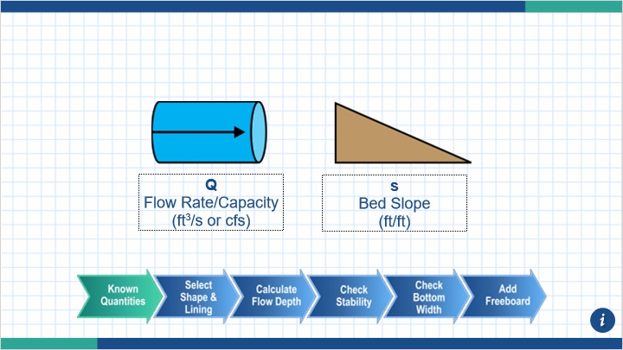
Notes:
When designing channels, the design flow capacity and the slope are typically already known.

The design flow is based off DEP or municipality requirements. DEP requires temporary channels in non-special protection watersheds to convey a 2-year storm event, or 1.6 cfs/acre. Temporary channels in a special protection watershed should be designed for a 5-year storm event, or 2.25 cfs/acre. Permanent channels should be designed for a 10-year storm event, or 2.75 cfs/acre.

Note that some municipalities do not recognize the multipliers since they only account for area and do not account for land cover or time of concentration. Local municipalities may require higher storm events than DEP.

A 100-year storm event may be needed in situations where permanent channels will convey runoff to a PCSM BMP which is designed for a 100-year storm event. This is a very common deficiency found during plan reviews.

It is also worth distinguishing the difference between a temporary and a permanent channel. A temporary channel is a channel that will be used during construction. At some point prior to the completion of the project, it will be removed. Permanent channels will remain on site after construction is complete.

3.4 Step 1
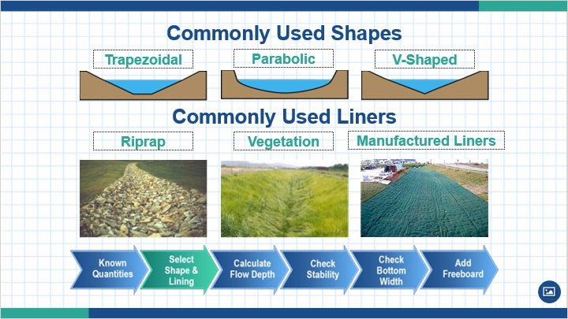
Notes:
The first step of channel design is to select a channel shape and liner. Trapezoidal channels are recommended because they are effective and easy to construct. Some of the most common liners are riprap, vegetation, and manufactured liners. Other types of linings are listed in Table 6.2 of the manual.

A suitable temporary liner should be provided until permanent vegetative stabilization is achieved. Separate calculations should be provided showing sufficient capacity and adequate protection both before and after establishment of the vegetation. Temporary stabilization is not required for channels lined with sod or riprap.

Find Manning’s n value for the selected liner either from the E&S manual or the manufacturer.

3.5 Step 2
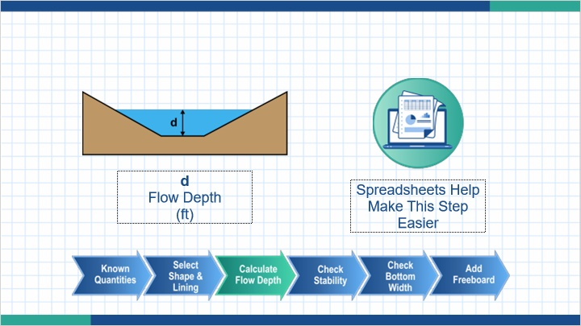
Notes:
The second step is to calculate the flow depth of the channel using Manning’s equation. Using a spreadsheet or computer software makes this step easier. This allows you to enter a value for the flow depth and trial channel geometry to calculate flow capacity. You can repeatedly adjust these parameters to hone in on the most effective flow rate that is greater than or equal to the required Q.

3.6 Step 3
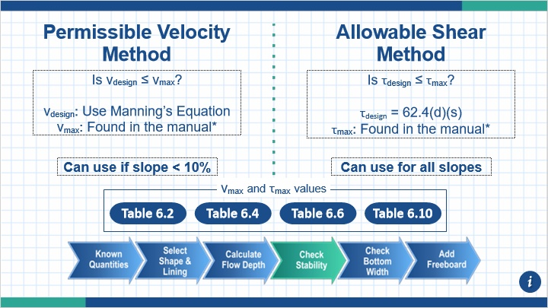
Notes:
The third step is to check if the channel lining can withstand the force of water running over it. This can be done using either the permissible velocity or allowable shear methods.

The permissible velocity method can be used for slopes less than 10%. Calculate the design velocity using Manning’s equation. Find the value of the maximum permissible velocity from the manual. The design velocity should be less than or equal to the maximum permissible velocity. If it is not, design parameters will need to be adjusted or different lining should be selected.

The allowable shear method can be used for all slopes. The design shear stress is directly proportional to the product of the flow depth and the slope. The value of the maximum permissible shear stress is found in the manual. The design shear stress should be less than or equal to the maximum permissible shear stress. If it is not, the design parameters will need to be adjusted or different lining should be selected.

3.7 Step 4
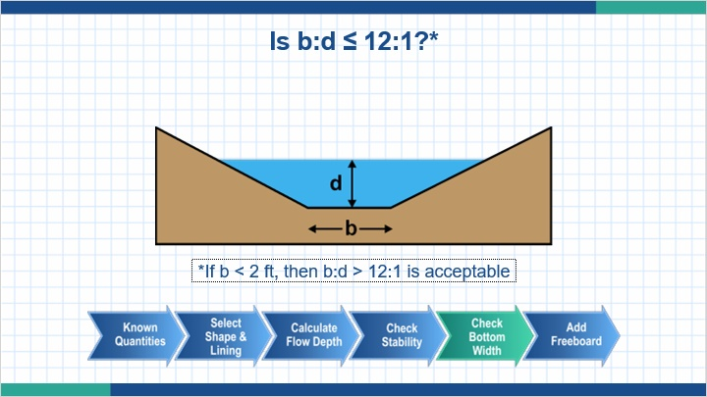
Notes:
The fourth step is to check the ratio of the bottom width of the channel to its flow depth. The bottom width of a channel can be calculated using the geometric formulas found in Table 6.1 of the manual. The bottom width should be no more than twelve times the flow depth. At greater ratios, flows tend to concentrate and cause erosion of the channel bed. If a channel already has a minimum bottom width (2 ft or less), greater ratios are acceptable.

3.8 Step 5
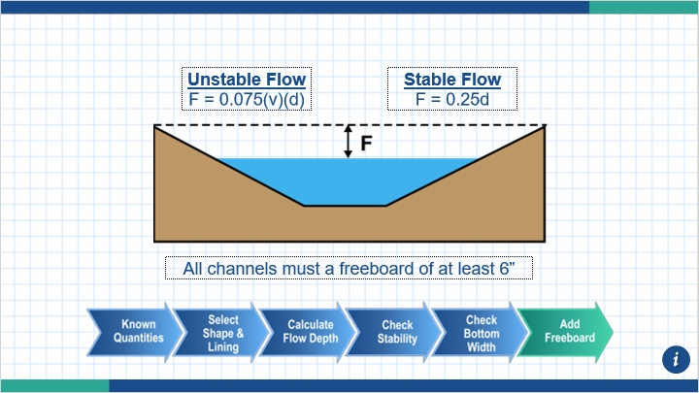
Notes:
The final step of channel design is to add the freeboard. Freeboard in a channel is defined as the vertical distance between the calculated flow depth, d and the top of the channel. The freeboard is a safety factor to prevent flows from overtopping the sides slopes during the designed storm event.

The equations on the screen show how to calculate freeboard for unstable flows and stable flows. All channels must have a freeboard of at least 6”.

3.9 Constructability Check

Notes:
A constructability check should be done before the design is finalized. A well designed channel that cannot be constructed due to site constraints will end up costing more time and money down the road.

3.10 Worksheet #11
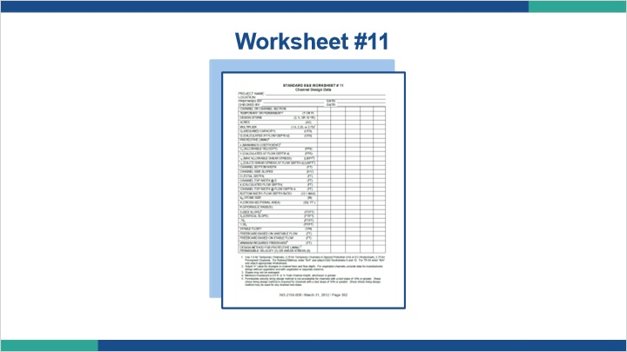
Notes:
Worksheet #11 or an equivalent should be completed for each segment of slope. If you decide to use vegetation as the lining, you will need to have calculations and construction details for a temporary liner as well.

3.11 Example
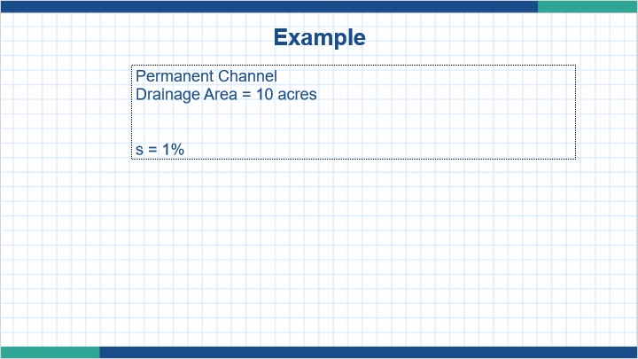
Notes:
Let’s walk through an example. The channel we are designing will be a permanent channel. The drainage area to this channel is 10 acres. The bed slope of the channel is 1%.

3.12 Example
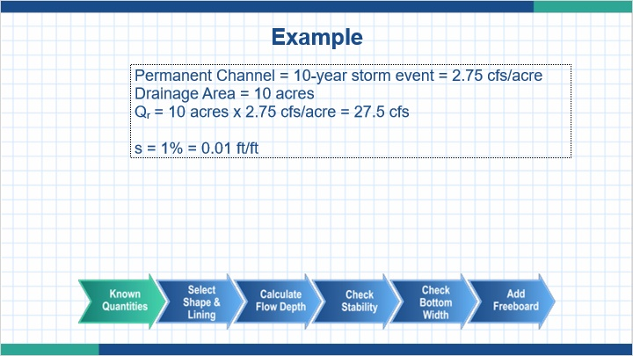
Notes:
Our known quantities are Qr, the required flow capacity, and slope.

We know that permanent channels are required to convey the flow from a 10-year storm event, or 2.75 cfs/acre. Multiplying this by our drainage area of 10 acres gives us a Qr of 27.5 cfs.

Our slope is 1%, but we will want to use decimal form for mathematical purposes. 1% = 0.01 ft/ft

3.13 Example
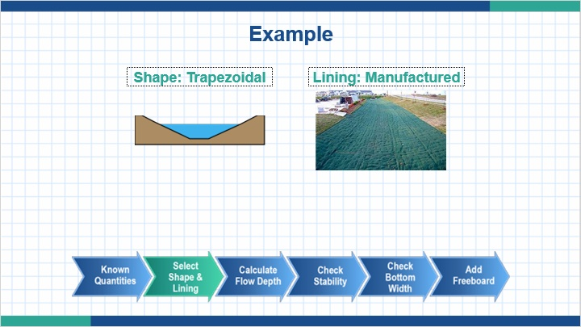
Notes:
For this example, we will select a trapezoidal shape and manufactured liner.

3.14 Example
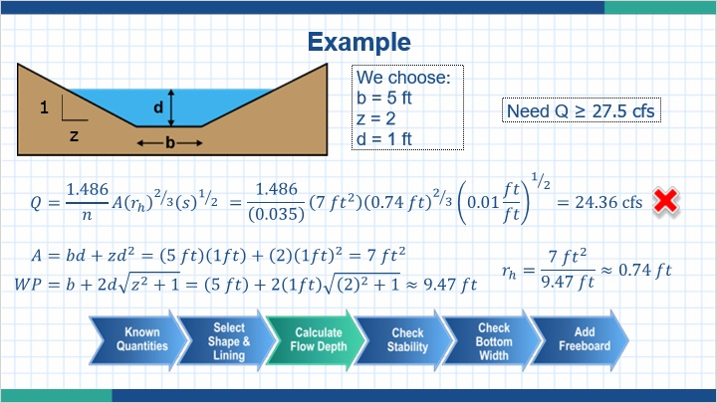
Notes:
Next we need to find dimensions of the channel which will meet our required Q of 27.5 cfs. We’ll start by arbitrarily choosing values of b = 5 ft, z = 2, and d = 1 ft.

To solve Manning’s equation for Q, we will need to find the area, hydraulic radius, and Manning’s n value.

Formulas for area and wetted perimeter around found in Table 6.1 (page 128). Inserting our values of b, z, and d give us an area of 7 ft² and an approximate wetted perimeter of 9.47 ft. The hydraulic radius is the quotient of the area and the wetted perimeter, which is 0.74 ft.

The Manning’s n value for our liner was provided by the manufacturer. For our example, n = 0.035.

Inserting these values into Manning’s equation yields a Q of 24.36 cfs. This is less than our required Q of 27.5 cfs, so we will need to tweak the dimensions.

3.15 Example
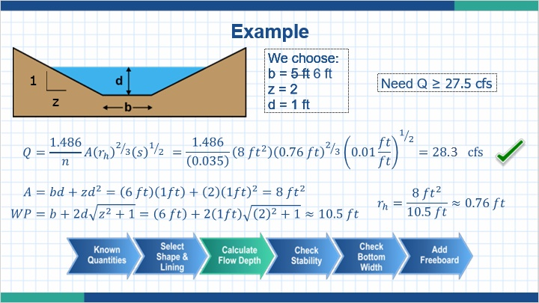
Notes:
Let’s adjust the bottom width to 6 ft instead of 5 ft. Doing so yields us a Q of 28.27 cfs, which is greater than our required Q of 27.5 cfs. We’re now ready to move onto the next step.

As you can see, it is quite tedious to repeat these calculations every time a dimension is adjusted. This is where a computer program or spreadsheet can both save time and prevent arithmetic errors.

3.16 Example
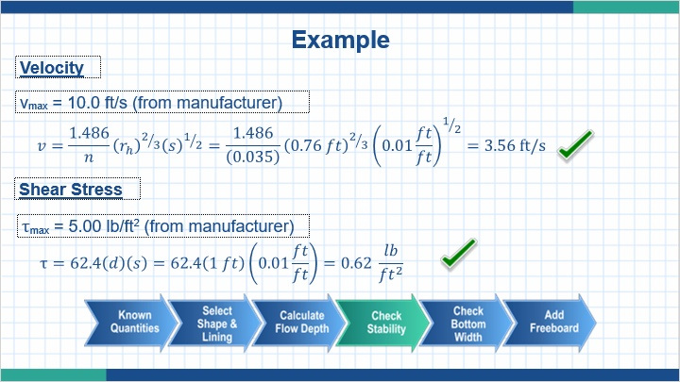
Notes:
Next, we will check the stability of our proposed channel. Since the slope is less than 10%, we can use the maximum permissible velocity method.

Like Manning’s n value, the manufacturer’s documentation listed the maximum permissible velocity. In this case, it is 10 ft/s.

Using Manning’s equation for velocity, we obtain a design velocity of 3.56 ft/s. This is less than the maximum permissible velocity, so the lining is acceptable.

Even though it is not required, we will also check the shear stress so you can see an example.

The manufacturer lists the maximum permissible shear stress as 5.00 lb/ft².

The design shear stress is calculated using the equation τ=62.4(d)(s). This yields us a result of 0.62 lb/ft², which is less than the maximum permissible shear stress.

3.17 Example
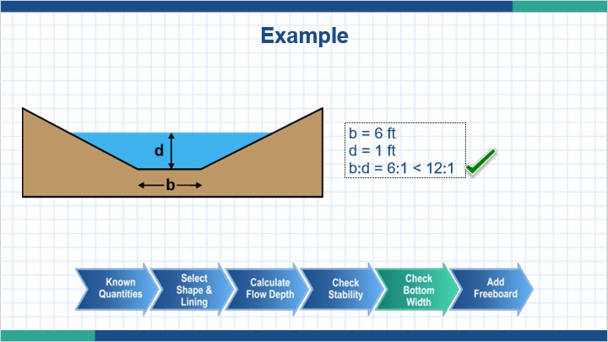
Notes:
From earlier steps, we know the bottom width, b, is 6 ft and the flow depth, d, is 1 ft. Our ratio of b:d is 6:1. This is less than the 12:1 requirement, so our bottom width is acceptable.

3.18 Example
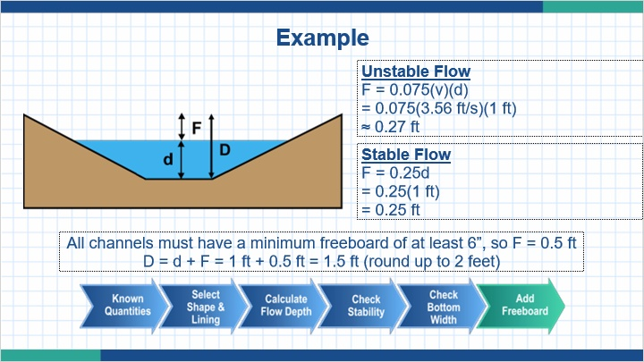
Notes:
Finally, we will calculate the freeboard and total depth of our proposed channel.

For training purposes, we will calculate both the freeboard for both conditions. The unstable flow gives a minimum freeboard of 0.27 ft and the stable flow gives a minimum freeboard of 0.25 ft.

However, page 139 of the manual states that all channels must have a minimum freeboard of 6 inches (0.5 ft) so we make our freeboard 0.5 ft.

The total depth of a channel, D, is the sum of the flow depth and the freeboard. For our proposed channel, this is 1.5 ft. We will round our final dimension up to the nearest foot.

3.19 Example
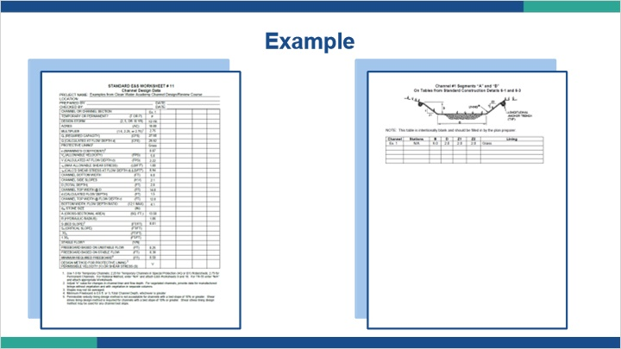
Notes:
Now that our proposed design is complete, we will add the necessary information into Worksheet #11 and the construction detail.

3.20 Example
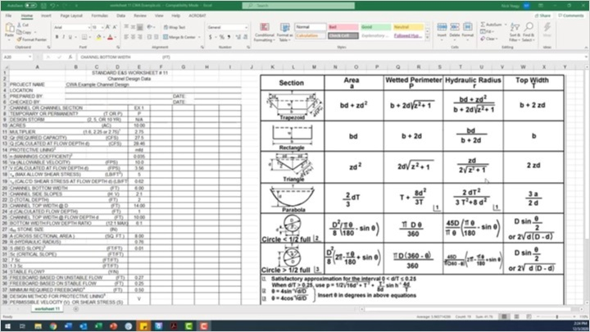
Notes:

3.21 Lesson 2 Summary
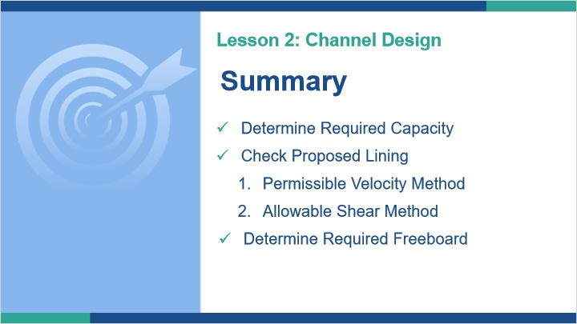
Notes:
This concludes Lesson 2. In this lesson, we discussed channel design. Specifically, we showed how to determine the required capacity, how to check a proposed lining using the permissible velocity and allowable shear methods, and how to determine the required freeboard.

4. Lesson 3

4.1 Lesson 3 Learning Goals
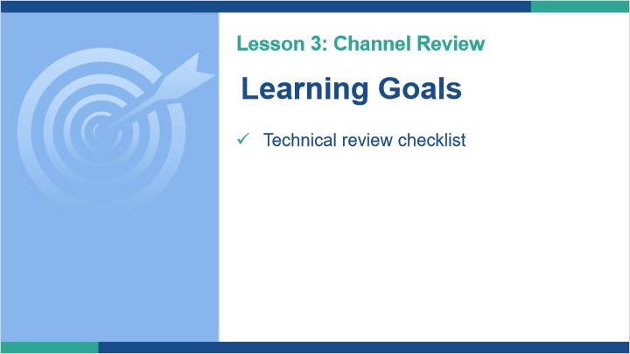
Notes:
Welcome to Lesson 3. In this lesson, we will discuss how channels are reviewed by DEP and conservation districts. We will take a close look at the channel specific items found on the technical review checklist.

4.2 Technical Review Checklist
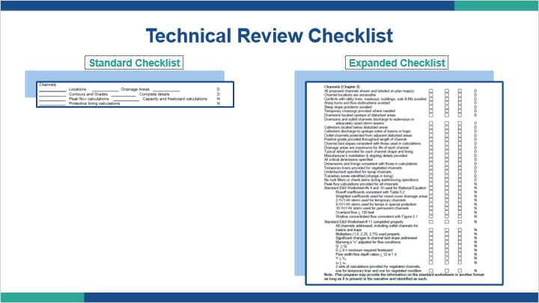
Notes:
The technical review checklist should be used when reviewing proposed channels. There are two checklists available for reviewers. The standard checklist is found on page 357 of the manual.

The expanded checklist is found on page 360 of the manual. Both checklists have the same items, but the expanded checklist has more detailed lists than the standard checklist. It is recommended that newer staff consult the expanded checklist until they feel comfortable using the standard checklist by itself.

For each checklist, you will notice a D or N next to each item. D means that the item is found on the plan drawing while items marked with N are found in the plan narrative.

4.3 Technical Review Checklist
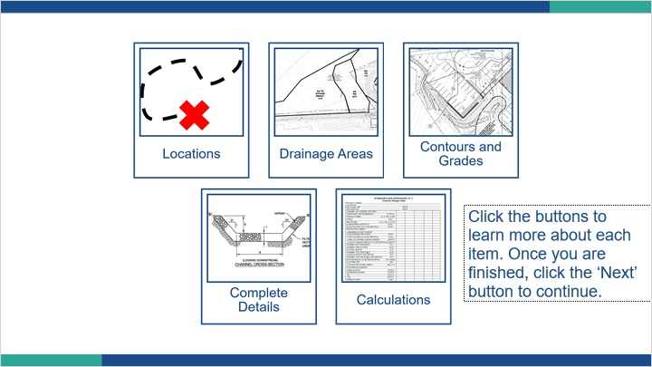
Notes:
The standard checklist outlines five items that must be checked during a technical review. They are the locations, drainage areas, contours & grades, complete details, and calculations for all proposed channels. Click the buttons to learn more about each item. Once you are finished, click the ‘Next’ button.

4.4 Locations
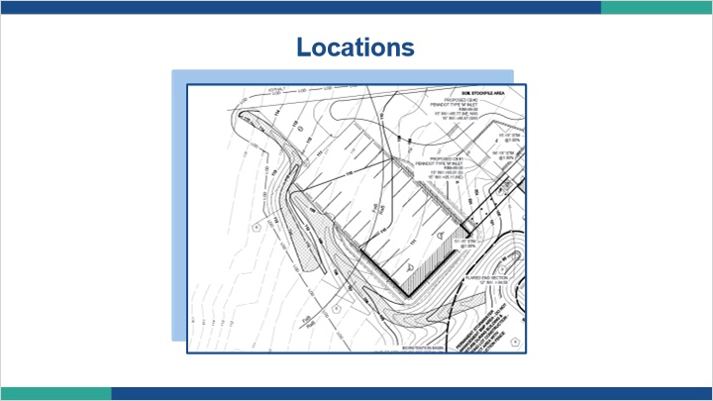
Notes:
When checking the locations item on the technical review checklist, you’ll want to check the following.

All proposed channels are shown and labeled on the plan maps.

Channel locations are accessible. Conflicts with utility lines, roadways, buildings, cuts & fills are avoided. Temporary crossings are provided where needed.

Sharp turns, flow obstructions, and steep slope problems are avoided.

Diversion channels are located upslope of disturbed areas and collector channels are located downslope.

Diversion and conveyance channels discharge to waterways or adequately sized storm sewers. Collector channels discharge to the upslope sides of basins or traps.

Conveyance channels are protected from adjacent disturbed areas.

4.5 Drainage Areas
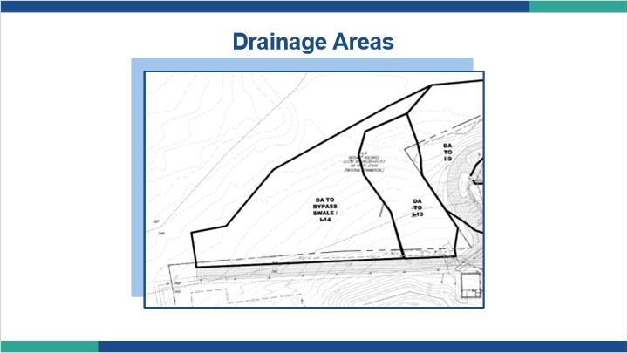
Notes:
Projects proposing channels should include a channel drainage area map. The drainage area map should clearly show the maximum drainage area to each proposed channel.

If the proposed channel will collect from an off-site area, the offsite area will need to be delineated along with existing contour information.

Drainage areas may change as construction progresses, it is not necessarily pre or post construction drainage areas. It is the project designer’s responsibility to ensure the channels are designed properly so it is the maximum drainage area.

All drainage area mapping should have a scale. The scale should be clearly shown on the drainage area maps.

Drainage area maps should contain soils information, contours, and cover type. Channels designed with rational equation should include the flow path used to calculate the time of concentration.

Note that drainage maps can either be included with the plan drawings or in the plan narrative. Either place is acceptable.

4.6 Contours and Grades
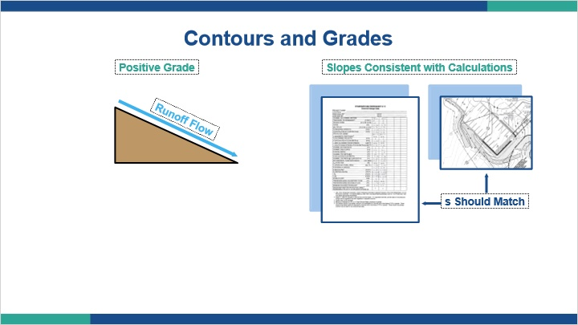
Notes:
It is important to check the contours and grading of channels during a technical review. There are two items we’ll want to look at.

First, channels must have positive grade provided throughout its length. This allows runoff to flow down the slope instead of ponding.

Second is that channel bed slopes, bottom width, and total depth must be consistent with those used in the calculations

4.7 Contours and Grading
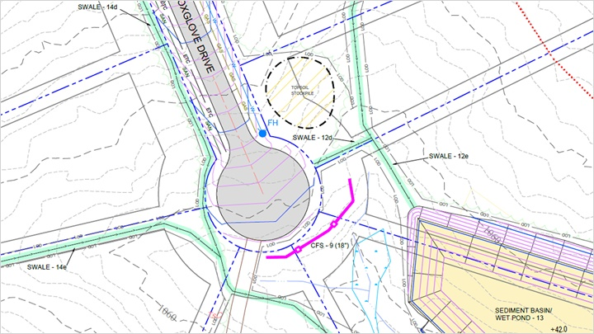
Notes:
Here is an example of a poor channel drawing. As you can see, the proposed contours are not shown on this drawing as required. Instead, arrows are used to show the direction of flow in the channel. This is not acceptable, and should be a comment for the designer.

4.8 Complete Details
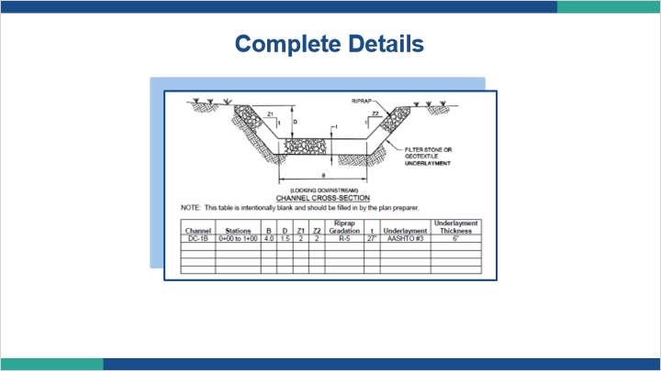
Notes:
Construction details must be included in the plan narrative. When reviewing details, you must look at the following.

A typical detail is provided for each channel shape and lining. All critical dimensions are specified on the detail. The dimensions and linings are consistent with those found in the calculations.

Any transition zones, which are changes in lining, are identified.

Manufacturer’s installation & stapling details are provided where applicable.

Temporary liner details are provided for vegetated channels.

For channels lined with riprap, the underlayment is specified on the detail.

Rock filters and check dams are not used during earthmoving operations.

4.9 Calculations
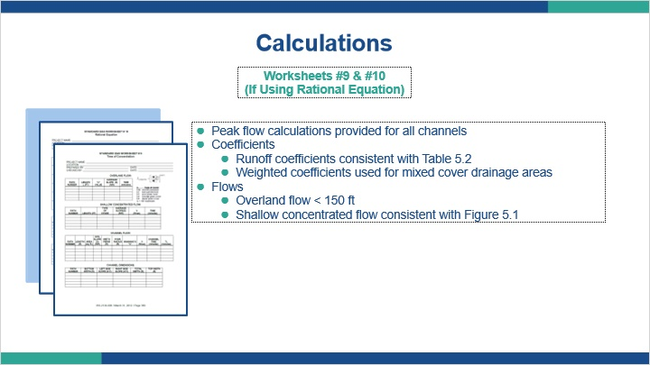
Notes:
In Lessons 1 and 2, we discussed the calculations associated with channel design. During a technical review, we check these to make sure the design calculations are correct and meet minimum requirements.

If the rational equation was used, Worksheets #9 and #10 must be checked. Here are some of the items to look at.

Peak flow calculations are provided for all channels.

Runoff coefficients are consistent with Table 5.2 and weighted coefficients are used for mixed cover drainage areas.

Overland flows are less than 150 ft (typically 100 ft is the limit) and shallow concentrated flows are consistent with Figure 5.1.

4.10 Calculations
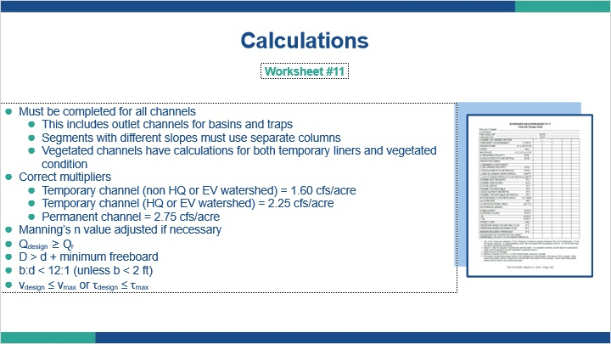
Notes:
Worksheet #11 or an equivalent should be provided for all channels. This includes outlet channels for basins, traps, compost sock diversion channels, and temporary channels. When reviewing Worksheet #11, there are several items you’ll need to check.

First is that channels with significant changes in bed slope are designed in segments. Each segment should be calculated separately and listed in separate columns on Worksheet #11.

Vegetated channels should have two sets of calculations provided. One set is for the temporary liner, and the other is for when the channel is completely vegetated.

Check that the correct multiplier is used for each channel. Temporary channels not in an HQ or EV watershed should use 1.60 cfs/acre, temporary channels in an HQ or EV watershed should use 2.25 cfs/acre, and permanent channels should use 2.75 cfs/acre.

Manning’s n value must be adjusted for changes in channel liner and flow depth. The manning’s n value is significant. The flow depth, hydraulic radius and cross-sectional area are calculated based on an accurate manning’s n value used in the manning’s equation. Reviewers should check this value first since an inaccurate manning’s n value will yield inaccurate information in Worksheet #11.

The design capacity of the channel must be greater than or equal to the required capacity. The required capacity is based upon the size of the drainage area and the design storm event.

The total depth, denoted by capital D, must be greater than the sum of the flow depth, denoted by lowercase d, and minimum required freeboard.

The ratio of flow width, denoted by b, to flow depth should be less than 12:1 to prevent concentrated flows. As mentioned in Lesson 2, ratios greater than 12:1 are acceptable if the flow width is less than two feet.

Finally, the design velocity must be less than or equal to the maximum permissible velocity, or the design shear stress must be less than or equal to the maximum allowable shear stress.

4.11 Lesson 3: Summary
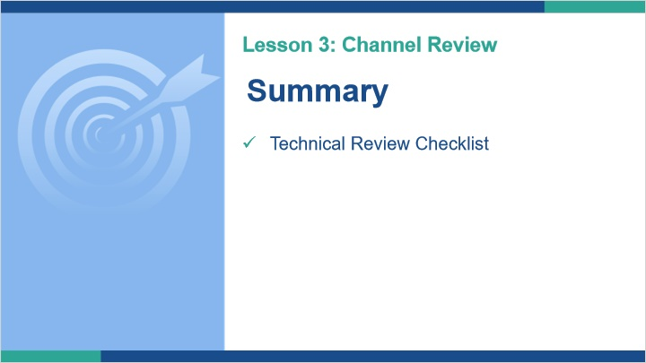
Notes:
This concludes Lesson 3. In this lesson, we discussed how channels are reviewed by DEP and conservation districts. Specifically, we took a close look at the channel specific items found on the technical review checklist.

5. Wrap Up

5.1 Course Summary
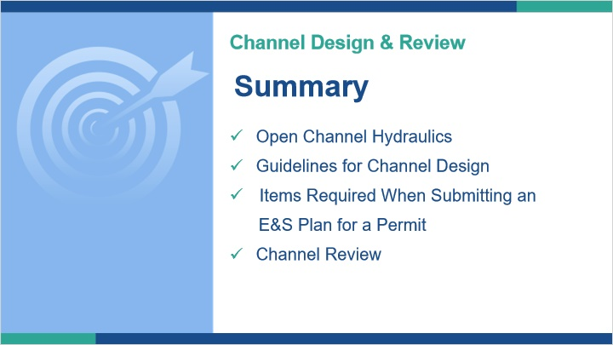
Notes:
This concludes the course. We discusse the basics of open channel hydraulics, guidelines for channel design, items which should be submitted with the E&S plan, and what DEP and conservation district staff need to look for when reviewing proposed channel designs.

5.2 Draw from Question Bank 1
Draw 10 questions randomly from Question Bank 1

5.3 Results
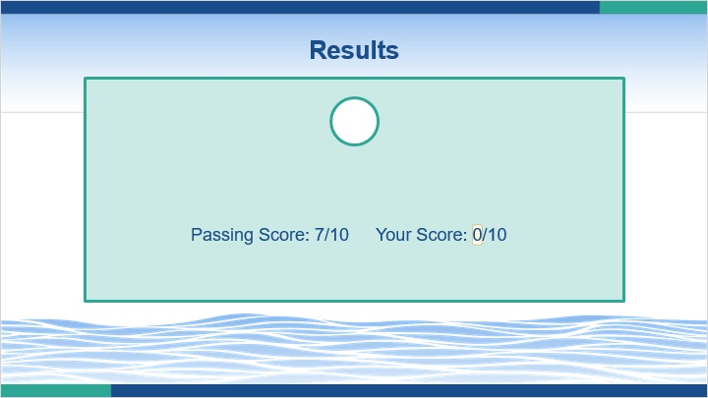

5.4 Certificate
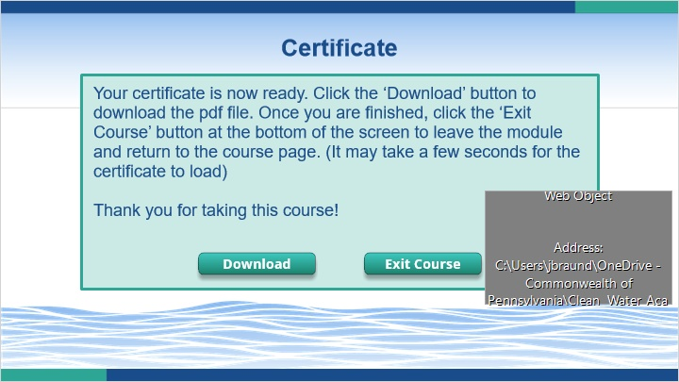

5.5 Certificate
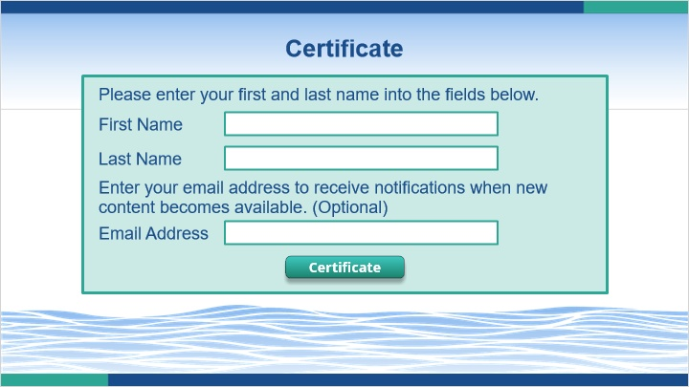

6. Review

6.1 Review of Part I

Notes:
Before we dive into open channel hydraulics, let’s review a few things from the first course. If you have not already done so, it is recommended to complete the first course before continuing.

6.2 Channel Types
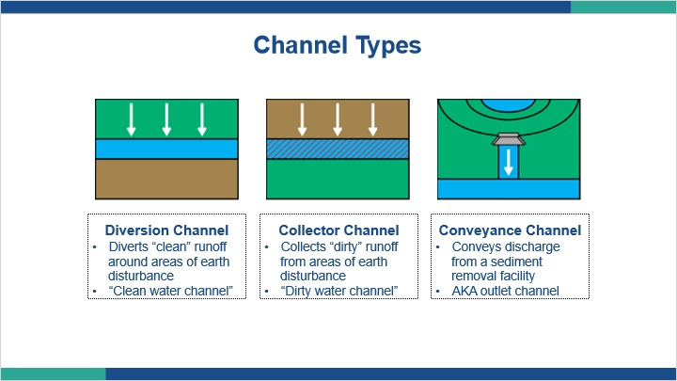
Notes:
There are three types of channels. Diversion channels are a “clean water channel” that diverts “clean” runoff around areas of earth disturbance. Collector channels are a “dirty water channel” that collects sediment laden runoff from areas of earth disturbance and conveys them to sediment removal facilities (such traps and basins). Conveyance channels convey discharge from a sediment removal facility or stormwater outfall to receiving surface waters. These are also referred to as outlet channels.

No matter what type of channel it falls under, all channels are designed in the same manner.

6.3 Channel Shapes
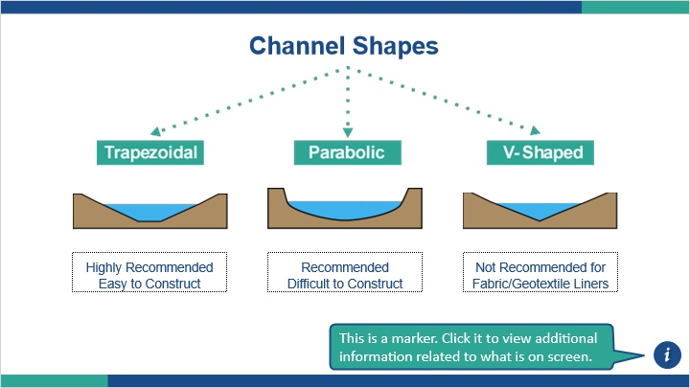
Notes:
Table 6.1 on page 128 of the manual shows some shapes used for channels. Among these, trapezoidal channels are highly recommended due to their effectiveness and ease of construction. Parabolic channels are recommended but difficult to properly construct. V-shaped channels are sometimes used but are not recommended when using fabric or geotextile liners.

6.4 Channel Design
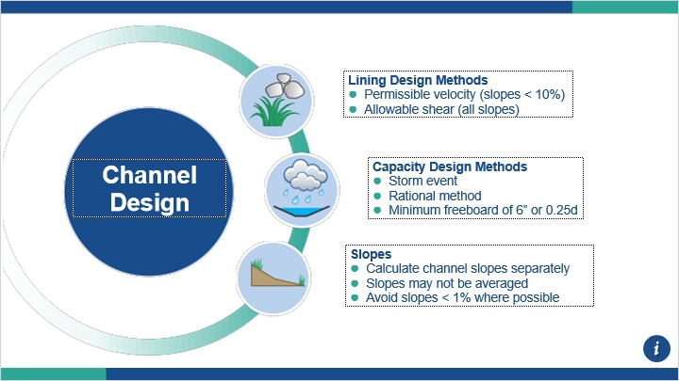
Notes:
There are two methods used when designing channel liners. The permissible velocity method may be used if the channel bed slope is less than 10%. The allowable shear method may be used for all channel bed slopes.

When determining the capacity for a channel, the manual outlines which storm events channels should be designed for. The pulsing marker shows a table of these values. The rational method can be used to determine channel capacity as well. Worksheets #9 & 10 are should be included when using the rational method. For both methods, an adequate freeboard should be included. The minimum freeboard is 6” or ¼ of the flow depth d, whichever is greater.

Channels which have multiple different slopes should be calculated separately in sections. Slopes may not be averaged instead of calculating the capacity and lining for each section separately. Slopes less than 1% should be avoided where possible as this can cause water to pool instead of adequately flowing.

We will explore all three of these principles in more detail later in the course.

6.5 Submission Requirements
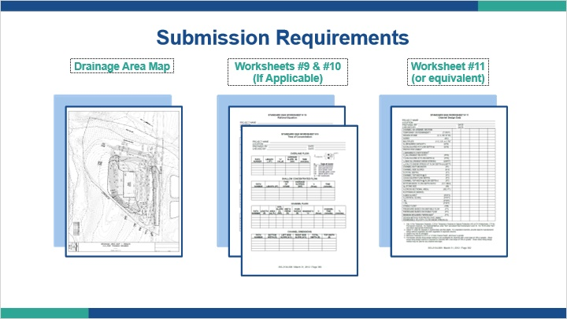
Notes:
Projects which have proposed channels should include a drainage area map of the channel, Worksheets #9 and #10 if the rational method is used, and either Worksheet #11 or an equivalent.

6.6 Course Menu
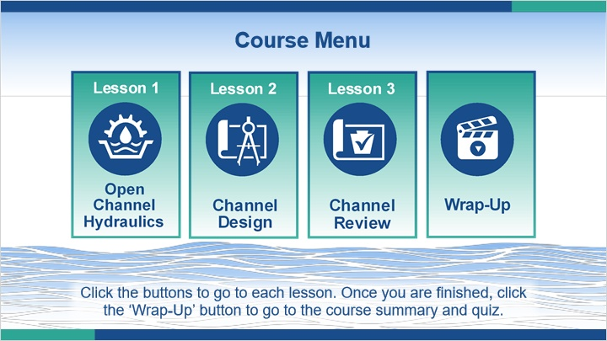
Notes:
This course is broken up into three lessons. Lesson 1 teaches open channel hydraulics, Lesson 2 covers channel design, and Lesson 3 discusses the review of proposed channel designs. Click the buttons to go to each lesson. Once you are finished, click the ‘Wrap-Up’ button to go to the course summary and quiz.

7. Untitled Scene

7.1 Results Slide
(Results Slide, 0 points, 1 attempt permitted)
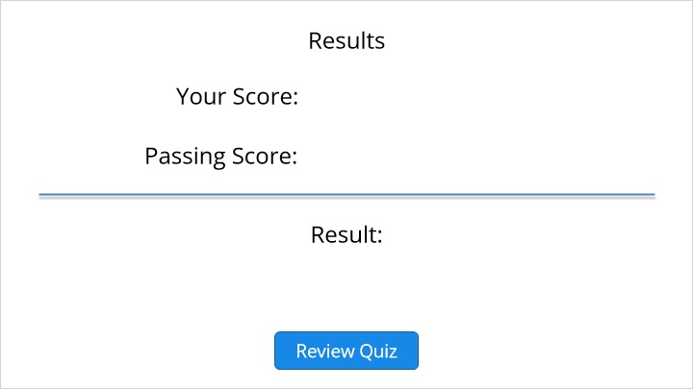

Results for
5.2 Draw from Question Bank 1

Result slide properties
Passing  Score | 70%

1. Question Bank 1

Q1.1 Match each channel type with the multiplier which should be used for determining minimum channel capacity.
(Matching Drag-and-Drop, 1 points, 1 attempt permitted)
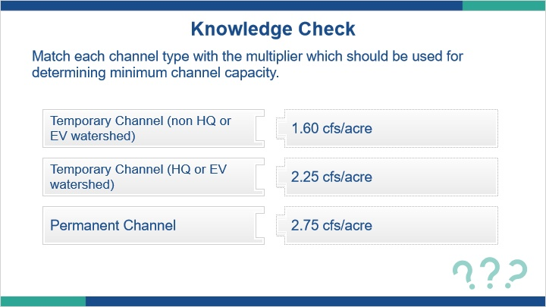
Correct | Choice
Temporary Channel (non HQ or EV watershed) | 1.60 cfs/acre
Temporary Channel (HQ or EV watershed) | 2.25 cfs/acre
Permanent Channel | 2.75 cfs/acre

Feedback when correct:
Temporary Channel (non HQ or EV watershed) = 1.60 cfs/acre
Temporary Channel (HQ or EV watershed) = 2.25 cfs/acre
Permanent Channel = 2.75 cfs/acre
Feedback when incorrect:
Temporary Channel (non HQ or EV watershed) = 1.60 cfs/acre
Temporary Channel (HQ or EV watershed) = 2.25 cfs/acre
Permanent Channel = 2.75 cfs/acre

Q1.2 Which of the following channel-specific items must be submitted for a technical review? (select all that apply)
(Multiple Response, 1 points, 1 attempt permitted)
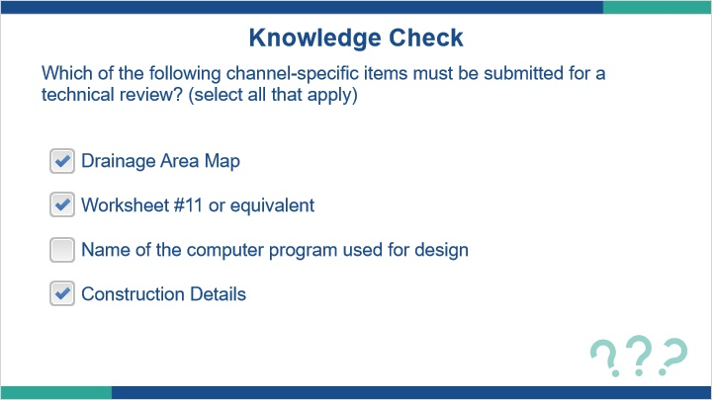
Correct | Choice
X | Drainage Area Map
X | Worksheet #11 or equivalent
 | Name of the computer program used for design
X | Construction Details

Feedback when correct:
Worksheet #11, construction details, and drainage area maps should be submitted for the technical review. The name of the computer program used to design the channel is irrelevant and not needed.
Feedback when incorrect:
Worksheet #11, construction details, and drainage area maps should be submitted for the technical review. The name of the computer program used to design the channel is irrelevant and not needed.

Q1.3 What is the wetted perimeter of this channel?
(Multiple Choice, 1 points, 3 attempts permitted)
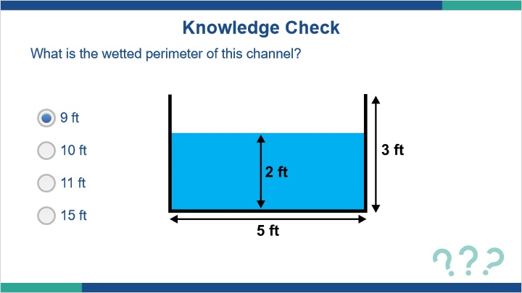
Correct | Choice
X | 9 ft
 | 10 ft
 | 11 ft
 | 15 ft

Feedback when correct:
The wetted perimeter of this channel is 9 ft. Remember that the wetted perimeter is the length of the boundary between the water and the channel sides and bottom. In this case, it is 2 ft + 5 ft + 2 ft = 9 ft.
Feedback when incorrect:
The wetted perimeter of this channel is 9 ft. Remember that the wetted perimeter is the length of the boundary between the water and the channel sides and bottom. In this case, it is 2 ft + 5 ft + 2 ft = 9 ft.

Q1.4 What is the cross-sectional flow area of this channel?
(Multiple Choice, 1 points, 3 attempts permitted)
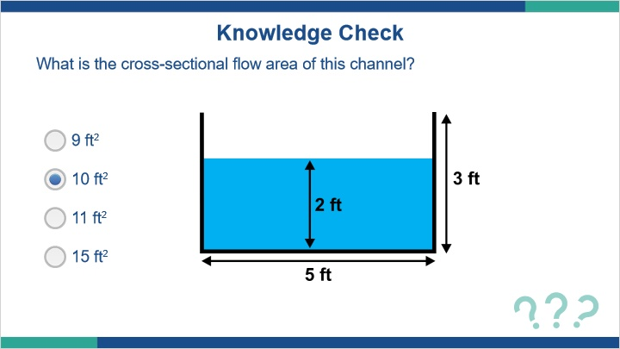
Correct | Choice
 | 9 ft2
X | 10 ft2
 | 11 ft2
 | 15 ft2

Feedback when correct:
Since this channel cross-section is a rectangle, we can solve for its area using simple geometry. 5 ft x 2 ft = 10 ft2.
Feedback when incorrect:
Since this channel cross-section is a rectangle, we can solve for its area using simple geometry. 5 ft x 2 ft = 10 ft2.

Q1.5 What is the hydraulic radius of this channel?
(Multiple Choice, 1 points, 3 attempts permitted)
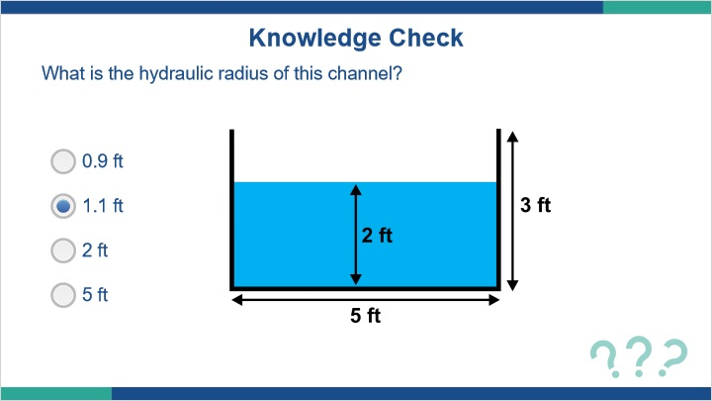
Correct | Choice
 | 0.9 ft
X | 1.1 ft
 | 2 ft
 | 5 ft

Feedback when correct:
Remember that the hydraulic radius is equal to the cross-sectional flow area divided by the wetted perimeter. From the last two questions, we know P = 9 ft and A = 10 ft2. Therefore, R = A/P = 10ft2/9ft = 1.1 ft.
Feedback when incorrect:
Remember that the hydraulic radius is equal to the cross-sectional flow area divided by the wetted perimeter. From the last two questions, we know P = 9 ft and A = 10 ft2. Therefore, R = A/P = 10ft2/9ft = 1.1 ft.

Q1.6 Which of the following issues would occur if the average slope was used in this figure instead of two separate segments?
(Multiple Choice, 1 points, 1 attempt permitted)
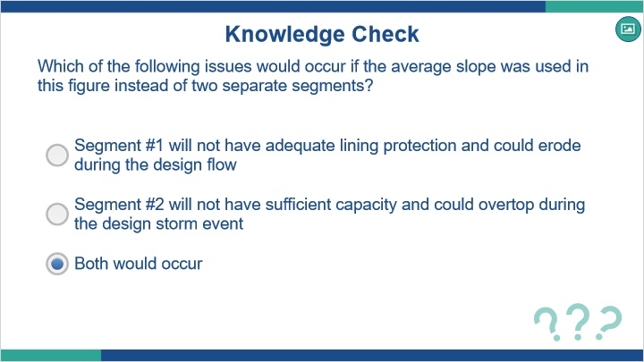
Correct | Choice
 | Segment #1 will not have adequate lining protection and could erode during the design flow
 | Segment #2 will not have sufficient capacity and could overtop during the design storm event
X | Both would occur

Feedback when correct:
Both of these issues could occur if the segments were designed together using the average of their slopes.
Feedback when incorrect:
Both of these issues could occur if the segments were designed together using the average of their slopes.

Q1.7 Which of the following are acceptable methods for designing the channel shown in the figure?
(Multiple Choice, 1 points, 1 attempt permitted)
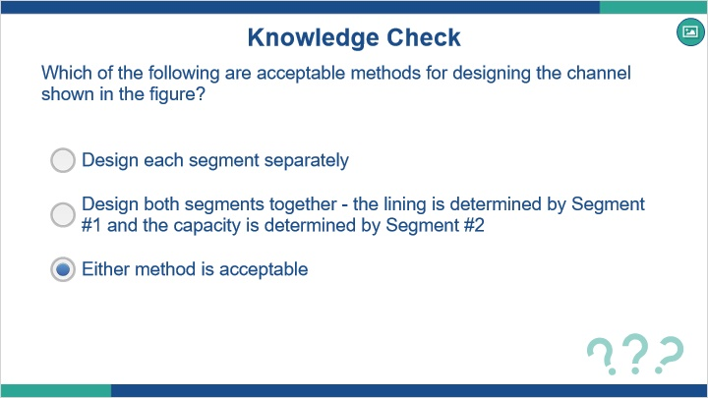
Correct | Choice
 | Design each segment separately
 | Design both segments together - the lining is determined by Segment #1 and the capacity is determined by Segment #2
X | Either method is acceptable

Feedback when correct:
Either method is acceptable, as long as all parts of the channel are designed with adequate lining and flow capacity.
Feedback when incorrect:
Either method is acceptable, as long as all parts of the channel are designed with adequate lining and flow capacity.

Q1.8 If a channel will be lined with vegetation, calculations and details must also be provided for a temporary lining.
(True/False, 1 points, 1 attempt permitted)
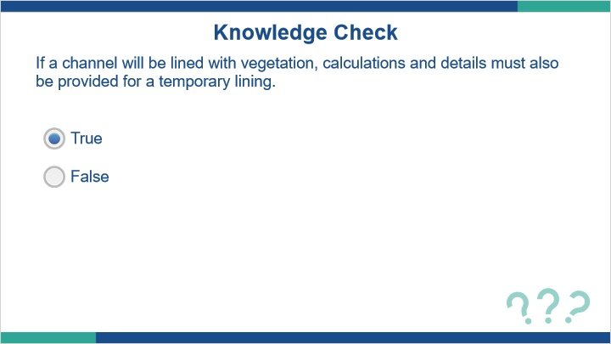
Correct | Choice
X | True
 | False

Feedback when correct:
Even though the channel will be lined with vegetation, a temporary liner is necessary until the vegetation is fully established. Calculations and construction details must be provided for any temporary linings.
Feedback when incorrect:
Even though the channel will be lined with vegetation, a temporary liner is necessary until the vegetation is fully established. Calculations and construction details must be provided for any temporary linings.

Q1.9 The allowable shear method may be used for all slopes.
(True/False, 1 points, 1 attempt permitted)
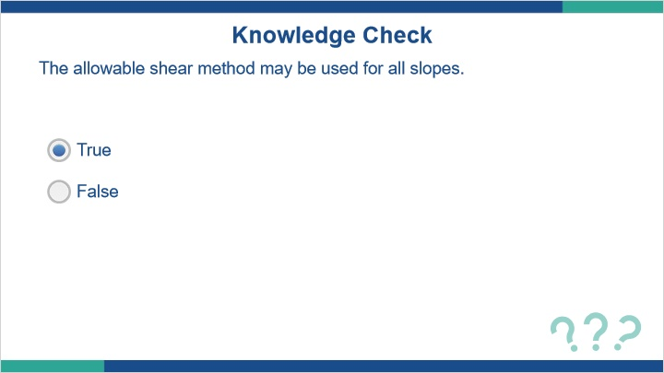
Correct | Choice
X | True
 | False

Feedback when correct:
The allowable shear method can be used for all slopes. The permissible velocity method may only be used for slopes <10%.
Feedback when incorrect:
The allowable shear method can be used for all slopes. The permissible velocity method may only be used for slopes <10%.

Q1.10 In channels where b:d > 12:1, flows tend to concentrate and cause erosion of the channel bed.
(True/False, 1 points, 1 attempt permitted)
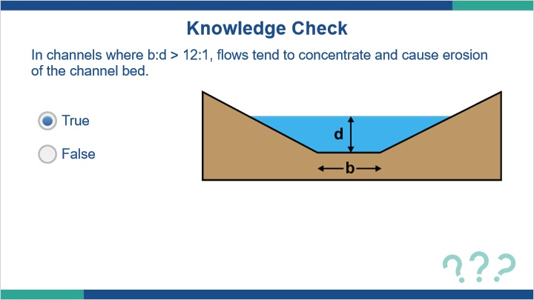
Correct | Choice
X | True
 | False

Feedback when correct:
In channels where b:d > 12:1, flows tend to concentrate and cause erosion of the channel bed.
Feedback when incorrect:
In channels where b:d > 12:1, flows tend to concentrate and cause erosion of the channel bed.

Q1.11 Sharp turns should be avoided since they can cause erosion.
(True/False, 1 points, 1 attempt permitted)
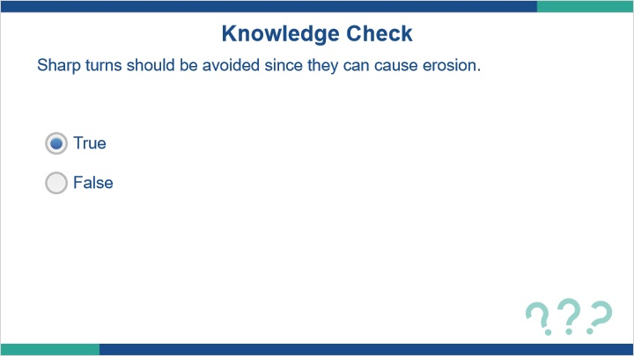
Correct | Choice
X | True
 | False

Feedback when correct:
Sharp turns can cause erosion and should be avoided if possible.
Feedback when incorrect:
Sharp turns can cause erosion and should be avoided if possible.

Q1.12 Which of the following can be computed using Manning’s equation? (select all that apply)
(Multiple Response, 1 points, 1 attempt permitted)
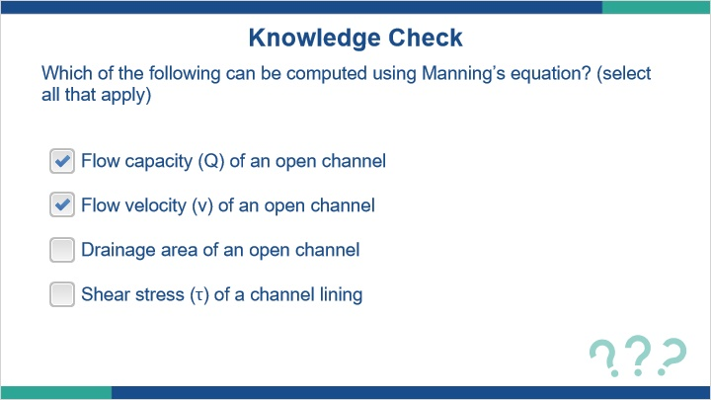
Correct | Choice
X | Flow capacity (Q) of an open channel
X | Flow velocity (v) of an open channel
 | Drainage area of an open channel
 | Shear stress (τ) of a channel lining

Feedback when correct:
The flow capacity (Q) and flow velocity (v) of an open channel can be calculated using Manning’s equation. The drainage area and shear stress are determined using other methods.
Feedback when incorrect:
The flow capacity (Q) and flow velocity (v) of an open channel can be calculated using Manning’s equation. The drainage area and shear stress are determined using other methods.

