Module 3: Design and Construction Considerations

1. DESIGN AND CONSTRUCTION

1.3 Design and Construction Menu
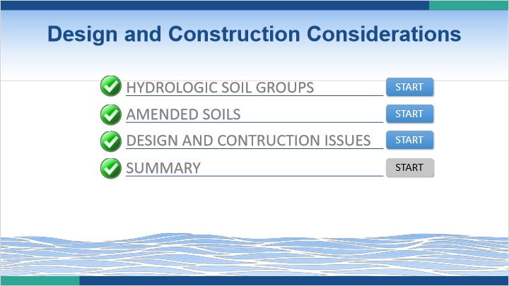
Notes:
Welcome to the Design and Construction Considerations Module. In this module, you will complete three lessons related to design and construction topics. Click on the start button for the first lesson to begin.

1.4 Hydrologic Soil Groups
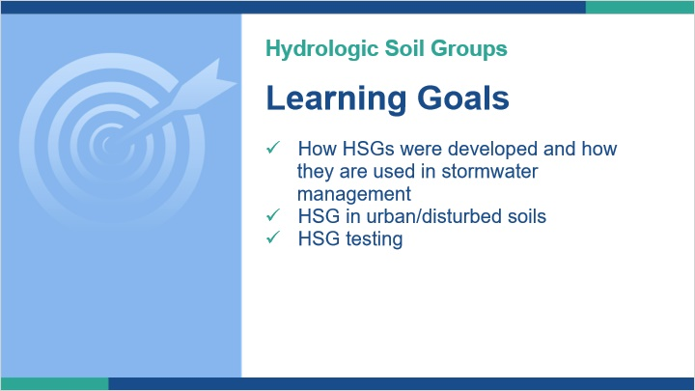
Notes:
Hydrologic Soil Groups are used when determining pre and post construction conditions. We aren’t going to discuss the use of them in that traditional sense. However, I think it is important to have a full understanding of what Hydrologic Soil Groups are and one particular area where more investigation might be warranted.

In this lesson we will review a brief history of how HSG came into existence. We’ll look at HSG in relation to urban soil polygons and other disturbed conditions. Finally, we’ll look at how site specific HSG determinations can be conducted.

1.5 Hydrologic Soil Groups
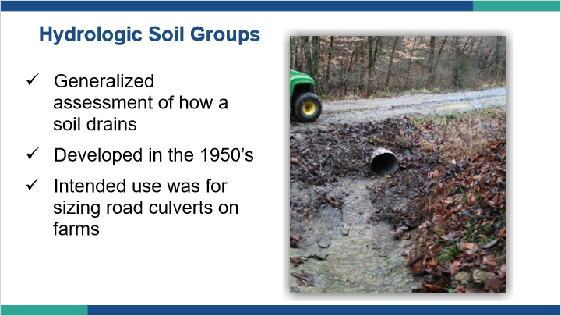
Notes:
Hydrologic Soil Groups were initially developed to help size road culverts on farms back in the 1950’s. They are a generalized assessment of how a soil drains.

1.6 Hydrologic Soil Groups
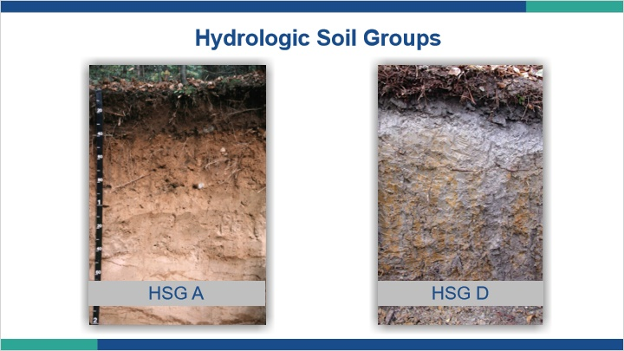
Notes:
When looking at Hydrologic Soil Groups, they fall into one of four designations: A, B, C, and D. A soils are the best drained, D soils are the worst drained. From a stormwater management perspective, A soils would be able to handle stormwater better than D soils.

1.7 HSG
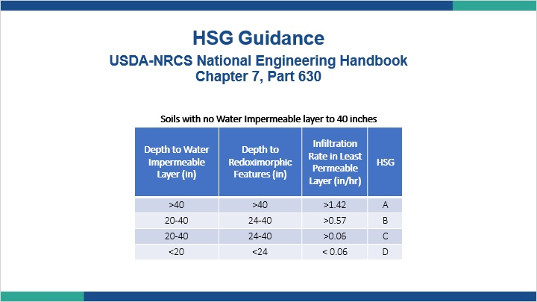
Notes:
Three main factors that are looked at are depth to a water impermeable layer, depth to redoximorphic features, and the infiltration rate in the least permeable layer. Based on tables like the one shown, soils are categorized into one of the groups.

1.8 HSG
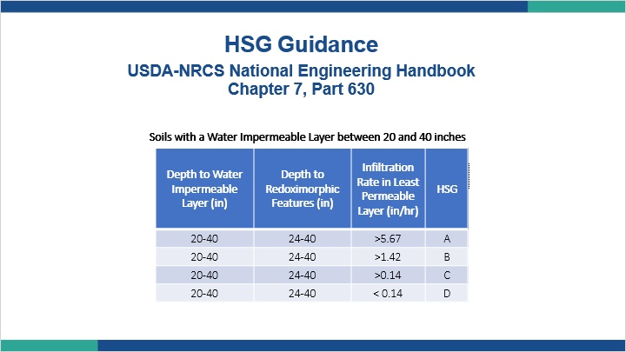
Notes:
As you can see, as the depth of useable soil decreases, the soil is expected to move more water to remain in the same group. In the previous table, for example, the infiltration rate for a group A soil was greater than 1.42 inches per hour. With a more shallow limitation, as expressed in this table, that rate needs to be greater than 5.67 inches per hour.

1.9 HSG
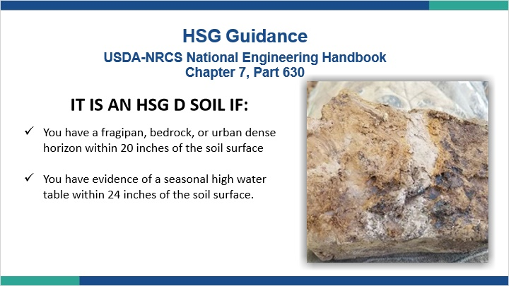
Notes:
As an example, a soil would be classified as a HSG D if it has a fragipan, bedrock, or urban dense horizon within 20 inches of the soil surface or you have evidence of a seasonal high water table within 24 inches of the soil surface.

1.10 HSG
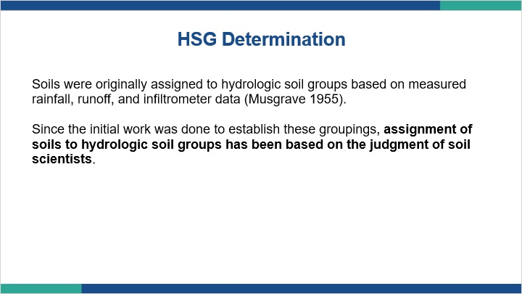
Notes:
Soils were originally assigned to hydrologic soil groups based on measured rainfall, runoff, and infiltrometer data. Since the initial work was done to establish these groupings, assignment of soils to hydrologic soil groups has been based on the judgment of soil scientists. So even though we can acquire HSG data for most mapped soil polygons, we need to understand the origin of that data and that it is being assigned on a pretty broad scale to map units.

1.11 Untitled Slide
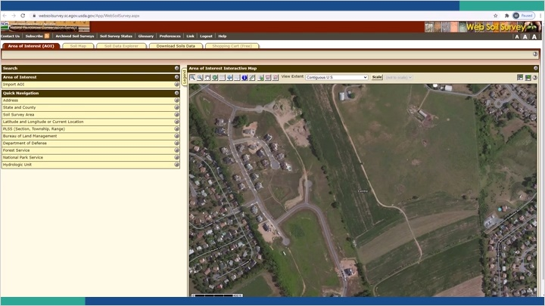
Notes:
To find the hydrologic soil group for soils on a particular site, you’ll need to open the NRCS web soil survey. On the Area of interest tab, you’ll draw a boundary around your site. Then you can click on the soil map tab to see the mapped soil polygons on your site along with an associated legend telling you the soil series names.
To view the hydrologic soil group assigned to those polygons, click on the soil data explorer tab and then the soil properties and qualities subtab. Under soil qualities and features you will find the hydrologic soil group. Expand the window and click on the view rating button. This will show a color coded map, but also as you scroll down you’ll see a table listing the map units and their associated hydrologic soil group. In this example, we have several soils with a B rating and some with a D rating. If you keep scrolling, you’ll see the description of what each hydrologic soil group means.
If you’d like to print this map and the associated tables. Go up to the top and hit printable version. Check off any changes you’d like to make, and then hit view. It will load into a pdf. As you scroll down you’ll see your map, map legend, and the hydrologic soil group table along with the descriptions.

1.12 What do you do with a HSG?

Notes:
Now that you have a hydrologic soil group, what do you do with it? Hydrologic soil groups are used along with antecedent runoff condition, cover type, treatment, and hydrologic condition to determine curve numbers. Curve numbers are used in different methodologies to estimate runoff conditions both pre and post development. The Runoff Curve Number Method in section 8.2 of the BMP Manual is one example.

Once you have the hydrologic soil groups, you can go to publications like the USDA Urban Hydrology for Small Watersheds (TR-55) to look up curve numbers based on your site conditions and hydrologic soil groups. A link to this document is included in the resource tab. Certainly there are computer programs that can be used as well, but for our discussion we will focus on the tabular data.

In the tables, you will be gathering data for changes from pre to post development. So for example, if you have a soil that falls into hydrologic soil group B that is in existing condition of a grassed meadow, you would navigate to that table and determine that the Curve Number is 58 for that scenario. Now, assuming you are going to turn that area into a parking lot, you would navigate to the table that lists parking lots and see that the Curve Number is 98 for parking lots in any hydrologic soil group. Without getting into the specifics of the calculations, what we do with hydrologic soil groups is use them to help estimate the changes between predevelopment runoff conditions and post development runoff conditions. In this case, the difference between our Curve number changing from 58 to 98. It is that change that we are going to have to account for when designing our stormwater BMPs.

1.13 HSG
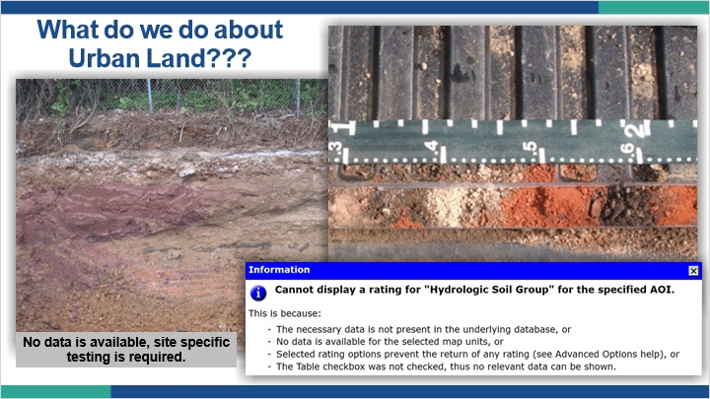
Notes:
The other issue that pops up is what to do in urban landscapes where a generic “urban” map unit is labeled? These units very often do not have a HSG identified, or even when they do the high variability in anthropogenic-impacted soils brings up the same range issues we discussed before.

1.14 HSG
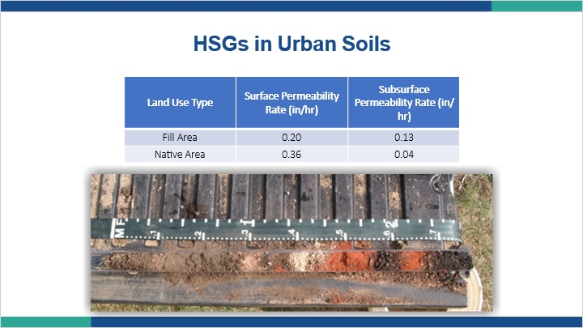
Notes:
I think the general assumption made with urban soils is that they must be worse than the native soils. However, depending on their composition of both material and pore space, they may actually behave more beneficially than native soils in relation to water movement. The problem is they are so variable, like all soils, it is hard to categorize them as either all good or all bad.

The great equalizer is data. By observing the soils and conducting permeability testing, we can more accurately assign an urban soil, or really any soil, into a more appropriate hydrologic soil group. Since we are making design decisions on calculations involving pre and post construction site conditions based on the HSG, having a more accurate understanding of actual site conditions should lead us to a better outcome.

1.15 Summary: Hydrologic Soils Groups Summary
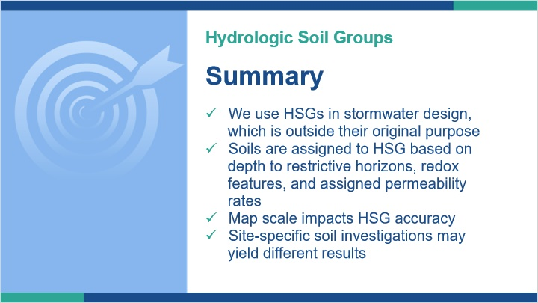
Notes:
In summary, Hydrologic Soil Groups used in stormwater management, although commonplace, is outside the original intended use. This isn’t necessarily a problem, but we should understand the framework that built the data we are utilizing.

Every HSG is classified as A, B, C or D, and that assignment is based on the depth to restrictive layer and redoximorphic features, with permeability ranges assigned for each class.

Within soil series and map units, there are multiple HSGs that are applicable. The scale of the map also impacts the accuracy of the assigned HSG>

Site-specific soil investigations may yield different results, which can have an impact on stormwater management design and costs.

If our intention in stormwater management is to accurately reflect the Pre-condition and to account for stormwater resulting from new impervious surfaces, then an accurate assessment of Hydrologic Soil Groups is essential.

1.16 Amended Soils
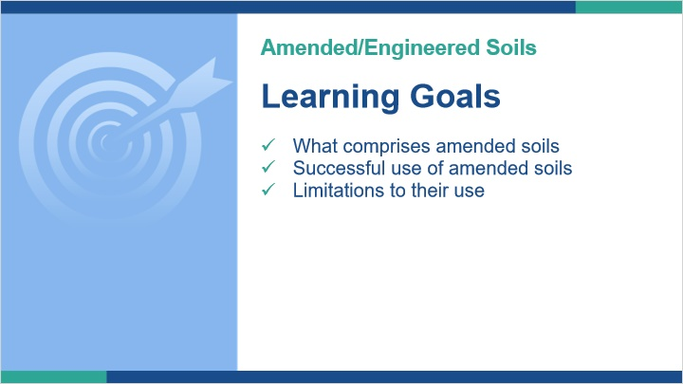
Notes:
In this lesson we will look at amended or engineered soils and how to increase the success of using them in stormwater control measures.

Although one can amend a native soil with things like organic matter while engineered soils connote a soil that is made and brought on site, most people use the terms interchangeably. For the purposes of this course, we will just use the term amended soil to simplify things.

1.17 You Have Unsuitable Soil, Now What?
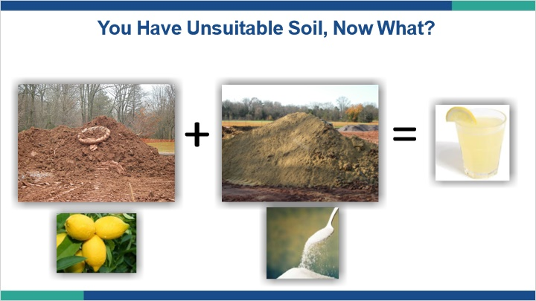
Notes:
If investigation of the native soils reveals limitations, we can potentially employ a few techniques to make an unsuitable condition suitable. One of those techniques is the use of amended soils. In the simplest terms, making an amended soil is kind of like executing a simple recipe, like making lemonade. You take a few ingredients that aren’t that great by themselves, mix them together and end up with something better. However, like most things, it’s not that simple. If your blend has too many lemons and not enough sugar, you end up with a bitter face. If your soil blend has too much of the wrong thing and not enough of the right thing, you end up with a bitter face for other reasons. Executed correctly, amended soils can be another tool in the toolbox to enhance stormwater management.

1.18 Making Soil!
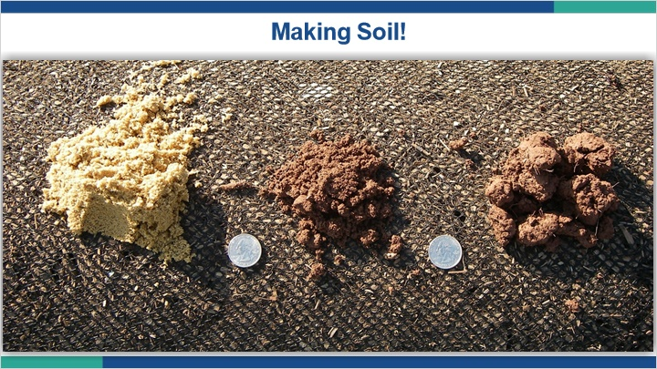
Notes:
So how does one make soil? We know that soil is comprised of sand, silt, clay and organic matter, so to make soil we just need to add those ingredients together right? We, also remember soils are comprised of matter and pore space, so we have to think through how we make the pore space component work. For example, we know from past lessons that fragipans typically have a loam texture, which means they have a somewhat equal mix of sand, silt, and clay. Loam textures generally are nice textures to have. However, in fragipans, the movement of that material causes all the different sized particles to pack tightly with the smaller particles filling the void spaces created by the larger particles. The result is we end up with very little well connected pore space, and therefore a horizon that restricts water movement.

If we’re making a soil and start mixing particles together, we run the very high risk of essentially creating a man-made fragipan. Since that’s not what we set out to do, we just spent a lot of time, energy and money make a bad situation worse.

1.19 Is this OK?
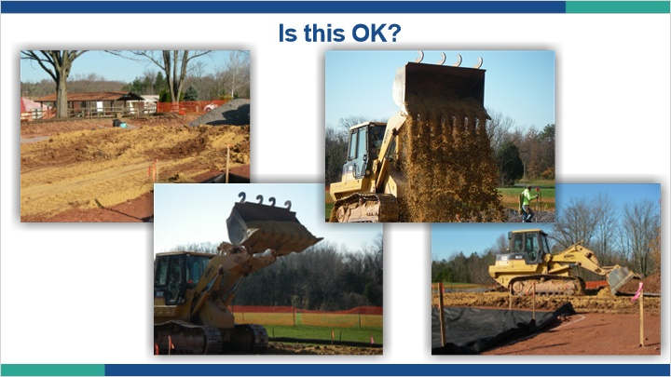
Notes:
Does this look like an efficient way to mix soils? Will the loader compact these soils and destroy structure? Remember, structure is typically how we institute good porosity in soils. Structure is also very hard to replicate from the natural state. So even when we might be using good materials, we may be doing it in a way that results in poor structure, which can mean poor water flow.

1.20

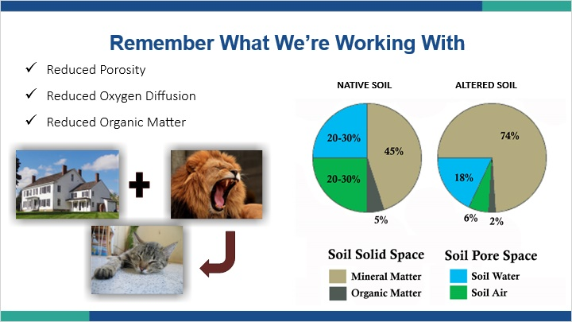
Notes:
So, just because we are trying to make a good soil, and seemingly have all the correct components, we’re never going to fully recreate what mother nature has produced. Just like you can’t make a domesticated cat by taking a wild cat and putting it in a domestic setting, you can’t make a fully functioning soil ecosystem by throwing some sand, silt, clay, and organic matter in a bucket and mixing it up. You can still end up with something useful, but it’s important to understand what we’re making, why we’re making it, and to do it in a manner that maximizes the positives of those goals.

1.21 Soil Mix Specifications
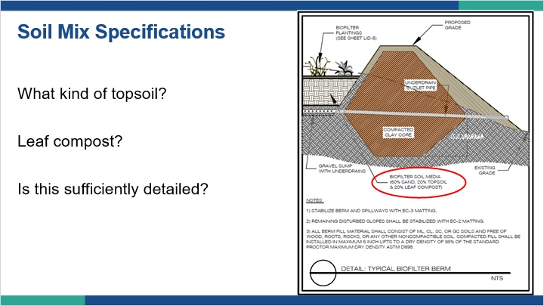
Notes:
In the movie Cool Hand Luke, there is a line that says, “What we have here is a failure to communicate”. That quote might apply fit many of our design specifications when it comes to amended soils. I don’t think it’s done intentionally but rather from a state of ignorance to some of the terms we’re using.

Take a look at this example for a bioremediation facility. The amended soil specification calls for:

60% sand

20% topsoil

20% leaf compost

Seems simple enough. Now let’s dig in a little. What kind of sand? Is this concrete sand, masonry sand, or washed masonry sand? Is it just for something that is sand sized even if it is man made like crushed glass?

What about the topsoil? Should we buy bags of topsoil from the home improvement store? Should we take the topsoil we scraped off onsite? What qualifies as topsoil? Is it just the first 6 inches of soil? How much clay is in topsoil? These are hard if not impossible questions to answer because topsoil isn’t a defined soil science term, it’s just a laymen’s term used to describe what soil scientists refer to as an A horizon. However, an A horizon only indicates an organically enriched mineral horizon. It doesn’t have any texture qualifications or other definable characteristics. So an A horizon could have 60% clay or no clay. It could have 3% organic matter or 15% organic matter.

Well surely leaf compost is easier to define, it’s compost made from leaves. Where can you buy leaf compost? How do you tell it’s leaf compost? What’s special about leaves that makes better compost? What if you can’t find leaf compost?

Clearly, what was meant to be a pretty straightforward and precise set of ingredients can result in a pretty wide range of characteristics.

1.22 Soil Mix Specifications
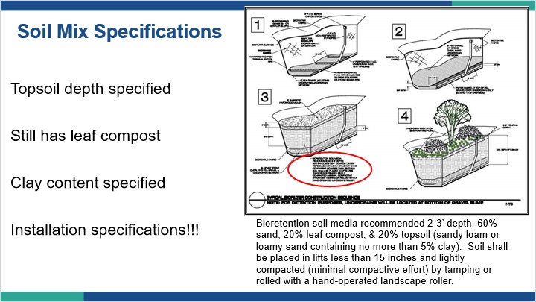
Notes:
Here’s another example that at first glance looks pretty similar. It recommends:

60% sand

20% leaf compost

20% topsoil just like the last specification.

This time, we get a bit more information for the topsoil. We’re told that it needs to be a sandy loam or loamy sand texture, containing no more than 5% clay. Sounds reasonable. However, let’s look at a textural triangle and see what that actually equates to.

Here we see in red the area that encompasses the texture range for the specified topsoil. That’s a pretty specific and narrow range, and the chances of finding it onsite are going to be pretty slim.

Also new to this specification is installation specifications. We’re told how to place our amended soil and to avoid compaction by using hand rolled techniques. Remember, pore space is critical to water flow, so this addition is more important than one might first think.

texture triangle (Slide Layer)
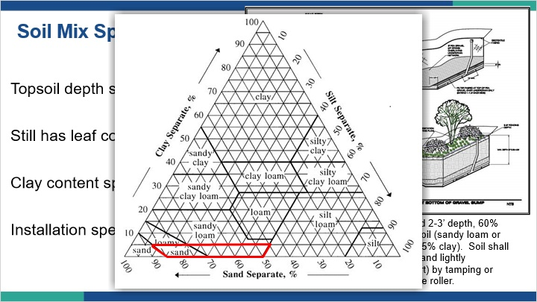

1.23 Athletic Field Turfgrass Specification
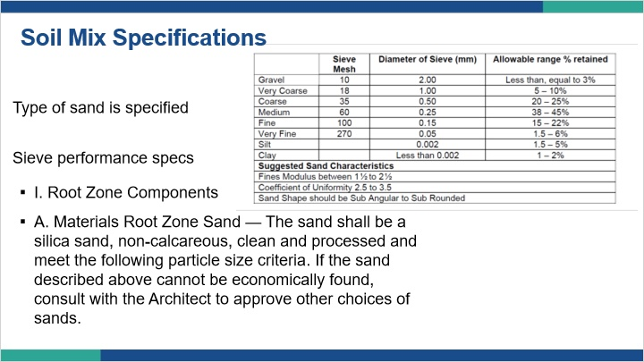
Notes:
Here we have a specification for just the sand component of the amended soil. This specification provides clear sieve guidelines so that a material can be tested and verified. It also discusses the makeup of the sand and that it should be washed of fines.

1.24 What’s the Perfect Amended Soil?
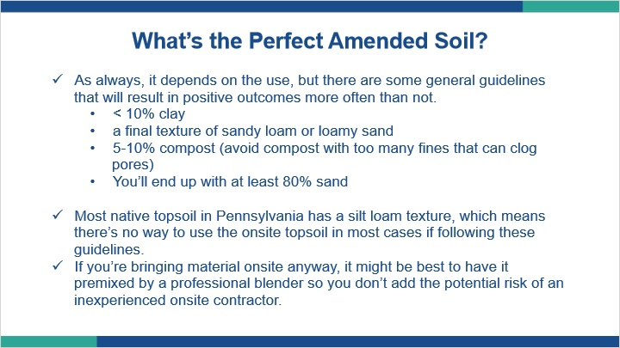
Notes:
What’s the perfect amended soil mix?

As always, it depends on the use and what materials are available, but there are some general guidelines that will result in positive outcomes more often than not.

less than 10% clay in the final mixture
A final texture of sandy loam or loamy sand
5 to 10% compost and avoid any compost with too many fines that can clog soil pores.
All of this will work out to the mix having at least 80% sand when complete. Avoid calcareous sands, like crushed limestone, as they will breakdown and have a pH effect.

Looking at this list and understanding the makeup of native Pennsylvania soils, most native topsoils in Pennsylvania have a silt loam texture which means there’s no way to use the onsite topsoil in most cases if following these guidelines.

If you’re bringing material onsite anyway, it might be best to have it premixed by a professional blender so you don’t add the potential risk of an inexperienced onsite contractor blending soils on the fly.

1.25 Poor outcome

Notes:
If one fails to get the mix right and place it with the care and attention it deserves, the result will be predictable, and not much fun to remedy.

1.26 Not a Magic Potion
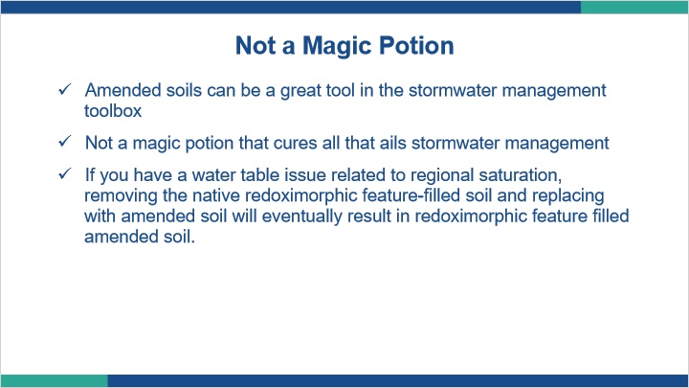
Notes:
Amended soils can be a great tool in the stormwater management toolbox, however, they are not a magic potion that cures all that ails stormwater management.

For example, if you have a soil that has redoximorphic features because of regional saturation and you decide to remove the issue of redoximorphic features by excavating the native soil out and filling the hole back in with amended soil, you didn’t address the real issue. The issue was shallow saturation from below, the symptom was the redoximorphic features. In the end, if you do this you will eventually end up with amended soils filled with the same redoximorphic features for the same reason the native soils had them.

1.27 Summary: Amended/Engineered Soils
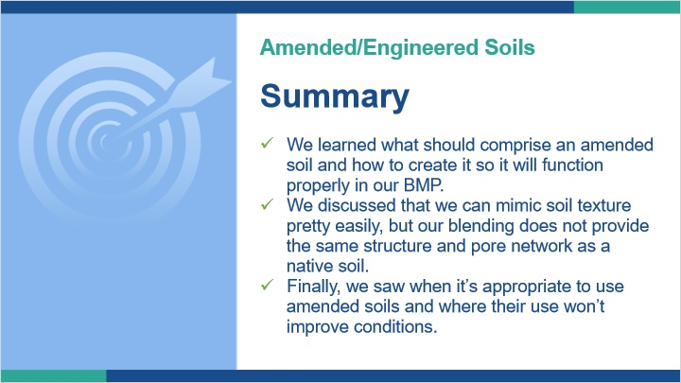
Notes:
In this lesson we learned what should comprise an amended soil and how to create it so it will function properly in our BMP.

We discussed that we can mimic soil texture pretty easily, but blending a soil does not provide the same structure and pore network that a native soil has. Therefore, we need to formulate our soil to make up for the structure deficiencies.

Finally, we saw when it’s appropriate to use amended soils and where their use won’t improve conditions.

1.28 Design and Construction Issues
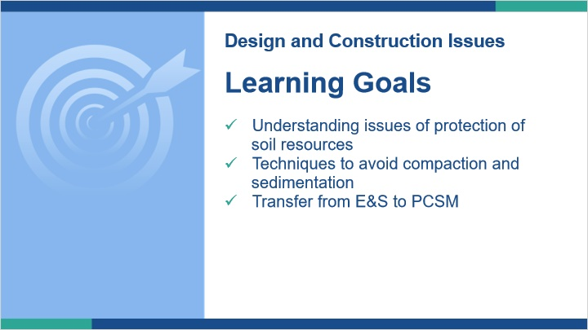
Notes:
In this lesson we will pull together the collective knowledge we have gained in this course to discuss a few topics related to BMPs. Critically, we will look at how we protect the soils to maintain properly functioning BMPs. This will include looking at avoiding compaction and sedimentation as well as things to consider when converting from active construction to post construction stormwater management.

1.29 Planning out the Construction Sequence
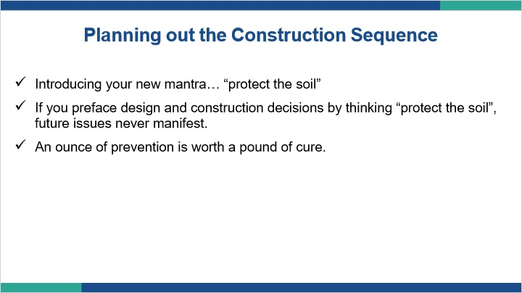
Notes:
We’ve spent this course looking at the properties of soils and how those properties can help us manage stormwater. That knowledge is great, but if it never makes it past the soil investigation stage it’s useless. Incorporating thinking about soil into the design and construction phases will yield the long term success we are striving for.

To that end, I want to introduce your new stormwater mantra, “protect the soil”.

If you preface design and construction decisions by thinking “how can I protect the soil?”, future issues will never manifest.

Remember the saying, an ounce of prevention is worth a pound of cure.

1.30 Planning out the Construction Sequence
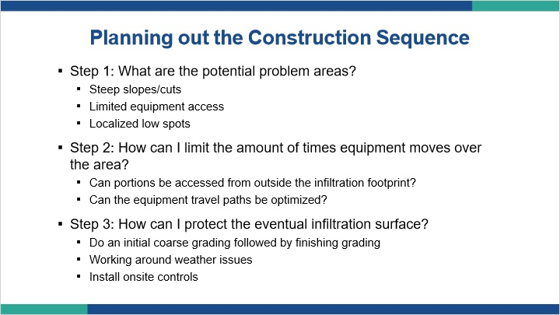
Notes:
Here are some things to consider during design and construction.

- Step 1: What are the potential problem areas?
- Steep slopes/cuts
- Limited equipment access
- Localized low spots
- Step 2: How can I limit the amount of times equipment moves over the area?
- Can portions be accessed from outside the infiltration footprint?
- Can the equipment travel paths be optimized?
- Step 3: How can I protect the eventual infiltration surface?
- Do an initial coarse grading followed by finishing grading
- Working around weather issues
- Install onsite controls

1.31 Onsite Controls
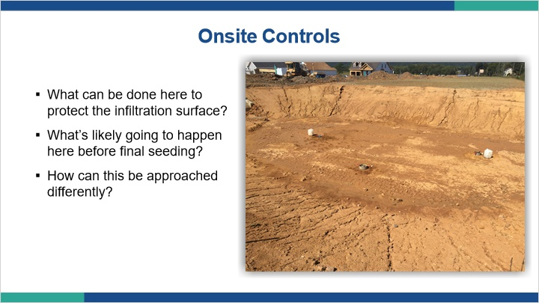
Notes:
Great design can only go so far. We need to get that design from paper into existence. If we slip up during that, no amount of soil characterization, hydraulic conductivity testing or design will save us. Here we see a partially constructed infiltration basin. What can be done to protect the infiltration surface? What’s likely going to happen versus what should happen before final seeding? How can this be approached differently? The condition of this basin isn’t the end of the world right now, if it is addressed properly before its seeded. However, some steps could have been taken to minimize the potential issues lurking here.

1.32 Onsite Controls
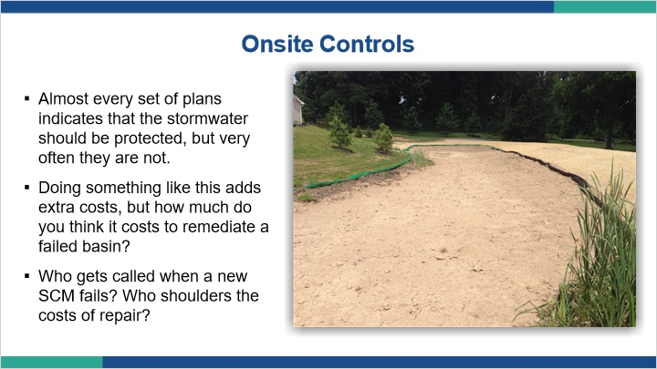
Notes:
Almost all plan sets indicate the BMP should be protected, but they often aren’t as shown in the last picture. Doing something like installing silt soxx costs more than doing nothing, but can be a lot cheaper than remediating a failed BMP.

1.33 Onsite Controls
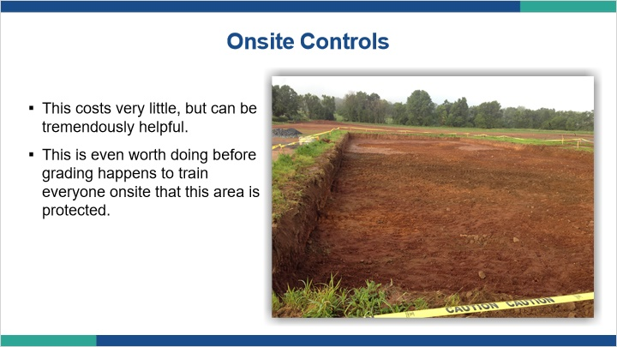
Notes:
Some controls cost almost nothing, like warning tape. Very simple concept, but the effect is tremendous by keeping equipment off our infiltration surface.

1.34 Working while Protecting
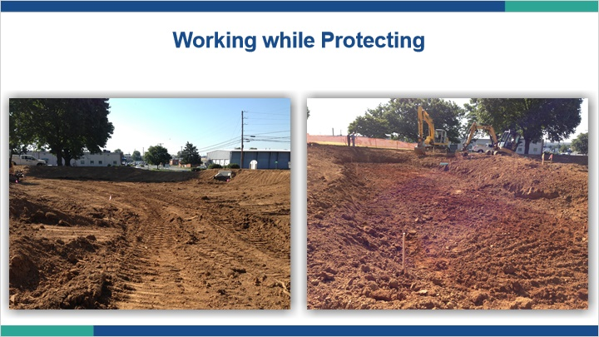
Notes:
Another simple technique is changing the way we operate around the BMP. If it’s understood that the area needs to be protected, we can work in such a way to avoid getting equipment into the area in the first place. Here you see an area that was run over by the track machine on the left, and an area that was excavated from outside the infiltration area on the right. Notice the compacted track marks on the left, and the absence of any tracks on the right.

1.35 Working while Protecting
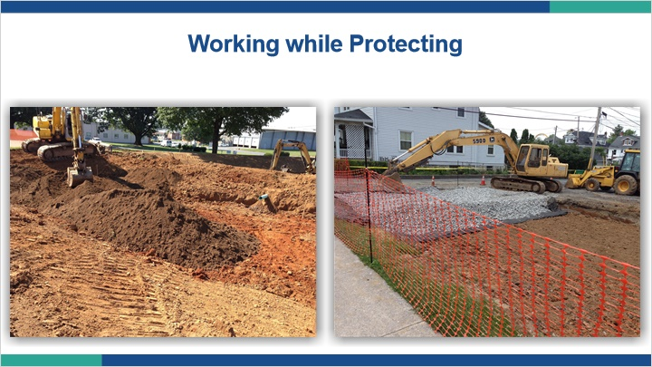
Notes:
In a similar fashion notice how the amended soil on the left and the aggregate on the right are being placed from outside the infiltration area.

1.36 Site Prep
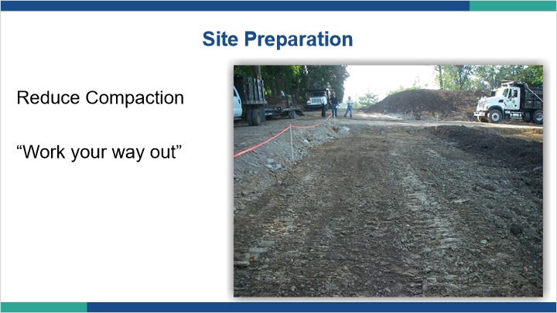
Notes:
In this case, compaction from equipment traffic has already occurred. Even in this situation all is not lost.

1.37 Site Prep
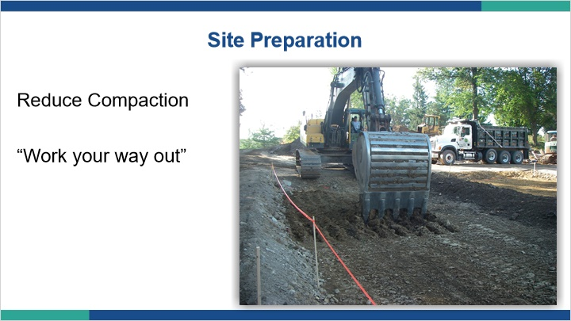
Notes:
If onsite staff are diligent, issues can be corrected before the BMP is finalized. Here we see a track excavator operating from outside the infiltration area scarifying the soil to break up compaction.

1.38 Site Prep
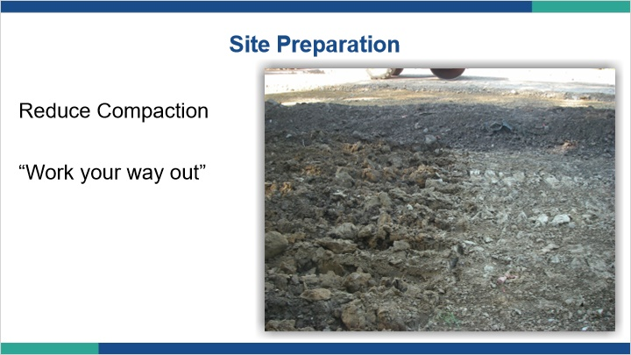
Notes:
Although counterintuitive to what one might think, the roughed up surface on the left is preferable to the smooth surface on the right. The roughed up surface may not look as nice, but it is creating a situation where macropores will be exposed to the stormwater.

1.39 Site Prep
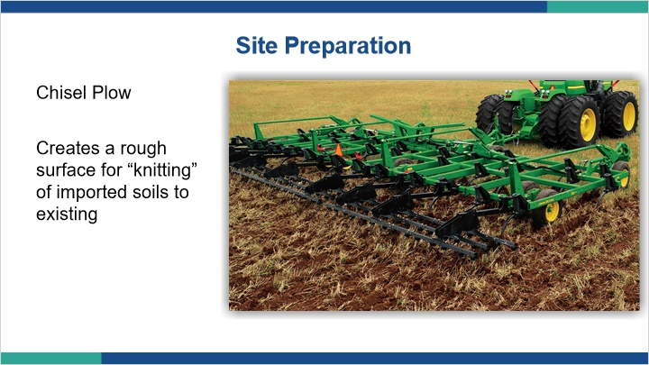
Notes:
Even in areas where compaction isn’t necessarily a concern, creating a roughed up surface to help knit the boundary between native and amended soils can be beneficial for performance.

1.40 Is your site ready?
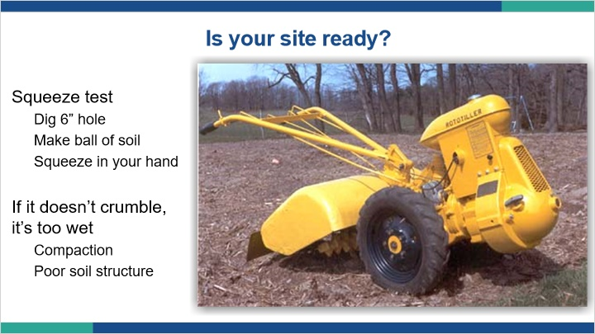
Notes:
Are soil conditions right for construction?

A squeeze test can help you determine if there is too much moisture in the soil. Dig a 6 inch hole, take a sample of soil and make a ball out of it and squeeze it in your hand. If it doesn’t crumble, it’s too wet. If it’s too wet, you have conditions that will exacerbate compaction and result in poor soil structure.

1.41 Construction Oversight
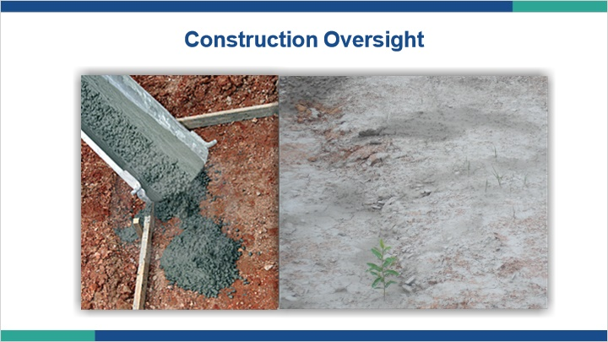
Notes:
We need to keep an eye on our BMPs during construction. There is a lot of activity and a lot of people on construction sites, and not all of them may be experts in stormwater BMPs. Make sure the convenient hole in the ground that someone sees doesn’t become a dumping ground for things like concrete wash water.

1.42 Dual Purpose E&S and Stormwater BMP
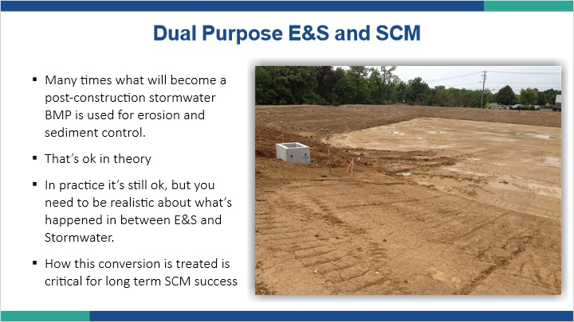
Notes:
We need to remember that erosion and sedimentation facilities will often become post construction BMP. That’s fine in theory, but we need to make sure that transition happens appropriately, with things like fine sediments removed and surface crusts and/or compaction scarified.

1.43 Get it wrong and this becomes this
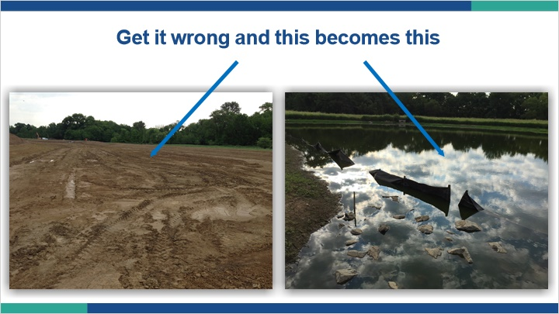
Notes:
If those things aren’t done, and the E&S basin isn’t properly converted to a PCSM basin, it’s predictably going to keep functioning like an E&S basin, which is not a desired outcome for stormwater management.

1.44 Perfectionism
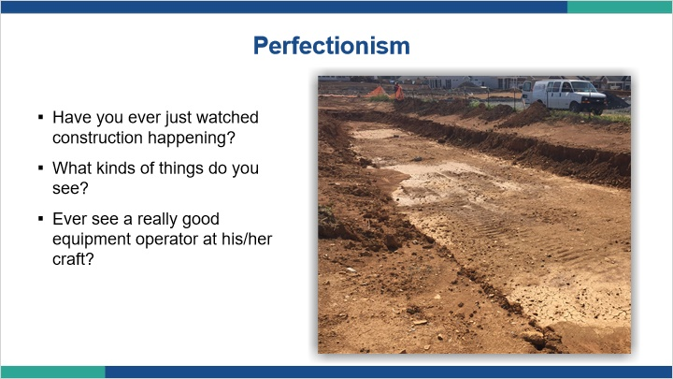
Notes:
Again, be careful about creating too perfect of a feature. Although the infiltration facility excavated in this picture looks nice as far as an even excavation surface, it’s clear from the track marks and mud puddles that the infiltration surface is getting shut off. A scarified “messy” surface would be preferable.

1.45 Problems
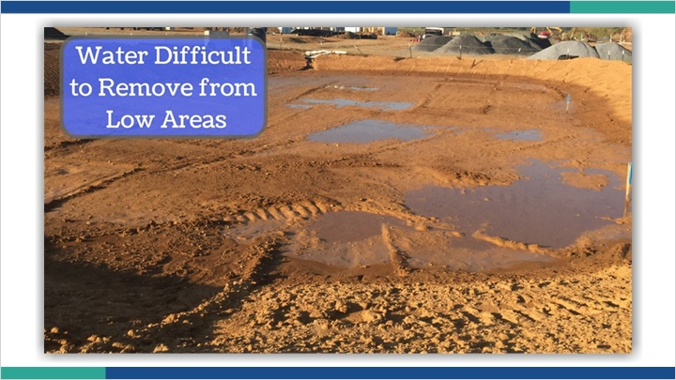
Notes:
Care needs to be taken once issues are noticed. Here the low areas collecting water will be prone to further compaction if equipment enters the basin again to smooth out the surface.

1.46 Problems
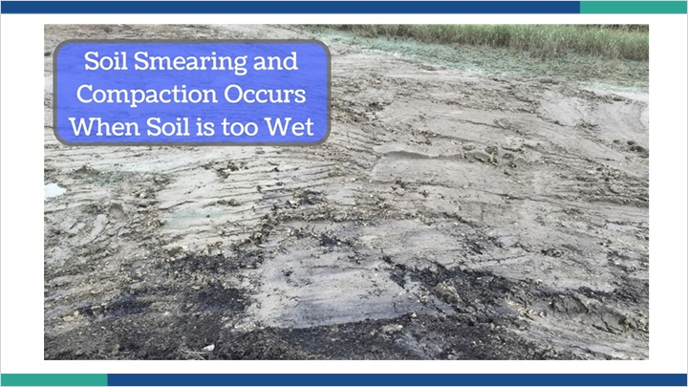
Notes:
The result will be similar to this picture where the soil is compacted and smear shut.

1.47 Problems
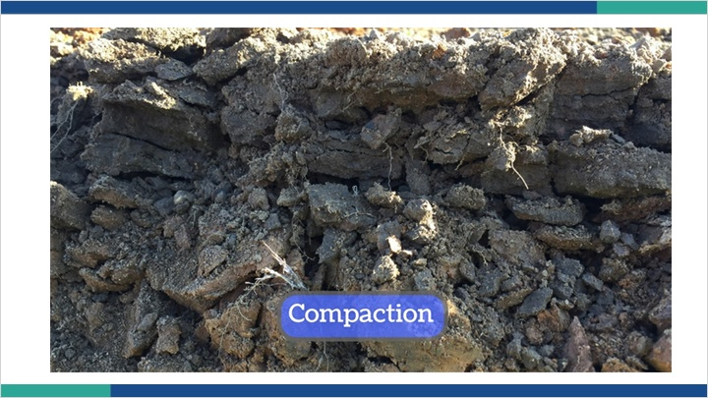
Notes:
The result is platy structure indicative of compaction that will limit the rate of water movement into the soil.

1.48 Problems
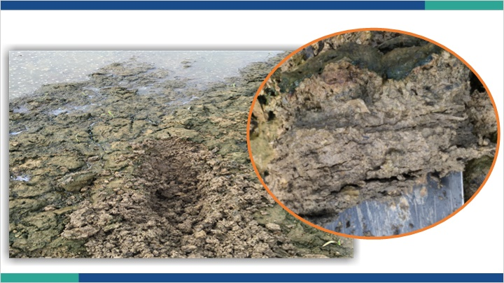
Notes:
Here is another photo showing the platy structure close up as well as the effects of the compaction depicted in the broader shot of the site where standing water and algae are dominant instead of robust vegetation.

1.49 Problems
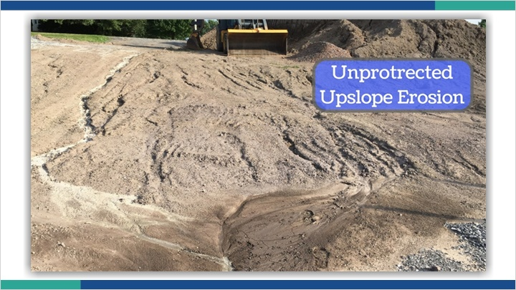
Notes:
The lack of protection for these soil stockpiles leaves them vulnerable to erosion.

1.50 Problems
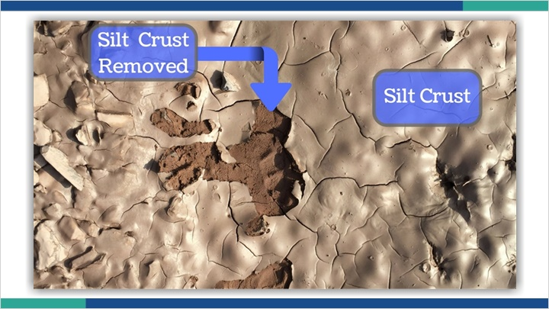
Notes:
Fine soil particles will preferentially flow into the BMP. The result is often a silt crust at the surface that acts as a water barrier. Here you see the very moist silt crust and underneath is soil that is not really wet at all because the water isn’t getting through the crust.

1.51 Establish Robust Vegetation
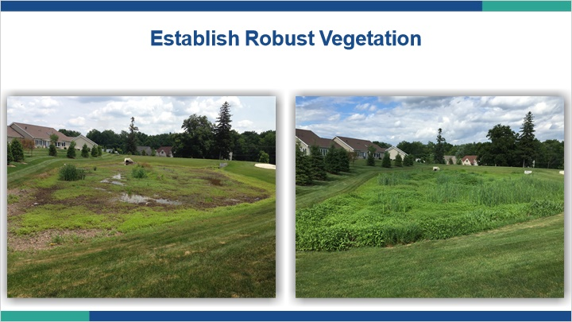
Notes:
In the end, we want to promote soil conditions that allow water to drain and vegetation to flourish. Nothing helps restore soil function like the root growth from robust vegetation.

1.52 Pulling it all Together
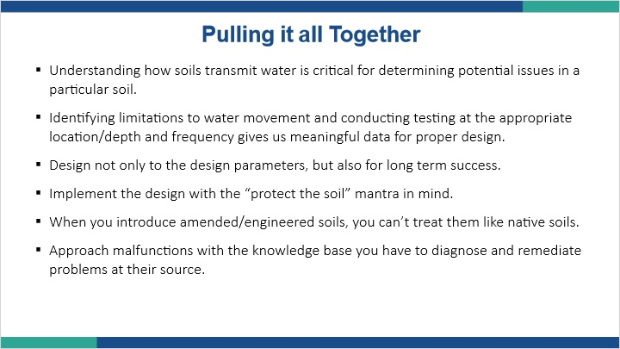
Notes:
There’s nothing routine about any soil based BMP, so we need to constantly examine a soil’s specific characteristics and use our knowledge of soils to make informed decisions.

It all starts with the initial site review and our gathered soil data. Taking that data and applying it to our design to not only meet our design parameters, but also long term BMP success.

If we’re going to expect the soil to help us treat the stormwater, we must protect the soil during construction, and for that matter, post construction.

Amended or engineered soils can be a useful tool, but we have to understand what they are and not assume they have all the same properties of a native soil with well developed structure.

Finally, when things do go wrong, use your knowledge base to diagnose and remediate problems at their source with solutions that will provide the intended improvement.

1.53 Summary: Design and Construction Issues
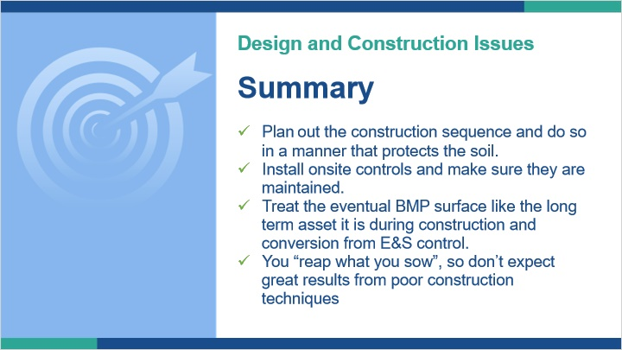
Notes:
In this lesson we discussed the importance of planning out a construction sequence that is rooted in a manner that protects the soil.
We discussed onsite controls upslope of BMPs, and how to convert E&S basins into PCSM BMPs.
With everything we reviewed, it became clear that you will reap what you sow when it comes to site construction, so don’t expect great results from poor construction techniques. Take the time to do things right so the BMP has long term success.

1.54 Summary
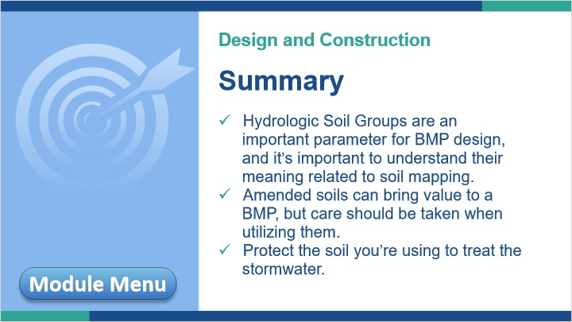
Notes:
This concludes Module 3: Design and Construction Considerations. This also concludes the course: Soil Considerations in Stormwater Management.

In summary, hydrologic soil groups are an important parameter for BMP design, and it’s important to understand their meaning related to soil mapping.

Amended soils can bring value to a BMP design, but care should be exercised when utilizing them, realizing they are not the same as a native soil with well developed soil structure.

Finally, remember soils are living ecosystems, and if we want treatment to occur, we need to protect that ecosystem and its functions.

You may review any of the lessons of Module 3 by clicking on the Module Menu button in the bottom left, or exit the course by clicking “Next”.

