Module 2: Site and Soil Considerations 09-28-21

1. SITE AND SOIL CONSIDERATIONS

1.3 Site and Soil Considerations Menu
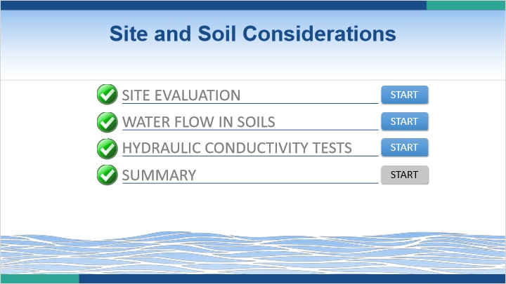
Notes:
Welcome to the Site and Soil Considerations Module. In this module, you will complete three lessons related to site and soil conditions. Click on the start button for the first lesson to begin.

1.4 Site Evaluation
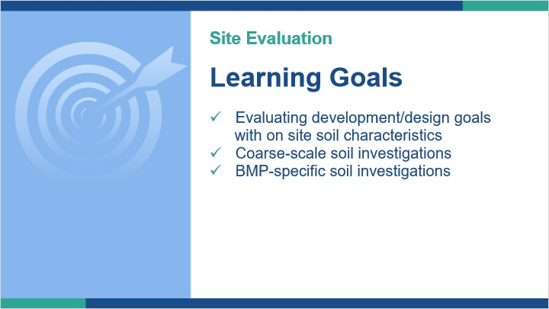
Notes:
In this lesson we are going to explore the process of evaluating development goals with on site soil characteristics.

We’ll look at more coarse-scale soil investigations and then more BMP-specific soil investigations

1.5 Three Phases of Evaluation
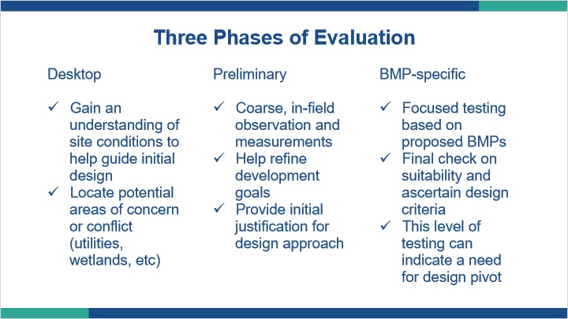
Notes:
There are generally three phases of site evaluation for soils.

The first phase is a desktop review. In this phase, we are looking at digital or hard copy data related to the soils and other site features, such as known wetlands and utility locations. In this phase, we can begin to understand site development potential in relation to on-site conditions and begin to identify some areas that may work for stormwater BMPs.

The second phase is the preliminary testing phase. In this phase we are actually looking at soil features on-site and taking site-specific measurements of key parameters. We’re not trying to characterize everything about the soils, rather we are trying to learn a bit more about the soils so we can refine our design approach. Ideally, our investigations would provide justification for our concept design. Alternatively, it may provide data that requires us to refine our design concept. In either case, the main goal here is to gather enough data to put us on the right design path.

The third phase is completed when we have a refined site plan and a much better idea of where and what type of stormwater BMPs we will implement. At this phase, we are trying to gather robust soils data for those areas so we can refine the specifics of the proposed stormwater BMP, including but not limited to depth of any limitations and a design hydraulic conductivity rate. As much as we hope this to be just a final data gathering exercise, results from this type of investigation can lead to the need to more drastically change our overall design if unanticipated soil issues or unacceptable hydraulic conductivity rates are encountered.

1.6 Web Soil Survey
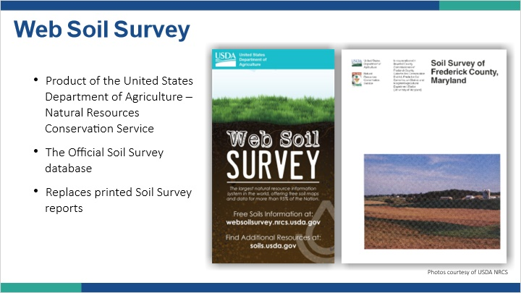
Notes:
The web soil survey is a product of the USDA NRCS, which oversees soil mapping in the United States. It’s the official soil survey database and it replaces the old printed soil survey reports. That means that if you are using the old printed maps, you are likely using unofficial data. When conducting a desktop review of soil information, the Web Soil Survey is a great place to start.

Note (Slide Layer)
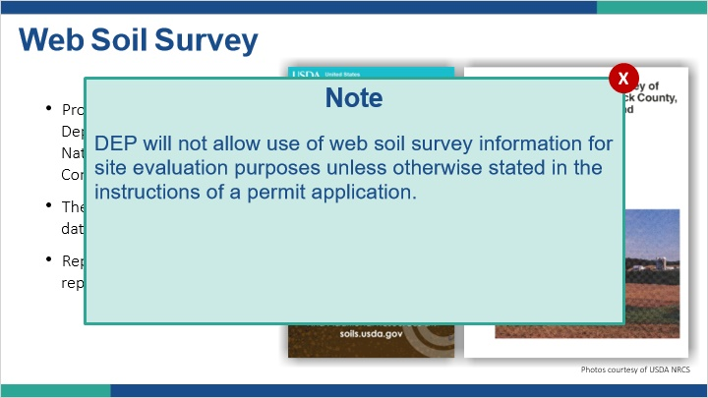

1.7 Web soil survey
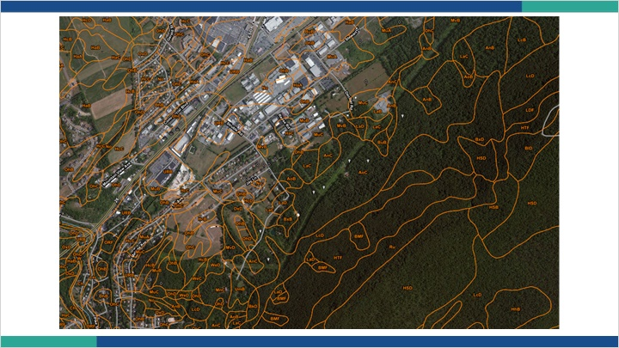
Notes:
Here is what a typical map from the web soil survey looks like. The polygons are map units and the letters in each map unit are the map unit symbol. There is an accompanying legend that tells you the soil series name associated with the map unit symbol. From here, you can search any number of soil properties contained in the NRCS soils database.

Some key things to note. The left side of the map has more developed areas while the right side shows nearly continuous tree cover. This is depicting a developed limestone valley and undeveloped sandstone and shale mountains. Notice how there seems to be less but larger polygons in the mountain area compared to the developed area which seems to have more, but smaller polygons. This is not likely a coincidence. Soil survey maps were originally generated for the purposes of agriculture, so more emphasis was placed in areas where agriculture might occur, and conversely less emphasis was placed in areas that were not likely to experience agriculture, such as mountains. This is an inherent scale and use issue present in the soil survey data, and something you should always keep in the back of your mind. Soil surveys are great tools, but they have the biases and scale issues that don’t make them appropriate for site specific uses.

1.8 Understanding Map Scale
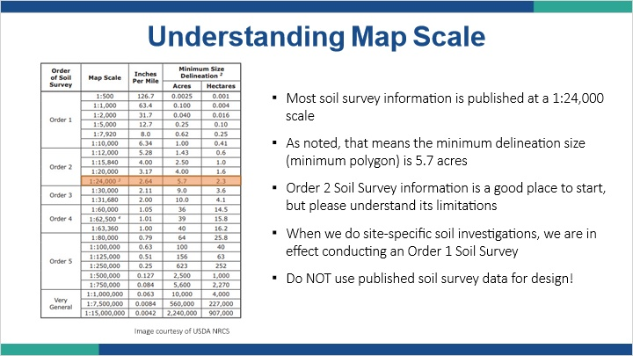
Notes:
It’s hard to talk about maps of any kind without discussing scale. Most of the soil survey information that’s been published in Pennsylvania was done at a 1:24,000 scale. If you’re not familiar with scales like this, that means for example, that one inch on the map is equal to 24,000 inches on the ground. It’s hard to visualize 24,000 inches, so a better way to say it is one inch on the map equals 2,000 feet on the ground. We call this scale of survey an order 2 survey. If you were doing a site specific soil evaluation and you produced a map for say a one acre site, that would be an order one survey.

When mapping at a 1:24,000 scale the minimum area that is represented in those soil polygons is 5.7 acres, and that’s just the minimum. So although soil survey information is a great starting point, the scale is just too coarse to make site specific determinations. That is why we need to go out and conduct site specific soil testing for stormwater BMP design. It is not appropriate to use published soil survey data for design.

1.9 Soil Classification
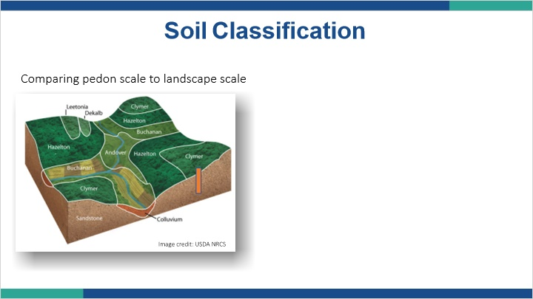
Notes:
How are soil maps made? At it’s most basic level, soil mapping and classification is a means to begin grouping similar soils with similar soil properties so that we can begin making land use decisions. To do this, we must first look at individual soils. As we begin to do that, we can make broader interpretations, such as “this soil is moderately deep to saturation. This soil with moderately deep saturation has some limitations to the type of stormwater BMP I can place on it. Therefore, other soils that I encounter that are moderately deep to saturation will likely exhibit similar limitations to stormwater management. This characteristic of moderately deep saturation is something I can use to group soils to talk about them. That is essentially what soil mapping and classification does.

Soil Profile (Slide Layer)
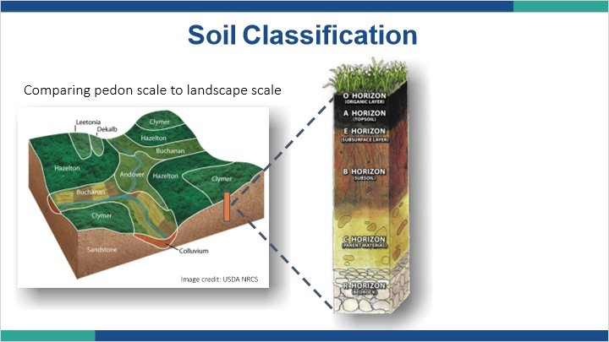

1.10 Official Soil Series Descriptions (OSDs)
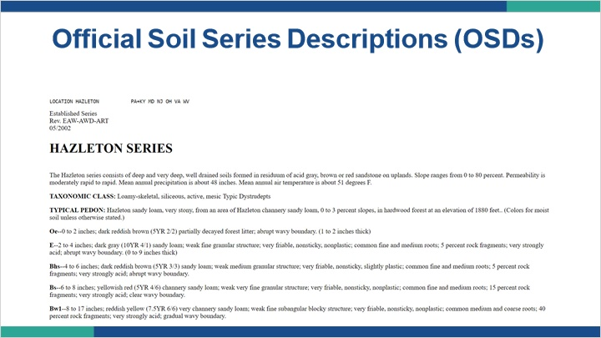
Notes:
Official Soil Series Descriptions or OSDs are the official soil description for a particular soil series as described by the NRCS. A portion of an OSD for the Hazleton soil series is shown. The OSD shows the typical profile sequence and characteristics as well as the range of characteristics a soil can have and still be classified as a particular soil series. OSDs are a good place to start when reviewing desktop soils data for a site. If you’re interested in exploring OSDs more, a link is provided in the resources tab.

1.11 Physiographic Provinces
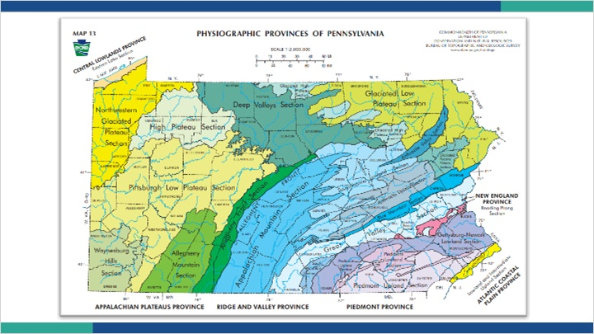
Notes:
We can get an idea of the types of soils and rock we might encounter by knowing where we are geographically. Here is the physiographic province map for Pennsylvania. Physiographic provinces are geographic regions in which climate and geology have given rise to an array of landforms different from those of surrounding regions. Links to this map and a history of Pennsylvania geology are provided in the resources tab. I encourage you to take a look at that information to learn more information about the landforms and geology in the areas you live and work.

Maps like this remind us that although we may be working on a specific property, that property sits in a much larger ecosystem. It’s important when doing site planning to make sure we aren’t like an ostrich with its head stuck in the ground, only looking at our site. We need to pull our heads out and see what’s affecting our site and what our site will affect.

1.12 Glacial Deposits
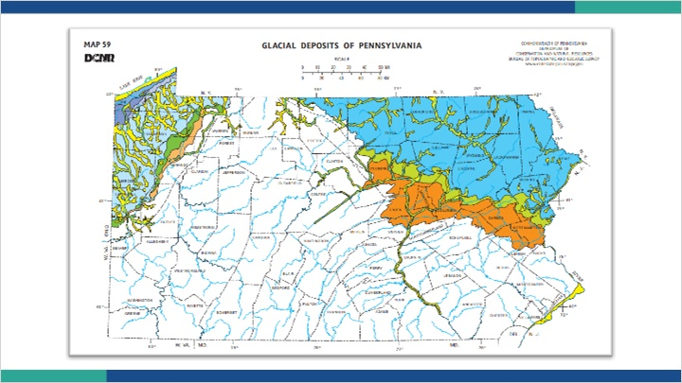
Notes:
A key geologic event in Pennsylvania that shaped the present day landscape of a significant portion of our state as well as the soils we see today, was the ice age. During this time, gigantic blocks of ice moved across some of the northern portions of our state. Even those areas that weren’t covered by ice were certainly affected by the very cold climate. It is hard to imagine today, but Pennsylvania used to have a very different climate. Shown here is a map of glacial deposits. Links to this map and some information on Pennsylvania’s Ice Age are provided in the resources tab. I encourage you to explore those to learn more about glaciers and how they affected our present day soils.

1.13 Carbonate Rock
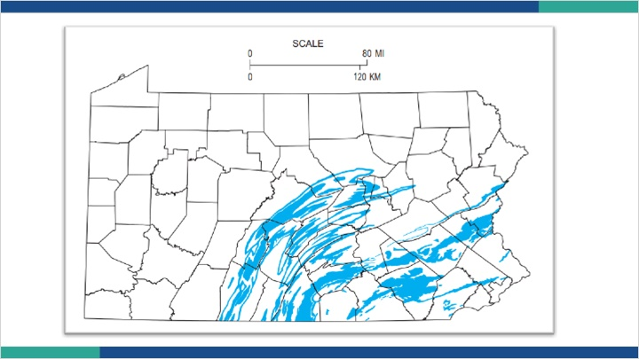
Notes:
Sinkholes are another major feature in parts of Pennsylvania that can have a profound impact on stormwater management. Although sinkholes can form for a variety of reasons, we’re going to focus on sinkholes related to the dissolution of carbonate bedrock. The map shown here depicts areas of the state where sinkhole prone carbonate rock is at or near the surface.

Geologic sinkholes form as carbonate rock is dissolved by water moving through the soil and rock. As the rock dissolves, voids are created where soil can migrate. This movement can manifest as surface depressions or in more extreme conditions an actual opening at the ground surface known as a sinkhole. There is a link in the resources tab to learn more about sinkholes if you desire. The bottom line for stormwater management is that areas prone to dissolution of rock and formation of sinkholes can be exacerbated by concentrating stormwater. Therefore care should be taken when assessing the risks associated with different Stormwater BMPs.

1.14 Karst feature density
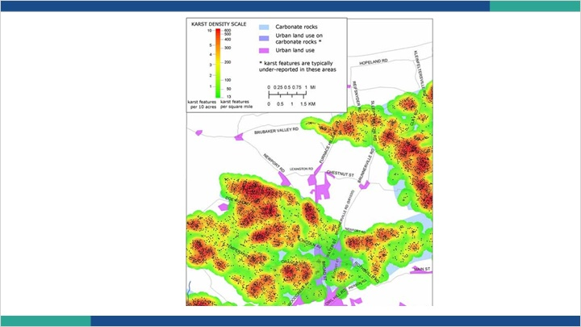
Notes:
An area underlain by carbonate bedrock does not automatically mean its too risky to construct stormwater BMPs. An evaluation by a trained geologist and the review of some karst feature data sets can aid in determining site suitability in carbonate areas. Pictured here is a karst feature density map. It shows how some carbonate rocks are more prone to dissolution and sinkhole formation while others are not. It also shows the intersection of developed areas and sinkhole prone areas. Data like this helps us to make informed decisions on risk when planning a site design.

1.15 Preliminary Investigation
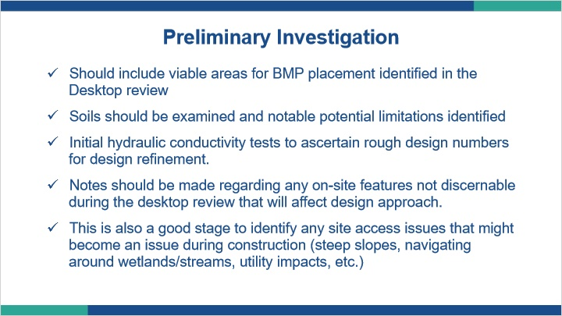
Notes:
The preliminary investigation should include viable areas for stormwater BMP placement identified in the desktop review. For example, there’s no point in testing in an area that is known to have a high density of utilities traversing it.

The soils should be examined and notable potential limitations identified.

The examination of the soils should then guide where to conduct preliminary hydraulic conductivity tests to ascertain some rough design numbers to help refine our site plan. Basically, we want to get an idea of how big the stormwater BMPs that will rely on soils for infiltration need to be.

Notes should be made regarding any on-site features not discernable during the desktop review that will affect our design approach.

This is also a good stage to identify any site access issues that might become an issue during construction such as steep slopes, navigating around wetlands, streams, or other sensitive features, utility impacts, etc.

1.16 BMP-specific Investigations
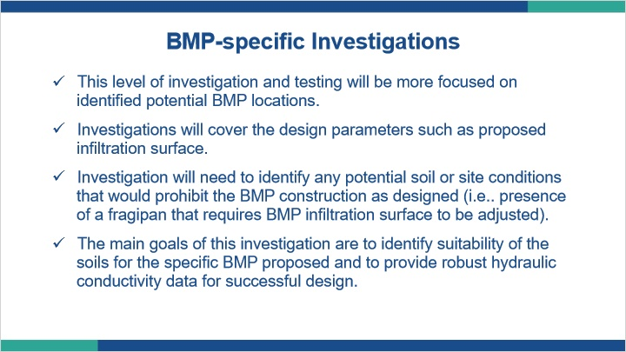
Notes:
At this phase, we are conducting a more robust investigation for specific stormwater BMPs.

We should have a fairly well developed site plan with stormwater BMP areas identified. We are now gathering additional data to determine soil suitability and confirm design depths and hydraulic conductivity rates.

Clearly, if we encounter a soil limitation such as a fragipan, we may need to adjust design depths for our stormwater BMP.

The main goals of this investigation are to identify soil suitability for the proposed stormwater BMP and focus in on gathering sufficient hydraulic conductivity data to ascertain a design rate.

1.17 Soil Investigation
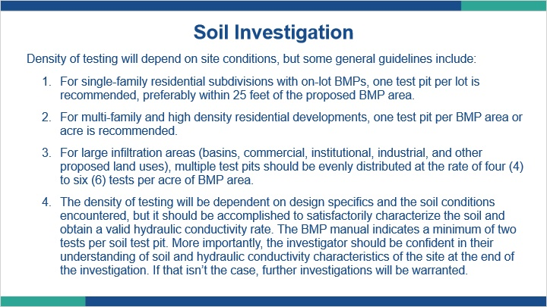
Notes:
The density of testing completed during this phase will depend on site conditions, but some general guidelines include:

1. For single-family residential subdivisions with on-lot BMPs, one test pit per lot is recommended, preferably within 25 feet of the proposed BMP area.

2. For multi-family and high density residential developments, one test pit per BMP area or acre is recommended.

3. For large infiltration areas (basins, commercial, institutional, industrial, and other proposed land uses), multiple test pits should be evenly distributed at the rate of four (4) to six (6) tests per acre of BMP area.

4. The density of hydraulic conductivity testing will be dependent on design specifics and the soil conditions encountered, but it should be accomplished to satisfactorily characterize the soil and obtain a valid hydraulic conductivity rate. The BMP manual indicates a minimum of two tests per soil test pit. More importantly, the investigator should be confident in their understanding of soil and hydraulic conductivity characteristics of the site at the end of the investigation. If that isn’t the case, further investigations will be warranted.

The recommendations just mentioned are guidelines, and additional tests should be conducted if local conditions warrant. Conversely, excessive testing and disturbance of the site prior to construction is not recommended.

Note that these guidelines are from Appendix C of the Stormwater BMP Manual.

1.18 Sample Soil Log

Notes:
There is no official soil description sheet for stormwater investigations, but there are some items that the BMP manual indicates one should collect. Here is an example description sheet that one might use while conducting a soil investigation. The sheet prompts the investigator to gather soil characteristics such as horizons, texture, coarse fragments, soil color, presence of redoximorphic features, depth to bedrock, and depth to saturation. The idea is to identify any limiting zones as well as provide the overall characteristics of the soils investigated. Ultimately, the investigator will be providing the designer with information that will dictate site design constraints.

1.19 Summary: Site Evaluation
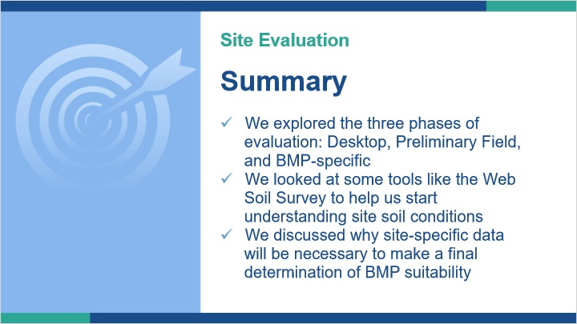
Notes:
In this lesson, we explored the three phases of site evaluation: a desktop review, a preliminary field investigation, and a BMP-specific field investigation.

We looked at some tools and resources, like the Web Soil Survey, that can help us gain a beginning understanding of site and soil conditions.

Finally, we discussed why site-specific data will be necessary to make a final determination of suitability for BMP installation.

1.20 Water Flow in Soils
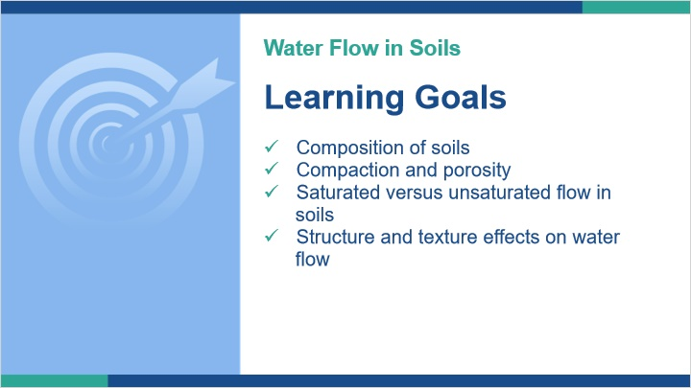
Notes:
In this lesson, we will look at the composition of soils and how compaction impacts that composition and affects porosity. We’ll see the differences between saturated and unsaturated flow, and how structure and texture affect water flow in soils.

1.21 Physical Properties
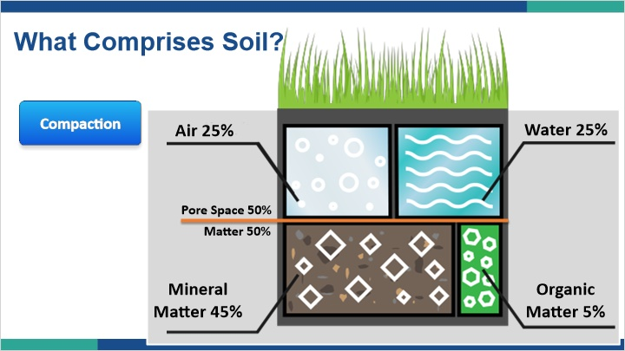
Notes:
We’ve discussed all the physical components of soils, like texture, structure, and color. But when we look at soil we need to remember that soil is all those things and more. If soil were just a pile of particles it would be as dense as concrete, actually more so. Soil is comprised of both matter and pore space. The pore space is where air and water travel through the soil. Certainly in the context of stormwater management, the movement of air and water is critical. What one would consider an ideal soil would contain about 50 percent matter and 50 percent pore space. The matter is typically mostly mineral material with a small percentage of organic matter, but in some soils it could be all mineral or all organic.

The pore space will vary between completely air-filled to completely water field depending on wetness conditions. Certainly after a long rain event the soil pores might mostly be filled with water, but during a time of drought, it might essentially be all air-filled.

When we start to disturb soils, such as running heavy equipment over it, we can compact the soil. What does that mean? When a soil gets compacted, the soil particles are pushed into the pore spaces, thereby reducing the amount of pore space. Since pore space is critical to air and water movement as we previously discussed, compaction has a significant impact on the function of soils. Press the compaction button to see what happens when we run a backhoe across our soil.

As you can see, the result of our simulated construction activity has reduced the pore space from 50 percent to 20 percent. Looking at the pictures of compaction on the left, we also see that the pore space remaining isn’t the same as the pore space we started with. Now we have platy structure, which is indicative of compaction and limits the downward movement of water by creating a more tortuous path for the water to take. So even though from a texture perspective we still have the same soil we started with, from a structure and pore network perspective we have a completely different soil now. This is why it is so critical to protect infiltration areas. The soils can look perfect when we do upfront testing, but if we treat them like dirt (pun intended) and run equipment all over them, we won’t get the functioning infiltration area we originally intended.

Untitled Layer 1 (Slide Layer)
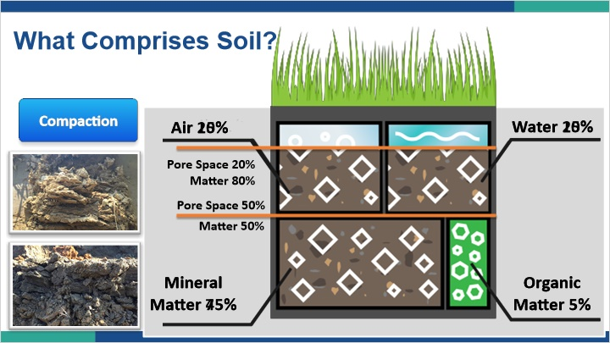

1.22 Bulk Density
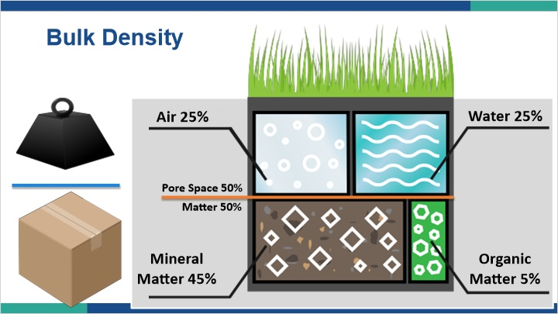
Notes:
Talking about compaction is important, and I think most people understand the concept, but it’s also important to quantify what is going on when a soil gets compacted. We can quantify the amount of pore space in a soil by measuring what’s called the bulk density. Like any kind of density measurement, bulk density is a measure of the mass per unit volume of a material. Here on the left we have a weight depicting our mass and a cardboard box depicting our volume. If we placed the weight into the box, we could determine the density of combined weight and box.

By clicking on the box on the left you can see what comprises the volume in our soil example on the right. By clicking on the weight illustration you can see what is included in the mass. Air is essentially weightless, but water certainly has a weight to it, so we need to exclude water from our measure of mass. So to get a measurement of bulk density, we need to determine our volume and then get the mass of the matter contained in that volume, but we need it oven-dried to exclude the mass of water.

1.24 Water Movement
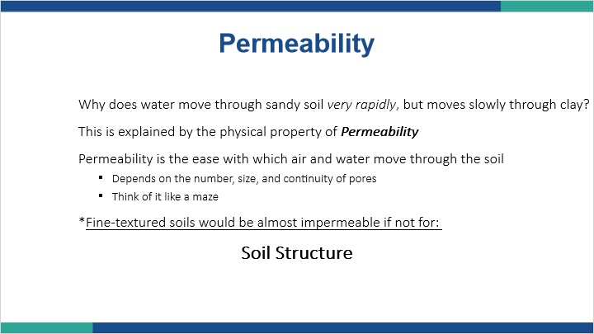
Notes:
We’ve now looked at soil as a whole, understanding that it has both matter and pore space. We know that not all pore space is the same, and that the amount, size, and interconnectedness of the pore network can play a big role in the movement of air and water through soil. If we compact a soil, we are reducing the amount of pores, which will negatively effect water movement. All these characteristics of the pore network help define the soil’s permeability, which is the ease with which air and water move through the soil.

It’s critical to remember that fine textured soils would be almost impermeable if not for soil structure. Therefore, it’s important to reduce compaction and protect the natural state of soils as much as possible if we intend to use them for infiltration BMPs.

1.25 Hydraulic Conductivity
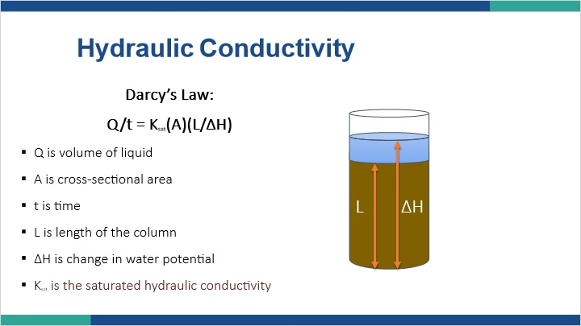
Notes:
The rate at which water moves through soil is called hydraulic conductivity. Water can move through soil in two ways, under saturated conditions and under unsaturated conditions. For that reason, a soil actually has a saturated hydraulic conductivity and an unsaturated hydraulic conductivity. For now, we are going to focus only on saturated hydraulic conductivity.

A French engineer, who worked in the field of water sanitation in the 1800s, conducted column experiments with sands to determine the flow rate of water through porous media. From that work, we have what is known as Darcy’s Law.

Here we see Darcy’s Law. Q/t which is the volume of water over time equal to the product of the saturated hydraulic conductivity times the cross-sectional area times the hydraulic gradient, which is length of the soil column over the change of the water potential, which is also in a length unit. Ksat is the proportionality factor in the equation that relates flux to the hydraulic gradient. Flux is the quantity of water moving in the direction of and at a rate proportional to the hydraulic gradient.

1.26 Hydraulic Conductivity
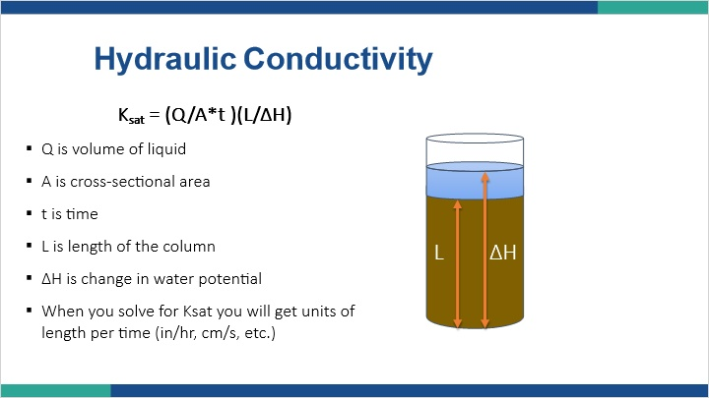
Notes:
If we rearrange the equation a bit, we can solve for Ksat. When you solve for Ksat you will get units of length per time such as inches per hour and centimeters per second.

1.27 Infiltration
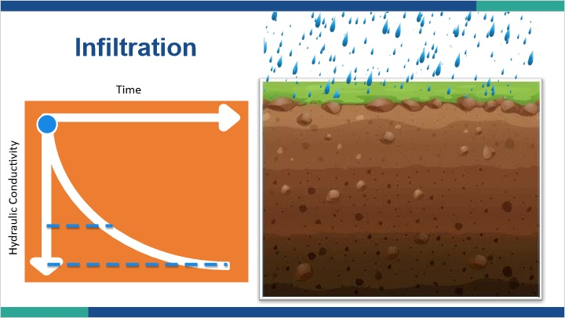
Notes:
Let’s talk briefly about the difference between infiltration rates and saturated hydraulic conductivity.

Infiltration rate is a measure of the rate at which soil is able to absorb water from the surface. The infiltration rate is dependent on many factors, including hydraulic conductivity. On the left we have a graph that shows hydraulic conductivity decreasing as we move down and time increasing from left to right. If we begin adding water the soil begins to infiltrate that water. As shown by the slope of the graph which starts out steep and then begins to level, the rate of infiltration starts at a high hydraulic conductivity but begins to slow. Where the graph has a slope, we are experiencing unsaturated flow. As we approach saturation, the curve begins to flatten and reach a steady state. At this point we have reached the saturated hydraulic conductivity. I’m sure you’ve noticed this effect when conducting infiltration tests. As you first start adding water you get more dramatic drops in water levels between the first couple of readings. Eventually your readings start to become more steady. This is happening because the soil is becoming saturated around the testing area.

As the soil becomes saturated, the infiltration rate begins to approach the saturated hydraulic conductivity. However, we don’t just take the raw infiltration rate and call it hydraulic conductivity. It should be adjusted for the head pressure and potentially temperature.

When conducting any procedure to determine water movement into soil, we need to be careful to make sure our measurements are correct. If we didn’t let the soil fully saturate and reach a steady state, we would be stopping our test along a different point of the curve. If we did that, we would end up with a faster rate. However, we know that if we let the system reach steady state, we would end up with a slower rate. If we design an infiltration BMP using an erroneously more rapid rate, we are dooming that BMP to eventual failure.

1.28 Soil Water Capacity
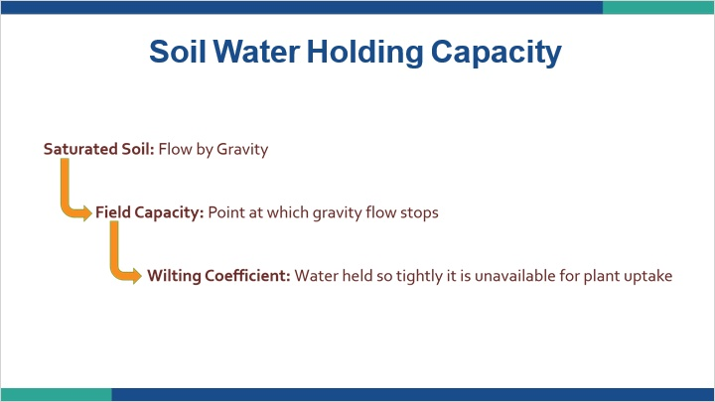
Notes:
Another important concept to discuss is water holding capacity. Based on the amount of pore space, a soil has a certain amount of water it can hold, or stated another way, it has a water holding capacity. Some terms you should be familiar with related to water holding capacity are saturated soil, field capacity, and wilting coefficient. Saturated soil occurs when all the soil pores are filled with water. In this scenario water flows by the force of gravity. If a soil is saturated and begins to drain, field capacity is the point when water stops flowing by gravity. As the soil continues to dry out, the wilting coefficient is reached when water is held so tightly by the soil that the plants can’t get access it for uptake, and begin to wilt. The wilting coefficient or wilting point as it’s sometimes called, can be different based on the plant species.

1.30 Summary: Water Flow in Soils
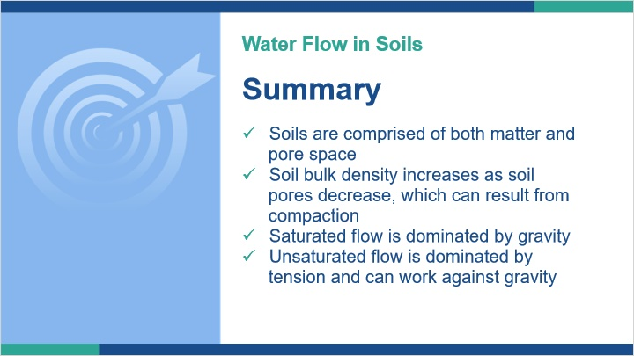
Notes:
In summary, soils are comprised of both matter and pore space. Soil bulk density is a way to measure the dynamic of matter to pore space. As bulk density increases, porosity decreases. This is known as compaction.

Saturated flow is dominated by gravity while unsaturated flow is dominated by tension that can work against gravity. Understanding how the water is moving helps us understand how well it will be renovated.

1.31 Hydraulic Conductivity Testing
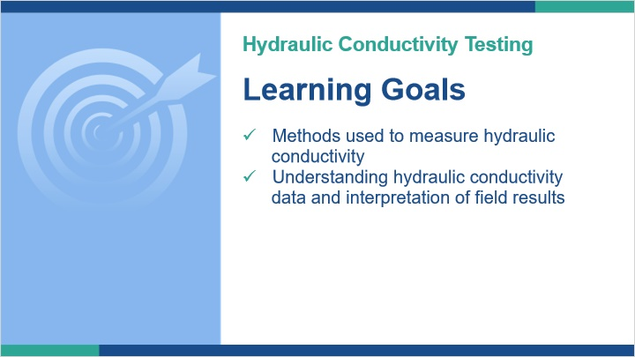
Notes:
In this lesson, we are going to explore some of the methods used for infiltration testing. More importantly, we’ll discuss interpreting the field results to determine if the design rate is appropriate for the soil conditions on site.

1.32 Double Ring Infiltrometer
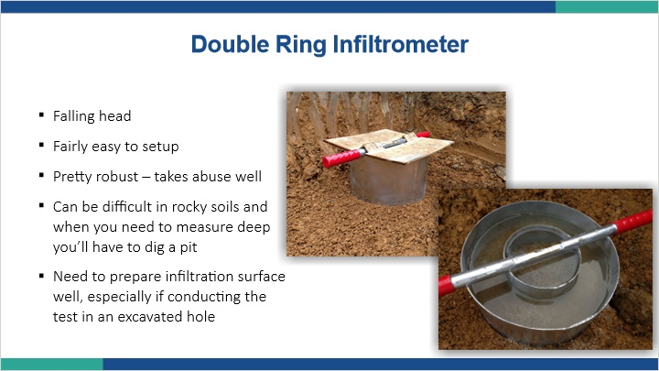
Notes:
Infiltrometers are common testing apparatuses in Pennsylvania for stormwater. They come in single and double ring varieties. It can be a falling or constant head measurement, meaning the level of water in the apparatus can be setup to remain constant or will drop in between readings as water enters the soil.

They are fairly easy to setup, and depending on the material they are made of can take some abuse during install.

Two items of particular importance with this and many test methods is to make sure the apparatus is properly seated in the soil, especially when rocks are present, and to make sure the testing surface is properly prepared by making sure it isn’t smeared, compacted, or otherwise not indicative of the soil horizon being tested.

1.33 Amoozemeter
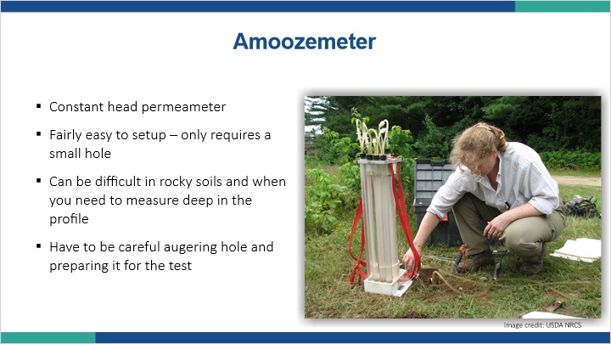
Notes:
The Amoozemeter gains its name from its inventor, Dr. Aziz Amoozegar, a soil physicist. It is a constant head permeameter, meaning it maintains a constant level of water in the test hole. It’s relatively easy to move around. The test prep includes augering a small hole with the provided auger, which can be difficult in rockier soils. Because of the relatively small hole dug with the auger, it is important to make sure the hole is adequately and properly prepared for testing.

1.34 Aardvark Permeameter
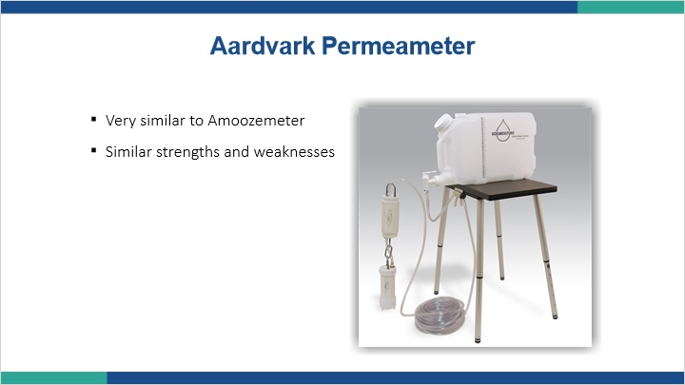
Notes:
The Aardvark Permeameter is another apparatus that is similar to the Amoozemeter in both concept and utilization. Therefore it shares similar strengths and weaknesses.

Certainly the list provided is not all inclusive. There are many ways to measure saturated hydraulic conductivity, and most scientifically defensible apparatus are valid to use. The key is to make sure correct mathematical adjustments are being made to the raw data and that the correct test setup is conducted to stay within the mathematical assumptions guiding the equations used to compute saturated hydraulic conductivity from these various apparatuses.

1.35 What are we trying to measure?
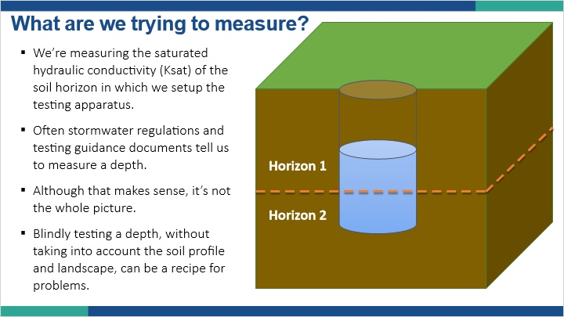
Notes:
Once you have an apparatus, what are we actually measuring in the field. Like most tools, the apparatus is only as good as the operator using it.

First, and it may seem obvious but it is often overlooked, is we are trying to measure the saturated hydraulic conductivity of the soil horizon in which we setup the apparatus.

Why this isn’t obvious is our testing guidance documents often indicate we should test at a particular depth where we intend to the infiltration BMP to eventually be built. However, blindly testing at a depth may have us violating the assumptions around the testing method we are using. For example, if you are conducting a test in an auger borehole, the depth of water may be 6 inches deep. If those 6 inches don’t reside in a particular horizon, but rather span two horizons, you are violating the assumptions behind the mathematics.

1.36 Soil Variability
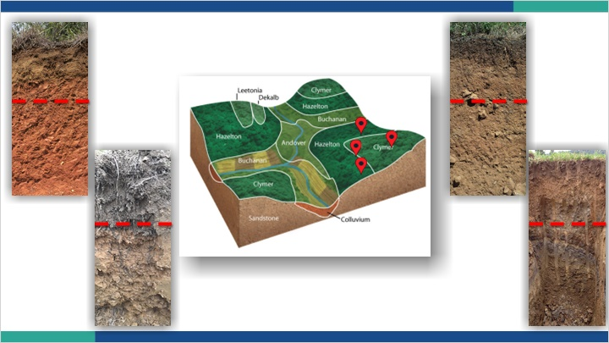
Notes:
Another potential issue if we are conducting several soil investigations over an area is we likely won’t encounter all the same soils in each location.

In this example, we test at four locations across two mapped soil series. Based on the photos, we seem to be looking at four very different soils. When it comes time to test, if we just test at the set depth indicated by the dashed red line, we could be testing completely different things. What then happens if we take an average of all those measurements?

What we effectively have done is to try and find the average size of apples by taking measurements of apples, oranges, strawberries, and kiwi and mixing them together. It might look like a nice fruit salad, but it’s not what we set out to do. It’s just not valid to lump some of these numbers together.

1.37 Number of Tests
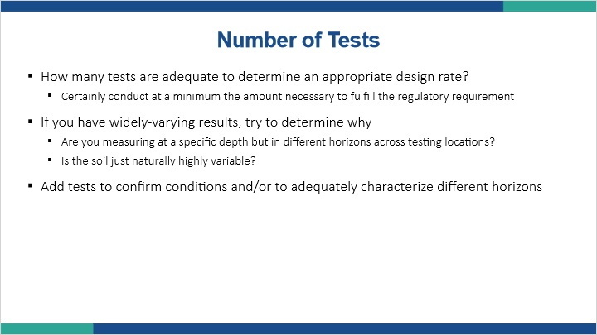
Notes:
So how many tests are enough? Certainly, at the bare minimum, we should be conducting at least as many tests as the regulatory authority dictates. However, it doesn’t mean we can’t and shouldn’t run more at a particular site. Remember, we are trying to come up with the steady state saturated hydraulic conductivity rate that will allow our BMP to function properly long term. Doing so in a scientifically defensible manner is what should be guiding our decision on number of tests, not a generic set of guidelines.

Therefore, you should be balancing what you are observing in the soil test pits with the proposed design criteria. So if you open up three test pits and they are all relatively the same, you can likely do less tests at that site compared to one where you open up three soil pits and the soils look very different. The key is identifying what is going to be the limiting issue within those soils and make sure you are adequately quantifying the hydraulic conductivity of that feature.

If you are unsure what feature might be most limiting just by sight and touch, then characterize both features and let the results tell you the answer.

If you run three tests in soils that look similar but the results are orders of magnitude different, you may need to add some more tests to get a better representation of what’s going on or forego calculating a geometric mean and choose the most restrictive number. BMPs are expensive to build, and they are even more expensive to rebuild. Don’t skimp on the front end or someone will be paying for it later.

1.38 Things to consider
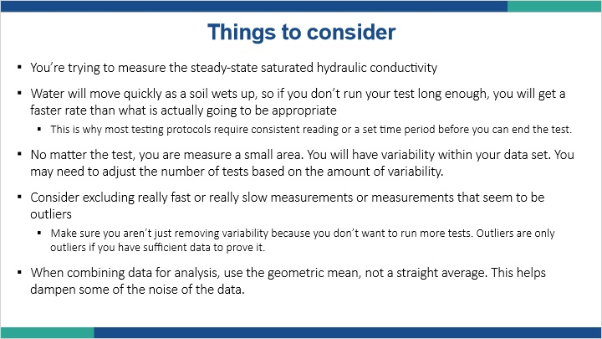
Notes:
Things to consider when analyzing your testing data and strategy.

1. You’re trying to measure the steady-state saturated hydraulic conductivity. As we discussed in the water flow discussion, water moves into the soil at a more rapid rate as the soil is wetting up, so if you stop the test prematurely, you are going to end up with a faster rate than the soils can actually handle. When that’s turned into a BMP design, you will end up with a smaller BMP then you should have designed for.

2. No matter what test method you use, you are physically testing a very small portion of the eventual infiltration surface. Saturated hydraulic conductivity can vary by orders of magnitude even in the same horizon in a relatively small area, so you need to be cognizant of what your results are saying and make sure the results are valid based on the number of tests run.

3. Consider excluding really fast or really slow measurements if they seem out of place. Don’t just exclude them because they’re too high or low. You should have a defensible reason to exclude. Additionally, make sure you have enough other measurements to still have a valid geometric mean once you remove some measurements from the calculation.

4. Use the geometric mean, not a straight average. This helps dampen some of the noise of this type of data and will keep outliers from swaying your data too much.

Note (Slide Layer)
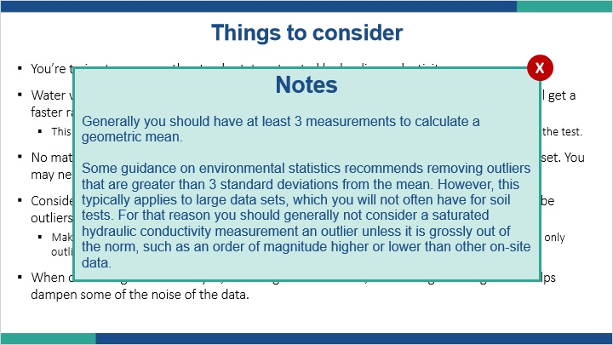

1.39 Example 1
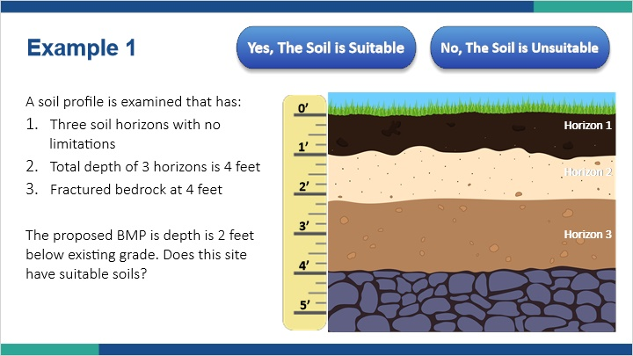
Notes:
Let’s take a look at some testing scenarios. For this example, we are examining a soil profile that has three soil horizons that have no limitations within those horizons. The total depth of the three horizons is four feet. At four feet we encounter fractured bedrock that would be considered a limiting zone. We know from the BMP manual that we need to maintain a minimum of two feet from a limiting zone.

The proposed BMP infiltration depth is two feet below existing grade. Does the site have suitable soils for the proposed design depth?

1.40 Example 1
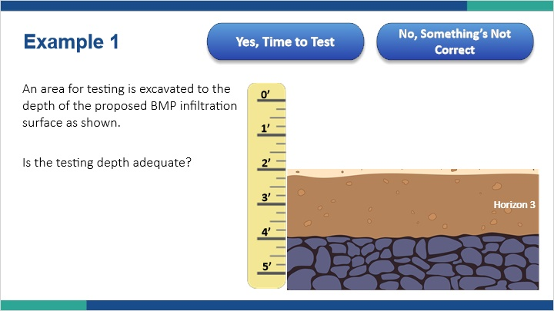
Notes:
Since the depth is adequate, we prepare an area for hydraulic conductivity testing by excavating off the upper two feet as shown. Based on the diagram on the right, is the test depth adequately prepared to place the apparatus?

1.41 Example 1
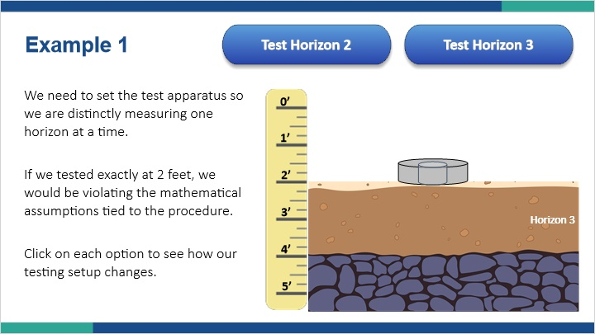
Notes:
Since proposed depth is right at the break between two horizons, to properly test this site, we need to determine which horizon is more restrictive. Assuming there are no obvious visual clues to let us know one horizon is clearly more permeable than the other, such as one being sand and one being clay, we should test both horizons for hydraulic conductivity to see which one will be rate limiting for our design.

Again, if we tested exactly at two feet below grade, we would be violating the mathematical assumptions tied to the procedure.

Click on each option to see how our testing setup will change.

By raising the test up by about 9 inches, we are getting a better representation of the hydraulic conductivity characteristics of horizon 2 without major interference from horizon 3.

By lowering the test a few inches, making sure it is completely within horizon 3, we will get a true representation of the hydraulic conductivity characteristics of horizon 3 without interference from horizon 2.

Horizon 2 (Slide Layer)
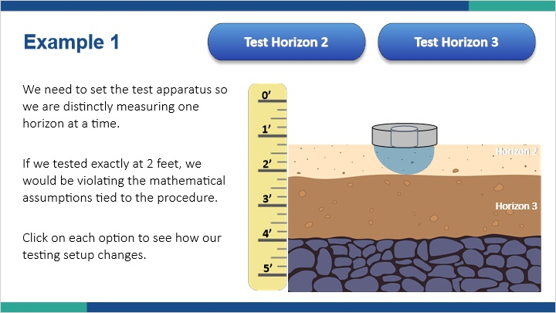

Horizon 3 (Slide Layer)
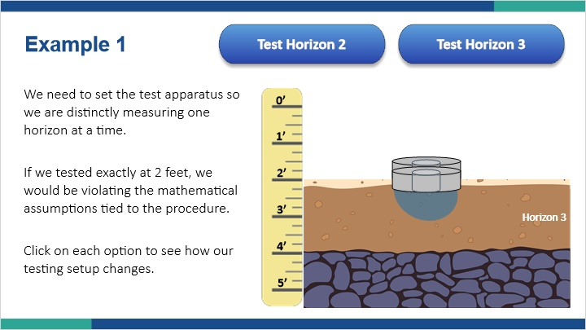

1.42 Example 2
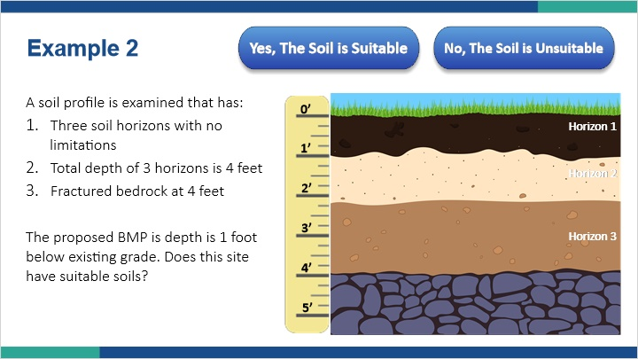
Notes:
For this example, we are examining the same soil profile that has three soil horizons that have no limitations within those horizons. The total depth of the three horizons is four feet. At four feet we encounter fractured bedrock that would be considered a limiting zone. We know from the BMP manual that we need to maintain a minimum of two feet from a limiting zone.

The proposed BMP infiltration depth is one foot below existing grade. Does the site have suitable soils for the proposed design depth?

1.43 Example 2
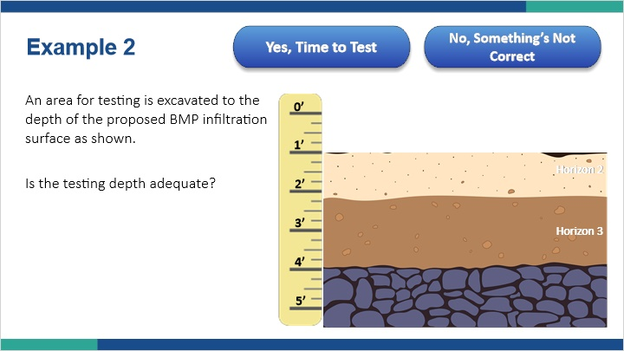
Notes:
Since the depth is adequate, we prepare an area for hydraulic conductivity testing by excavating off the upper one foot as shown. Based on the diagram on the right, is the test depth adequately prepared to place the apparatus?

1.44 Example 2
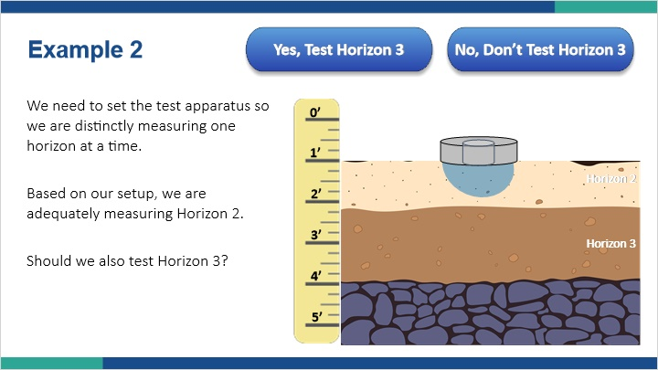
Notes:
We need to set the test apparatus so we are distinctly measuring one horizon at a time. Based on our setup, we are adequately measuring Horizon 2.

Should we also test Horizon 3?

1.45 Example: Bedrock
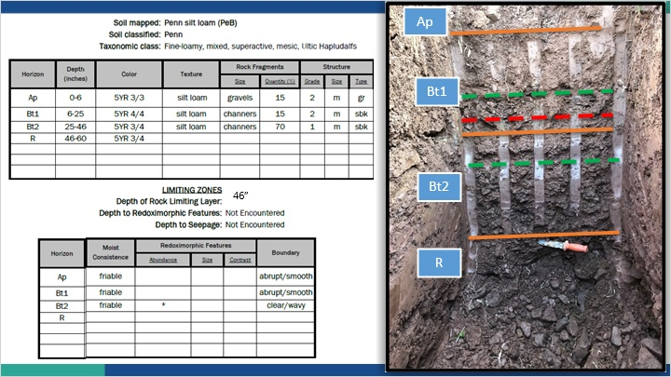
Notes:
Let’s take a look at an actual soil profile and description and determine how it might affect a stormwater design.

Here we see a description sheet. As you can see, the soil was mapped by the NRCS as a Penn soil series. The soil classifier who did this particular profile also determined it met the Penn soil series criteria. The soil scientist described four horizons to a depth of 60 inches or 5 feet. Those horizons are labeled Ap, Bt1, Bt2, and R. At this point, don’t concern yourself with the meaning of these letters and numbers. We’ll just use them to reference the horizon we are discussing.

No observed saturation or redoximorphic features were present, but bedrock was encountered at 46 inches below the surface as shown with the knife in the picture.

So our limitation to stormwater treatment is bedrock at 46 inches. Knowing we have to maintain a minimum of 24 inches of separation between the bottom of a BMP and the top of the limiting zone, we could install a BMP in this soil that is no deeper than 22 inches from the surface. We get that by subtracting 24 inches from 46 inches.

Looking at our soil description, we have a horizon break at 25 inches. If we wanted to place the BMP at 22 inches, we need to run a hydraulic conductivity test at that depth. Because it’s only 3 inches to the next horizon, we should probably run our test a little more shallow in the profile to make sure we are only measuring the Bt1 horizon and not a mix of the Bt1 and Bt2 horizons. In this case, we might want to test at about 18 inches to characterize the Bt1 horizon correctly.

Because the water from the BMP will eventually have to travel through the Bt2 horizon as well, we want to make sure that horizon doesn’t have a slower hydraulic conductivity than the Bt1 horizon. In that case, if we are concerned that it might be slower, we could also run hydraulic conductivity tests in the Bt2 horizon, say at 30 inches below grade.

We would evaluate the tests run in the Bt1 horizon separately from those run in the Bt2 horizon. We would base our design rate on the slower of the two horizons.

Note (Slide Layer)
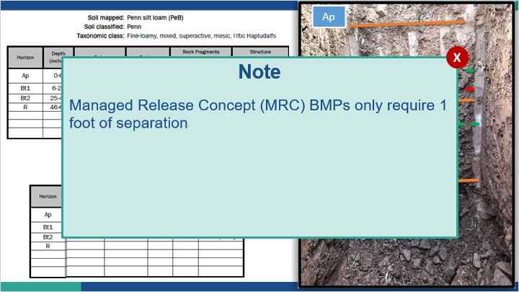

1.46 Example: Saturation
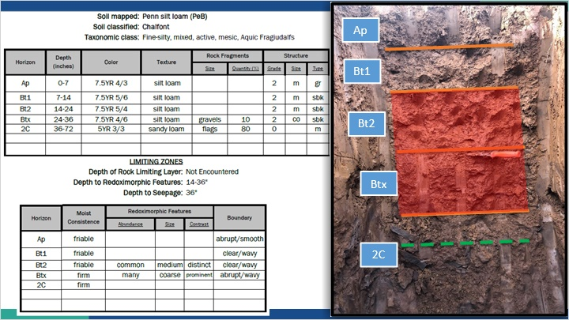
Notes:
Now let’s look at another soil profile.

On this description sheet, the soil was mapped by the NRCS as a Penn soil series, just as the previous example. However, in this example, the soil scientist who did this particular profile determined what they described more accurately aligns with the Chalfont series, not Penn. This does not mean the NRCS mapping was done poorly or the soil scientist describing the pit doesn’t know what they’re doing. This is a result of the scale issue between the mapped soil survey data and site specific conditions. This is exactly why we do site specific testing. The soil scientist described five horizons to a depth of 72 inches or 6 feet. Those horizons are labeled Ap, Bt1, Bt2, Btx, and 2C.

The ‘x’ on the fourth horizon refers to a fragipan, which if you recall is a restrictive soil horizon that often perches water. The top of the fragipan is shown by the knife in the photo at 24 inches. Indeed, looking at the horizon above the fragipan we see the expression of redoximorphic features, which are an indicator of long term saturation. Those are present in the Bt2 and Btx horizons, but not in the 2C horizon. This depicts the perched nature of this saturation.

Based on our observations, we would set the limiting zone from 14-36 inches. This is observed as redoximorphic features and water seepage at 36 inches.

Knowing we need 24 inches of separation, we could not place a BMP above this limitation. However, since the issue seems to be perched saturation, it may be possible to remove the problematic soil horizon, in this case the fragipan, and place the BMP deeper in the 2C horizon. Additional soil and site conditions would need to be explored before this determination could be made, but based on the soil description, it remains a possibility. Based on our observation to 6 feet, and knowing we need 2 feet of separation, we would have to run hydraulic conductivity tests at a depth between 36 to 48 inches, as the BMP could not go any shallower or deeper than those depths. It’s possible that the soil is still suitable beyond 6 feet, but since we did not observe it we can’t make that assumption. We would need to dig deeper to determine suitability beyond 6 feet.

1.47 Reviewing Field Data
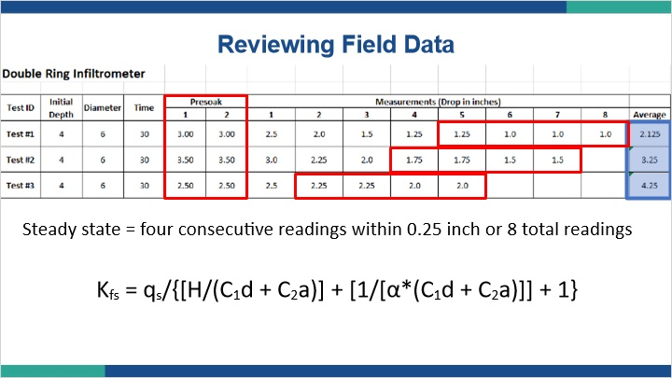
Notes:
When reviewing field data from hydraulic conductivity testing, there isn’t a one form fits all approach. Depending on the apparatus used, there will be different procedures followed. However, the BMP manual does indicate some guidance for the collection of data. One item is that the readings reach a steady state, which is defined as four consecutive readings within 0.25 inch of each other or a maximum of 8 readings. Once you have reached steady state as defined, you would take the average of those last four readings, which becomes your raw field average for that test.

In our table, we ran three double ring tests. The first one reached steady state after the seventh measurement, but an eighth measurement was taken, so we average the last four measurements and multiply by two to get the average rate in inches per hour.

The second test reached steady state by the seventh measurement and we calculated an average of 3.25 inches per hour.

Finally, the third test reached steady state by the fifth measurement and we calculated an average of 4.25 inches per hour.

Please note that we ran two presoak measurements as well, so the total time each test was run was 5 hours for test 1, 4.5 hours for test 2, and 3.5 hours for test 3.

The averages we have computed are not saturated hydraulic conductivity. The averages are a quasi-steady state infiltration rate expressed in inches per hour.

Although we have collected our field results, we still have some computations to do to get our final design number. For this particular test, the following equation is used to calculate a field saturated hydraulic conductivity from our quasi-steady state infiltration rate. Let’s take a closer look at this calculation.

1.48 Adjusting Raw Field Data
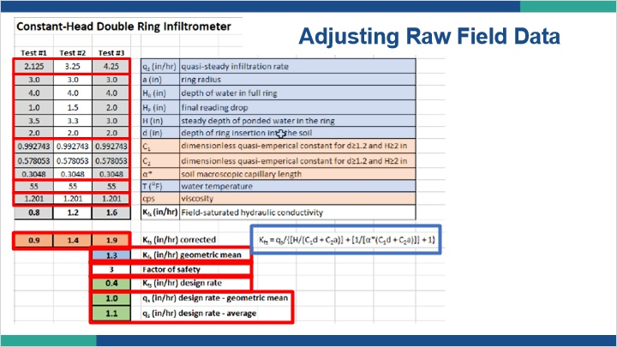
Notes:
Here we have an excel spreadsheet setup to take our quasi-steady state infiltration rate and convert it into a field-saturated hydraulic conductivity. In the upper left of the table, you will see our three average quasi-steady state infiltration rates that we calculated from our field measurements.

Additionally, we have filled in some data from our tests like the radius of the testing ring and the temperature when we ran the tests.

Finally, we have some equation specific constants based again on the test we are running and some of the test-specific conditions. All of those numbers are run through the equation shown here and we end up with a field-saturated hydraulic conductivity rate in inches per hour that has been corrected for temperature and other test conditions.

The numbers range from 0.9 to 1.9 inches per hour, which is quite different than the infiltration rate data we started with that ranged from 2.125 to 4.25 inches per hour.

From those three corrected numbers, we calculate a geometric mean field saturated hydraulic conductivity rate of 1.3 inches per hour. This geometric mean will need to have a factor of safety applied to it, which typically is 2 or 3. More information on factors of safety can be found in the BMP manual Appendix C.

In this case, we applied a factor of safety of three. As a result, we obtain a field-saturated hydraulic conductivity design rate of 0.4 inches per hour. This is the number that should be provided to the designer.

The last two numbers in our table are calculated for discussion purposes. They are the result of taking either the geometric mean or straight average of the quasi-steady state infiltration rate divided by the factor of safety of 3. As you can see, not correcting for the field saturated hydraulic conductivity and instead using the raw infiltration rate has resulted in a design rate that is 2.5 to almost 3 times faster than what the hydraulic conductivity is. Clearly this deviation will have an effect on the size of the BMP and possibly the long term performance.

1.49 Knowledge Check 1
(Hotspot, 10 points, 1 attempt permitted)
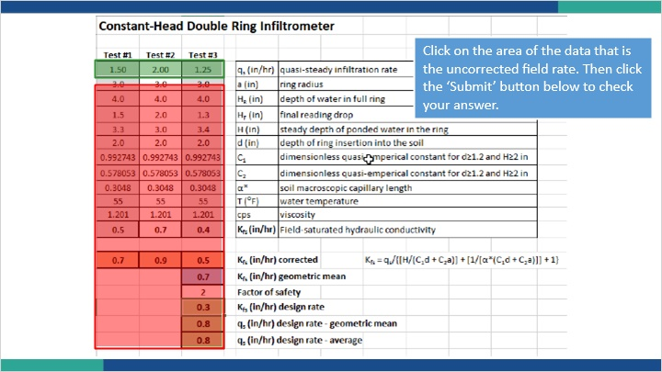

Notes:
Let’s take a look at some data from another site similar to the one we just reviewed. In this data set, click on the area of the chart that contains the uncorrected data we entered from our field testing.

1.50 Knowledge Check 2
(Hotspot, 10 points, 1 attempt permitted)
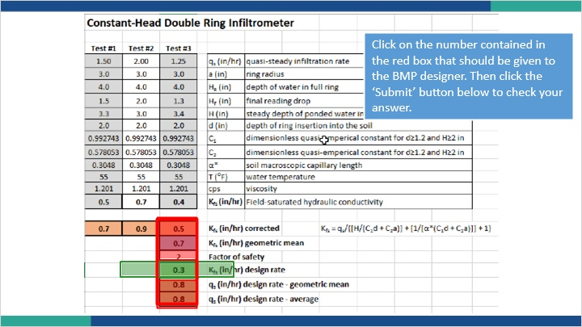

Notes:
Looking at the same data, which number from the list highlighted here should we give the designer?

1.51 Summary: Hydraulic Conductivity Tests
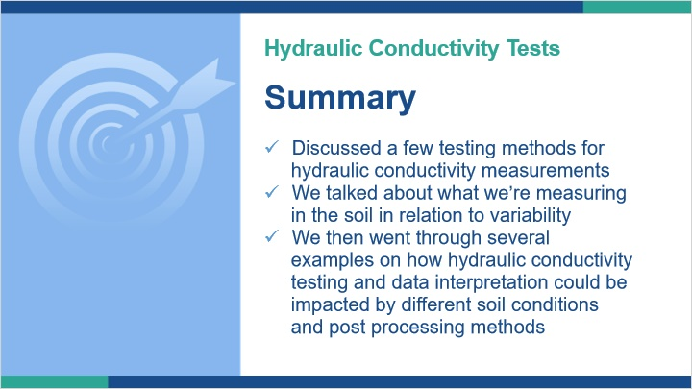
Notes:
In this lesson, we discussed a few testing methods for taking hydraulic conductivity measurements.

We talked about what we are actually trying to measure in the soil and how variability in soil horizons can potentially impact the data we are collecting.

Finally, we went through several examples on how hydraulic conductivity testing and data interpretation could be impacted by different soil conditions and data post processing methods.

1.52 Summary
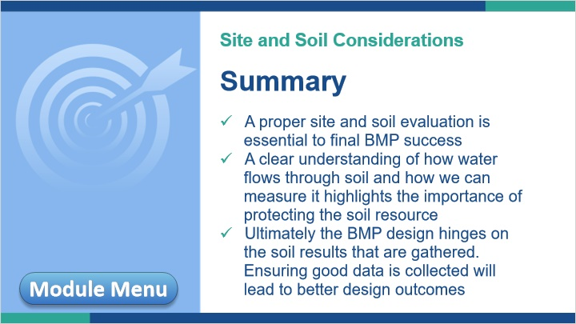
Notes:
This concludes Module 2: Site and Soil Considerations.

In summary, a proper site and soil evaluation is essential to final BMP success.

We saw how a clear understanding of how water flows through soil and how we can measure it highlights the importance of protecting the soil resource we are relying on to treat our stormwater.

Finally, we highlighted that better design outcomes are achieved by gathering scientifically defensible data and interpreting it correctly.

You may now move on to Module 3 by clicking the ‘Next’ button in the bottom right or review any of the lessons of Module 2 again by clicking on the Module Menu button in the bottom left.

